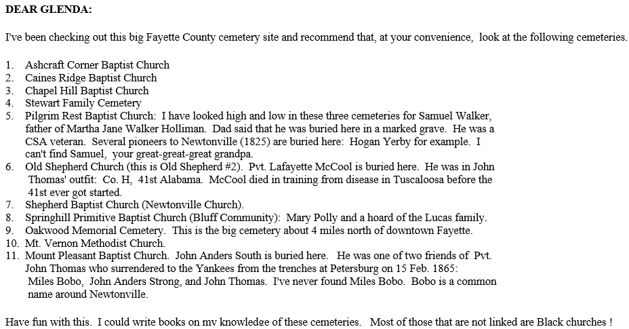

----- Original Message -----

From: Rosie Heveran
To: grmr@sisna.com
Sent: Saturday, February 17, 2007 6:17 PM
Subject: Rainwater, Lucas, Holliman

Glidie,
If you wish you can send Glenda my e-mail address or forward this to her and if she wishes, can contact me.

This is the connection:
Charles Daniel Lucas m. Mary Hasten or Hastings
They had 10 Children, the eldest Daughter Elizabeth Lucas
m. (1)William Rainwater (2) Cornelous Holliman

William and Elizabeth had three sons. Richard, John R. and
ElKaney Rainwater.

Elkaney m. Mary M. Burrow, their daughter Mary Matilda m.
Rev James Alfred Trimm. Two of their sons were Isiah
Henry (my grandfather) and Amasar.

December 2005 at a Trimm Family Reunion we took up a collection to have a marker erected.

It is believed that Charles Daniel Lucas was full blooded Cherokee Indian, Apparently he claimed to be Black Dutch
which more ofter than not was to cover up the Indian Ancestry,

Charles was a tailor by trade in Marlboro Co. South Carolina,
in Alabama he did stock dipping and was also an agent to the
indian reservations.

According to the Holliman"s they came to Alabama with a couple other Holliman brothers and the Charles Daniel Lucas
Family.

Charles is buried in Fayette County on land that he once owned.
There are three indian graves as well.

Hope this clearifies Glenda's question.

Hugs, Rosie
HERE IS OUR ANSWER!!!!! I'M SOOOOOOO EXCITED!!!!

>>> "Glidie Mobley" <grmr@sisna.com> 02/16/2007 3:51 PM >>>
Hello Glenda,
I'll try to explain it for you. My William Rainwater was in War of 1812 and he was discharged in 1814 in Pass Christian,Miss. He drew bounty land in Tuscaloosa Co (which at the time covered most of Ala).He married Elizabeth Lucas on 15 Nov 1823 in Marengo Co.,Ala.
They had 3 sons--Richard-bn 14 May 1824;John R- bn Jan 1826 and Elkaney--bn 29 May 1830. By Apr of
1839 Wm is deceased and Cornelius Holliman was appointed administrator of his estate(which was mainly the bounty land) Cornelius and Elizabeth (Lucas)Rainwater md on 23 Jun 1839.
Needless to say the boys
never recieved any benefit from their Dad's land.From stories passed down from Elkaney's descendants Cornelius was a very brutal man and made the boys miserable. Richard and John R(my line) came to Miss between 1850 and 1860. They went to Winston Co first, then Richard eventually settled in Attala Co and John R migrated to Franklin Co and eventually made it to Lincoln Co where he remained.Elkaney remained in Fayette Co.,Ala and raised his family there.

Elkaney and John R md sisters--Elkaney md Mary Matilda Burrows(Burroughs) and John R md Margaret/Marguerite Burrows. Elkaney and Mary had 7 children:
1-John Wiley-6 Apr 1848(md Sarah A Neale) 2-Mary Matilda-6 Apr 1848 (md James Alfred Trimm) - ( he was a minister)
AMASAR'S PARENTS!!!!

3-Susannah J-30 Jul 1853(md Joseph M.Neal) 4-Maletia-Mar 1857(md O.M.Roberts) 5-William James-1859(md Virgin Virginia Adeline
Sizemore----deserted her and moved to Utah and
Idaho where he had a whole other family)
6-Samuel--1860 died young
7-Charles D-28 Jan 1862-died 26 Jan 1897 (I wonder if Mary named this one after Charles Daniel??)

James Alfred Trimm and Mary Matilda Rainwater married 5 Apr 1874 and they
had:
1-Jeremiah M--13 Nov 1874 (md Amanda Elzada
McClung)
2- Mary Martha-1 Oct 1876(md O.E.Langston) 3-Isaiah Henry--14 Sep 1878(md 1st Rosa Clementine
Barnes;2nd Jala Reese)
4-Amaziah(Amasar)M-18 May 1881(md Mollie M
Dodson)
5-Martha J-6 May 1884 (Md Oscar Pate)
6-Joel B"Albert"-27 Aug 1886(md Ethel Estes) 7-Eli Francis-20 May 1890;died 14 Jun 1891

A lot of my Trimm information came from Rosie (Trimm) Heveran who is a descendant of Isaiah. I stay in contact with her and also a Kenneth Rainwater who is descended from John Wiley Rainwater.Kenneth is in Ala and Rosie is in Ark.
I have more information on Wm and Elizabeth's other sons as I am descended from John R but I've researched all three of them. I can't get beyond Wm though.Still working on that.
Hope this helps you some.

Glidie(Rainwater)Mobley

----- Original Message -----

From: "Glenda Norris" <gnorris@bcbsal.org>
To: <grmr@sisna.com>
Sent: Friday, February 16, 2007 12:10 PM
Subject: Lucas - RAINWATER - Holliman

I was hoping you can explain to me the relation of Elizabeth Lucas Rainwater
Holliman to Mary Matilda Rainwater Trimm?
I have found a census showing Elizabeth Lucas Rainwater Holliman living in
the same household with Elkaney Rainwater (1870's). At that time she was 62
years old.

I am a descendant of Charles Daniel Lucas from Newtonville, Alabama. We
found his burial site which has a marker on it that reads "Charles Daniel
Lucas from the descendants of Mary Matilda Rainwater and Amasar Trimm" -
there is a date listed on the stone, but it does not match up with any dates
I have regarding Charles Daniel Lucas. I am trying to figure out exactly
where the Rainwaters and Trimm's fit into the Lucas/Holliman line.

Would appreciate any info you may have.

Glenda

-----------------------------------------
This lady had some info to offer on the Rainwater families...

>>> Lynn Fusinato <LynnFusinato@tx.rr.com> 02/13/2007 11:49 AM >>>
Hi,

I don't keep records of Rainwater descendants past my gg-grandmother's generation but I looked up the names you mentioned at the Rainwater genealogy site

www.chronography.com/rainwater/marriage.html

and found the following marriage records listed in consecutive order:
Lamar Co. Alabama marriages:
> Mary Matilda Rainwater m. James A. Trimm, 5 Apr 1874 [110]
> Mary M. Rainwater m. Walter A. Guin, 16 Oct 1884 [110] -
The second Mary M. Rainwater is daughter of my
great-great-great Uncle Silas Rainwater

At website http://www.census-online.com/links/AL/Lamar/
a check of the 1870 Lamar Co. Census data lists E. Rainwater, a 40 year old farmer born in Alabama living with Nancy Rainwater, age 50 and probably wife of E. Rainwater.
Children in household:
M. M. Rainwater 21 yr female
S. J. " 17 female
William J. " 10 male
Matilda " 13 female
C. D. " 8 male
In next household is J. W. Rainwater, a farmer age 21, and
S. A. Rainwater 23, his wife, and
their 3 month old son M. P. Rainwater
J. W. is probably the son of E. Rainwater and Nancy.

www.FamilySearch.com under Search option-> Census option->
1880 Census, a search for Rainwater/Rainwaters turned up the following Rainwater and Trim neighbors in Lamar and Fayette Counties. They seem to be the sons of E. and Nancy Rainwater. Matilda Rainwater Trim apparently lived next door to her brother William. I would guess that James A.
Trim might be a son of widow Manika Trim. I do not have a clue as to what happened to the parents, E. and Nancy Rainwater.

1880 Census, Lamar, Alabama, very close neighbors:
John W. RAINWATERS Male White 33 Farmer AL AL AL
Sarah A. RAINWATERS Wife Female White 26 Keeping House AL AL AL
Mary RAINWATERS Dau Female White 9 At Home AL AL AL
N. J. RAINWATERS Dau Female White 7 At Home AL AL AL
William D.RAINWATERS Son Male White 3 At Home AL AL AL
Virgie RAINWATERS Dau Female White 9M At Home AL AL AL
Betsy HOLLIMAN Mother Female White 70 At Home VA VA VA

Manika TRIM Widow Female White 55 Keeping House NC NC NC
Sarah E. TRIM Dau Female White 20 At Home AL NC NC
Francis M. TRIM Son Male White 18 At Home AL NC NC
Robert A. TRIM Son Male White 16 At Home AL NC NC
Mike TRIM Son Male White 14 At Home AL NC NC

1880 Census, Fayette Co Alabama, next door neighbors:
W. J. RAINWATER Male W 20 Farmer AL AL AL
Virginia RAINWATER,Wife Female W 20 Keeping House AL AL AL
John H. RAINWATER, Son Male W 2 AL AL AL
M. J. SIZEMOORE,MotherL Female W 37 AL AL AL

J. A. TRIM Male W 25 Farmer AL AL NC
Mary TRIM Wife Female W 31 Keeping House AL AL AL
Jeremiah TRIM Son Male W 5 AL AL AL
Mary A. TRIM Dau Female W 4 AL AL AL
Isah TRIM Son Male W 1 AL AL AL

I did not find anything on Charles Daniel Lucas. But I don't know when and where he was born or when he died. Is he some kin to the Trims?

Good Luck with your search.
Lynn

Glenda Norris wrote:
> I read your article on the Rainwater Family in Fayette County Alabama.
> Was hoping you could identify some names for me.
>
> Mary Matilda Rainwater
> Amasar Trimm
>
> See attached photo
>
> Charles Daniel Lucas is my 4+ grandfather. We just recently located
> his grave in Fayette. He is buried in an Indian Burial Ground off of
> Rt 100 in Newtonville. This memorial marker was placed marking his
> grave. I do not have any records of Rainwater or Trimm's in the Lucas Family.
>
> Would appreciate any info you may have.
>
> Glenda Norris
>
> ----------------------------------------------------------------------
> --
>
> * *
>

