Sam’s 2nd wife was NOT Salina….it is SARENA!!!!!!!!

I did a search on Ancestry.com (I’m doing a free 14 day “trial”).

This is what I found:
Samuel T. Walker
HOME in 1900: Hico, Fayette, Alabama
Estimated birth year: 1822
Alabama
Father
White
Pinkney M. walker 49 - Head
Martha C. Walker 50- wife
Cathus T. Walker 22- son
Ulus E. Walker 20 - son
Samuel T. Walker 78 - Father
Sarena Walker 74 – S-mother

Sam and Sarena lived with Sam’s son “Pinkney” and his wife Martha. Cathus and Ulus must be Pinkney and Martha’s son’s…

I’ve been searching for a “salina” all this time. Papa had it wrong in his book. Its weird though because I have found a marriage record which matches the marriage date of Sam and Sarena…but it does have Sarena’s spelling as Salina…go figure?????

Martha Jane Walker Holliman Will 1931

Here is what I have so far...
June 5
Mother an Children
Billey the bed he likes and stiac (stack?) as it stanas (Stands?). 2
sheets 2 quilts. Leelan the bed in the front room is his 2 sheets 2
quilts. My bed is ____?when I am gone with its 2 sheets 2 quilts and
the berlan (?) Jim one of my amble more country (?pen).Wlyns the clock
(?) if I dye (die) first. Johns bed and close (Clothes?), blankets (?) 4
quilts. The rest of my things (I think this is what she means) ???
assign a number to all of you. Be cind (kind?) and goode to each other
and think of Mother when you are here. (this sentence is tough...just
words doesn't make sense to me) Thing a mange you all gets g___ bed back
when he been was c____??? Leelan never has had anything. With ______
an his to w____ her you all.
Mother has loved you all.
Maybe Bishop can add to this as well.
Glenda

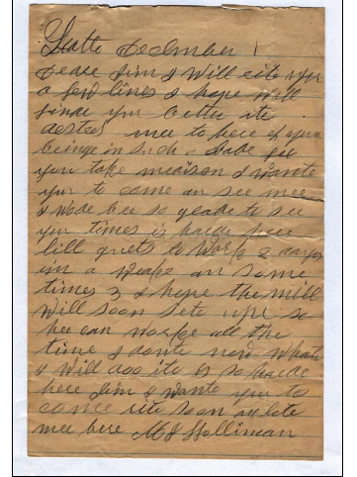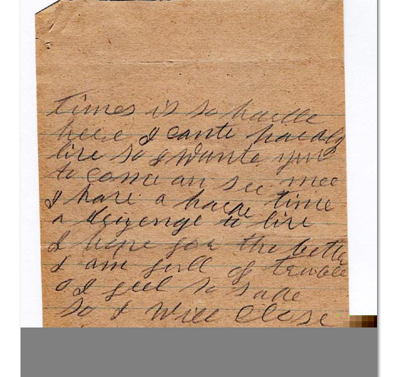Dear Glenda:

While I'm sitting here, I'll mail the other 3 letters off to you (attached). I think that this is all I have from MJH. As this story unfolds, you will find out why JTH and MJH were so poor. Their decline coincided with the Great Depression and the fact that John Thomas surrendered to the Yankees 141 years ago yesterday !!!
He was ostracized and ridiculed by his neighbors in Fayette for 65 years before he died in 1930 !!! A very sad life. It's too bad that he had to come back to such a small-minded community after the War.

I'll get stated scanning John Thomas' letters now. Big job ahead ! Love, Uncle RhodesIt’s amazing how names got messed up back then. I think all of these names go with Samuel’s 2nd wife.
I found another census and it has “Selina”, 40 years old female, keeping house, with Barnet Moss age 61 – farmer, this census is dated 10/1870.
There is a Moss Cemetery with only two names listed. Barnet Moss May 8, 1809, February, 1876 and MOSS, Eleanor Kuykendall June 12, 1812-February 1864. I am think that Eleanor passed away…Barnet took Selina in to help him manage his home (not sure if he married her or if she is a daughter…who knows???) I will try to find the “Moss Cemetery” one of these days….not sure why I am hung up on finding Sam’s second wife???

