Sunday, May 26, 2013

Isaac Holliman - A Story of the Old South, Part I
by Glenn N. Holliman
Last year in this space, Sandi Royal of Virginia, told the family story of her great great grandparents, one a former slave and one a slave owner's daughter, who defied the severe mores of the 1800s, eloped, married and against social odds raised a family. In the 21st Century descendants of this couple, Isaac and Ann Gray Holliman, gather regularly in southeast Virginia to celebrate their history and family. In October 2012, my son, Christopher S. Holliman, and I joined several of these descendants to explore our shared history in Isle of Wight County, Virginia.
This is a story of people connected by history and family....
As the tobacco and later cotton culture of the southern colonies and later states took hold in the 18th and 19th Centuries, some Holliman families, descendants of Christopher Holyman (who died in 1691 without owning other human beings), purchased slaves. We know this because in their Wills, these Hollemans (of various spellings) devolved persons in bondage to their off-spring.
Due to the lack of legally recording early births in Virginia, we have an incomplete understanding of family relations, especially so among African-Americans, most of whom were held as slaves. In addition, marriage was not legally recognized or recorded for slaves. Indeed part of the special horror of southern slavery was that husbands were sold away from wives and children, and children from their parents.
As generations passed these African-Americans who had lost their language, their religions and their very names, adopted European names and melded the remains of their past with the emerging culture of a new United States. Persons held in bondage took the names of the slave owners, and hence today, especially in southeastern Virginia, one will find numerous African-American Hollimans who have gone on to prosper in the New World.
Which leads us into the story of Isaac and Ann Gray Holliman....
Below, soy bean fields and autumn wild flowers on the original farm of Christopher Holyman, who came to Virginia in 1650 from Bedford, Bedfordshire, England and farmed in Isle of Wight, Virginia until his death in 1691.
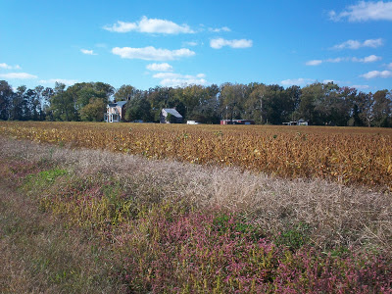
Below some descendants of Isaac Holliman and Ann Gray on an autumn tour in southeastern Virginia to explore ancestral sites. Right to left are Cyndi Barnett, Tammy Hunt, Doris Knox and Robert Royal, husband of Sandi Royal. This photo was taken October 2012 on a bridge overlooking the Blackwater River in Isle of Wight County, Virginia, the area where Isaac and Ann Gray Holliman lived after the Civil War. The original Christopher Holyman plantation was established along the Blackwater River and Mill Swamp bordering Surry County. Hollemans today of African and English descent still live in these first settlements of what became the United States.
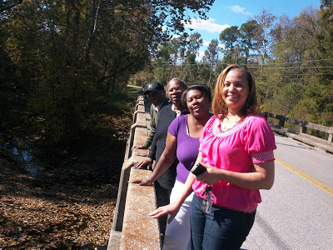

Next posting, more of the amazing story of Isaac and Ann Holliman and their American legacy....

Thursday, June 6, 2013

Isaac Holliman - A Story of the Old South, Part II
by Glenn N. Holliman
A Holyman Family with Deep Roots in Virginia....
We continue the fascinating story of the family and descendants of Isaac and Ann Gray Holliman....
Below, left to right, Doris Knox, Tammy Hunt, Cyndi Barnett and Sandi Royal visit Holliman graves at Chapel Grove Cemetery, Windsor, Virginia. All in this photograph, both living and those who have gone before, are descendants of Isaac Holliman, a former slave who had 12 children with Ann Gray, who by family tradition was a daughter of a slave owner.
Isaac did have a son Robert W., probably born in or around 1851 by an earlier relationship with a woman named Matilda. Tammy Hunt is descended from these first parents.
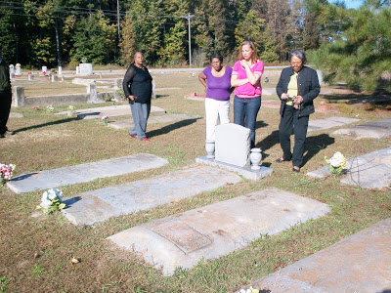
According to family records, the girls of Isaac and Anne were Anne Lou, Joanna, Luzerne, Monil J. and Rosanna. The boys were Isaac T., James H., Jeremiah P., John H., Joseph, P., Joshua, and Nonnie J.
Who was Isaac Holliman? The 1880 census states an Isaac Holliman of Isle of Wight, Virginia was born in 1824 and had a wife named Ann. Her birthday is in uncertain, born perhaps in 1832, 1845 or 1852.

According to Sandi Royal, Isaac may or may not have been the offspring of his owner, whose name was Holliman. DNA testing to this date has been inconclusive as to whether Isaac and his offspring are genetically related to the descendants of Christopher Holyman (d 1691). However, there is not doubt that the two families are historically related by time, place and circumstance.

The name of the white Holliman family that held Isaac in bondage is not known with certainty although Mrs. Royal has an opinion based on careful reading of George Holleman's 1953 history of the family (reprinted by Tina Peddie and available for sale).

Isaac did adopt the name Holliman, and after having fathered one child, at some point in his life 'jumped the broomstick' (married) a woman named Ann Gray, evidently during the Civil War. Family tradition records Ann who died in 1930 as 'being the white grandmother' and tales abound of Ann being a slave owner's daughter. The couple literally 'ran into the woods' to escape Ann's angry parents.

The document below, found by Hollyman historian Jeanette Holiman Stewart, was issued October 8,1866 at Fortress Monroe, Virginia. The letter requests for Isaac Holliman, his wife, Ann, and son Robert transportation back to Nansemond County (an extinct county which bordered Isle of Wight County). The three are identified as 'freed people' who, as were tens of thousands of former bonds people, displaced by the upheavals and destruction of slavery during the Civil War.
Note Isaac's age is listed as 47 and Ann as 21 (which would make her born in 1845) and the stepson of Ann, Robert, is 15. This Federal document suggests Isaac and Ann were only recently married, given her young age (if accurate) and the lack of children listed.
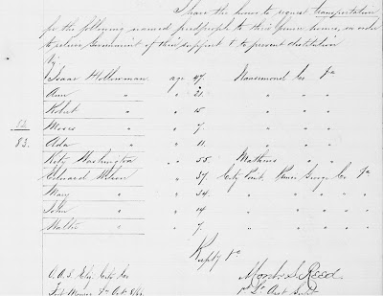

Next article more on this couple who defied the laws of their time to marry and found a family in post-Civil War Virginia. And who was Ann Gray?

Thursday, June 27, 2013

Isaac Holliman - A Story of the Old South, Part III
by Glenn N. Holliman
Who were Ann Gray Holliman's Parents?
The oral family tradition is compelling and dramatic. Perhaps during the Civil War, a man held in bondage, one Isaac Holliman, ran away with a white woman, Ann Gray, evidently half his age. Her parents were furious, and the couple escaped their outrage by hiding in the forests or swamps of southeast Virginia.
Below the Chapel Grove United Church of Christ in Windsor, Virginia where Isaac and Ann Holliman may be buried. Many of their descendants rest here.
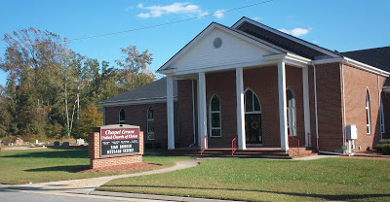
Who was Ann Gray? Who were her parents and where did this family live? Oral tradition places both Ann and Isaac as natives of Isle of Wight County, Virginia. Grays and Holymans were both early settlers of Isle of Wight, and their ancestors live near each other even today.
We have some hints but only a very few....
In a published Isle of Wight will, one Ann Gray is recorded as a grand daughter of Josiah Holleman who died in 1847. Josiah Holleman had a son named Wilson Holleman. The will also lists a daughter, Virginia Gray and another grand daughter, Virginia Gray, the same name.
In the Census of 1860, a family is listed in Smithfield, Isle of Wight, of William Gray, age 40, Matilda, age 34 and among the children, one Ann, age 13. Is this the same Ann Gray recorded in Josiah's 1847 will? Is this the Ann Gray who will marry Isaac Holliman? She could be as the age almost works, but, it is difficult to be certain. As descendant Nonnie Holliman notes, this Ann is no longer with the Gray family in the 1870 Census.
As noted in the last posting, one Isaac Holliman, age 47, and Ann, age 21, and a minor, Isaac's son Robert, age 15 by a first liaison, are recorded in U.S. Freedman records in 1866. This Ann is close to the age recorded in the 1860 Federal Census in the William Gray family.
This couple, with increasing numbers of children, appear in every Federal census until Isaac's death before 1900. Isaac and Ann are recorded as mulatto, that is of mixed African and European DNA. These several censuses place the couple as living in Windsor, Isle of Wight County, Virginia which is located near the original Christopher Holyman plantation founded in the 1680s.
So here we are....
1. The above Pre-Civil War records may or may not identify Ann Gray's parents and grandfather. Circumstantial evidence is there. Is it enough? It is hoped that more records can be discovered to verify parentage beyond a reasonable doubt.
2. Federal censuses identify Isaac as mulatto which begs the question - was he the biological son of a white man named Holyman, Holleman or Holliman? After all Isaac took the name Holliman from the family that owned both him and perhaps his mother.
3. DNA testing done to date has not yet tied the European Hollimans to the African American Hollimans. DNA from a male, directly descended from Isaac through males only, is needed to test the thesis that Isaac is descended from Christopher Holyman, 1618-1691.
4. To my knowledge no one has approached any Gray descendants for DNA testing. Research could be done to locate persons who have Gray ancestors in Isle of Wight County. (For DNA testing cousin Tina Peddie can provide assistance; see information below in blue.)
5. The evidence we do have is remarkable - oral tradition that Ann was the 'white grandmother', the Freedman's record of 1866 and the Federal Census records that place the family in Windsor, Isle of Wight, near the historic homes of the Grays and Hollemans.
Isaac and Ann Gray Holliman left a legacy of children and later descendants who proudly claim this remarkable couple as their 'founding family'. From time to time, descendants gather in southeastern Virginia to celebrate their heritage and the blessings of being American. Sandi Royal and others have published a book on the descendants of Isaac and Ann Gray Holliman. For information on future reunions and this publication, Mrs. Royal can be contacted through this writer at glennhistory@gmail.com.
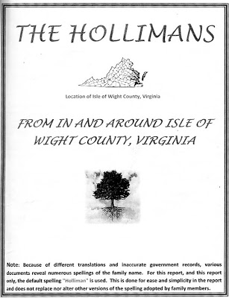

In the Autumn of 2012, Holliman descendants on an afternoon of discovery visited the Mill Swamp Baptist Church Cemetery in Isle of Wight, County, Virginia to learn more about our shared history and possible ancestors. Below, left to right are Christopher S. Holliman (the writer's son), Doris Knox, Cyndi Barnett, Tammy Hunt, Glenn Holliman (the writer) and Sandi Royal.

The gravestone, pictured above, is a memorial to several Isle of Wight County 20th Century descendants of Christopher Holyman (1618-1691), of whom recent members generously gave the land for the cemetery. More will be written on this branch of the Holleman family in future posts.
Research work remains to be accomplished to verify if our Holliman families are genetically related. However, it is very appropriate to state that we are related by time, place and the tides of history, and that we share in the American story!
I am grateful to the above descendants and others of Isaac and Ann Gray Holliman who have written and told me this intriguing story and encouraging additional research. Any errors in these posts are mine alone, and I would be grateful for any additional information and/or corrections.
Next posting....more on Isle of Wight Hollemans....
Descendants of Isaac and Ann Gray Holliman will hold a family reunion at the Wakefield Conference Center and Campground, Wakefield, Virginia August 10 and 11, 2013. Cost is only $35. For information, contact Tammy Hunt at hunttl_sept2571@yahoo.com.
Have questions about Holliman family history? You are invited to join the Hollyman Email List at Hollyman-Subscribe@yahoogroups.com and the Hollyman Family Facebook Page located on Facebook at "Hollyman Family". Post your questions and perhaps one of the dozens Holyman cousins on the list will have an answer. For more information contact Tina Peddie at desabla1@yahoo.com, the list and Facebook manager for Hollyman (and all our various spellings!). Mrs. Peddie can assist also in any DNA research.
Since early 2010, I have been publishing research and stories on the broad spectrum of Holliman (Holyman) family history at http://hollimanfamilyhistory.blogspot.com/ . For stories on my more immediate family since the early 20th Century, I have been posting articles since early 2011 at http://ulyssholliman.blogspot.com/ .
Let's save the past for the future! If you have photographs, letters, memorabilia or research you wish to share, please contact me directly at glennhistory@gmail.com. Several of us have an on-going program of scanning and preserving Holyman and related family records. Write please and tell us of your items. Thanks to the Internet, we are able to scan, upload to the web (with your permission) and return the materials to you.
A seminar is to be held at the Rose Hill Inn, Fayette, Alabama, October 18 and 19, 2013 for more serious students of Holliman and related families. Just write me for more information. GNH
Posted by Glenn N. Holliman at 5:00 PM
Labels: Ann Gray, Christopher S. Holliman, Cyndi Barnett, Doris Knox, Glenn Holliman, Isaac Holliman, Josiah Holleman, Sandi Royal, Tammy Hunt, William Gray

Monday, September 2, 2013

Exploring Further Holliman History in Old Virginia, Part 1
by Glenn N. Holliman
Descendants of Christopher Holyman (d 1691) who reside in Virginia to this Day.....
Recently in this space I wrote of Isaac and Anne Gray Holliman, the anguished story of two persons caught in the racial and cultural divides of 19th Century Virginia. Seeking to know more of our family heritage from Isle of Wight County, Virginia, I have been fortunate enough to meet Holleman cousins of Virginia who have kindly shared family stories, lineages and photographs. For the next several articles, with their permission, I shall be writing a synopsis of this research.
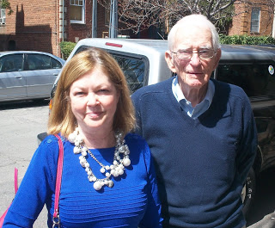

﻿
Recently Susan Holleman Brewer and her father, Joseph Howard Holleman, Jr., both of Richmond, Virginia, kindly shared lunch (pictured above). The conversation deepened my understanding of the family branch that resided and still resides along the Blackwater River near the Mill Swamp in Isle of Wight County and also in Surry County, Virginia.
Susan opened several doors which led to visits with Holleman cousins Caroline Holleman Thomas and Sarah Barlow Wright who both shared their family memorabilia and photographs. Their stories and that of other Hollemans will be published in future articles.

To refresh memories, Christopher Holyman, the fore bearer of most Hollimans in America today, arrived in Virginia in 1650 from Bedfordshire, England, the son of a cordwainer and inn keeper, and by the time of his death in 1691, established a plantation of 1,020 acres in Mill Swamp, Isle of Wight County, Virginia.
﻿
The farm was divided amongst his four sons - Christopher, Jr., Thomas, William and Richard Holyman. Many of their descendants had by the 1800s scattered, for the most part, to the southern and southeastern parts of the United States. The names were altered into various spellings depending on one's literacy (and that of the county register and census taker!) as the centuries progressed.
﻿
Susan and her father, Joseph Howard Holleman, Jr. are descended from the oldest son, Christopher Holyman, Jr. who inherited and/or purchased from his brothers a significant portion of the original 1691 plantation. Although now much reduced in acreage, the farm has remained in their branch of the Holleman line for over 300 years.

Today the land and Federal period 1830 house are owned by William Joseph Holleman of Smithfield, Virginia.

Joseph Howard Holleman, Jr. was born in 1923 on the original farm, then owned by his uncle and aunt Josiah (1851-1937) and Augusta Hannah White Holliman (1859-1941). Joseph Jr.'s father was Joseph Howard Holleman, Sr. (1897-1979) and his mother, Bessie Faircloth (1896-1986) of Southampton County.
﻿
Below, Joseph Howard Holleman, Sr. in his uniform as a Virginia Military Institute cadet in the middle 1910s. This photograph and the one below it are courtesy of Sarah Barlow Wright.
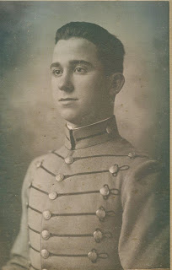

Below, a photograph taken during World War II. The girl is Caroline Holleman Thomas, sister of Joseph, Jr. who is in the Army uniform. Left and right are their parents, Joseph Sr. and Bessie.
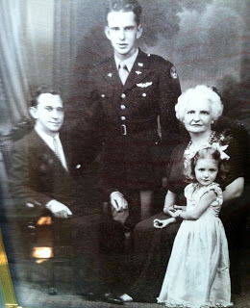
Joseph Holleman, Sr. purchased a Chevrolet dealership in Surry County, Virginia and entered politics. From 1934 until 1948 he represented Surry and Prince George Counties and the City of Hopewell in the Virginia House of Delegates.
﻿
Joseph Sr.'s long time service in the House of Delegates lead to a career opening for his son, Joseph, Jr. who became a decade's long Clerk of the Virginia House. With his vast knowledge of the Virginia legislature, Joseph Jr. wrote a definitive work entitled 'Speakers and Clerks of the Virginia House of Delegates 1776-1976'.
﻿
Joseph, Jr.'s daughter, Susan, pictured in the first photograph, is a law professor at a Richmond college, and continues the family's legacy of serving the legal needs of the Commonwealth of Virginia.
﻿
Next more on the Hollemans who remained in Virginia....

Friday, September 20, 2013

Exploring Further Holliman History in Old Virginia, Part 2
by Glenn N. Holliman
Descendants of Christopher Holyman (d 1691) who reside in Virginia to this Day....
We continue to report on the descendants of Christopher Holyman (1618-1691), who live in the Isle of Wight County and Richmond, Virginia. My thanks to the distant cousins who kindly shared their time and photographs. There will be several more articles on Isle of Wight County, which to most Holymans (and many various spellings) is our American ancestral starting point.
Below, Caroline Holleman Thomas and her husband, Bill, in their Richmond, Virginia home earlier this year. Caroline is the sister of Joseph Howard Holleman, Jr., about whom I wrote in the last post. Both are children of Joseph Howard Holleman, Sr. and Bessie Faircloth Holleman. Bill and Caroline are retired educators.
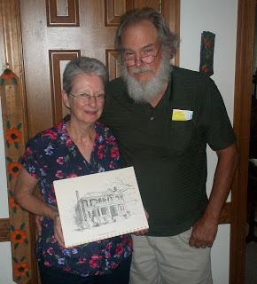
Above, Caroline holds a drawing of the 1830 Holleman House located along the Blackwater River near the Mill Swamp Baptist Church in Isle of Wight, Virginia. Caroline and Bill had their wedding rehearsal dinner by romantic candlelight in the historic home in December 1962. The dinner party was hosted by her Aunt Louise and Uncle Algenon (Nonnie) Holleman.
Most persons in the U.S who bear the Holleman name (and various spellings such as Holliman, Holloman, etc.) trace their linage to this farm adjacent to the Mill Swamp near the Blackwater River in Isle of Wight County, Virginia.
If there be a 'Plymouth Rock' for Hollimans, this is the place although, of course, the brick 1830 home was not built during the 17th Century. Christopher Holyman's original home, most probably a log cabin, would have lasted only 20 to 40 years as a habitable house. Since the 1680s, Hollemans have lived on the same land patented by Christopher Holyman during the reign of King Charles II of England.
Below, this water color is in the possession of Sarah Barlow Wright of Smithfield, a first cousin of Caroline Holleman Thomas. Mrs. Wright has told me that the clapboard building on the right of the painting pre-dates the Federal style home, and was the Holleman home while the 1830 building was being constructed. The out building still stands today, probably of 18th Century construction.
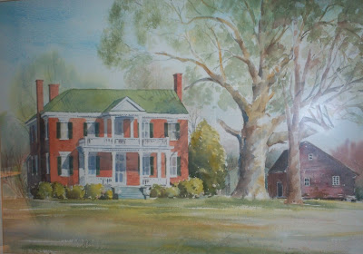
Below, Algenon Holleman who with his wife, Louise, hosted the 1962 rehearsal dinner for their niece, Caroline Holleman, and Bill Thomas. Algenon's son, William Joseph (Billy Joe) Holleman, owns the home today. His son, Joseph (Joey) Holleman, lives in the historic home with his family.

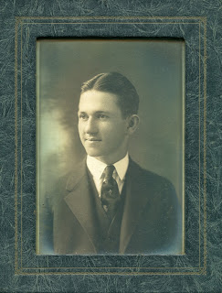

This above photograph is courtesy of Sarah Barlow Wright, whose mother, Gladys Holleman Barlow, grew up in the early 1900s at the Holleman House. We will begin their stories in the next posting.
Next more on the Hollemans of Isle of Wight, Virginia....

Saturday, October 5, 2013

Exploring Further Holliman History in Old Virginia, Part 3
by Glenn N. Holliman
We continue to report on the descendants of Christopher Holyman (1618-1691), who live in the Isle of Wight County and Richmond, Virginia. My thanks to the distant cousins - Sarah Barlow Wright, Janet Barlow Moore and Susan Brewer -who kindly shared their time and photographs and proof read the article. There will be several more postings on Isle of Wight County, which to most Holymans (and its many various spellings) is our American ancestral starting point.
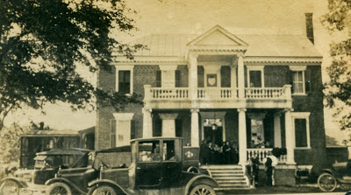
Above, the Holleman House at Mill Swamp, Isle of Wight, Virginia in 1921. The family gathering was being held at the home of Josiah James and Augusta White Binford Holleman. Picture from the collection of Sarah Barlow Wright.
Below, Sarah Barlow Wright in her Isle of Wight, Virginia home with treasured family photographs of her grandparents, Augusta Hannah White Binford Holleman (1859-1941)and Josiah James Holleman (1851-1937). Sarah's grandfather gave the land for the cemetery at the Mill Swamp Baptist Church adjacent to the historic Holleman House near the Surry County border.

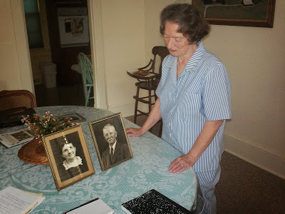

Now retired, Mrs.Wright was a teacher or principal for over 35 years. She grew up in Isle of Wight County at Oak Crest, the Gordon Barlow Farm, five miles north of Smithfield, close to the James River. Her mother, Gladys Hortense Holleman Barlow (1895-1996) was born at the Holleman Farm at Mill Swamp, and later married Gordon Eugene Barlow (1891-1973).
Sarah Wright's lineage in Isle of Wight extends from at least 1661 when Christopher Holyman purchased land from George Smith along the Cypress River. Smithfield, Virginia takes its name from this family. Arthur Smith, a descendant of George, was the founder of the town in the 1750.
Augusta Hannah White Binford Holleman had two children by a first marriage and three with Josiah J. Holleman. Their children were Gladys Hortense Holleman Barlow (mother of Sarah Wright), Joseph Howard Holleman, Sr. (written about in earlier posts, he is the father of Caroline Holleman Thomas and Joseph H. Holleman) and Algernon Hardy Holleman (father of William Joseph Holleman, current owner of the Holleman House).
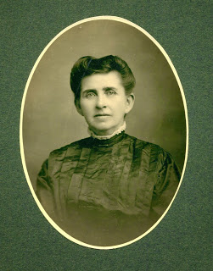
Right , Augusta White Holleman
The lineage for this branch of the Holleman family
flows as follows:
Josiah James Holleman (1851-1937), son of
James Henry Holleman (1819-1858), son of
William H. Holleman (1795-1836), son of
Josiah Holleman (1771-1848), son of
Jesse Holliman, Sr. (1737-1824), son of
John Holleman (1688-1751), son of
Christopher C. Holyman (1660 ca - 1731), son of
Christopher Holyman, Sr. (1618-1691), the immigrant from Bedfordshire, England who arrived in Jamestown, Virginia in 1650.
The 1684 plantation, patented by Christopher Holyman, Sr. eventually descended to Wilson Holleman (1803-1873). The current house was built by Wilson and Ann Nicholson Holleman. Wilson left it to his son, Algernon Sidney Holleman (1838-1906), who died childless. The House and farm then went to Josiah James Holleman, a first cousin.
Josiah left it to his son, Algernon Hardy Holleman (1902-1963), who passed the property to his son, William Joseph Holleman, who owns the home today. His son, William Joseph Holleman, Jr. now lives on the farm, continuously occupied by Hollemans for almost 350 years.

Next posting, more on the Holleman descendants who have remained in Isle of Wight, Virginia since the Christopher Holyman arrival in Jamestown, Virginia in 1650.

Sunday, November 17, 2013

Exploring further Holleman History in Old Virginia - Part 5
by Glenn N. Holliman

We continue our series of articles on the descendants of Christopher Holyman (d 1691) who have remained in Isle of Wight County, Virginia and vicinity for hundreds of years. My continued thanks to Sarah Barlow Wright, Janet Wright Moore and Susan Holleman Brewer for their kind help.

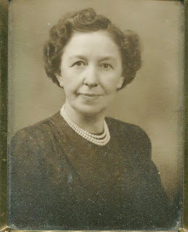
Above, a portrait of Gladys Holleman Barlow (1895 - 1996)

In the 1986 Many Voices, a treasury of Isle of Wight County, Virginia personal memories, Gladys Holleman Barlow spoke of her life of the early 20th Century on the family home, the Holleman House at Mill Swamp adjacent to the Surry County border. We continue...

"My parents were farmers, and my husband and I were farmers. One of my earliest memories is riding around in the horse and cart with my father when he was measuring up peanuts. The peanut pickers would pick up peanuts, and my father would go around late in the afternoon to measure them and pay the pickers ten cents a bushel for having picked them up. Hardly anybody picked over three bushels a day."
Below, the Holleman House and farm in the 1980s ca. To the right of the main 1830 structure is possibly the oldest structure on the property, a wood frame building that was the home of the Wilson Holleman family prior to the construction of the two-story imposing red brick structure. Approximately 100 acres of the original 1691 plantation of 1,020 acres still remain in the Holleman family. Photograph of Gladys Holleman Barlow and the below plantation courtesy of Sarah Barlow Wright, her daughter.
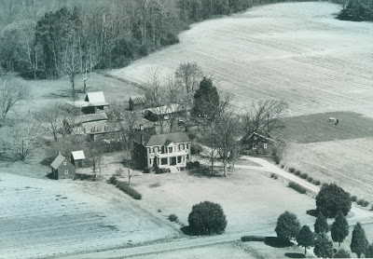

"Another thing that was done then, but wouldn't be done now, was to burn corn stalks on cold winter nights. My father would go around with a fire brand and have these piles of corn stalks about the field to light. I loved going around with them doing that. Another time, they would have corn shuckings. All the neighbors would come and shuck corn. We would have a long row of it in the backyard, and I always had a girl come home with me so we could walk in the shucks.

There was an old brick house on our farm that was said to be haunted. My father stored peanuts there without fear of anyone stealing them because the neighborhood people were afraid of ghosts. Some strangers came one time and asked him if they could dig around the house for treasures, and he told them he felt sure there were no treasures, and he didn't want them digging up his field, so he didn't give his permission. But the next day, he went there, and they had during the night, so they must not have been afraid of ghosts. We don't know whether they found treasures or not."
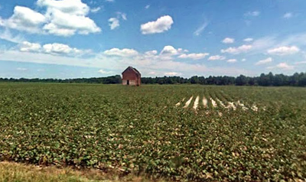

Above, the 'haunted' abandoned brick house in a former Holleman field in Mill Swamp approximately a half mile from the 1830 home. One Holleman cousin believes this may have been the site of the original 1690s Christopher Holyman house; another cousin disagrees.
Shown above, soybeans are often the crop of choice for Isle of Wight farmers in the 21st Century and of course, peanuts are still grown. In the 1600s, farmers such as the Hollemans would have grown several acres of tobacco as the cash crop, and acres of corn for the table and animals.
Hogs would have roamed freely in the woods until frost eating the mast. In the 1670s, according to a Surry County court case, Native Americans stole and butchered some of the Holleman hogs. A year later Bacon's Rebellion broke out in the colony due in large part to continuing friction between the two cultures.

Next posting, more on Isle of Wight and the Holleman farm....

