SUNDAY, JANUARY 30, 2011

Our Family's Colonial Era, Part XVI
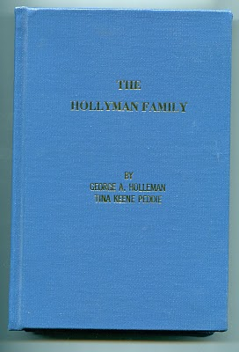
by Glenn N. Holliman

Who Were the Children of ChristopherHolliman, Sr.?

In 1952, George A.Holleman, formerly of Chicago and later Columbus, Mississippi, wrote and published privately a work calledThe Hollyman Family. To my knowledge this work, which was expanded and reprinted by Holliman genealogist TinaPeddie, is the first and still the only comprehensive volume to discuss the founding of our Holliman family and to list hundreds of names of Holliman descendants. It is a monumental piece of research for the pre-internet age. Those of us who are his distant cousins are grateful for this volume, and Tina's work to update it and keep it alive.

The 350 odd page volume is available from Tina Peddie, desabla1@yahoo.com.

In this book George Holleman published, probably for the first time, a list of the children of Christopher Holyman Sr.

They are:

Thomas Holyman - ? to 1734

Christopher Holyman, Jr. - ? to 1731 in Isle of Wight Co.

William Holyman - 1661 - 1704

Richard Holyman - ? to 1711 in Surry Co.

Ann Holyman who married John Atkinson in 1691

Mary Holyman who married James Atkinson (John's brother) in 1691

The genealogists, reports and data I have read seem in agreement that primarily Hollymans, Hollemans, Hollimans, Hollomons, etc. in the United States are descendants of this family. This is not to say that other Hollimans could not have migrated later to other colonies or that other Virginia Holymans, such that have been discussed in other postings, did not leave families also.

However, to my knowledge (and I wish to be corrected if in error), most if and not all Hollimans (and variations) trace their lineage through Christopher Holyman, Sr. Personally, this is my branch, so those of you related to me through grandfathers and great grandfathers are descendants of dear Christopher Sr.

And thank you George A. Holleman for your pioneering work!
Posted by Glenn N. Holliman at 4:25 AM 3 comments
Labels: Ann Holyman, Christopher Holyman, George A. Holleman, Jr.,Mary Holyman, Richard Holyman, Thomas Holyman

THURSDAY, JANUARY 20, 2011

Our Family's Colonial Era, Part XV
by Glenn N. Holliman

The New Life of Christopher Holyman, Sr. in 1650

DNA testing and research both come to the same conclusions that the father of the Holliman family in America (Holleman, Hollomon and other variations) is Christopher Holyman, Sr (1618 - 1691), who landed at Jamestown, Virginia on May 22, 1650.

Unfortunately, we know his first wife only by her first name, Anne, and we do not know how and where Christopher lived during his first decade in Virginia. His name first appears in a legal document in 1660 in Isle of Wight County on the west side of the James River. If ThomasHolyman of Martin's Hundred (assuming he was Christopher's brother, a considerable 'if'') who had arrived in 1635 was still alive, no doubt he may have materially assisted this Holyman in his first years in the New World. Sadly Thomas Holyman is lost to history, and we can only speculate.

Imagine the America in which Christopher settled in 1650. Barely 50,000 Europeans were scattered from Boston to Jamestown, hugging the east coast with a fragile toe hold. There was no Charleston (or South or North Carolina), no Baltimore, no Philadelphia (no Pennsylvania) and New Amsterdam (later New York) was a small settlement at the tip of Manhattan surrounded, as were all colonies, by semi-hostile Native Americans. Only 15,000 or so settlers lived in Virginia, and the roads, such as existed, were mud hollows in wet weather.

Jamestown itself was little more than a village of 30 to 50 cabins and a brick church (see below) that also served as the colonial assembly building. Williamsburg did not exist.
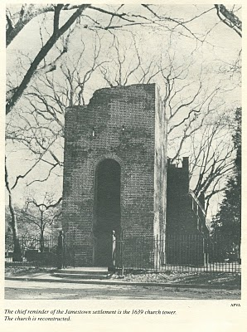
The New World, although blessed with boundless forests, rivers teeming with fish, and savannas ripe with game, was a hostile environment. If one survived the wretched voyage in small ships across the North Atlantic (and on average, one out of four did not), then there was the period of 'seasoning' when immigrants had to face and overcome American diseases such as malaria and yellow fever from Virginia mosquitoes, and the usual small pox and other assorted maladies that took the lives of many. Until settlers established apple groves, there was a lack of vitamin C. Most wells were shallow in the Tidewater with resulting contamination and disease.

In 1650 already enshrined in Virginia law was the requirement that all white men carry muskets when leaving their homes. Powhatan Indians had delivered bloody blows to the encroaching settlements in both 1622 and 1642. In the last encounter, eight years before our Christopher arrived, over 500 Virginia colonists had been slain by Indians. The tension between the two cultures remained real and dangerous.

We know that on January 11, 1661, Christopher and Anne Holymanpatented land along the Cypress River, Isle of Wight County from the founder of Smithfield, Virginia, George Smith. This would be virgin land, not yet exhausted by tobacco. In 1668, Christopher Holyman, this time with a new wife, Mary, would sell the land to Thomas Pittman. Google these names and one will find 'Holyman' and these sales articulated in several web sites.
Several sources besides web sites reveal these early transactions. In addition to Brodie's book I discussed in a previous post, Blanche Adams Chapman's Wills and Administrations of Isle of Wight County, Virginia, 1647 - 1800, Books 1 - 3 contains considerable legal recordings of the Holyman families. Chapman's book (pictured below) is available through Heritage Books, 65 E. Main Street, Westminister, Maryland 21157.
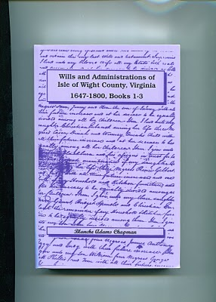
The Story of Christopher Holliman, Sr. continues with the Next Post....
Posted by Glenn N. Holliman at 11:46 AM 0 comments
Labels: Anne Holyman, Christopher Holliman Sr., Mary Holyman

MONDAY, JANUARY 10, 2011

Our Family's Colonial Era, Part XIV
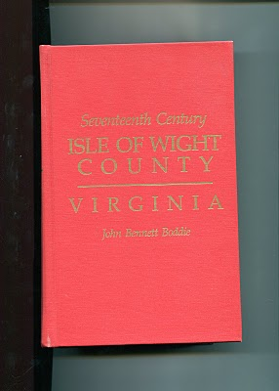by Glenn N. Holliman

The Observations of Historian John Bennett Boddie

In 1938, Virginian historian John Bennett BoddiepublishedSeventeenth Century, Isle of Wight County, Virginia. My 1994 reprint by the Genealogical Publishing Company of Baltimore, Maryland is brimming with abstracts of county records and Boddie'sown history of this part of Virginia in the 1600s. Yes, there are many Holymans,including Christopher Holyman, Sr. and Jr., recorded in this volume, and much to study and upon which to reflect. In the next few postings, I shall pull out and examine some findings that reflect on our family and our country.

Isle of Wight Country had its first English settlers in 1619, one Captain Christopher Lawne responsible for a few pioneers. He represented his fledgling county in the historic first House of Burgess's meeting in 1619. Lawne's settlement floundered, but one Robert Bennett transported 120 settlers to Isle of Wight by 1621.

As I have recorded in earlier posts, the Powhatan Indian Confederacy launched an uprising on Good Friday, March 1622. After the day of murder, only 50 or so English remained in Isle of Wight Country, and 950 so English in the entire colony. English Virginia barely survived, but in recovering the settlers launched all out war on the Native Americans. From 1622 to 1632, annual forays into Indian territory resulted in destruction of many villages and food supplies.

Colonial Virginia was safer for current and future English settlers, and the amount of available land taken by a decade of conquest considerably enlarged frontier borders. TheWarascoyak's tribe of Isle of Wight Country was destroyed in the extensive conflict.

In recording the above, Broddie on pages 84 to 86 notes three important precedents established by the Virginia House of Burgess in that ten year war. I thought them so important to understanding the future of our country, that I record them here.

1624 - Virginia General Assembly required 'that those shall be hurt on service shall be cured at public charge and the lame to be maintained by the county according to his person and quality'.
The care of veterans wounded in combat is enshrined into legislation very early in our history!

1629 - The Assembly gave Plantation commanders the authority and power 'to levy men to fall upon the Indians'. This is the first conscription or 'draft' law in colonial America, a precedent that all future draftees (such as myself in 1968) can appreciate!

1632 - Assembly required that no man shall attend church without carrying firearms or work ground with out arms and a sentinel. In a foreshadowing of the 2nd Amendment to the 1789 U.S. Constitution, later Assembly laws required that white males own a musket, shot and powder. This requirement provided an instant militia and saved money by not requiring a central armory for each county.

More on Colonial Virginia and our family in the next posting....

