FRIDAY, JANUARY 13, 2012
Some Notes on a West Alabama Family by Laura Vonceil Duckworth, Reform, Alabama.
This is second in a series of four postings on the family and ancestors of Laura Vonceil Duckworth, a descendant of Christopher Holyman (1618 - 1691) of Isle of Wight, Virginia.

"My ancestor, Charles Holliman migrated to Fayette County, Alabama with his two brothers, Warren and Cornelius, from the family home in Lancaster, South Carolina of their father, James Grantson Holliman (1850 – 1836) in 1836.

Elijah’s Civil War record would take pages to tell. For now, I continue to share my family tree below with several photographs. My great grandmother, his second wife, Permelia Gibson Holliman, was the 6th child of Tillman Gibson of Fayette, Alabama.

My grandmother, Laura Jannie Holliman (29 August 1873 – 6 December 1936) married Virgil Constantine Clemmons, son of Woodson Clemmons and Rebecca Reece Clemmons. Jannie is buried at Bethlehem Baptist Church Cemetery, Reform, Alabama, Pickens County along with her husband. These are my grandparents, Jannie and Virgil Clemmons. Their photographs are below.
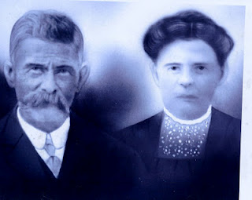

Their children are Melinda Elizabeth ‘Lizabeth’ Clemmons (1893 – 1895), William Edward Clemmons, Thomas Tillman Clemmons, Elvin Elijah Clemmons, Charlie Dennis Clemmons, Minnie Lee Clemmons and Mamie Lou Clemmons.

On July 12, 1935, the extended family gathered in Lamar County, Alabama for Elijah Holliman’s 96th birthday. He was the oldest Confederate veteran in his county when he died May 11, 1937.
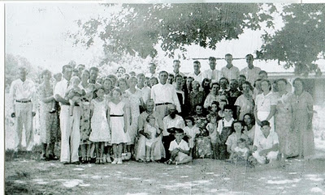
Above the family of Elijah Holliman, center for his birthday in Reform, Alabama in 1935. Assistance is sought from his family to identify persons in the photo above. Please contact glennhistory@gmail.com, a close family member or leave a comment below.
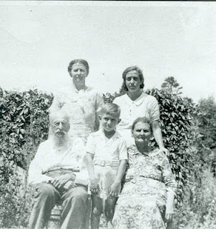
Above at the 1935 reunion are front row left to right, Elijah Holliman, his great, great grandson, Sonny Cunningham and Mary Elizabeth Shaw, Elijah's daughter by his first wife, Mary Shaw. Back row, left to right are grand daughter, Pattie Holliman Whaley and great granddaughter Mary Sue Whaley Cunningham.
One of the children of Virgil and Jannie Holliman Clemmons was my mother, Mamie Lou Clemmons (14 August 1918 – 13 January 1984) who married my father, Dewey Delmer Bonner on 29 December 1937.
Their seven children were Dewey Max Bonner (13 June 1939), Laura Vonceil Bonner Duckworth (18 December 1941), Shelby Marie Bonner McDaniel (13 June 1944), Johnnie Mae Bonner Babb (20 January 1946), Jimmy Keith Bonner (25 November 1950), Clayton Gregory Bonner (5 November 1953), and Frances Marilyn Bonner Elmore (12 March 1956)."

Next week, another posting of Vonceil Duckworth's family tree....
Posted by Glenn N. Holliman at 11:40 AM 0 comments
Labels: Elijah Holliman, Vonceil Duckworth

FRIDAY, JANUARY 6, 2012
Some Notes on a West Alabama Familyby Laura Vonceil Duckworth, Reform, Alabama.

One of the joys of exploring family history is learning from 2nd, 3rd and 4th cousins of great uncles and aunts who lived in different times and places. Laura Vonceil Duckworth of Pickens County, Alabama and I visited twice in 2011 and have traded emails about descendants of James Grantson Holliman (1750 - 1836), our common 4 GGF.
What follows below is in no way comprehensive of Elijah Holliman's Civil War struggles but does allow us to begin to know of his life and offspring. Our thanks to Vonceil for this glimpse of her family and their lives in West Alabama. Any errors in these articles belong to me, and I welcome additions and corrections. - GNH

“My great grandfather was the famed Civil War veteran Elijah Holliman, born on 12 July 1839 in Newtonville, Fayette County, Alabama. He was the son of Charles and Barbara Walters Holliman who emigrated from South Carolina in 1836.

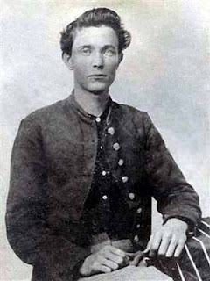
Elijah Holliman in his Confederate uniform during the Civil War
Elijah married three times. His first marriage was to Mary Shaw of whom three children were born: Sarah Melissa Holliman, Mary Elizabeth Holliman and Peter Aaron Holliman.

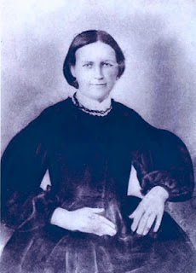
Mary Shaw Holliman
His second marriage was to Permelia Gibson ( 1834-1873). She is my great grandmother. From this union there were two children: William Green Holliman and Laura Jane (Jannie) Holliman, my grandmother. Unfortunately I do not have a photograph of Permelia or even know where she is buried.
Elijah’s third wife (photo below) was Malinda Elmina Levisa Jane Johnson, born December 23, 1846 and died September 12, 1926. She is buried in Springhill Southern Baptist Cemetery, five miles west of Millport, Alabama next to Elijah.

Next po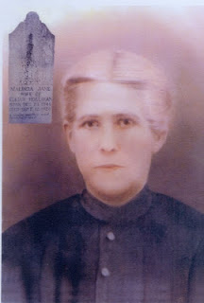sting more on Vonceil Duckworth's Holliman ancestors....

Posted by Glenn N. Holliman at 10:44 AM 0 comments
Labels: Elijah Holliman, Malinda Elmina Levisa Jane Johnson Holliman,Mary Shaw Holliman, Permelia Gibson Holliman, Vonceil Duckworth

SATURDAY, DECEMBER 31, 2011

A Gathering of Hollimans, Part IV
by Glenn N. Holliman
This is the fourth in a series of articles concerning the October 14/15, 2011 family seminar held in Fayette, Alabama, the ancestral location of many Hollimans living today.
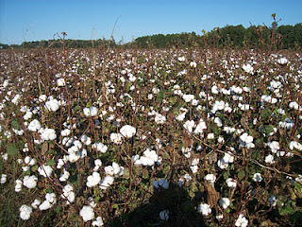
On the outskirts of Fayette last October were many cotton fields (above) waiting for the harvest. This crop was important to Southern Holliman families for several centuries. The farm land in the Sipsy River bottoms and the the timber and minerals of the ridge and ravine topography of the area have provided income to generations of Hollimans in that part of west Alabama.
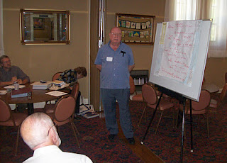
Above at the Fayette, Alabama seminar for Holliman descendants, Raiford Brandon, Bill Holliman and Vonceil Duckworth took notes while Joe Parker (above) shared his many insights in the Holliman family.
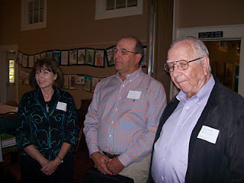
The gathering did not lack for educational expertise. In addition to Kathleen and Jimmy Holliman (above left), a professor at Auburn, was Lenwood Holliman (above right) of Lamar County, Alabama, a retired superintendent of schools. Both Lenwood and Jimmy descend through Charles Holliman, a son of James Grantson Holliman.
The Hollimans attending, sans spouses, were left to right front row: Jeanette Holiman Stewart, Vonceil Duckworth, Lenwood Holliman, Glenda Norris(number 12), Jimmy Holliman, Raiford Brandon andDavid Jennings. Back row: James Franklin Holliman, Glenn Holliman, Bill Holliman, Joe Parker and Lynn Holliman.

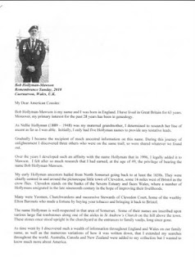

Sending greetings to Alabama from Caernarvon, Wales in Great Britain was cousin Bob Hollyman-Mawson (left) who forwarded some of his humerous findings on Holyman behaviors in Nottingham, England in the 1500s. His article, which generated chuckles, was distributed at the seminar.
Finally after a presentation on our English heritage to the Fayette group, an accumulation of my articles on English Holymans, was distributed (see below). If anyone would like a copy of Bob Hollyman-Mawson's article and/or mine, I am happy to email. My email address isGlennhistory@gmail.com.
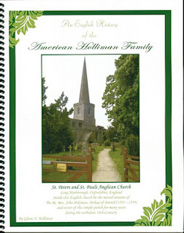
This publication describes my adventures during 2010 and 2011 in the search of the Holliman families of England before our ancestors became Americans. The parish church on the cover is Long Hanborough, Oxfordshire, England where a very great uncle of the America Hollimans was born in 1495. This uncle became The Rt. Rev. John Holyman, appointed a bishop during the turbulent reign of Queen Mary Tudor.
One cannot close our visit to Fayette, Alabama without a word of thanks to the Rose Hill Inn for their generous hospitality, the staff at the Fayette County Civic Center who worked on a Saturday for us, and my genealogical partner and second cousin, Glenda Norris who donated great time and energy to insuring the Holliman Round Table event would occur.
And much thanks to those who came so far and shared knowledge and asked good questions as we all sought to know better our ancestral roots.
Next postings, more on Alabama Hollimans before we return to Merry Ole England and Wales in search of our Medieval and Renaissance roots.

