**Wednesday, January 2, 2013**

**When We Were English, Part XIL**

by Glenn N. Holliman  
  
**Return to England, Part 3, The John Holyman Will of 1533**  
  
*In my last post, we examined the will of the person I believe to be my generation's 12th great grandfather,* ***John Holyman*** *of Cuddington, Buckinghamshire, England.  With this article, we begin a review of his elder son, my very probable 11th great grandfather,* ***John Holyman's*** *will.  Here is a portion of the 1533 will, with other sections to follow in my next articles.*   
  
*Each line of the will is numbered and the explanations refer to the numbered lines.  Genealogist Anne Holmes of Buckinghamshire is due the credit for her transcription and interpretations of a will almost 500 years old! (Although any errors are mine alone.)*  
  
This will is markedly different from John's father's which we examined in my last post.  The Reformation is sweeping Europe and is engulfing England.  King Henry VIII has fallen in love with Anne Bolyen and in early 1533 married her, she several months pregnant with a child who would become Queen Elizabeth I.  
  
The Pope had refused Henry a divorce from his still living first wife, Catherine of Spain and mother of Mary Tudor.  When a conservative Archbishop of Canterbury died, Henry appointed Thomas Cramner, a supporter of the growing Protestant tide.  Cramner hastily granted Henry his divorce and conducted the rites of marriage for Henry and Anne.  
  
Into this gathering maelstrom which divided the clergy and laity of England, strode a monk, Brother John Holyman of Cuddington, baptised in 1495 at the same font from which his probable uncle and cousin, the John Holymans, d 1521 and d 1533, had been sprinkled with holy water.  As I have written earlier Brother John Holyman boldly stood at St. Paul's Cross in London and on several occasions decried the divorce, the remarriage and the growing radicalism of many English concerning their faith.  
  
With this background of the early 1530s, we can better understand the will of John Holyman of 1533.  The first 20% is a homage to the Roman Catholic Church.  The will of John's son Thomas Holyman in 1558 will read very much differently, much more Protestant.  Again my thanks to genealogist Anne Holmes for this transcription taken from the original will in the Aylesbury, Buckinghamshire archives.

[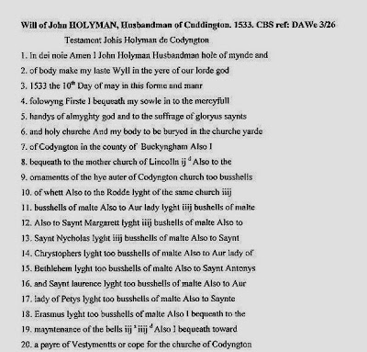](http://2.bp.blogspot.com/-EPnoSYlJbPA/UNXz6kMeI5I/AAAAAAAAFUQ/kQwHIefzXig/s1600/1533+John+Holyman+will,+20+lines.jpg)

Line 1 - John identifies himself as a husbandman, a term to describe a free tenant farmer or small landowner.  A yeoman farmer, higher up in social status, would have had more acreage than a husbandman.  As the Oxford Companion to Local and Family History (1996) states the words yeoman and husbandman were gradually replaced in the 18th and 19th centuries in England by 'farmer'.  Interesting that this John describes himself as a husbandman, as the Holymans rose economically and socially in the 1500s.  
  
Line 6 -  He directs, as did his father, to be buried in the St. Nicolas church yard, Cuddington.  
  
Line 8 - He leaves a bequest to the Diocese of Lincoln cathedral.  
  
Lines 9 -18 - John Holyman leaves bequests, bushels of malt barley, for the holy lights on the High Altar and for the altars of St. Mary, St. Margaret, St. Nicolas, St. Christopher, our Lady of Bethlehem, St. Antony, St. Laurence, our Lady of Peter's light and St. Erasmus or Elmo.  This tells us the parish is still Roman Catholic with numerous altars and chapels for various saints.  In 1534, Henry VIII will have himself proclaimed the head of the English Church replacing the Roman Catholic pope. English churches will soon change.  
  
*It is not unusual to find in English parishes even today the posting of legacies to the local church.  This one in Cuddington, Buckinghamsire recognizes one Nicholas Almond for his bequests in his will.  However, no sign hangs for John Holyman whose bequests were made when the parish was Roman Catholic and not Anglican. Photograph November 2012.*

[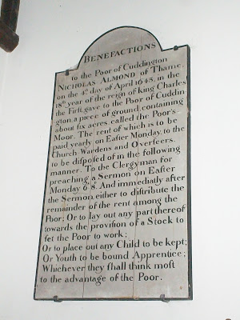](http://2.bp.blogspot.com/-vfvFZ-ZqQH8/UNX39xoWu9I/AAAAAAAAFU8/eikuLNYNNkY/s1600/2012+11+Cuddington,+England+legacy+at+St.+Nicolas.JPG)

Line 19 - Bells remain to this date in St. Nicolas in Cuddington.  
  
Line 20 - He leaves funds for the purchase of a pair of vestments or cope, another indication of John's support of the Roman faith, then under growing criticism in an England in political turmoil due to Henry VIII's 'Great Matter' - the divorce of Queen Catherine and remarriage to Anne Bolyen.    
  
His cousin, nephew or in-law, Brother John Holyman, later Roman Catholic Bishop of Bristol, would have approved mightily of this will!    
  
***Next post, more of John Holyman's will of 1533....***

**Wednesday, January 16, 2013**

**When We Were English, Part L**

by Glenn N. Holliman  
  
**A Continued Look at John Holyman's 1533 Will and What It Means....**  
  
With our last post, we began a review of the 1533 will of John Holyman of Cuddington, Buckinghamshire focusing on his bequests to St. Nicolas Roman Catholic Church.  In this article we continue our review of his estate plans and note a significant increase in family wealth when compared to his father's 1521 will.  As genealogist Anne Holmes (who transcribed these wills) observes, the Holymans in the 1500s were a family on the rise socially and economically.  
  
*Below Cuddington in the distance.  This photograph was taken on a small rise southwest of the village.  Undoubtedly some of this land was at one time in the Holyman family.  Note the sheep grazing just as they did five centuries ago.  November 2012*

[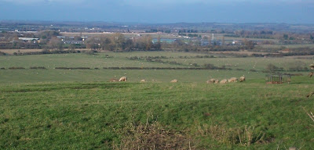](http://3.bp.blogspot.com/-tBFSZtcn9Ug/UOwvmqVStRI/AAAAAAAAFbU/CdnAerZ6VM8/s1600/2012+11+Cuddington%2C+England+area+photo.JPG)

**Below the next section of John Holyman's 1533 will**

[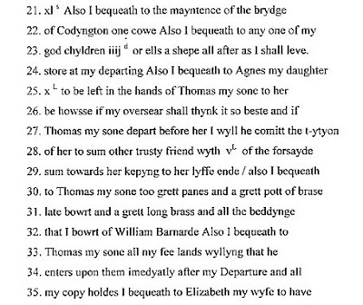](http://2.bp.blogspot.com/-riT-6_d-56Y/UOtwVphm4qI/AAAAAAAAFaU/3l2gvYfyLE4/s1600/1533+John+Holyman+will+p+5-A.jpg)

Line 21 - A cow is left to help maintain the Cuddington bridge over the River Thames, a tributary of the larger Thames.  No public works departments in the Tudor era!

Line 23 - A legacy is left to unnamed God Children.

Line 24 - Ten pounds is left for his daughter Agnes as a trust to be held by her brother Thomas or if she outlives him, another trusted friend.  In essence this is called a 'life estate' in the 21st Century legal terms. According to Anne Holmes, the equivalent value today would be approximately $5,000.  Agnes received the income as long as she lived.  This oversight by the elder son of his sister gives us an insight to the much more restricted rights women had in England at that time.

Line 30 - Various house hold items are left to son Thomas.  Metal pots and pans were valuable items during this era.

Line 33 - The heart of the will is the leaving of fee lands (lands held without conditions attached) to Thomas and his copy holds to his wife Elizabeth.  Through Line 52, John goes into great detail describing what must be done with any grain harvested.  The carefulness by which he articulates his farm activities gives us a clue to his organizational and management skills that must have been somewhat responsible for the increase affluence of this branch of the family.

Line 35 - 'A copy hold was a form of customary tenure by which a tenant held a copy of the entry in the roll of the manorial 'court baron', which recorded his or her possession of a holding on agreed terms.' - *The Oxford Companion to Local and Family History (1996).* Ms. Holmes states copy hold lands were subject to manorial custom and an obligation to undertake certain services for the Lord of the Manor e.g. military service.

﻿

**[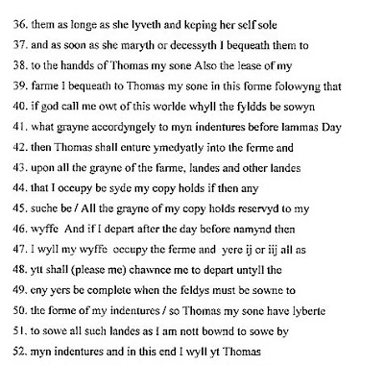](http://2.bp.blogspot.com/-DnZSYq7Kakg/UOt1t1MtalI/AAAAAAAAFa0/0d2mQ4GumPg/s1600/1533+John+Holyman+will+p+6-a.jpg)**

Line 41 - Lammas Day was not a religious holiday, but prior to 1572 and the change in the English calendar, was August 1st.  *The Oxford Companion to Local and Family History,* while recognizing some dispute about the matter, states it was a date that allowed for a second mowing of hay.  Again we see John Holyman reaching beyond his grave to dictate farming practises! Anne Holmes notes it was traditionally the festival of the wheat harvest. Lammas means loaf-mass from the Anglo Saxon hlaf-mas.  
  
Line 50 - An indenture is a formal contract in this case concerning use of fields.  The formal agreement would be copied twice, signed and then cut or torn in two at the indent, with each party having an identical statement of the bargain.    
  
More on the Will next posting....  
  
Genealogist Anne Holmes of Buckinghamshire, a careful and accurate historian, wanted these corrections listed in this article, which she noted after the first posting.

*"Correction Line 26 'be howsse' should be 'be howffe' The letters f and s can look the same, especially when written as double letters. This is meant to read in modern language 'to her behoof' that is to her best advantage. I am still struggling with the end of line 26. I think this undeciphered word may be an abbreviation of some kind. The obvious is something along the line of 'trusting' or 'keeping' but the letters do not quite fit with those words.*

*Correction Line 31 'grett long brass' should be 'grett long broche' A broche is a term connected with the weaving of tapestries. It could either be a weaving spindle of some kind or a long strip of woven tapestry see* [*http://dictionary.reference.com/browse/broche*](http://dictionary.reference.com/browse/broche) *Perhaps it was some kind of woven tapestry that went over the bedding mentioned in the next phrase of the Will.*

*Also yt in old documents can be an abbreviation for either 'it' or 'that' depending on context."*

*Have questions about your family history?  You are invited to join the Hollyman Email List at* [*Hollyman-Subscribe@yahoogroups.com*](mailto:Hollyman-Subscribe@yahoogroups.com) *and the Hollyman Family Facebook Page located on Facebook at "Hollyman Family".  Post your questions and hopefully one of the dozens on the list will have an answer.*   
  
*For more information contact Tina Peddie at* [*desabla1@yahoo.com*](mailto:desabla1@yahoo.com), *list and Facebook manager for Hollyman (and all our various spellings!)*