TUESDAY, OCTOBER 26, 2010

When We Were English, Part XXIII
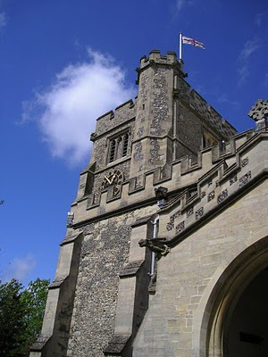by Glenn N. Holliman

Before We Leave England (for a while anyway)

As readers of this blog know, I have been writing of English Holymans (aka Holliman, Holloman, Holleman, etc.) for the past twenty-three articles, often from my research on-site in the Tring, Hertfordshire area. These articles owe much to the work of others who 'plowed ground' before me.

In this space, it is time to return to the Holliman story in the North American Colonial period, the 17th century when our ancestors arrived in Virginia. Before doing so, I want to sum up my findings (responsibility for errors and incorrect interpretations are mine) and suggest where more work is needed. (Above the parish church of St. Peter's and St. Paul's in Tring, Hertfordshire. Photo 2010 by Barbara Holliman.)

Findings

1. I have not found evidence that John Holyman (1572 - 1650) who died in Virginia is our great grandfather, nor have I found information that this elusive, but widely reported fore bearer of our family name, is from the Tring, Hertfordshire area. This person is recorded in a widespread web site as the 'founder' of the American Hollimans, and the father of Christopher Holyman, Sr. (1630 ca - 1691).

2. In and around the Tring area were many Holymans in the 15th to 17th centuries, some such as Ezekiel Holliman who immigrated to Massacusetts and helped found the American Baptist Church. Another Holyman was the Roman Catholic Bishop of Bristol (1495 - 1558) during the reign of Queen Mary Tutor. The 'manor' farm of The Rt. Rev. John Holyman still exists in Cuddington, Buckinghamshire and can be visited. I think it probable that these persons are distant cousins and great uncles and aunts.

3. Research by Joe Parker, Maxine Wright and others (LDS records i.e.) reveals that a Holyman family lived not far from Tring in Bedford, Bedfordshire in the late 1500s and 1600s. As I expounded in my last posting, these names - John, Thomas, Christopher and Judith - are the names that show up in recorded records in Virginia from 1630s to 1650s. I join Joe and Maxine in believing it highly probable this is our 'Founding Family'.

4. DNA testing conducted through Tina Peddie's good offices this summer revealed I and others are descendants of Christopher Holyman, Sr. (D 1691) of Virginia who immigrated from England in 1650 with his probable sister, Judith.

Work to be Done

1. Continue to research the Tring records in the 16th and 17th centuries looking for this John Holyman. There are more files and registers to explore.

2. Dig deeper into the family history of the Thomas Holyman family of Bedford (this Thomas was born in 1576). This can be done on-line and on-site at the Bedford-Luton Archives. I have plans to visit these archives in the spring of 2011, Good Lord willing. I note an LDS record lists Thomas Holyman's father as a John Holyman. As a wealth of information was found in the Hertfordshire Archives and Tring library, I strongly suspect a richness of material awaits a Holliman researcher in Bedford and at the National Archives in Kew (a suburb of London).

3. Establish relationships with Holyman's in Bedford and Tring and kindly ask for DNA testing.

4. Explore what ties exist between Bedford Holymans and Tring Hollimans. Geographically speaking, these communities are only twenty five to thirty miles apart, but in the 1500s, this was a two day walk. It is possible (probable?) that a Holyman from Tring moved to Bedford in the 1400s or 1500s and established a family.

5. Do not ignore other Holymans in England in the 17th century. A recent researcher on the Tina Peddie Hollyman chat room noted a Christopher Holyman was born in the early 1600s in Worchestershire, England. As with all genealogical research, be open minded and willing to change interpretations based on the evidence and critical inquiry.

To Summarize

Whether Tring or Bedford, the Holliman line is English, no ifs, ands or buts. Our great grand parents brought to Virginia the customs and culture of England - its forms of government, justice, religion and social mores. Of course, this culture was modified in a new environment that was, ironically, both hostile and welcoming.

To know from whence you come, study the history of England - it is our story. The Stuart, Tutor and Plantagenets - these are the monarchs of our family. The Normans, the Vikings, the Angles and Saxons, the Romans and Celts - these peoples too are part of our DNA, our genetic code, our human family.

Next posting, this story returns to Colonial America and the founding of a new nation.
Posted by Glenn N. Holliman at 1:31 AM 0 comments
Labels: Bishop John Holyman, Christopher Holliman Sr., John Holyman,Thomas Holliman

THURSDAY, OCTOBER 14, 2010

When We Were English, Part XXII
by Glenn N. Holliman

Are the Holymans from Bedford, rather than Tring?
On the map below, one can see Bedford within the red circle almost due north of London. Tring (unnamed) is located at the red dot just northeast of London. Click on map to enlarge.
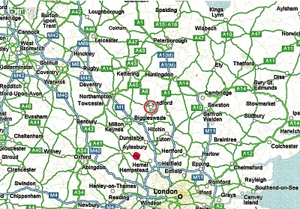
As readers of this blog know, I have spent the past four months expounding on research of our Holyman (Holliman, Holleman, Holloman, etc.) originsconducted earlier this year in England. In the late 1990s, a Holyman family tree was posted on the Internet, and many of us took it as gospel. This site, still posted, lists one John Holyman (1572 - 1650) of Tring, Hertfordshire as the English father of our Holliman families in America. A John Holyman really did die in 1650 in Virginia, as recorded by Virginia records.

However, a continuing search of Internet archives, family trees, research by others, and my own exploration in the Hertfordshire Archives has failed to turn up this elusive character in Tring or surrounding villages, although we have found an abundance of Holymans with some fascinating biographies. I trust they are our relations in some form or fashion.

However, this begs the question concerning John Holyman - have we been looking in the wrong places?

Alas, thanks to research by cousins Maxine Wright, Joe Parker and others, an interesting parish register has turned up in Bedford, Bedfordshire, England. The parish is St. Mary's, now a redundant facility administered by a trust. Bedford is located approximately 50 miles north of London, and about 25 miles or so from Tring. (See map above) The following information is taken directly from the parish register, and can be found in RootsWeb and LDS internet files.

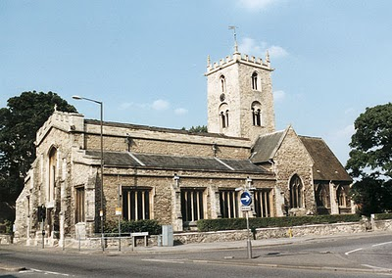St. Mary's parish church, although closed, still stands just south of the River Ouse in Bedford. A few blocks away is the Bedfordshire and Luton Archives.

For those of you cognizant of the names of early Virginia Hollimans, these Bedford names are nothing less than amazing. Remember our Christopher Holyman, Sr. arrived 1650 (the same year John died) along with a woman named Judith, believed to be his mother or sister. Another Christopher Holliman and another Judith arrived in 1653. Our Christopher Sr. was first married to a woman (our great grandmother!) named Mary.

Be aware, according to colonial records, a Thomas was already in Virginia at Martin's Hundred, one of America's first real estate developments (so to speak).

Now look at these names from the St. Mary's parish register of Bedford!

1576 - Thomas Holman baptised March 4 in Bedford.

1609 - This Thomas married Helena Poynard on Oct. 23. Their children are listed below.

1610 - September 16, one John Holliman baptised.BINGO! Is this our elusive John, the reputed American founder of our family who died in South Hampton, Virginia in 1650? John married a Mary Parrell on July 25, 1641.

1612 - On September 13, Ellenora Holliman baptised.

1613 - On November 14, Joan Holliman baptised.

1616 - Thomas Holloman baptised on March 20. Is this the Thomas of Martin's Hundred near Jamestown who took land in the 1630s?

1618 - Christopher Hollaman baptisted on September 2. Is this our Christopher Holyman Senior who immigrates to Jamestown in 1650, raises a large family, makes his earthly fortune and dies 1691?! Is this my generation's 8th or 9th great grandfather?

1621 - Judith Holliman baptised on February 11. Is this the Judith who arrives in Jamestown with Christopher in 1650 or later in 1653?!

1623 - On May 14, Eleanor Hollyman baptised at St. Mary's.

1625 - Stephen Holloman baptised on December 24.

1628 - Mary Holiman baptised on September 13.

So the question is begged - have we found the Holyman family that settled in Isle of Wight, Virginia in the early 1650s?

If we have, then Thomas and Helena Poynard of Bedford, Bedfordshire are our English fore parents, and not John Holyman of Tring!

I will leave you here to ponder on the above, and to allow me time to gather further notes 'to push this envelope'. Again, this research belongs to Maxine, Joe and someone who entered the above in LDS records. My continuing thanks to them. If I have omitted others, please allow me to correct the record and give credit where credit is due.

This Holyman history gets more and more interesting....(if you are addicted to family history!)
Posted by Glenn N. Holliman at 1:03 AM 0 comments
Labels: Christopher Holliman Sr., Helena Poynard, Joe Parker, John Holyman, Judith Holyman, Maxine Wright, Thomas Holliman, Thomas Hollyman

THURSDAY, OCTOBER 7, 2010

When We Were English, Part XXI
by Glenn N. Holliman
Weddings and Witches
In the Hertfordshire Archives is a book entitled Hertfordshire Parish Registers by Phillomore's, 1907, 3 volumes. Of course out of print and I had precious few hours to review it. It is on my list to revisit some day. However, I did find several weddings of Holyman females to local males. For the record, they are listed below.

By the way, the first two marriages were from yet another village, just a few miles also from Tring - Berkhamstead. Below is a view of it's High Street in 2010.
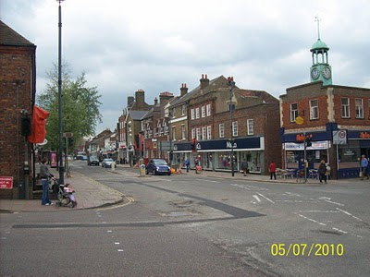
The Berkhamstead Marriages:

Franncys Hadden to Margery Hollyman on 6 May 1601.

Henry Lawrence to Jane Hollyman (Holeman) on 7 February 1638.

Here are two Tring marriages in the same publication:

William Hollyman to Grace Neelie on 20 July 1607 (This is the son of William of Tring whose will we reviewed in When We Were English, Part XIX).

Goff Babylong to Anna Holliman on 7 May 1634

So above some more information for the Holyman history trail in England. Cousin Maxine Wright has ordered Tring Parish microfilm and hopefully may find yet our hidden John Holyman who died in Virginia in 1650. My on-site research has failed to turn him up, but I did find a host of very interesting Holymans who impacted English and American religious history. Hopefully when I return to England next spring I can collect some DNA samples from possible ancestors and search again in local archives.

Some times it is not what one finds in genealogical research, it is also what one does not find. And sometimes, one may feel bewitched and frustrated not to collect more information. That leads me to my closing historical tidbit you may enjoy.

While reading in the Tring library the 1940 work by Arthur MacDonald, That Tring Air, I found that the year 1596 must have been very stressful to our ancestors. Our John Holyman would have been 24 years old at the time, and perhaps observed the following out break of, well, witchcraft in his own community!!
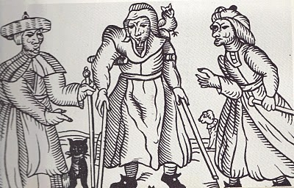Above a 16th century drawing of three English witches. Rather ugly creatures. Note the black cat.
That year in Tring, one Alice Crutch 'bewitched one Hugh Walden who languished and died'. Nor did the episode of nefarious deeds end there. Another woman, named Elizabeth, put a curse on Thomas Grace's valuable horse and it died!!

For their witchery, these two ladies were 'suspended by neck until dead'.

So this Hallowed Eve, think on all the quaint customs of England and Europe that passed through our families to our New World, which we celebrate to this day!

Posted by Glenn N. Holliman at 6:19 AM 1 comments
Labels: Anna Holyman, William Hollyman
Newer PostsOlder PostsHome
Subscribe to: Posts (Atom)

