THURSDAY, OCTOBER 27, 2011

The Legacy of Walt Holliman
by Glenn N. Holliman
The Research and Writings of Walter O. Holliman Preserved and Being Shared with a New Generation
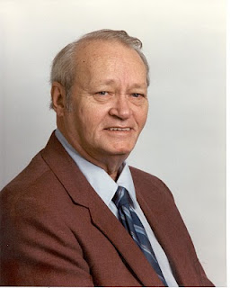

Walter Orien Holliman, pictured above, a meticulous family researcher, passed away November 1, 2003. His birthday was May 5, 1927. Walt's father was Moses Holliman, the son of Warren C. Holliman, the son of Charles Holliman (1795 - 1841 ca), who was the son of James Grantson Holliman (1750-1836), a common grandfather to almost all reading this blog.
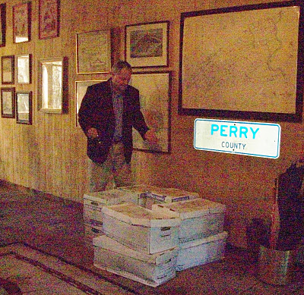
Above, Glenn N. Holliman, distant cousin of Walt Holliman, surveys over 300 pounds of papers and books donated to his Holliman Collection from the children of Walt. The material is housed in a 5,000 volume collection of books and papers in Newport, Pennsylvania (yes, it is in Perry County as the liberated highway sign reveals).
"I walked into my library/barn just as the UPS truck was pulling away to discover this awesome collection of research, manuscripts, raw data and genealogical books. The children of Walt - Lynn, Bryan and Ann - had been in touch with me about preserving the collection. After checking with other children - Debbie and Paul - they decided to pass this invaluable material to my growing family history collection. This is 24 feet of shelf space of important papers and books.
I am honored by their trust. This winter I intend to inventory the collection and begin posting appropriate materials on the web so that other Hollimans and associated families can benefit from the decades of work accomplished by Walt. After my time is over, I intend to pass the collection to a new generation of family members, perhaps in some type of family association or corporation.
While I have not had time to study the materials in depth, there are unpublished manuscripts and meticulous will and land transfer records obviously representing years of work and travel. It is obvious Walt was careful and documented everything he did. His work is an excellent example of a historian who enjoyed his craft.
We are fortunate in our extended family to have this work saved. Others in the family, the late Cecil Holliman and his son, Rhodes Holliman, Ron Holliman, Maxine Wright, Joe Parker, Vonceil Duckworth, Jeanette Holiman Stewart, Glenda Norris and other members of Tina Peddie's chat room have been likewise industrious in saving and preserving our family's history. The story of the Hollimans and our associated families is America's story.
Walt was born in Birmingham, Alabama as was I. A Boy Scout, he enlisted at age 16 in the U.S. Navy serving in World War II as a air gunner. After the war, he graduated from the University of Tennessee and went on to a successful career in mobile home manufacturing and the aviation industry. Tiring of travelling, he settled back in the Birmingham area as a stock and real estate broker. He was a member of Mensa International, the American Legion, the Veterans of Foreign Wars, the Methodist Church and various business associations.
From his last home in Pelham, Alabama, he spent countless hours collecting raw data, saving it and typing thousands of pages of notes and stories on his families.
Our great thanks to the family of Walt for preserving his work and their generosity is sharing it with the larger family. I am happy to report that in the first few weeks of receiving this material, I was able to:
(1) pass along a thick file for review on the Blakeney family to genealogist Glenda Norris, a Blakeney descendant in Alabama,
(2) review Walt's materials on Samuel Holliman (1707 - 1789) with Lynn Holliman (Texas) and Joe Parker (Texas), and together come to consensus, that yes, Samuel is the father of James Grantson Holliman, and
(3) respond quickly to David Jennings of Pickens County, Alabama who sought to know the name of his great, great grandfather. Like Walt, David descends from Warren C. Holliman, son of Charles Holliman, son of James Grantson Holliman."
For information on the Walt Holliman Collection or if you have papers to preserve, please contact yours truly at Glennhistory@gmail.com. Together we can save our history for our children who come after us.

Posted by Glenn N. Holliman at 7:35 AM 0 comments
Labels: Cecil Holliman, Glenda Norris Jeanette Stewart, Glenn Holliman,Joe Parker, Rhodes Holliman, Vonceil Duckworth, Walt Holliman

WEDNESDAY, OCTOBER 19, 2011

When We Were English, Part XXXV
A Cuddington, Buckinghamshire Connection? Maybe So
by Glenn N. Holliman
8. In the 1580s, Robert Holyman of Cuddington had real estate dealings with Thomas Tyringham, whose home was in the near village of Nether Winchendon, Buckinghamshire, and may have had family in Tyringham near Sherington. (See article posted July 28, 2010) Could a Robert Holyman relative be our Christopher Hollyman of 1589 in Sherington? Could this be the tie to the Cuddington Holymans, approximately 30 miles south of Sherington?

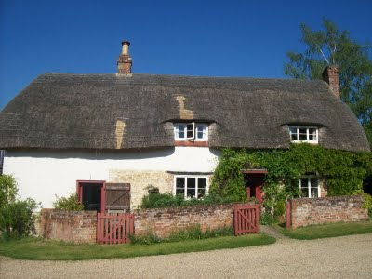
The pub at Cuddington, Buckinghamshire, only a few blocks from the former Holyman farm, sports a thatched roof, a not uncommon architectural feature in English villages.
A scenario can be constructed that Christopher Holyman, Sr. who died Isle of Wight, Virginia in 1691, was the son of Thomas Hollyman, probably born in Sherington, Buckinghamshire who by 1609 was earning a living in Bedford, Bedfordshire and married that year at St. Peter’s parish.

And this Thomas, a second son who inherited some assets, but not family property, from Christopher Holyman (will of 1589) of Sherington, is the same Thomas Hollyman who went to grammar school in Lathbury, Buckinghamshire in 1595.

And while more research is needed, this 1589 Christopher Hollyman of Sherington may have moved to the area from the central part of Buckinghamshire, the Cuddington, Tring or Cholesbury area, perhaps being born sometime from 1520 to 1550. Perhaps!

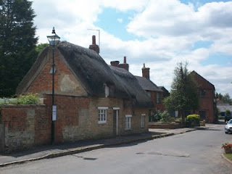
Thatched roofs in Sherington, Buckinghamshire. Did Holymans centuries past sleep and live under threshes?
Now who then is the Christopher 1589’s father?!!! Are we on the edge of taking the family tree another one hundred years or so back in time, to the time when The Rt. Rev. John Holyman, Counter-Reformation Bishop, was born in 1495 in Cuddington, Buckinghamshire? (See blog article of September 2010.)
Notwithstanding the significant number of Holliman families in Worcestershire, is this Christopher Hollyman of Sherington, Buckinghamshire the grandfather of the Christopher Holyman who sailed to Virginia in 1650? Have we found my generation’s 9th great grandfather?

And indeed, are we a few more bits of research from tying the Cuddington/Tring Holymans to the Sherington and Bedford Holymans? Are we pushing the family history back to the 1400s!

Posted by Glenn N. Holliman at 1:35 AM 0 comments
Labels: Christopher Holyman, Richard Holyman

TUESDAY, OCTOBER 11, 2011

When We Were English, Part XXXIV
Have We Found the English Family of Christopher Holyman, Sr. of Virginia? by Glenn N. Holliman
Let’s play family history detective. Here are the facts and what can be deduced.
1. Christopher, according to family historian Peter Smith of Bedfordshire, was an uncommon first name in the 1500s and 1600s, so locating the name in 1589 is important. In all my research, I have not found it ANY WHERE ELSE in England attached to the surname Holyman or one of its various spellings, except, of course, for the 1618 birth of Christopher Holyman in Bedford.
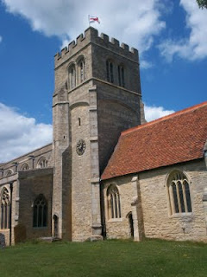
The parish church in Sherington, Buckinghamshire is named after St. Laud of France. It is just possible that my generation's 9th great grandfather, Christopher Holyman's dust, may be embedded in the grounds surrounding this 19th Century restoration.
First names are often repeated from one generation to another. Thomas of 1589 and 1595, is he the same Thomas Hollyman who marries in Bedford, Bedfordshire at St. Peter’s in 1609?

3. And the Christopher Holyman born in Bedford in 1618 to Thomas, is he a grandson and named after the 1589 Christopher of Sherington, Buckinghamshire?

The Great River Ouse (yes, that is the name of this lazy 'river') flows from Sherington to Bedford. Here the stream meanders past Tyringham House, a great county estate a few miles west of Sherington. Yes, the river flows west for a bit and then turns north and finally east, moving through Bedford and eventually to the North Sea.
4. Sherington is upriver on the Great River Ouse which flows through Bedford, two blocks from St. Mary’s parish where Christopher Holyman, b. 1618, was baptized. Sherington is approximately 12 walking miles from Bedford. Hmmmm.....

5. We can find no records of Holymans in Sherington parish records after 1602 (and no records exist prior to 1603, except 1576 and no Hollymans that year).

6. No records exist in Bedford, Bedfordshire prior to 1609 on Hollymans.

7. No records exist in Bedford recording the death of Christopher Holyman, b. 1618, or his sister, Judith, b 1621, in Bedford. (Of course not if they died in Virginia!)
The clues point to a connection....
Posted by Glenn N. Holliman at 1:35 AM 0 comments
Labels: Christopher Holliman Sr., Christopher Holyman
Newer PostsOlder PostsHome
Subscribe to: Posts (Atom)

