Thursday, October 4, 2012

From the Galaxy of Holliman Cousins, Part II
by Glenn N. Holliman
Recently distant cousin Allen Holleman (photo below) of North Carolina and I met and shared a meal. I had noticed Allen's comments and thoughtful questions on the Tina Peddie Holyman Group chat room, and thought as I would be in his area, would like to meet him. As we indulged in our common passion for comfort food and Holliman/Holleman history, it was an enjoyable and long lunch.

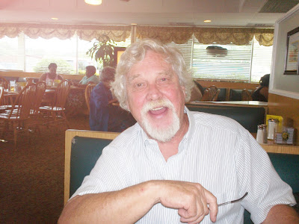

Over three glasses of an iced beverage (unsweetened) he told me his family branches, which intrigued me because I knew a lot of Holleman/Hollimans had moved across the Virginia border into North Carolina, not long after the unpleasantness with the Tuscarora tribe ended in the early 1700s. For many the western march meant moving south by southwest as did my branch of the family. Allen's moved into Wake County after the Revolutionary War. His ancestors put down roots and some, such as Allen, remain in the Raleigh area to this day.
His lineage begins in America as does mine with the arrival in Jamestown, Virginia in 1650 of Christopher Holyman, Sr. who had four sons and two daughters. The daughters married Atkinsons. The four sons married and had children and swoosh, the family branches started multiplying.
Allen's branch emerged from Christopher, Jr. (mine from Richard Holyman, one of his brothers) who begat John who begat Jesse, the husband of Charity Cofer. Their son, John Holliman, left Virginia and moved to Wake County, North Carolina. Then came David Holleman, John Austin Holleman , Junius Dowd Holleman and then Joseph Holleman, Allen's grandfather, a carpenter - the first Holleman in this branch to leave the occupation of farming.
Allen's father, Joseph Allen Holleman, Sr., was in the building business. Joseph Allen Holleman, Sr., our Allen, joined him, bought and sold it and other business and has thrived as a creative entrepreneur. He now claims he is retired (which I doubt given his high energy level), but he looks great in his blue Mustang convertible.

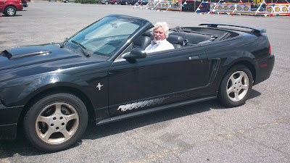
Allen's resume is amazing - scuba diver, car race driver and U.S. Marine helicopter gunner in Viet Nam - are just a few of his endeavours. Indeed, he must have the same DNA as Christopher Holyman, Sr. who in the 17th Century left England, sailed a dangerous sea, scratched a farm out of a wilderness and kept a look out for wild animals and angry Indians as he stripped his tobacco. A salute to both Allen and his 8th great grandfather, Christopher, Sr. for their spunk and achievements!
Another post next week from our amazing Galaxy of Holliman cousins....

Saturday, October 20, 2012

From the Galaxy of Holliman Cousins, Part III
by Glenn N. Holliman
"Medicine is the Venue to Peace"
Over dinner in July 2012, Dr. Jim Holliman of Pennsylvania, son and grandson of family historians, Dr. Rhodes Holliman and Cecil Rhodes Holliman, Esq., shared the above wisdom. The occasion was an evening with Jim and our two wives, Karen - his, and Barb, mine. We had been trying to find time to meet for several years. With Jim's incredible schedule of travelling and speaking, this had been difficult.
Below, Glenn Holliman, left, and Jim Holliman, right. John T. Holliman (1844-1930) is Glenn's great grandfather and Jim's great, great grandfather.
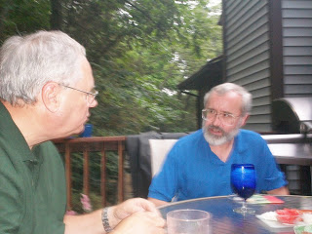
Jim is this country's and probably the world's foremost expert on Emergency Medical Trauma, having written six books on the subject, and visited 50 countries on six continents practising and establishing emergency medicine programs, teaching and supervising. Raised in the stimulating home of two professors at Virginia Tech in the 1960s, he did his undergraduate work at Duke and gathered his M.D. at George Washington in St. Louis. After residency in Utah and practise in Reading, Pennsylvania, he settled in 1989 in Central Pennsylvania at the famed Hershey Medical Center.
Since then he has served in three wars for the Department of Defence, taught at the United Services University in Bethesda, Maryland, and directed the Center for Disaster and Humanitarian Assistance Medicine. Presently he is president-elect of the International Emergency Medicine Consortium, a global organization of regional and national agencies dedicated to improving emergency medical care. The walls of the home cannot hold the large number of awards and gifts he has received over the past few decades from grateful nations and organizations.
Below, four of the numerous books, Jim has authored or co-authored.
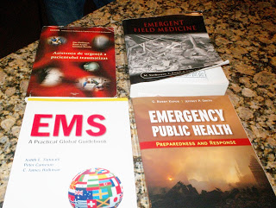

His wife, Karen, has experienced an important career herself in paediatrics rehabilitation helping children with developmental and autistic challenges. This talented couple met in medical school, and have two grown children. They are about to become grandparents for the first time.

Below, Karen and Jim Holliman visiting the Glenn and Barbara Hollimans, September 2012.
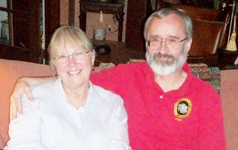

Jim has seen much pain and injury in his career across the world. Having been up close to our recent wars in the Middle East, he thought carefully when I asked him what summary statement would he make for our extended Holliman family to ponder. He did not hesitate - "Medicine is the venue to peace". Truly Karen and Jim know the truth of that statement as both their lives have been dedicated to reducing human suffering.
For more on Jim, visit the web site EPIjournal.com to read some of his articles. He welcomes hearing from cousins, especially those in or who might be considering the medicine as a career. Jim has been and remains a mentor to many. With permission, his email address is jholliman@cdham.org.
Note: Jim Holliman is also a first cousin of Glenda Norris, a frequent contributer to this blog and the understanding of Holliman family history in Alabama.
As always, an education and inspiration when I visit with Holliman cousins both near and far....more later.

Tuesday, October 30, 2012

From the Galaxy of Holliman Cousins and Great Uncles and Aunts
by Glenn N. Holliman
The Biology Professor who became the Alabama Holliman Family Expert....
No one living knows as much about the Cornelius Holliman (1792-1862) family that migrated from South Carolina to Alabama in 1836 than Dr. Rhodes Burns Holliman of Virginia. When I started writing this blog 2 1/2 years ago, the first articles on John Thomas Holliman (1844-1930), Martha Jane Walker Holliman (1846-1931) and James Franklin Holliman (1839-1911) were by Rhodes.
Earlier this year I posted a three part series by Rhodes on his summers in Fayette County, Alabama in the 1930s and how different life was then than now in the country. According to my blog counter, this is one of the most read series that has been posted in this space.
Below, Rhodes at his desk, composing articles and saving photographs of 19th Century family members such as the Hollimans, Blakeneys and Bakers of central Alabama.
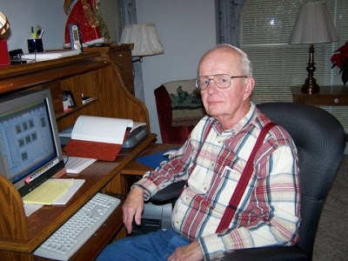

Last posting in this space, I wrote of Rhodes' dedicated physician son, Jim Holliman. Jim, as does Rhodes, follows in a line of talented ancestors. Jim's grandfather was Cecil Rhodes Holliman (1902-1986), a distinguished Birmingham, Alabama attorney, who eagerly collected family stories and wrote a major manuscript on the Samuel T. Walker (1821-1900) families. One of Cecil's grandfathers was Samuel Taylor Walker, a Confederate Civil War veteran.

Below Cecil Rhodes Holliman as a 1921 cadet at the Marion Military Institute, Marion, Alabama. Dr. Rhodes Holliman, a specialist in exotic diseases and retired professor from Virginia Tech, acquired his love of family history from his father, Cecil. This photograph and the one below are from the Rhodes Holliman collection.
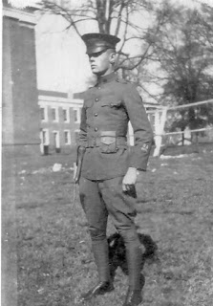

Cecil's father was the dynamic pioneer of this branch, James Monroe Holliman (1878-1938), who married a Fayette County girl, Elizabeth Ann Baker in 1899. James studied law, served as county solicitor, and later moved to Birmingham to set up a law practice that continues to this day under his great and great, great nephews, Jim and John Holliman, attorneys at law.﻿
Below, James Monroe Holliman in a 1924 photograph, who left the farm run by his father, John Thomas Holliman, and by his wits and enterprise became a successful Alabama attorney. He sired a distinguished prodigy of children, grandchildren and great grandchildren.
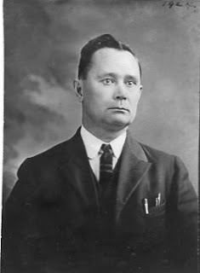
Next post, more on my cousins, great aunts and uncles from this distinguished and successful branch of the Holliman family....

