Saturday, October 5, 2013

Exploring Further Holliman History in Old Virginia, Part 3
by Glenn N. Holliman
We continue to report on the descendants of Christopher Holyman (1618-1691), who live in the Isle of Wight County and Richmond, Virginia. My thanks to the distant cousins - Sarah Barlow Wright, Janet Barlow Moore and Susan Brewer -who kindly shared their time and photographs and proof read the article. There will be several more postings on Isle of Wight County, which to most Holymans (and its many various spellings) is our American ancestral starting point.
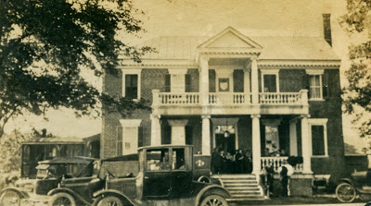
Above, the Holleman House at Mill Swamp, Isle of Wight, Virginia in 1921. The family gathering was being held at the home of Josiah James and Augusta White Binford Holleman. Picture from the collection of Sarah Barlow Wright.
Below, Sarah Barlow Wright in her Isle of Wight, Virginia home with treasured family photographs of her grandparents, Augusta Hannah White Binford Holleman (1859-1941)and Josiah James Holleman (1851-1937). Sarah's grandfather gave the land for the cemetery at the Mill Swamp Baptist Church adjacent to the historic Holleman House near the Surry County border.

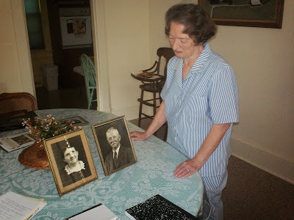

Now retired, Mrs.Wright was a teacher or principal for over 35 years. She grew up in Isle of Wight County at Oak Crest, the Gordon Barlow Farm, five miles north of Smithfield, close to the James River. Her mother, Gladys Hortense Holleman Barlow (1895-1996) was born at the Holleman Farm at Mill Swamp, and later married Gordon Eugene Barlow (1891-1973).
Sarah Wright's lineage in Isle of Wight extends from at least 1661 when Christopher Holyman purchased land from George Smith along the Cypress River. Smithfield, Virginia takes its name from this family. Arthur Smith, a descendant of George, was the founder of the town in the 1750.
Augusta Hannah White Binford Holleman had two children by a first marriage and three with Josiah J. Holleman. Their children were Gladys Hortense Holleman Barlow (mother of Sarah Wright), Joseph Howard Holleman, Sr. (written about in earlier posts, he is the father of Caroline Holleman Thomas and Joseph H. Holleman) and Algernon Hardy Holleman (father of William Joseph Holleman, current owner of the Holleman House).
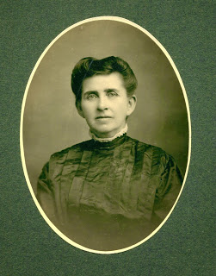
Right , Augusta White Holleman
The lineage for this branch of the Holleman family
flows as follows:
Josiah James Holleman (1851-1937), son of
James Henry Holleman (1819-1858), son of
William H. Holleman (1795-1836), son of
Josiah Holleman (1771-1848), son of
Jesse Holliman, Sr. (1737-1824), son of
John Holleman (1688-1751), son of
Christopher C. Holyman (1660 ca - 1731), son of
Christopher Holyman, Sr. (1618-1691), the immigrant from Bedfordshire, England who arrived in Jamestown, Virginia in 1650.
The 1684 plantation, patented by Christopher Holyman, Sr. eventually descended to Wilson Holleman (1803-1873). The current house was built by Wilson and Ann Nicholson Holleman. Wilson left it to his son, Algernon Sidney Holleman (1838-1906), who died childless. The House and farm then went to Josiah James Holleman, a first cousin.
Josiah left it to his son, Algernon Hardy Holleman (1902-1963), who passed the property to his son, William Joseph Holleman, who owns the home today. His son, William Joseph Holleman, Jr. now lives on the farm, continuously occupied by Hollemans for almost 350 years.

Next posting, more on the Holleman descendants who have remained in Isle of Wight, Virginia since the Christopher Holyman arrival in Jamestown, Virginia in 1650.

Monday, October 21, 2013

Exploring Further Holliman History in Old Virginia, Part 4
by Glenn N. Holliman
We continue our series of articles on the descendants of Christopher Holyman (d 1691) who have remained in Isle of Wight County, Virginia and vicinity for hundreds of years. My continued thanks to Sarah Barlow Wright, Janet Wright Moore and Susan Holleman Brewer for their kind help.
A portion of Christopher Holyman's 1,020 acre plantation still remains in the Holleman family to this day. On that farm in 1895 Gladys Hortense Holleman came into the world, the daughter of Josiah James and Augusta Hannah White Binford Holleman, the then owners of the property.
Gladys would marry Gordon Eugene Barlow in 1921 and live most of her life at the Barlow farm, Oak Crest, in Isle of Wight County, but she retained many memories of her childhood in Mill Swamp. The photograph below of Gladys is courtesy of her daughter, Sarah Barlow Wright of Smithfield, Isle of Wight, Virginia.
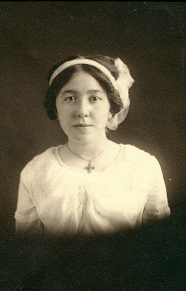

Below around 1907 (at Holleman House), Gladys stands to the far left wearing a black hat and white dress. Walking in front of her is her brother, Joseph Howard Holleman, Sr. Standing in front of the white picket fence is another brother, Algernon Hardy Holleman, and their mother, Augusta Hannah Holleman. Sitting on the porch, obscured, is Josiah James Holleman. Sarah Wright believes this picture was made as the children were going off to school.

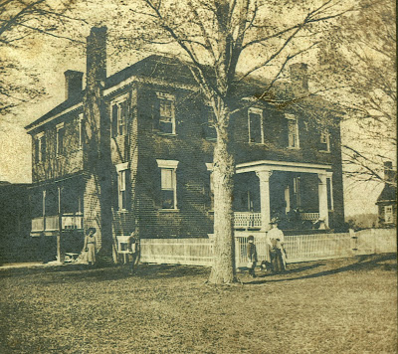

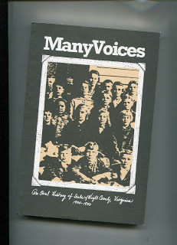

In 1986, an oral history of Isle of Wight County was published and included several pages of memories by Gladys. The work, Many Voices, is available from the Isle of Wight Museum and Historical Society in Smithfield, Virginia. The following two paragraphs are from the book:
"When I was young, our entertainment was centered around the home, church and school. I admired the ministers' families and the school teachers; they were the educated people of the community, and we looked up to them.
I went to a one-room school in Mill Swamp, and when I was fifteen, I came to Smithfield High school and graduated there in 1913. I went to Westhampton College of the University of Richmond."
Below, a later version of the school at Mill Swamp, adjacent to the Holleman plantation and the Mill Swamp Baptist Church. The date is unknown. This picture also courtesy of Sarah Barlow Wright.

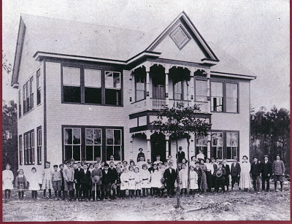

Sarah Barlow Wright remembers her mother's story of her first day at school in the one room school house -
"The one room school house was next to Mill Swamp Baptist Church. On my first day in the first grade, I thought the little recess was lunch time, so I took my lunch outside when we went to play. When we went back inside, I forgot my lunch. At lunch time, we found that hogs had eaten my lunch! I began to cry. The teacher, who was the preacher's daughter, took me across the road to the parsonage for lunch."
That traumatic day of school in 1901 did not deter Gladys Holleman from continuing her education. After graduating from college in 1917, she taught school in Wakefield, Virginia and became principal of that same little school at Mill Swamp before her marriage in 1921.
Next more on Isle of Wight history and the Hollemans....

Tuesday, October 29, 2013

Annoucing a New Holliman Genealogical Resource
by Glenn N. Holliman
The 2013 Holliman Genealogical Forum in Fayette, Alabama

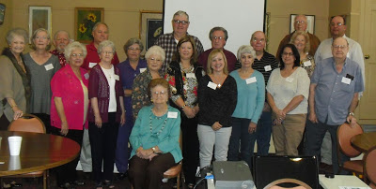

Gathering for two days of sharing and learning during beautiful autumn southern weather were left to right: Anne Holliman Windel (Alabama), Jeanette Holiman Stewart (Texas), David Jennings (Alabama), Shelia Nichols (Alabama), Glenn Holliman (Pennsylvania), Janie Holliman (Alabama), Lois Sherrill (Alabama), Sarah Hall Holliman Hatch (Colorado), Nell Holliman, sitting (Alabama), Harvey Holliman (Texas), Alice Holliman Murphy (Texas), Glenda Norris (Alabama), Frank Holliman (Alabama), Rachel Lee (Alabama), Eddy Smith (Alabama), Marilyn Wilson Galvan (Texas), Vonceil Duckworth (Alabama), Linwood Holliman (Alabama), Jimmy Holliman (Alabama) and Joseph Parker (Texas)
At the October 2013 Holliman Genealogical Forum in Fayette, Alabama, a tremendous new genealogical web site was announced. The web site, designed as a virtual archives, can be found at The Hollyman Family at MyFamily.com. The top portion of the site is visible below. Note the numerous titles available at the location.
Already on this MyFamily site one will find:
Over 14,000 names on the extensive Holyman Family Tree

Dozens of research files and family histories

Several thousand photographs

A discussion forum

And more information added almost daily!

However for accuracy purposes, the site remains private; that is one needs an invitation to participate.

Whether you live in the United States, the British Isles, Canada, Australia or where ever on the globe, that invitation is easily granted if you email this writer at glennhistory@gmail.com or Jeanette Holiman Stewart at Htreekeeper@outlook.com.

Or go to the HOLLYMAN GENEALOGY MyFamily site at http://myfamily.com/group/hollyman .
Then click on "Request to Join" in upper righthand corner!

Below, Jeanette Holiman Stewart double checks her records as Jimmy Holliman and Vonceil Duckworth join her at the Shepherd Baptist Church Cemetery in Newtonville, Alabama. On this site in 1836, their ggg grandfather Charles Holliman located his family after migration from Lancaster County, South Carolina. Jeanette monitors the Tree at MyFamily.com and has entered over 14,000 names and thousands of photographs and documents!

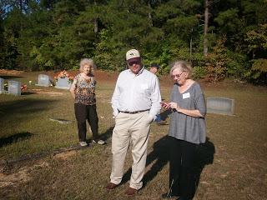

You will be welcomed to this living museum and world-wide resource center, a place where those of us with ancestors by the names of Holyman, Hollyman, Holliman, Holiman, Holleman, Holloman, Hollemon, Hollomon and numerous other variations can find and share family history information. Associated families are encouraged to join us in this program.
This site was founded after extensive discussions following a 2011 reunion in Fayette, Alabama by family historians Joseph Parker, Glenda Norris, Lynn R. Holliman, Jeanette Holiman Stewart, Tina Peddie and Glenn N. Holliman, all descendants of Christopher Hollyman, Sr. (1618-1691). These persons, four of whom are in the group picture above, administer the site.
As regular readers of this space know, this Christopher, Sr. came from Bedfordshire, England to Jamestown, Virginia in 1650, married twice, had six children and prospered leaving a plantation of 1,020 acres at his death in Isle of Wight County, Virginia. While other persons with the name of Holyman (or a derivative) evidently migrated later to the New World, our evidence to date traces almost, but not all Holymans (and various spellings), back to the four sons of Christopher, Sr. Their names were Thomas, Christopher, William and Richard. There were two daughters – Ann and Mary who married two brothers from a neighboring plantation – John and James Atkinson.
The purpose of this MyFamily site is to gather the most complete information possible on Holymans, post and share without fees to the larger family. Our goal is to establish a central gathering place for Holyman Family information and research materials. We have designed our management to be self-perpetuating, to maintain service and enlarge this site as the years and decades pass.
Left, one of the hosts for the Alabama Holliman Forum and dedicated genealogist, is Glenda Norris, descended from Cornelius Holliman, one of three brothers who caught 'Alabama Fever' and migrated to the state from South Carolina in 1836.
Of course, genealogy is a process, and as new information is discovered, lineages and dates may change. If your research differs from what might be contained on this site, let us know and corrections or differences of opinions will be noted. This site is for education only and not for commercial or legal purposes.
Additional Resources are available!
Join the Hollyman Email genealogical conversation at Hollyman-Subscribe@yahoogroups.com.
Or the Hollyman Family Facebook Page located on Facebook at "Hollyman Family".
For more information on these sites, contact Tina Peddie, one of our MyFamily administrators, at desabla1@yahoo.com. Mrs. Peddie can assist also in any DNA research.

Remember for your Hollyman MyFamily invitation, contact glennhistory@gmail.com or Htreekeeper@outlook.com.

Or go to the HOLLYMAN GENEALOGY MyFamily site at http://myfamily.com/group/hollyman .
Then click on "Request to Join" in upper righthand corner!
﻿
Next week, back to another bit of Holleman history....

