WEDNESDAY, NOVEMBER 17, 2010

Our Family's Colonial Era - Part VIII
by Glenn N. Holliman

In 1635, persons whose last names are similar to Holliman, were living in Virginia. Are they our ancestors? Who were Thomas Holeman (Holman) and Robert Hollman?

Cousins Jeanette Stewart, Joe Parker and Maxine Wright have drawn my attention to the name and landownership of Thomas Holeman who purchased property in 1635 in Martin's Hundred, approximately ten miles south of Jamestown, Virginia. On p. 30 of Nugent's Cavaliers and Pioneers, Patent Book No. 1, Part I is a listing of a purchase of fifty acres of land in James County, adjacent to John Dennett and Capt. John West. The land had belonged to one Thomas Harvey who had died (the death rate was very high in early Virginia).

Is this the Thomas Holyman (Holiman, Holman, etc.) who was baptized September 13, 1612 at St. Mary's, Bedford, Bedfordshire, England? As noted in early posts, Thomas and Ellenora Holliman of Bedford were the parents of a Thomas and three other children with the names of John, Judith and Christopher Holyman, the same names as other persons who lived in Virginia in 1650.

In some recent research at the Library of Virginia in Richmond, I consulted numerous works, seeking to know more of this Thomas. Martha W. McCartney in Virginia Immigrants and Adventurers 1607 - 1635, also writes of Thomas patenting land on August 24, 1635. Ms. McCartney spells his name 'Holman', not 'Holeman'. Likewise, Gary Parks' index of Virginia Land Records records Thomas as a 'Holman'.

Gravestones were not common in Colonial Virginia until the 1700s when the colony began to 'mature' and relatives had the resources to purchase and craftsmen to carve rock. Below is the memorial marker for Alice Holleman of the 19th Century, who lived and is buried on the original plantation of Christopher Holyman Sr. Unfortunately, of course, there are no markers for ancestors who lived in the 1600s and precious few for the 1700s. Weather and time have eroded even stone.
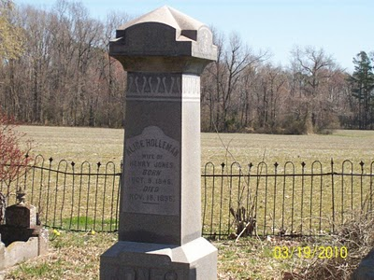
And Who was Robert Holliman?

Then there is twice mention of one Robert Hollman (not Holman or Hollyman) in Virginia Land Records, pages 666 and 674, on the dates of June 1 and March 6, 1635 in Henrico County, Virginia. Henricio is north of Jamestown and now encompasses the city of Richmond. This Robert Hollman owned land adjacent to the 'main' river, that is the James.

Granted spelling was atrocious in Colonial Virginia. The records are hard to read, and last names were spelled in different ways and often inaccurately.

So are Thomas and Robert our Holliman ancestors or some one else's?
If so, at least 15 years before Christopher Holyman Sr., our known ancestor, arrived, were his relatives, perhaps a brother and/or a cousin, already in the Chesapeake region? Did they prepare the way for more Hollimans who arrived in 1650 and later?

More in our next posting....as ever your knowledge and research, most welcome.

THURSDAY, NOVEMBER 11, 2010

A Veterans' Day Salute
by Glenn N. Holliman
U.S. Army, Vietnam 1969
A Thank You to our Veterans

I suspect our family members have been represented in our country's battles from Colonial Chesapeake to the 21st Century Middle Eastern Wars. As it is impossible to list all of them in any kind of complete listing, I will let my nephew, Capt. Jonathan Murphy, USA, take the salute for all who been on active duty, the Reserves or National Guard. Jonathan is on duty somewhere in Afghanistan, his second tour in four years. His family waits for him in the States.

For a time he was Captain of the Guard at the Tomb of the Unknown Soldier in Washington, DC. Below are two photographs - one of Jonathan leading his platoon up the steps of the Memorial and the second of him walking the Guard. For those of us who have stood on guard in other fields and seas, including my father, uncles, nephews and cousins, we express our appreciation to him and all relatives who have gone before him.
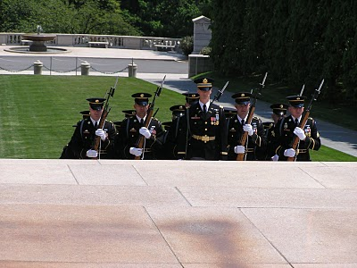
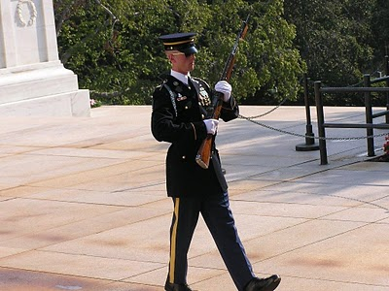
Among his ancestors are family members who served in the French and Indian War, Revolution, War of 1812, Civil War, World War II, Viet Nam, the Cold War and recent Middle East conflicts. One great grandfather, Luke Stansbery (1750 - 1848), was held as a prisoner of war of the British in Charleston, SC 1780 during the American Revolution.

Back to Colonial America with the next post....
Posted by Glenn N. Holliman at 3:18 AM 1 comments
Labels: Christopher Holliman Sr., Jonathan Murphy, Luke Stansbery

TUESDAY, NOVEMBER 2, 2010

Our Family's Colonial Era - Part VII
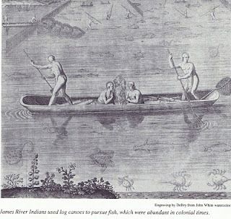
Conflict with Native Americans – A Clash of Cultures
by Glenn N.Holliman
Between April and June, 2010, I published six articles on theHollimanfamily in 17thCentury Colonial America (they can be found in the archive section of this blog). After having published 23 articles on our English past, I now return to the history of the Virginia English colony and the travails our family experienced.

This was truly a new frontier with both opportunity and premature death. Only the brave or foolish ventured from England to Virginia from the early to mid -1600s. Perhaps our pioneering family of Christopher Holliman, Sr. was a mixture of both.
Michael Mallary in his 2004 work, Our Improbable Universe, makes the point that everywhere farmers went taking their technology and culture, the hunter-gatherers melted away before them. “The high population density that could be supported by agriculture depleted game well below the density that hunters (such as American Indians) required” observed this historian.
This then was the societal reality when Christopher C. Holliman, Sr. with his probable sister, Judith, arrived in Virginia in 1650. The frontier required bravery, a tenacious attitude to attack the virgin forests and a strong constitution not to succumb on the voyage or to disease and malnutrition upon arriving. Fortunately this Hollimanfamily had such attributes, although Anne, Christopher's first wife, died in the 1660s. Mary Grey, perhaps the daughter of a member of the House of Burgesses in Jamestown, became Sr’s second wife.
In only a generation or so, soil exhaustion from tobacco cultivation forced families or young farmers to move to virgin land, to push the American frontier ever westward. The quest for land to grow tobacco and later cotton meant more and more Native Americans were displaced. The result was violence as American Indians naturally resisted encroachment on their hunting grounds and villages. The Indian did not go quietly to his cultural demise in Virginia and greater America.

The founding of Jamestown in 1607 meant the English had come to stay. Unlike the earlier 1580s failed Roanoke experience, this time our Anglo fore bearers mustered the necessary resources to establish a permanent colony. The English Diaspora employed superior technology, organization and the financial resources to grasp and hold an expanding piece of the New World.
Perhaps 15,000 to 25,000 Native Americans lived in Southern Virginia in the early 1600s. Benjamin Woolley’s Savage Kingdomrecords Captain Christopher Newport’s 1607 initial visit up the newly named James River to the site of present day, Richmond. He sighted numerous Indian villages. John Smith’s adventurous tales record numerous Indian settlements and evidence of many warriors. What English people knew as Virginia, Native Americans calledTsenacomoco.
Although there were numerous skirmishes and at least one large assault on early Jamestown as the two cultures brushed and bruised each other, the English were fortunate the central Indian chief was Powhatan. By and large he was an accommodating weroance (chief) who failed to anticipate the ultimate threat of the English invasion.
At his passing, his brother, Opechancanough, already an old man, recognized the Anglo incursion for what it was – a death threat to Indian culture and territory. On the Christian Good Friday in March, 1622, this war chief unleashed a Pearl Harbor on the small colony. By stealth, Indians conducted well-coordinated attacks on plantations and settlements all up and down the James River on both south and north banks. Over 1/3rd of the English colonists were killed in one day – 347 men, women and children. It was a close run thing if the colony could repel the attacks.
While a tactical victory for Native Americans, the attacks were not enough to drive the English into the ocean. Within a year, the colonists struck back and killed over 200 Indians, althoughOpechancanough escaped. For two decades the frontier was mostly quiet, but in 1644, now almost 100 years old, ever determinedOpechancanough struck one last time. Five hundred settlers died, particularly along the York and Pamunkey rivers. (Records indicate several settlers named Holyman already were living in the colony in the 1630s and 40s. We will explore this in later postings.)
This time under a controversial but stubborn royal governor, Sir William Berkeley, the Virginia militia now much stronger and more numerous than warriors the Indians mustered, capturedOpechancanough and destroyed most of his forces. The old chief died in captivity in Jamestown, slain by a vengeful guard. Surviving Native Americans were relegated to a piece a land near the fall line, at present day Richmond.

Of course, beyond the settled frontier, other Indians remained as yet only modestly undisturbed by the ever westward moving Europeans. As yet undisturbed….

Next posting more on our Holliman family and their challenges in a new world.

