SUNDAY, NOVEMBER 27, 2011

The Louisiana Hollemans
by Glenn N. Holliman
The Family of Sidney Anthony Holleman, Jr.,Well Written and Neatly Bound
Last spring on a tip from Joe Parker, ace Holliman family historian, I discovered a volume of family history by a distant cousin in Texas, one Dr. Sidney Anthony Holleman, Jr. By email I contacted Dr. Holleman and after covering printing and mailing costs, a 197 page tome on the Hollemans (or Holyman, Holliman, Holiman, etc.) arrived.
It is a handsome book, well bound and paperback, but certain to last in one's library for generations to come. Dr. Holleman researched the work, obviously for years, and published it in 2004. While later research has eclipsed some thoughts on our English roots, Sidney calmly and carefully moves his branch of the family from Christopher Holyman, Sr. (1618 - 1691 and Isle of Wight, Virginia eventually to Texas, the state he claims as his birthplace.
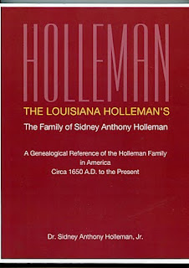
His Hollemans, as have most branches of our family, followed the southern migration across the southland from Virginia to North Carolina to Georgia and by the Civil War to Louisana. There the family became Roman Catholic and strengthened itself with some Acadian DNA. By the turn of the last century, the family had GTT - Gone to Texas! There Sid's parents raised him and where he has raised his own family.
If there is an 'e' as the second vowel in your Holliman name, you will want to obtain this book. Respecting Dr. Holleman's privacy, if you wish to contact him, send me an email and I will put him in touch with you.
Even if you don't have an 'e' in your name, you will appreciate the time, effort and family lore that has gone into this work.
Posted by Glenn N. Holliman at 4:47 AM 0 comments
Labels: Dr. Sidney A. Holleman

TUESDAY, NOVEMBER 15, 2011

Our Family's Colonial Era, Part XXVI
by Glenn N. Holliman
Christopher Holliman, Sr's. Will, a Further Look...
In the last posting, I published the will of my ancestor, Christopher Holliman, Sr., died 1691. Christopher left his two married daughters, Anne and Mary, not land, but one ewe each. That may seem unfair to 21st Century standards, but there were probably mitigating circumstances.
1. When they married their neighbor's sons, the Atkinsons, they married men who were expected to support their wives and children, and were expected to inherit land, just as did the Holliman sons.
2. The Atkinsons may very well have been provided doweries, thus in effect receiving their inheritances upon marriage.
3. Symbolically Anne and Mary both received an ewe, a female sheep. Most clothing worn by families in the 1600s of Colonial Virginia was home spun, that is clothes from the spinning of sheep wool. An ewe could become pregnant, and those produce additional sheep and wool for the family. Cotton would not become a cloth of choice until the invention of the cotton gin in the 1790s in Georgia.
The will left everything else including land to the wife, Mary, during her lifetime. At her passing, two sons (but not all four) received the remainder. Hmmmm....perhaps Christopher Sr. was trying to be fair to all, or perhaps he favored two of his sons, Christopher and Richard, over Thomas and William. Perhaps he had distributed some land earlier to these sons. We will never know.
Mention is made of orchards, an important supplement to the Colonial Virginia diet. Until English persons were able to plant and harvest apples, the lack of fruit and subsequent vitamins had resulted in malnutrician and many early deaths.
Notice no slaves or indentured servants are mentioned in the Holliman will. Although African-American slavery existed in the 1690s in Virginia, and the Assembly was passing more and more draconian slave laws, the great increase in importation of Africans would not occur until after 1700. Tragically by 1790, one out of five Americans (700,000) would be enslaved, an incredible statistic. Virginia and South Carolina had the largest populations of trapped human beings.
Of considerable interest is the importance of the tobacco culture in his will. The cultivation of tobacco, the cash crop, was critical. The volume below by husband and wife historians tells the story of Middlesex county, Virginia during the 17th Century. The Rutmans record that a whole tobacco crop of seeds could be cupped in one hand. These tiny seeds were placed in dirt hills, three to four feet apart. It was not even necessary to clean the land completely; just girdle the trees.
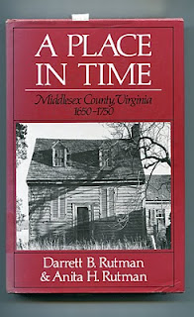

No more equipment was needed than a hoe. One laborer would 'crop' two to three acres which produced 1100 to 1200 pounds of cured tobacco. Corn could be interspersed with the tobacco. After a few years, when the soil was exhausted, the planter moved to new acres, and allowed hogs and cattle to graze on the abandoned land, allowing time and animal mature to re-nourish the soil.
The Rutmans published this cycle of a typical colonial agriculture year (see below and click to enlarge). With very little imagination, we can picture our ancestors working this pattern year after year. Not to be reproduced for commercial purposes.
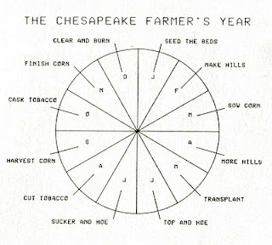
In future postings, we shall follow the fortunes of the Holliman children and their descendants....

SATURDAY, NOVEMBER 5, 2011

Our Family's Colonial Era, Part XXV
by Glenn N. Holliman
The Will of Christopher Holliman, Sr.
Isle of Wight County, Virginia 1691
Below is Christopher Holyman's (Holliman, Holleman, etc) Virginia will of 1691. This is an easy to read version, but it is authentic and prepared, I believe, by a distant cousin. The original was filed in the Isle of Wight when William and Mary occupied the thrones of England. The colonies were almost a century away from George Washington, another Virginia, becoming President of the United States. Let's examine the will and see what we can learn. (Click on will to enlarge.)
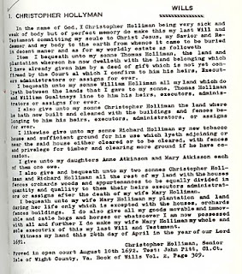
We note first of all a salutation common to English and colonial wills of the time, a statement of faith and belief in Christ Jesus. These faith statements are less common today. Christopher's grave is lost. Until the late 18th century, grave stones were rare in the colonies and virtually none at all in the 1600s Virginia. A family cemetery is now located adjacent to the current 1830s two-story brick Holleman house on the site of the original 1,020 acres that Christopher Holliman, Sr. owned. One suspects this might be the location of the first home, certainly a log house, and family grave sites (Click Archives and visit articles April 2010.)
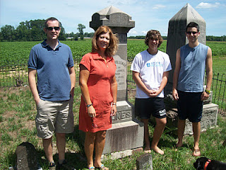
Distant cousins visit at the original Christopher Holyman, Sr. (1618 - 1691) plantation in July 2011. Pictured above at the Holleman farm in Isle of Wight County, Virginia are left to right, Bryan Payne (Tennessee), Alice Holliman Murphy (Texas), and Spenser and Corey Holleman, brothers who live at the original site. This Holleman family cemetery, with the earliest headstones from the first decades of the 1800s, may have been the location of the grave of Christopher Holyman, Sr.
Let's look at the bequests:
Thomas - Christopher had deeded already a plot of land to this son. The number of acres is not mentioned for any of the bequests.
William - This son received that portion of land between Thomas's plantation and the neighbor, William Gualtney (later spelled Gwaltney and of Welsh origin). The Gualtney's in the late 1800s will become merchants, first selling peanuts and later hams. These are now the famous Smithfield Hams of Isle of Wight County. Many of the Queen Anne style homes of downtown Smithfield were constructed from the financial success of the family. Records indicate Holliman daughters married Gualtney's from time to time.
Christopher, Jr. - This first borne son received his cleared land and buildings already constructed.
Richard - The youngest son received land for tobacco growing, timbering and clearing more if he wished. His bequest is the only mention of the principle crop - tobacco - and a bequest of a tobacco barn. Richard continued what became my branch of the family tree as he is my 6th great grandfather. More on him later in my writings.
Next posting, more analysis of this 17th Century family will....

