Friday, November 9, 2012

From the Galaxy of Holliman Cousins and Great Uncles and Aunts
by Glenn N. Holliman
This continues the series on Dr. Rhodes B. Holliman and his ancestors and associated families....
Below in 2002, my son, Christopher S. Holliman rendezvoused in Virginia with Dr. Rhodes Holliman, who passed along to Chris a book shelf constructed by Ulyss S. Holliman (1884-1965) in the 1920s. Ulyss was Chris's great grandfather and Rhodes's great, great uncle. Chris is a librarian and Rhodes, a Ph.D. in biology, who chronicles the history of the Holliman family with emphasis on Alabama since 1836.
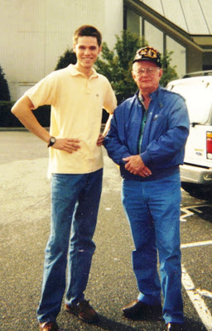

Rhodes's great grandfather was James Monroe Holliman. James was the first of the Holliman sons of John Thomas and Martha Jane Walker Holliman to leave farming as a profession and enter a service industry - an attorney-at-law. Until 1920, half of all Americans, according to the Census of that year, lived in a rural environment. But the industrialization of the country, the decline in farm prices and more than anything, the rise of modern transportation, revolutionised how people earned their livings,

In the lives of sons of John Thomas Holliman, four of the six left farming for other pursuits at the turn of the 20th Century. Their father, caught up in the seemingly never ending farm crisis's of the 1890s and 1920s died in near poverty in 1930 at a time of no Social Security and no modern safety net for seniors.

James Monroe Holliman (1878- 1938) was determined to earn his living by his mind and mental talents. He also married well - Elizabeth Ann Baker, a descendant of another Fayette County, Alabama pioneer family.

Below, James Monroe and Elizabeth Baker Holliman in October 1899 leave Newtonville, Alabama for their honey moon. Note the clothing styles and the buggy that carried them away to married life.

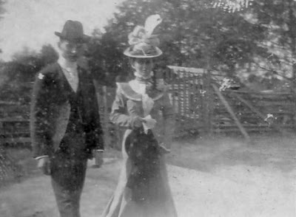
. ﻿
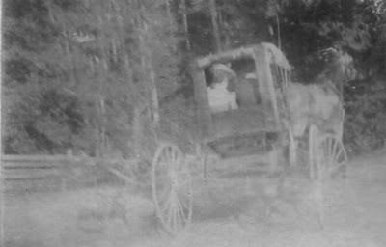
The 19th Century pictures above are from the collection of Dr. Rhodes Holliman, who received them from his father, Cecil and grandfather, James Monroe Holliman. In 1899, the horse and buggy world was about to give way to gasoline and automobiles. Cruelly, James would die of infection when his finger were caught in a slamming car door in 1938. He was only age 60, but he left behind a legacy of descendants to carry on the family names and service to the communities in which they lived.
Next post...more on Fayette, Alabama and one of its citizens....

Thursday, November 22, 2012

From the Galaxy of Holliman Cousins and Great Uncles and Aunts, 2
by Glenn N. Holliman
This continues the series on Dr. Rhodes B. Holliman and his ancestors and associated families....I am grateful to him for access to his historic photographs of Fayette, Alabama and family.
Below James Monroe Holliman (1878-1938), third son of Civil War veteran, John Thomas Holliman (1844-1930). The photograph below is dated 1896, when James was 18, three years away from marriage to Anne Elizabeth Baker. They would have two boys who lived to maturity - Cecil Rhodes Holliman and Charles Baker Holliman.
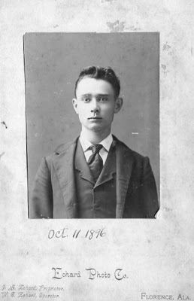
The year before James married Anne Elizabeth Baker, the Baker family which lived in Newtonville, Alabama posed for this photograph which caught the a southern family in 1898 wearing their Sunday best. Note James Mutius Baker on the far right in wing tip collar and hat.

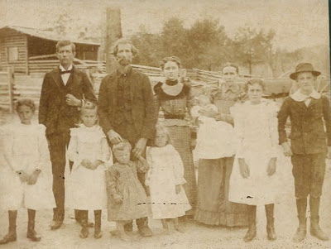
Back row, left to right: Frances Hillman Baker, George Washington Baker, Anne Elizabeth Baker, Belzy Ann Blakeney Baker, Georgia Bell Baker (babe in arms). Front row, left to right: Guyton Baker, Pearl Baker, Frederick Coleman Baker, Montie Lea Baker, Allie Mac Baker, James Mutius Baker.
Below, the Fayette County, Alabama courthouse in 1898. It was destroyed in the town fire of 1911.

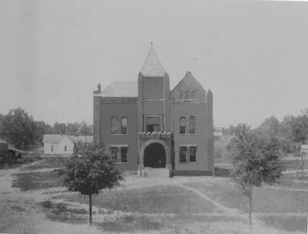
Fayette in 1898 was still captured by the cotton culture of the old South as this picture taken in front of the Court House suggests. Family farmers all over the nation suffered in the 1890s giving rise to the Populist movement which flowered briefly and then faded in Alabama.
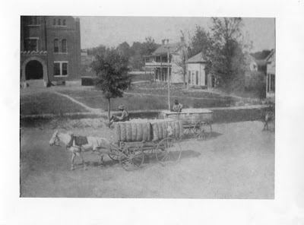

Two of James's brothers would work as farmers all their lives. Not James. He first practised law in Fayette, Alabama serving as county solicitor in the 1910s. A horrible fire swept through Fayette in 1911 destroying much of the downtown.
The fire, the inability to advance in a political career running as a Republican in the solid Democratic South and the lure of the Magic City of Birmingham, must have moved James to make an important move around age 40. As with millions of other Americans, north or south, James Monroe Holliman would head to the big city.
In the future more on James Monroe Holliman and his brother, however, next post, back to England and our European roots....

