Sunday, November 17, 2013

Exploring further Holleman History in Old Virginia - Part 5
by Glenn N. Holliman

We continue our series of articles on the descendants of Christopher Holyman (d 1691) who have remained in Isle of Wight County, Virginia and vicinity for hundreds of years. My continued thanks to Sarah Barlow Wright, Janet Wright Moore and Susan Holleman Brewer for their kind help.

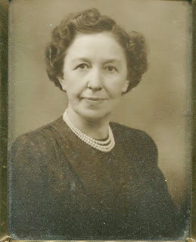
Above, a portrait of Gladys Holleman Barlow (1895 - 1996)

In the 1986 Many Voices, a treasury of Isle of Wight County, Virginia personal memories, Gladys Holleman Barlow spoke of her life of the early 20th Century on the family home, the Holleman House at Mill Swamp adjacent to the Surry County border. We continue...

"My parents were farmers, and my husband and I were farmers. One of my earliest memories is riding around in the horse and cart with my father when he was measuring up peanuts. The peanut pickers would pick up peanuts, and my father would go around late in the afternoon to measure them and pay the pickers ten cents a bushel for having picked them up. Hardly anybody picked over three bushels a day."
Below, the Holleman House and farm in the 1980s ca. To the right of the main 1830 structure is possibly the oldest structure on the property, a wood frame building that was the home of the Wilson Holleman family prior to the construction of the two-story imposing red brick structure. Approximately 100 acres of the original 1691 plantation of 1,020 acres still remain in the Holleman family. Photograph of Gladys Holleman Barlow and the below plantation courtesy of Sarah Barlow Wright, her daughter.
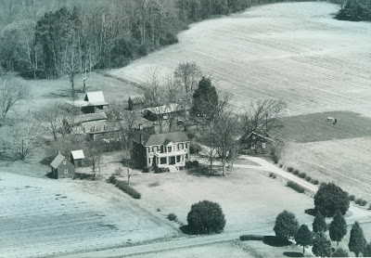

"Another thing that was done then, but wouldn't be done now, was to burn corn stalks on cold winter nights. My father would go around with a fire brand and have these piles of corn stalks about the field to light. I loved going around with them doing that. Another time, they would have corn shuckings. All the neighbors would come and shuck corn. We would have a long row of it in the backyard, and I always had a girl come home with me so we could walk in the shucks.

There was an old brick house on our farm that was said to be haunted. My father stored peanuts there without fear of anyone stealing them because the neighborhood people were afraid of ghosts. Some strangers came one time and asked him if they could dig around the house for treasures, and he told them he felt sure there were no treasures, and he didn't want them digging up his field, so he didn't give his permission. But the next day, he went there, and they had during the night, so they must not have been afraid of ghosts. We don't know whether they found treasures or not."
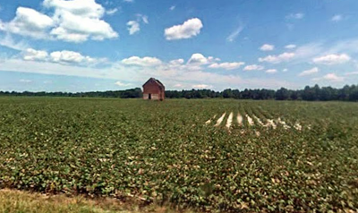

Above, the 'haunted' abandoned brick house in a former Holleman field in Mill Swamp approximately a half mile from the 1830 home. One Holleman cousin believes this may have been the site of the original 1690s Christopher Holyman house; another cousin disagrees.
Shown above, soybeans are often the crop of choice for Isle of Wight farmers in the 21st Century and of course, peanuts are still grown. In the 1600s, farmers such as the Hollemans would have grown several acres of tobacco as the cash crop, and acres of corn for the table and animals.
Hogs would have roamed freely in the woods until frost eating the mast. In the 1670s, according to a Surry County court case, Native Americans stole and butchered some of the Holleman hogs. A year later Bacon's Rebellion broke out in the colony due in large part to continuing friction between the two cultures.

Next posting, more on Isle of Wight and the Holleman farm....

