FRIDAY, DECEMBER 10, 2010

Our Family's Colonial Era, Part XI
by Glenn N. Holliman

Some 17th Century Holymans - Who Were They?

Most of us reading this blog are descendants from Christopher Holyman (Holliman, etc.) who was born in England, immigrated in 1650 to Jamestown with a person named Judith, presumed to be his sister, both from either Bedford or Tring, England. Judith disappears from the story, but we know Christopher, Sr. died in Isle of Wight County, Virginia in 1691, having prospered as a planter.

In other blogs, I have shared research by others on ThomasHoleman who in 1635 purchased land at Martin's Hundred, south of Jamestown. There was also one Robert Hollman, who in March 1635 owned land in Henrico County, along the James River. Then there is John Holyman who died in Southampton, Virginia in 1650, a possible brother of our Christopher Holyman and the above Thomas Holeman.

There are still more Hollimans!

Beside the descendants of Christopher Holliman, Sr., otherHollimans also were arriving in the New World. Here is a list I have put together so far, and of course, welcome information, additions and clarification.

1653 - Another Judith Holyman and a secondChristopher Holyman arrived three years after our Christopher Holyman Sr. and the original Judith Holyman stepped ashore at Jamestown. Most genealogists believe they were relatives, perhaps a son, a daughter or a mother?

1656 - On April 25, 1656 one William Holliman arrived, transported courtesy of Thomas Rolfe. Who was Thomas Rolfe? None other than the son of John Rolfe and his famous wife, Pocahontas, the daughter of Powhatan, chief of the tribes when Jamestown was founded. Well....my goodness....By 1658, William Holliman was a land owner. All this from Nell Nugent, Volume 1, pages 328 and 377,Cavaliers and Pioneers.
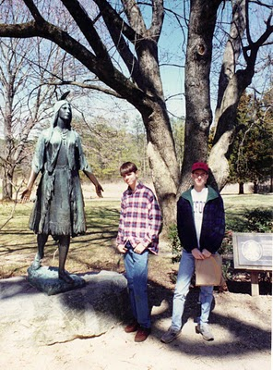Above in this 1994 photograph, my son, Christopher S.Holliman and my nephew, Bryan Payne, pose at Jamestown in front of the statue of Pocahontas. Both are direct descendants from their multi-great grandfather, Christopher Holyman, Sr., who landed at this site in 1650.
1658 - February 26, one John Hollman transported by John Dorrant. A Holliman simply slightly misspelled?

1659 - How about some indentured servants, poor people who bought their passage to Virginia in exchange for years of work? Labor to work tobacco fields was very scarce in the colony. There was Jane Hollyman, unknown family, who on September 10th was ordered to serve her master an extra year at the end of her indenture for running away. This freedom loving female Hollyman had escaped for six months from one William Cox. The county was York, Virginia. Interesting, our Christopher Holliman, Sr. was transported in 1650 by one John Cox. Relationship?

1675 and 1681 - The names of Thomas Hollyman pop up twice, both times in Lancaster County, Virginia as indentured servants. Are they the same person or two named Thomas Hollyman? The second in 1681 is listed as a servant of Lt. Colonel John Carter, ah ha, of the famous Carter family. Later the Carters will cease using indentured servants and instead utilize African slaves. This John Carter will die early eventually leaving the entire family estate to Robert "King" Carter who will become the wealthiest man in Colonial Virginia, acquiring over 300,000 acres and 1,000 slaves. This John Carter got his start in Isle of Wight County in the 1640s, the same country were our direct great grandparents would put down roots.

For citations on Jane and the two Thomas Hollymans, go to the Immigrant Servants Database on the web. Citations in original records are given. A very neat web site where one can cross check numerous family trails.

From whence did these Hollymans come? Bedford or Tring, England? Some other part of the England? Are these distant cousins? Perhaps, probably, perhaps. Joe Parker has identified even more Hollimans who lived in Virginia in the second half of the 17th Century. So there are more stories to tell.

More on Colonial Virginia and the Family of Christopher Holyman, Sr. in the next post....

Posted by Glenn N. Holliman at 4:59 AM 0 comments
Labels: Bryan Payne, Christopher Holliman, Jane Hollyman, John Thomas Hollyman, William Holliman

THURSDAY, DECEMBER 2, 2010

Our Family's Colonial Era - Part X
A Civil War in England and
War with the Dutch in the Chesapeake Bay
by Glenn N. Holliman
Virginia was not immune from the disturbances in England. After the English Civil War, and Charles I losing his crown and head, Oliver Cromwell’s Commonwealth ruled from 1649 to 1660. Robert Berkeley, a long serving royal appointee, was dismissed as governor of Virginia in 1652 when a Commonwealth ship sailed up the James River and demanded Berkeley’s surrender of the colony and his post.
Below Oliver Cromwell, the uncrowned king of England during the Commonwealth Era.
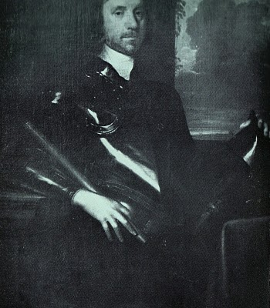
With the restoration of Charles II to the British throne in 1660, Berkeley left his plantation and exile at Green Spring (near present day Williamsburg) and returned to lead from Jamestown, still the capitol.
Violence never was far away from the Hollimans and their farms in what is now Smithfield, Virginia on the Cypress River (a short river which emptied into the Pagan and then into the James) and later the Blackwater Swamp, still in Isle of Wight County. In 1667, a Dutch fleet sailed up the James and burned twenty colonial ships carrying tobacco. Six years later, the persistent Dutch in a continuing trade war with Britain, returned and burned or captured another ten ships.
Did the Holliman’s suffer financial losses as a result of this international war? Did they hear the guns and see the smoke? Undoubtedly the Virginia militia was turned out. Was this long-forgotten naval engagement (and war) the first occasion for Holliman’s to muster in defense of their new country?

Economically the Virginia colony was suffering from a surplus of tobacco, falling commodity prices, restrictive trade laws and increasing taxes. In addition to Dutch and Mercantile wars, the frontier (northern Isle of Wight County was a border) still experienced friction and violence between settlers and Native Americans. If this sounds like 21st Century America, we are reminded that physical and economic security are paramount issues in any community or century.

Next posting, other Hollimans arrive in the Virginia colony....
Posted by Glenn N. Holliman at 12:20 AM 0 comments
Labels: Oliver Cromwell

THURSDAY, NOVEMBER 25, 2010

Our Family's Colonial Era - Part IX
by Glenn N. Holliman

More on Thomas Holeman, 1635 Land Owner at Martin's Hundred in Virginia

Martin's Hundred, a real estate development if you will, was named after the Society for Martin's Hundred of London, a land holding group in 1618. This huge settlement was located east of Jamestown and west of Skiffe's (Keith's Creek). It contained 20,000 acres and was a principle settlement site at that time. The websiteJamestowne Rediscovery has an excellent summary.

Records indicated 140 or so English lived in the development when in 1622 on Good Friday, a surprise American Indian uprising took the lives of at least 78 of the settlers in Martin's Hundred. The remaining were captured or fled to Jamestown. According to historian Bob Dean in his book The River Where America Began, 347 settlers, more than 1/4th of all the colonists died in that one day massacre.
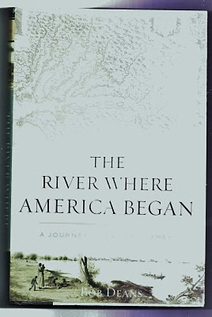
The Virginia colony was in great jeopardy, but struck back violently the next year against the Native Americans. The Crown took control of the dispirited colony from the Virginia Joint Stock Company that had founded Jamestown and had hoped to make a financial fortune.

Slowly the colony recovered, and immigrants arrived again. One beingThomas Holeman who purchased land in Martin's Hundred in 1635. Fifteen years later, Judith andChristopher Holyman, perhaps his siblings, arrived. Judith probably married quickly, and her name is lost to history.

In that same year of 1650, one John Holyman of Southampton, Virginia died leaving a will listing worldly goods but no land. He named a friend as an executor. When did he arrive and were Thomas, Judith and Christopher his siblings, all from Bedford, England?

We know Christopher survived and thrived, dieing in 1691 with an Isle of Wight County farm of 1,020 acres and numerous children. Most of us reading this today are his descendants.

In 1627, approximately 1,500 English persons lived in Virginia, mainly along the James. From 1606 until 1624, the Virginia Company had sent out over 7,000 settlers of whom over 6,000 died! By 1650, the year Christopher Hollimanarrived, some 15,000, ten times as many white settlers were present, or about seven times as many Anglos over Native Americans by this time in Virginia. Many of the Indians had been destroyed by European diseases and malnutrition, as well as warfare. The English were living longer thanks to better diet and shelter.

What happened to Thomas? At this writing I know of no research that has surfaced a will or marriage record. He purchased land, and may have died early as did many. Unfortunately James City County records were destroyed when Richmond was burned during the Civil War, and only some land patent records survive to my knowledge. Martin's Hundred ceased to exist as an entity in the early 1700s.

Did Thomas survive long enough to welcome to Virginia other members of his family - assuming John, Judith and Christopher Holyman were his siblings (families often immigrated together or after one had settled and encouraged others to immigrate)? Can we ever know the whole story?

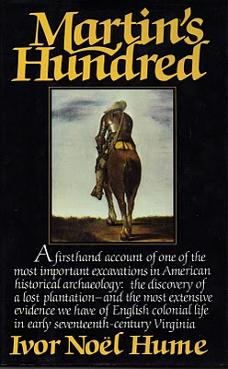
In the 1970s with a grant from the National Geographical Society, archaeologist Ivor Hume, excavated part of Martin's Hundred, now included in the Carter Grove Plantation and incorporated in theWilliamsburg Foundation. Much of Hume's 1988 book (pictured above) focuses on the 1622 Good Friday Massacre and the physical remains of that day. The cover of the book shows an English soldier of the time, garbed in armor. It is compelling reading.

More in the next posting on our Colonial past....

