Sunday, December 2, 2012

From the Galaxy of Holliman Cousins, Part IV

by Glenn N. Holliman
Another Look at Alabama Roots....
Over the Thanksgiving holidays, distant cousin Tom Hughes from North Carolina visited his brother and relatives in Alabama. For those of you who have been reading in this space the memories and photographs of Dr. Rhodes Holliman, you may find Tom's 2012 reflections of interest. Tom writes a blog at
http://tahughesnc.wordpress.com/2012/11/27/discovering-my-rural-alabama-heritage/ , and he invites one to read and ponder.
Tom was visiting cemeteries over the holidays looking for Hughes and Wilson memorials in Lamar County in west central Alabama. He stumbled on several Holliman grave sites at Ashcraft Corner Baptist Church and Wilson Cemetery, both in Lamar County . He sent photographs of his findings thinking they might be of interest to those who follow Holliman genealogy closely. He gave me kind permission to share with you.
These Holliman and one Duckworth resting sites pricked my interest as in this space in January/February 2012, cousin Vonceil Duckworth of Lamar County shared her family lineage and photographs with us. Below the Wilson Cemetery, Kennedy, Lamar County, Alabama.
The Wilson Cemetery
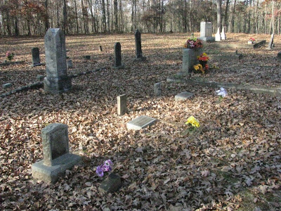
One will find the shared graves of James Wilton Holliman (4/5/1880 - 9'27/1953) and Beulah Holliman (9/11/1876 - 9/11/1959) at the Wilson Cemetery.
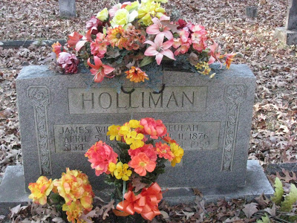

Maurine Holliman, daughter of James Wilton and Beulah Holliman, born 4/10/1914, must have died as a child as no death date is given. Maurine is listed in Mary David Elmore's The Community of Kennedy, Alabama as the daughter of "Wilson Holliman and wife", a possible slight typographical error.
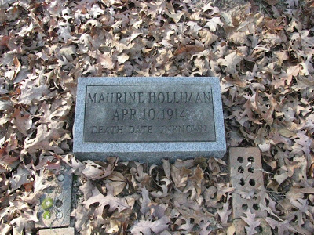
Nor is there a death date for a Manley Holliman, born 10/8/1902.
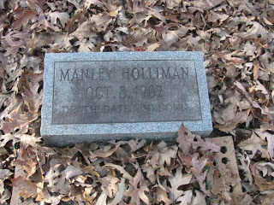
Below, Anita Duckworth (12/27/1940 - 6/4/1941) lies also in the Wilson Cemetery. The Duckworths and Hollimans intermarried on occasion in Lamar County, according to the family tree of Vonceil Duckworth but this infant was not a close relation of Vonceil's.
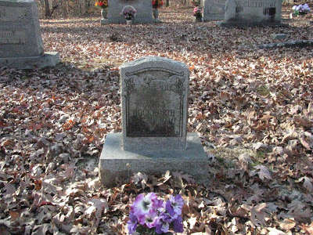

The Ashcraft Corner Cemetery

Murlee W. Holliman (10/4/1902 - 10/9/1965) although buried in Ashcraft Corner Cemetery, is a child of James W. and Beulah Holliman, buried a few miles away in the Wilson Cemetery.

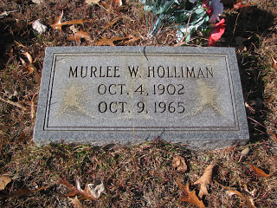
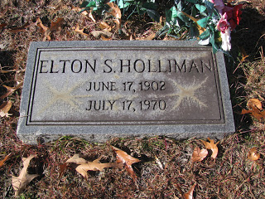
Mary David Elmore in her 1995 book lists Elton Holliman as a deacon at the Pleasant Ridge/Ashcraft Corner Baptist Church from 1921 to 1924. Is this Elton the son of Deacon Holliman?
Our thanks to Tom Hughes, a distant cousin, for sharing his Thanksgiving genealogy and photographs with us. Hopefully they will prove helpful to a searching genealogist. If you are related to these Hollimans listed above, we would enjoy hearing from you and learning more about this branch of the family.

Wednesday, December 12, 2012

When We Were English, Part XVIIL
by Glenn N. Holliman
RETURN TO ENGLAND, Part 1

On two occasions in 2012, I had the opportunity to travel to England to research further my Holyman family roots. During this time I was assisted by family historian Peter Smith of Bedfordshire and professional genealogist Anne Holmes of Buckinghamshire.

Their research and my own examinations of original source materials continue to deepen my understanding of my ancestral families before the immigration of Christopher Holyman and his sister to Virginia in 1650.

In this space for several years, I have been writing of my findings, inviting the reader into my search to discover the roots of the Hollimans. Many of you have been 'walking' with me. If one desires to review earlier writings, please go to the 'Archives' section of this home page or just click over the name of a person or location in "Labels' portion of the home page.

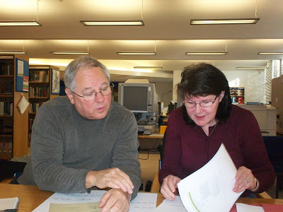

Above, Glenn Holliman, left, and right, genealogist Anne Holmes of Buckinghamshire, England examine Holyman records of the 16th Century in the archives in Aylesbury, Buckinghamshire, United Kingdom in November 2012.
Briefly what new findings do I have to report.

1. Thanks to the research of Anne Holmes, the scenario of the Holyman family from John Holyman, d 1521 in Cuddington, Buckinghamshire to his great grandson, Christopher Holyman, d 1588 in Sherington, Buckinghamshire appears solid. This thesis is backed up by translated wills and parish records which will be examined in future articles.

2. The thesis that I have been promoting that Christopher Holyman of Sherington (d 1588) is the father of Thomas Holyman of Bedford and the grandfather of our Christopher Holyman (d 1691) in Ile of Wight, Virginia is not disproved and continues to be a very plausible explanation of lineage.

3. Thanks to Anne Holmes we know Thomas of Bedford lived near St. Mary's Parish on Caldwell Street, which even today runs in front of the church. His wife, Eleanor Holyman, died in 1553 and is buried in that churchyard cemetery.

4. A fascinating piece of information is that Thomas Holyman was a shoemaker, a cordwainer if you will! While an honorable profession, this seems a comedown on the social ladder for the Holymans of Cuddington who were substantial landowners just a half century earlier. However, he did own the Blue Boar Inn lease which he sold for 40 pds in 1640, a tidy sum in that era. Let's call him a craftsman and a businessman.
Below, the bridge connects then north side of the Great River Ouse in Bedford to the south side. Behind the high rise hotel on the left stands St. Mary's parish church and Caldwell Street, the lane (then) that housed the residence and business (es) of Thomas Holyman (b bef. 1587 - d bet. 1646-1652).
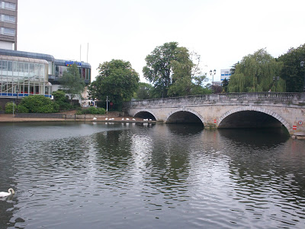
5. Anne will continue to investigate the Bedford records to add context to our family story. As yet, we have not found burial records for Thomas and Eleanor's children named Christopher and Judith (we have of their other children) thus strengthening the argument that the Christopher who arrived in Virginia in 1650 and died there in 1691 is indeed from Bedford, Bedfordshire, England.
We will follow the story wherever additional research may lead!
Much more in the next postings...

Friday, December 21, 2012

When We Were English, Part XVIIIL
by Glenn N. Holliman
Return to England, Part II
In the last post, I began to share the findings of my recent trip to England, and especially the research of professional genealogist Anne Holmes. My thesis, which Ms. Holmes has endorsed, is that one John Holyman of Cuddington, Buckinghamshire, England (d 1521) was the father of John Holyman, same community (d 1533) and this Holyman was the father of Thomas Holyman, again Cuddington (d 1558). One of Thomas's sons was Christopher Holliman (d 1588) of Sherington, Buckinghamshire.
It is my thesis that Christopher of Sherington was the father of Thomas Holyman of Bedford, Bedfordshire and the grandfather of Christopher Holyman, who died in Virginia in 1691, the founding father of almost all American Hollimans (and various spellings). This is a long winded way of saying that John Holyman, d 1521, would be my 12th great grandfather!
We do not yet know the date of John Holyman of Cuddington's birth, but he died in 1521 leaving a will. As a way of perspective Henry VIII, the great Tudor king, was 30 years old that year and still married to Catherine of Spain. Henry would forsake his Roman Catholic allegiance to Rome in the 1530s, a decision that would shake the foundations of the country and the Holymans in particular.
As Ms. Holmes observes, the Holymans were on the rise financially and socially in the 1500s. One relation, another John Holyman, would be appointed Bishop of Bristol by Queen Mary Tudor, Henry's first daughter, in 1554. Another ancestor, Christopher Holyman (d 1588 and 9th great grandfather of mine) would marry into the prominent Lee family of Hartwell House fame near Aylesbury.
We have the will of John Holyman (d 1521) which demonstrates the affluence of the expanding family. We know Holymans had lived in Cuddington since at least the 1440s, and one did not leave a will unless one had wealth to pass on to descendants.
John's will (below) is available on line at http://www.bucksvoice.net/brs/online-volumes/volumes-11-19/. The will is found on two pages in E.M. Elvy's (pub. 1975) The Courts of the Archdeanonry of Buckinghamshire 1483-1523 in Vol. 19 of the Bucks Record Society.
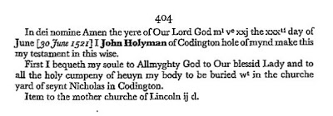

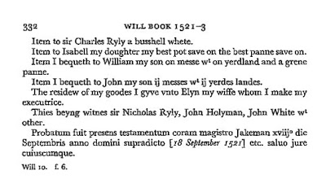
What do we learn from this will?
1. John asked to be buried in St. Nicolas parish cemetery. It is safe to say his remains are some where in the photograph of the church yard in Cuddington, Buckinghamshire. The memorials visible date from the late 18th and early to middle 19th Centuries and later, as few outside stones are legible before 1800. Pictured are the author, family historian Peter Smith and his wife, Maureen November 2012.
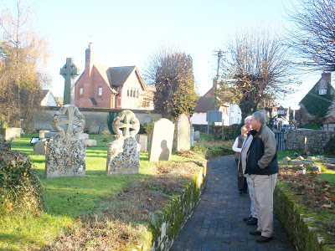
2. John left a bequest to the 'mother church' of the Diocese of Lincoln of which Cuddington belonged in the 16th Century. Remember until the 1530s and the upheaval of Henry VIII's divorce, England was Roman Catholic. However, a Reformation was sweeping western Europe and concerning matters of faith, much was about to change.
3. Daughter Isabell seems to be left only a pot and pan. Household items were of great value in England at this time, and as later in the American colonies, were often included in wills. One suspects Isabell was married and cared for by a husband. Could that husband have been Sir Charles Ryly who was left a bushel of wheat?
4. Son William Holyman, while receiving some land, also inherited 'a grene pot'. Anne Holmes, whom I sourcie throughout this article, suggests this may have actually been a grain vat, a large vessel or structure used in agricultural work. Also William, evidently the second son, was left a 'messes', that is a messuage or a dwelling house with a 'yard land', a term for an area of land associated with a building, anywhere from 15 to 40 acres.
5. John Holyman, from whom American Hollimans reading this are descended, received the greater value of the farm land, being two dwelling houses and two yard lands.
6.Wife Elyn, whose last name unfortunately is lost, received the residue of the worldly goods.
7. Note the witnesses - another Ryly, another 'sir' if you will, suggesting the deceased John enjoyed enhanced community status. Was Isabell the wife of Nicholas or Charles Ryly? In addition to a John White, John Holyman, presumably my generation's 11th great grandfather, signed the will.
To Ms. Holmes I owe a debt of continuing gratitude for her interpretations and explanation of the wording of the will. More of her important insights in the next posts.

For a comprehensive listing of Holyman (Holliman and various spellings) ancestors in my 'branch of the tree', please click on the Family Lineage page in the upper right column of this Home page.

﻿
Next, the Will of John Holyman, 1533....

