THURSDAY, FEBRUARY 2, 2012

A Holliman History by Walter O. Holliman, Part I
by Glenn N. Holliman
What follows are dozens of pages of critical Holliman family research prepared in 1995 and 1996 by the late Walter O. Holliman (1927-2003). In the fall of 2011, his children shipped me his papers and since then I have been indexing and reading his marvelous research and conclusions. In the left column of this post, one will find the Walter O. Holliman manuscripts and research folders of his voluminous work.
With this posting, I begin publishing his interpretation of our family's history. He prepared two documents. The 1995 copy contains his understanding at the time of the first Holyman's in America and takes us into the 20th Century. In his 1996 work, he omits the early Virginia Hollimans and begins with his 4th great grandfather, James Grantson Holliman, again traveling late into the last century. For privacy sake, I cease the history with Walt's parents, uncles and aunts. My introductory comments are in red. Walt's pages are as he prepared them. Click twice and the pages should enlarge.
I know I speak for his children and all who are interested in Holliman history when I say comments and critique are welcome. As Walt himself notes, genealogy is never finished. New information continues to come forth and alter earlier interpretations.
The Title Page - I have omitted his address. The documents are posted with permission of his children. As far as I know he never published this tome. This title page is from 1995.
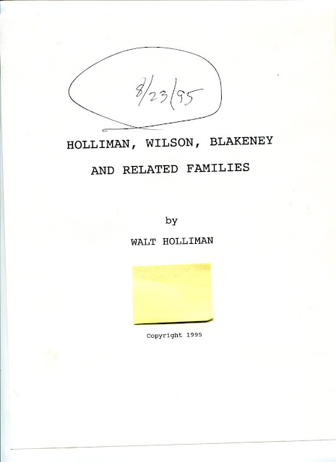

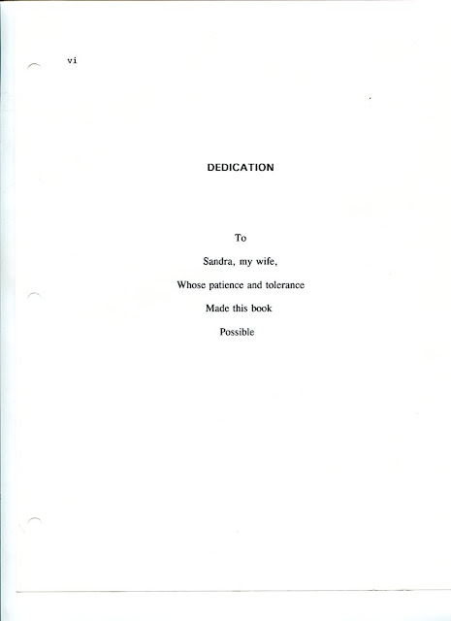
Index - This really is Walt's table of contents. He created manuscripts for all the families listed below, over fifty, and research on another fifty or so! These manuscripts are available, but are not part of the series of posts that will be forthcoming immediately.
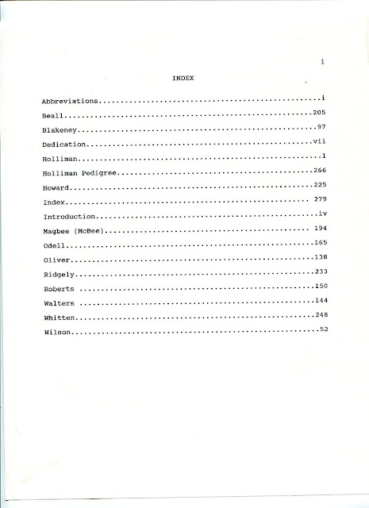
Abbreviations -Walt was meticulous as this listing of abbreviations indicates. He belonged to Mensa International, an organization for persons with a high I.Q. (Well, would we not except that from a Holliman!?)
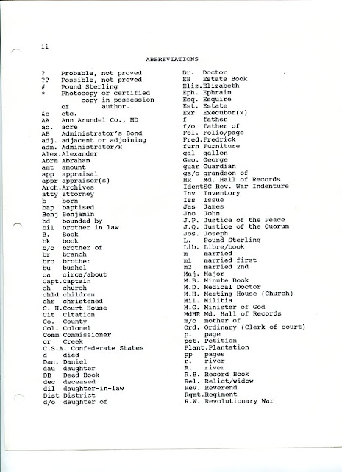
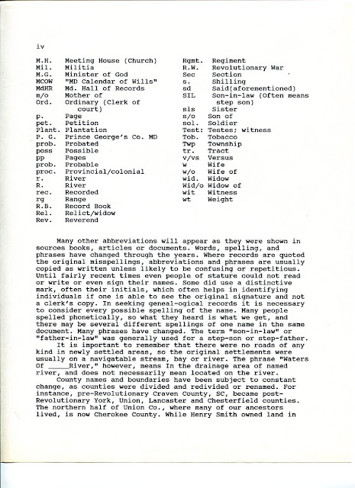
The next page is missing, and it becomes impossible to separate the 1995 and 1996 editions. However, the conversation, slightly truncated, continues below. The pages are not always in order due to Walt's dual publications and evidently additional changes. He provides some very useful commentary on genealogical research.
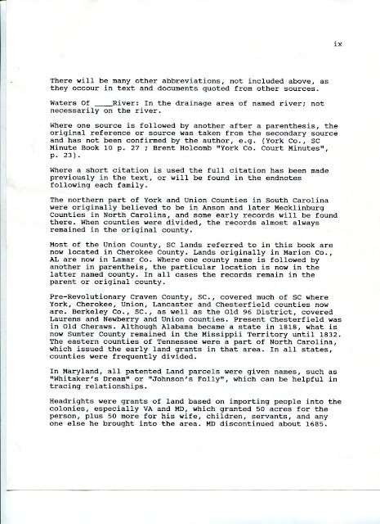
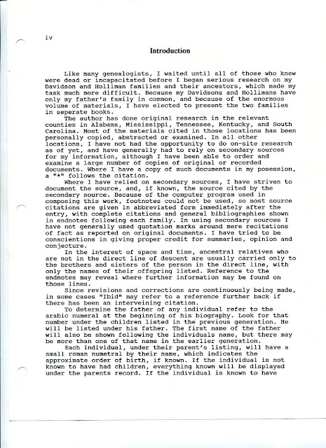
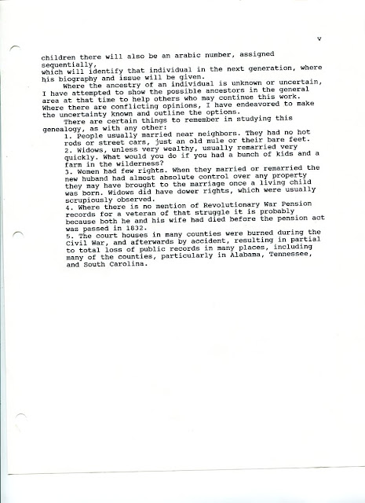

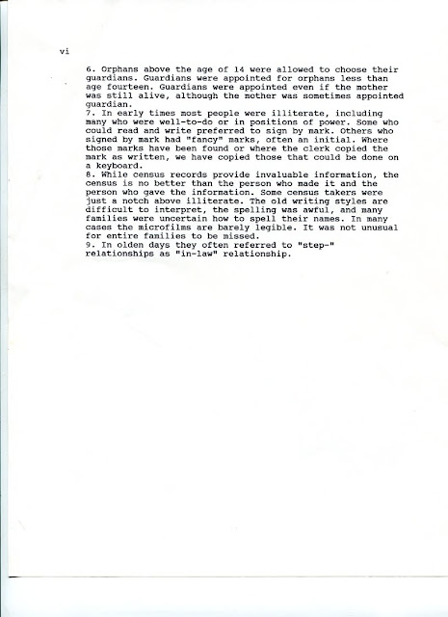
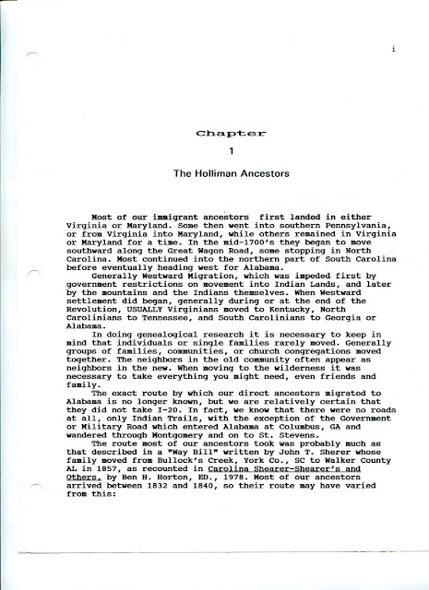

This description of the trek west to Alabama in the 1830s from South Carolina is important. Imagine horses, cows, pigs, hand carts and wagons. Women and children, along with young husbands and fathers, moving through near wilderness pushing ever westward.

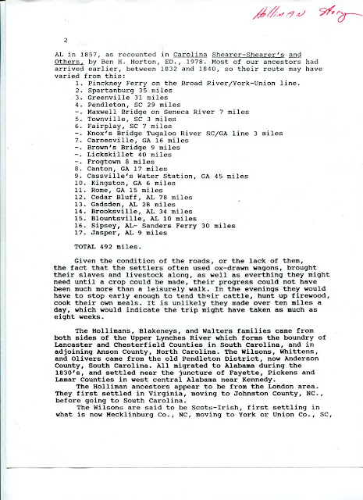

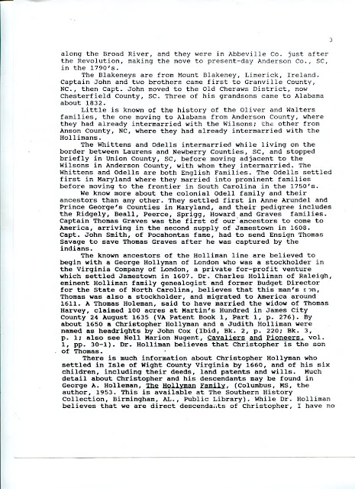
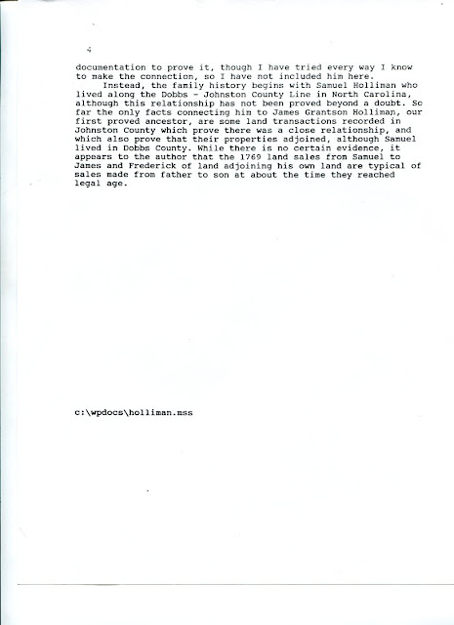
In the next post, we will begin Walt O. Holliman's generation by generation interpretation of our early Holyman history.
Posted by Glenn N. Holliman at 12:16 PM 0 comments
Labels: Walt O. Holliman

TUESDAY, JANUARY 31, 2012
Some Notes on a West Alabama Family by Laura Vonceil Duckworth, Reform, Alabama.
In this final article of a series of postings by Laura Vonceil Duckworth of Reform, Alabama, she writes a tribute to her late mother, whose words reflect the respectful wisdom of the family-oriented culture of the Deep South. Both are descendants of Christopher Holyman, Sr. (1618 - 1691).
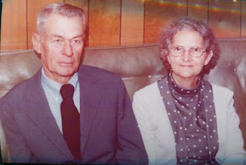
Right, Mamie Lou Clemmons and Dewey Bonner in the 1970s
My mother, Mamie Lou Clemmons, a descendant of Hollimans, had a great influence on my life. She always was at home taking care of seven brats. Very few times was a switch used, but she used her soft voice for corrections, teaching us that it was wrong to talk about others.

West Alabama Wisdom from Mamie Lou Clemmons

- ‘If you can't say anything good about other people, it is best not to say anything.

- Never take anything for granted.

- Always give a helping hand when you can, as you never know when you might need help.

- Learn and use your mistakes when you have children of your own.

- Always tell the truth and then you don’t get into trouble because your daddy has checked the mileage of the old car.

- Other people will look at you and know what kind of parents you have by the way you act.

- Your education can never be taken away.’

Mom’s parents passed away while she was still a teenager. She dropped out of school in the ninth grade, and she married at the age of nineteen. Dewey D. Bonner was fourteen years older, but he provided well for her. He always said she was different from any of the other women he had dated.

Never in my life did I hear my mother utter a curse word. One of the most wonderful things I ever heard her say was, 'The greatest thing I get out of life is helping others.' What a tribute to leave behind.

She passed away on January 13, 1984 in Birmingham, Alabama from complications of acute leukemia. She had been diagnosed two weeks before while in a hospital in Columbus, Mississippi. She had a heart attack the day she left that hospital and a stroke the same night. What a defeat.
Or was it? She longed to see her husband whom had passed away May 16, 1979. I say she was received with open arms.”

Soon another reminiscence of West Alabama by Dr. Rhodes Holliman, a prominent Holliman family historian....

Posted by Glenn N. Holliman at 1:06 PM 0 comments
Labels: Mamie Lue Clemmons Bonner, Virgil Bonner

SATURDAY, JANUARY 21, 2012
Some Notes on a West Alabama Family by Laura Vonceil Duckworth, Reform, Alabama.
This is the third article in a series of four postings on the family and ancestors of Laura Vonceil Duckworth, a descendant of Christopher Holyman (1618 - 1691) of Isle of Wight, Virginia.
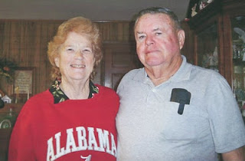
Wearing a shirt seen all over Alabama every autumn is Vonceil Bonner Duckworth with her husband of almost 50 years, Lonnie Morris Duckworth.
" I married Lonnie Morris Duckworth on 14 December 1962. Our children are – Kenneth Morris Duckworth (7 February 1964) and Michael Keith Duckworth (19 November 1967).
My siblings are as follows:
Dewey Max Bonner married Dorothy Faye Holliman, daughter of Kenneth Holliman, son of Frank and Kesta Howard Holliman in June 1958. Their children are Wanda Faye Bonner Hicks (13 May 1960), Franklin Max Bonner (12 April 1964), Camelia ‘Millie’ Diane Bonner Elkins (15 September 1961) and Jeffrey Dale Bonner 8 December 1965)."
Shelby Marie Bonner married Allen Wilson McDaniel. They have one child, Allen Mitchell McDaniel.

Johnnie Bonner married Charles Babb, and their children are: Steven Gregory Babb, Kristen Michelle Babb Hill.
Jimmy Keith Bonner’s two children are Amanda McDaniel Sullivan and Brandon Keith Bonner.

Clayton Gregory Bonner married Linda Ann Junkin Bonner (now divorced). Their children are Jason Gregory Bonner and Lezlee Ann Bonner.

Frances Marilyn Bonner married Jimmy Donald Elmore. Their children are: Jacy Elmore, Jared Donald Elmore and Jala Dawn Elmore.
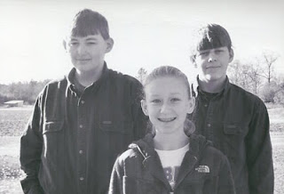
Above, Tyler and Tim, twins, and their cousin, Lauren Duckworth

Tyler, Tim and Lauren Duckworth are our grandchildren. The twins are the children of our son Kenneth Morris Duckworth and Judy Renee Gray Duckworth, now divorced. Lauren is the daughter of son Keith and Amy Duckworth. Through their Holliman line, these grandchildren can trace their lineage all the way back to the Tutor age in England."

Next posting, some timeless wisdom from a Lamar County, Alabama sage - Vonceil's mother!

Posted by Glenn N. Holliman at 1:38 PM 0 comments
Labels: Vonceil Duckworth
Newer PostsOlder PostsHome
Subscribe to: Posts (Atom)

