bTUESDAY, MARCH 1, 2011

Our Family's Colonial Era, Part XIX
by Glenn N. Holliman

The Rebellion Close to the Holyman Plantation

By the fall of 1676 Nathaniel Bacon's revolt had attracted hundreds of adherents, some who took delight in ransacking the homes and plantations of wealthy planters. A few of the rebels were of the planter class themselves, the most visible to history being one William Byrd, whose descendants would prosper financially, leave diaries and a political dynasty. (In the 1700s one Mary Byrd of this family would marry a grandson of Christopher, Sr.)

Other rebels, hundreds of young men in fact, were indentured servants and African-American slaves, an interesting mingling of persons, generally of a less economically prosperous class. The presence of armed Blacks during this period would later result in the House of Burgess passing highly restrictive slave codes in Colonial Virginia. As far as this writer knows this would be the last time that poor whites and Blacks would make common cause against a white power structure in Southern history prior to the Civil War. For the next several hundred years, white racial prejudice would overwhelm the common economic interests these two groups could have shared .

Isle of Wight and neighboring Surry County produced both supporters of Bacon and defenders of Governor Berkeley. Historian John Boddie in his work 17th Century Isle of Wight records numerous conflicts amongst neighbors and the forces of the Crown and the rebellion. A Major Arthur Allen, a prominent Crown supporter, fled his home near the James River, not fifteen miles north east of the Holyman plantation. Constructed in 1665, and still one of the finest examples of 17th Century Jacobian architecture remaining in the western hemisphere, the home was occupied for four months in 1676/77 by William Rookings, other commanders and up to seventy supporters of Bacon.
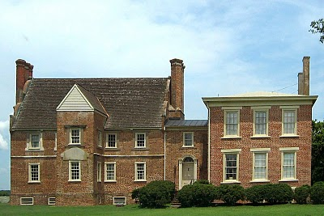
The rebellion collapsed in the late fall of 1676 after Bacon died of dysentery, and his body buried in the York River. Allen recovered the home in 1677 and later sued the occupants of his home for damages. This wealthy neighbor of the Holymans would not doubt be angry that his residence has become known as 'Bacon's Castle' after his nemesis! Today the home is on the National Register of Historic Places, is administered by the Association of the Preservation of Virginia Antiquities and is open to the public. Google Bacon's Castle and view the home and read its history.

Bear in mind, this is one of the few examples of 17th Century brick construction surviving in North America. The Holymans and 99% of other Virginians at the time were living in unpainted wooden structures that in a short time disappeared to natural decay or fire. Virtually no 17th structures remain in Virginia. Bacon's Castle is one of the few.

During your next trip to Jamestown and Williamsburg, do cross west over the James River, visit the museum in Smithfield, the Holleman home near the Mill Swamp Baptist Church in Isle of Wight County and nearby Bacon's Castle.

Next posting, the Empire Strikes Back!

Posted by Glenn N. Holliman at 5:41 AM 0 comments
Labels: Christopher Holliman Sr.

SUNDAY, FEBRUARY 20, 2011

Our Family's Colonial Era, Part XVIII
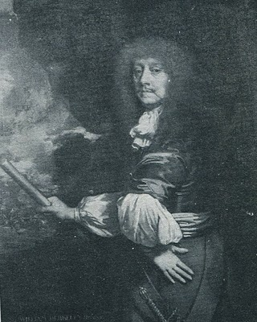
by Glenn N.Holliman

Why theHolyman's were Caught in the Middle of Bacon's Rebellion

The painting at right is Sir William Berkeley (1606 - 1677), a well-educated Englishman appointed by Charles I during the English Civil War to govern the colony of Virginia. He was successful when he arrived in 1642 to defeat the latest Powhatan Indian attacks and usher in a period of peace. Turned out in the early 1650s by the Commonwealth, he returned with the Stuart Restoration. He grew old in the position and became content with loyal assemblymen from a House of Burgess that sat from 1661 to 1676. Bacon's Rebellion resulted in the burning of his capitol, Jamestown, the loss of his post and eventually his recall to London. He died in 1677 before he could defend his actions before the Court.

In the 1671 Surry County, Virginia Record Book, p. 2 is this fascinating insight into our family and the Virginia colony on the eve of a great civil rebellion. It is recorded in George A. Holleman's original history of Hollymans in 1952.

"Att a courte houlden att Southwarke for he County Mar. 5, 1671...Upon complaint of Christo Holiman itt manifestly apearinge that the Coppahunck Indians have kild two hoggs of ye saidHoliman. Itt is ordered that Capt. Pipsicoe within thee months make payment unto ye said Holiman of Six Buck and Six doe well drest Skins & in Case itt doe apeare heere after that any Indian shall Kill any hogg or hogs of ye English that they shall pay for every Hog by them Kild twnety Buck skins."

Well, what to make of this?

1. Surry County, founded from James City County in 1647, lies just north and west of Isle of Wight County.

2. The parish of Southwarke was located across the Isle of Wight County line. The plantation of Christopher Holyman straddled the county lines, and his theft occurred in Surry County. Many Holyman descendants will move into Surry County and from there to Johnston County, North Carolina in the 1700s.

3. The Indians were Quiyoughcohanocks (Cohanocks), allied with the Algonquian Powhatan Confederacy. This tribe had participated in the Good Friday Massacre of 1622 which almost wiped out the Virginia colony.

4. Subsequently, the Virginia House of Burgesses had passed draconian legislation that any Indian who crossed the Blackwater River could be shot on sight! The Holyman plantation was (and parts of it still are) adjacent to Surry County and the Blackwater River.

5. The 1670s saw considerable Indian unrest up and down the eastern seaboard. In 1675 the tension burst into King Phillip's War in New England. Thousands, both white and red, died in the greatest outburst of violence to that date in the English colonies.

6. As in New England, the increasing dissatisfaction with the population increase of the English settlements, let to Indian resistance in Maryland and Virginia. The population of Virginia more than doubled from 15,000 to over 30,000 by the 1670s further encroaching on Indian lands.

7. The theft of hogs from the Holymans was a typical incident between the English and Indians. The English, who went armed and hunted deer for food and hides (a valuable commodity), evidently had little sense they were reducing the caloric intake possibilities of Indians. Indians felt that since whites could enter their hunting lands, and take game, they were entitled to enter English farms and take livestock! Tit for tat one would say.

The Hollimans and other colonialists did not see it that way.

Multiply these incidents by the dozens, add indiscriminate murders by both colonists and Native Americans, mix with land hunger by the English and decrease of hunting land by the Indians, and one has the recipe for another Indian War. In fact a murder of Nathaniel Bacon's overseer near Richmond, Virginia triggered a vigilante response led by Bacon. A peaceful Indian village near the North Carolina border was wiped out, and Indian women and children brutally murdered by Bacon's irregulars.

This was in defiance of Governor William Berkeley, a long serving administrator who wanted to build forts rather than unleash the militia. Those living on the edge of the frontier, presumably including the Holymans, desired immediate offensive action against Native Americans. Although Berkeley was furious with Bacon's actions as he had tried sincerely to maintain the peace, the rugged take-charge, take-no-prisoners attitude of Bacon attracted many colonial adherents.

Bacon also demanded reduction of taxes on tobacco, the money crop for almost all colonialists. Tobacco prices had plummeted in the recent decade due to too many settlers growing too much of Nicotiana tabacum. The English Navigation Act of 1663 forbade the colonists from trading with any nations other than the English. With Dutch and Spanish markets cut off directly from Virginia, there were fewer outlets and competition for the increasing supply of tobacco. Yet while income went down, taxes remained the same.

Something had to give.

Give it did with Bacon's Rebellion, a toxic brew of racial strife, physical fear, land lust and a burdensome tax load. Planters such as the Holyman's had to be sorely tempted to use force to defend the frontier and do something to reduce taxes. Some of the Holyman neighbors did join Bacon, and the result was strife in and around Isle of Wight County.

The Holymans, caught between two forces, remained loyal to the Crown.
Posted by Glenn N. Holliman at 1:52 AM 0 comments
Labels: Christopher Holliman Sr., William Berkeley

THURSDAY, FEBRUARY 10, 2011

Our Family's Colonial Era, Part XVII
by Glenn N. Holliman

Bacon's Rebellion - The Virginia Civil War Before the American Revolution

Some have called it the precursor to the 1776 Revolution, only one hundred years earlier. Actually, my reading of the violence and pain of 1676 Colonial Virginia is more of that of a Civil War. Two factions, one wealthier and in power, and the other less wealthy, less powerful and feeling physically threatened by Native Americans, clashed over taxes and 'homeland' security.

The insurgents, hundreds of white and some Black young men, rallied around Nathaniel Bacon, age 32, a cousin by marriage to the Virginia Royal Governor, and a planter near the Falls that is now Richmond, Virginia. A number of issues led to Bacon's revolt which resulted in brutal attacks on Indian villages, the rousting of the Royal Government and the burning, of all places, Jamestown, the capitol. Many died and many were hung by a recovering Royal authority.
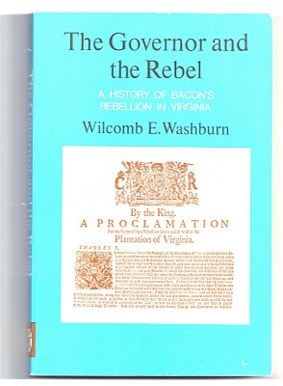
Were Christopher Holyman, Sr., a planter with a thousand acres or so, and his children caught up in these events? Yes, they were. The Holymans had some legitimate grievances, but when push came to shove, they opted to support the Royal Governor, one William Berkeley. For that no Holyman swung by their necks as did 22 rebels in the autumn of 1676, including a few of their neighbors.

Still the standard for understanding Bacon's Rebellion is Wilcomb E. Washburn's 1955 work. It is fair, balanced and points out the issues on both sides.

Numerous historians have provided excellent interpretations of the events of the rebellion such as Alan Taylor's, American Colonies and especially Edmund S. Morgan's American Slavery, American Freedom.
Next Post, the Rebellion and Why the Holyman's were Caught in the Middle....
Posted by Glenn N. Holliman at 11:21 AM 0 comments
Labels: Christopher Holliman Sr., Nathanel Bacon
Newer PostsOlder PostsHome
Subscribe to: Posts (Atom)

