TUESDAY, FEBRUARY 28, 2012

A Holliman History by Walter O. Holliman, Part VI
by Glenn N. Holliman
This is the sixth in a series of a history of the Holliman family written by Walter O. Holliman in 1995 and edited in 1996.
In this Third Generation as Walt labels his manuscript, his ancestor Cornelius Holliman (1792-1862) leaves the used-up soil of South Carolina, and with a good dose of Alabama fever, he and two of his brothers leave the grave of their father, James Grantson Holliman, and migrate to West Alabama in 1836.
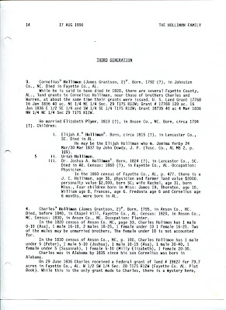

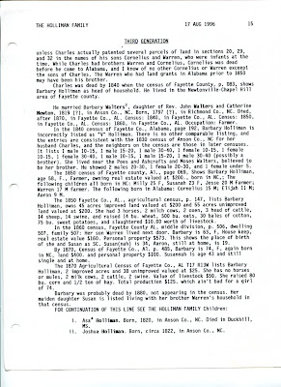

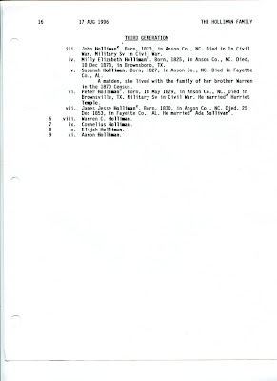
If you have information to add to this narrative, please let us hear from you.
Posted by Glenn N. Holliman at 3:48 PM 0 comments
Labels: Charles Holliman, Cornelius Holliman, Warren Holliman

FRIDAY, FEBRUARY 24, 2012

A Holliman History by Walter O. Holliman, Part V
by Glenn N. Holliman
This is the fifth in a series of a history of the Holliman family written by Walter O. Holliman in 1995 and edited in 1996.
In this Second Generation document, Walt shares his research on James Grantson Holliman (1750 - 1836). There is more to be written on this Holliman's Revolutionary War record in which he served in his local Johnston County militia as a young man, but this manuscript does include a copy of his petition seeking a pension for his service. Also included in this material is the story of two of his daughters seeking financial redress for his military years.
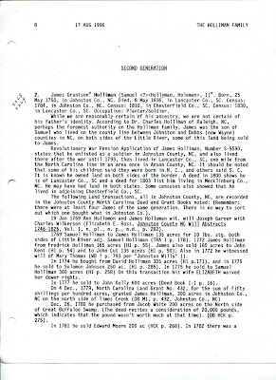

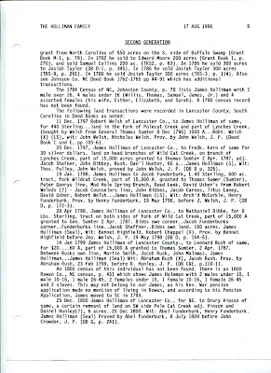

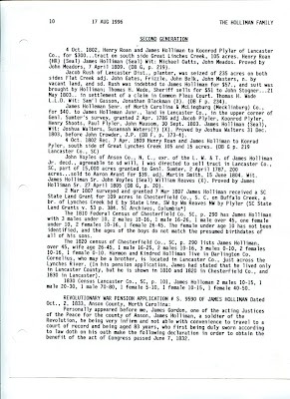

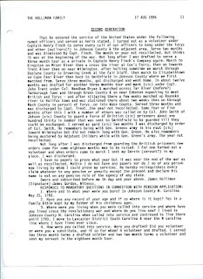

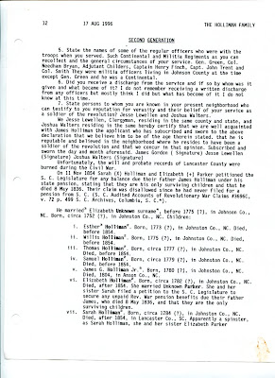

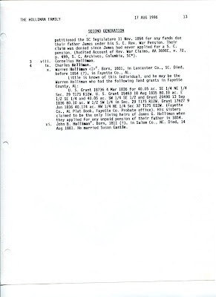
At this writing, Walt was not aware that James' wife was Elizabeth Bryant, evidently from a neighbouring farm, and related to a distinguished family in Johnston County, North Carolina.
Posted by Glenn N. Holliman at 2:24 AM 0 comments
Labels: Elizabeth Bryant Holliman, James Grantson Holliman

SATURDAY, FEBRUARY 18, 2012

A Holliman History by Walter O. Holliman, Part IV
by Glenn N. Holliman
This is the fourth in a series of a history of the Holliman family written by Walter O. Holliman (1927 - 2003) in 1995 and reworked by him in 1996.
In this posting of a manuscript written in 1996, Walt labels this chapter as Generation One choosing to begin his Holliman family history with Samuel Holliman (1707-1789). Walt was uneasy about the accuracy of his information on Christopher Holyman, Sr. and other early Hollimans in Virginia. As I have pointed out in early blogs, he had reason be concerned about the veracity of information he had gathered on Holymans in the early to late 1600s.
Some of the material Walt presents below concerning the origins of Hollymans in America has been superceded by new research. However, in this story there could be some tid bits that could yet lead us in new paths of genealogical research.
Walt provides valuable research on Samuel Holliman's real estate dealings in North Carolina. On page three, Walt states one Elizabeth Jones, born Isle of Wight, was a wife of Samuel Holliman. This is the first time I have seen such information and welcome comment on it.
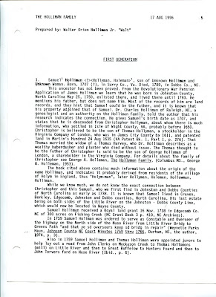

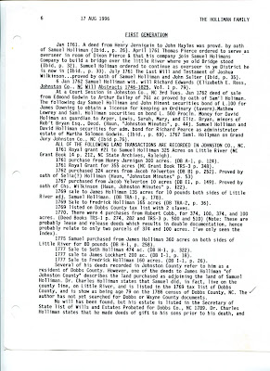

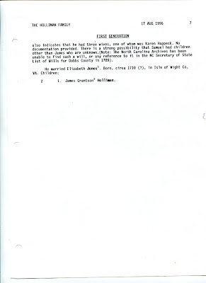
As I have written extensively, I believe the Hollimans emerged from a family in Bedford and Buckingham Shires, England with Christopher Holyman, Sr. (1618-1691) arriving in Jamestown in 1650. My descendant, in my opinion, is through Richard Holyman (1660s ca - 1711), a son of Christopher, Sr., through Samuel Holliman (1707-1789) and on to James Grantson Holliman (1750-1836). Still, it is fascinating to study Walt O. Holliman's manuscript and reflect on what adds to our genealogical picture and challenges our perceptions.
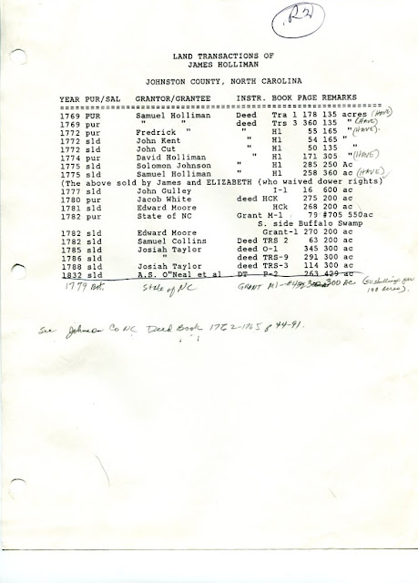
Above in Walt's own handwritting and type is his research on Holliman land sales in Johnston County, North Carolina in the 1700s. This is valuable for those seeking North Carolina roots.
Posted by Glenn N. Holliman at 2:24 PM 0 comments
Labels: Richard Holyman, Samuel Holliman, Walter O. Holliman
Newer PostsOlder PostsHome
Subscribe to: Posts (Atom)

