Friday, February 1, 2013

When We Were English, Part LI
by Glenn N. Holliman
Continuing the 1533 Will of John Holyman of Cuddington....and a Surprise Relative Listed!
Below two family historians, yours truly left and professional genealogist, Anne Holmes, right, examine the 16th Century wills of the Holyman family of Cuddington, Buckinghamshire. We are pictured in the Buckinghamshire archives in Aylesbury, England, November 2012.
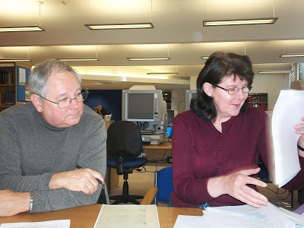

The 1533 Will of John Holyman continued....
﻿

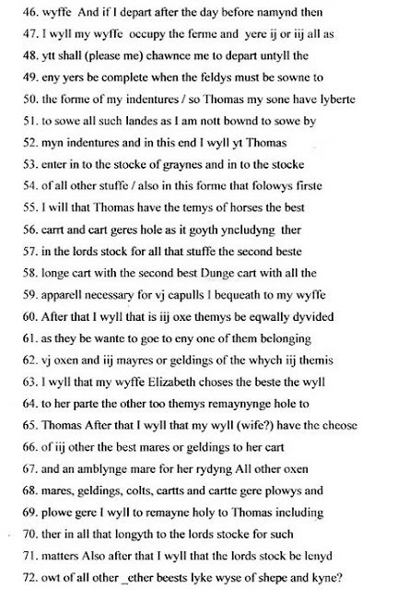

As we continue to review John Holyman's will, one is struck by his meticulous descriptions and abundance of 16th Century wealth.

Line 56 - A cart geres hole according to Ms. Holmes is translated as 'cart gears whole', that is machinery connected with the carts, harnesses and such.

Lines 58 to 62 - Here John leaves his wife his second best carts, including the dung cart (this is a farm). The couples are probably pairs of oxen. The wife does receive the best mare or gelding.

Line 70 - An interesting term of which Ms. Holmes describes as follows: "The lords stock: this was probably animals that the tenant looked after for the lord of the manor at the tenant's own cost, perhaps part of the tenant's copyhold agreement. It was common practice for tenants in the the medieval and early modern period to look after animals, at their own expenses for either the lord of the manor or the church. In some areas in England this practice continued into the twentieth century."

﻿
﻿
﻿
﻿
Lines 73 - 84 - John continues to divide his abundance of worldly goods between his wife, son Thomas and God Children. Notice he has lumber and timber to leave. As John made a will and has much property to distribute, we know he was a relatively wealthy man of his time. As Anne Holmes has written, the Holymans were a family on the rise in the 16th Century.

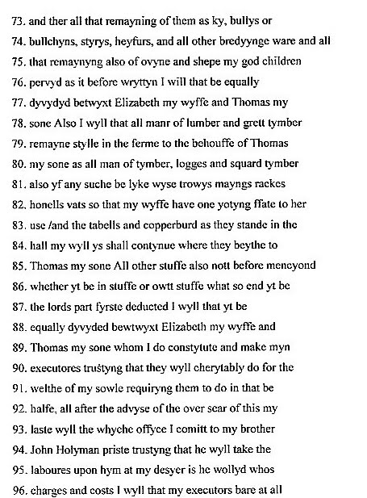

Lines 88 - 90 - Wife Elizabeth and son Thomas are appointed executors of the estate.

But look who is appointed overseer of the will!

Lines 93 - 95 - For those of us you have studied the relationship of The Rt. Rev. John Holyman, Bishop of Bristol, 1554-1558, and prominent opponent of Henry VIII's divorce of Anne Bolyen, to the our lineage, these are important sentences. I quote again from genealogist Anne Holmes:

"John Holyman priste almost certainly refers to the John HOLYMAN who was to become Bishop of Bristol. John is requesting the priest to be the overseer of is will. There is no financial bequest other than that to cover any expenses incurred in the task of overseer. John calls him 'brother' . It is unlikely they were siblings. It is possible the were cousins or kinsmen. The other possibility is the testator John HOLYMAN had married the sister of the priest. It was not illegal to marry a first cousin or other cousin at that time."

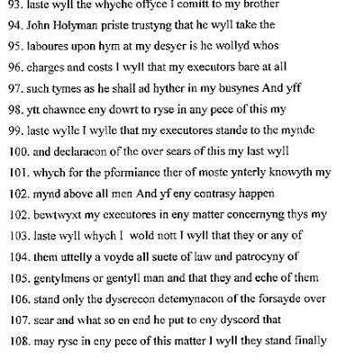

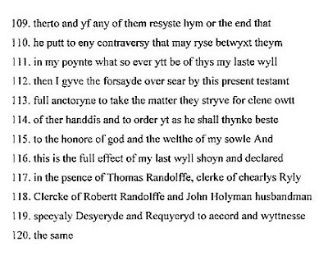
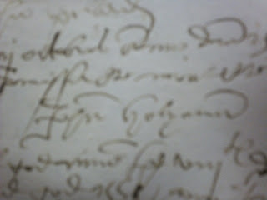

And so, John signs his will, signature above, a comprehensive document. In the next post, we will examine son Thomas' will, the off spring whom evidence indicates is probably my generation's 10th great grandfather.

Saturday, February 16, 2013

When We Were English, Part LII
by Glenn N. Holliman
The Holymans during the Tudor Era....
Below is a family tree of the Cuddington, Buckinghamshire Holymans from John (d 1521) to Thomas (d 1558) and their siblings. This important document was prepared by English professional genealogist Anne Holmes with information gathered from the original wills in the Buckinghamshire Archives in Aylesbury. Click twice on the tree and it should enlarge.
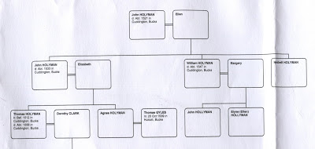

In previous posts we have analysed the estates of John Holyman and his son, John Holyman, both landed farmers who, along with other branches of the family in the village of Cuddington, Buckinghamshire, were leading their generations to higher social and economic status.
These fathers and sons lived in a momentous period of English history during the reigns of Henry VIII (1509-1547), Edward VI (1547-1553) and Mary (1553-1558). The Protestant Reformation and Henry's love life coincided to produce a revolution in the Roman Catholic Church in England. The boy king Edward VI, all of nine years old, and his protectors, embraced the revised Christianity of Protestant Anglicanism, what is now known as the Church of England. When his young life ended, his half sister, devout Roman Catholic Mary, daughter of Henry and Queen Catherine, attempted a Counter-Reformation.

The Holyman family of Cuddington had as a member, The Rt. Rev. John Holyman, a conservative Roman Catholic, appointed Bishop of Bristol in 1554 by Mary Tudor's Cardinal Pole, and who served on the commission that found the discredited Archbishop of Canterbury, Thomas Cramner, guilty of heresy. Cramner, author of the famous Book of Common Prayer, was burned at the stake in Oxford. Likewise, our relative, the fanatic Bishop John Holyman, oversaw the immolation for five Protestants during his time in Bristol before both he and Queen Mary died in 1558 of natural causes.

In early posts I have written extensively on Bishop John Holyman and his life. As for now, let us begin an examination of the life of Thomas Holyman who died in the same year as his probable cousin or uncle, the ecclesiastical John, and the Tudor Queen known as 'Bloody Mary'. Double click on the translation and it should enlarge.
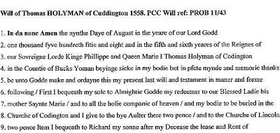

Line 3 - Thomas Holyman dated his will as the fifth and sixth year of the reigns of King Phillip and Queen Mary Tudor. This was a very controversial marriage in which the 38 year old Queen married the 27 year old Roman Catholic Spanish Prince Phillip, son of Charles V, Emperor of the Holy Roman Empire.

Mary was doomed to disappointment as her husband found reasons to spend his time in the Spanish Netherlands rather than with her. She endured a false pregnancy and died early, possibly of uterine cancer. Most English leaders breathed a sigh of relief when her 25 year old Protestant sister, Elizabeth, succeeded her. Phillip ceased to be King of England.

Ironically Elizabeth's brother-in-law, later King Philip II of Spain, sent his Armada to subdue Protestant England in 1588. As every English school child knows, the invasion ended in a massive Spanish failure. A soldier of Queen Elizabeth, who also died that year of 1588, a member of the Queen's Guard, was one of Thomas Holyman's sons - Christopher Holyman, whom I believe to be my 9th great grandfather! As far as we know, Christopher died of natural causes and not in the war.

Line 4 - Thomas described himself as a yeoman, an upgrade socially and economically from the title 'husbandman' that his father and grandfather used to describe their status in life.

Lines 6 and 7 - This was a Roman Catholic person's Will. Note the gifts to the altar of Mary, Mother of Jesus. The next generation would see a reversion to Protestantism by most English persons, who must have felt religiously whip lashed by their Tudor monarchs!

Lines 7 and 8 - Thomas Holyman asked to be buried in the church, not in the church yard as did his father and grandfather. Only persons of status were buried under the physical nave or sanctuary. So as Thomas was moving physically down to this grave, his surviving family was moving up socially! Unfortunately for us, there is no memorial stone surviving for Thomas.

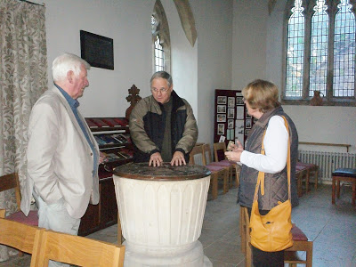
Above, yours truly discusses with family historian Peter Smith and his wife, Maureen, that the Holyman families for generations were baptized in this 13th Century font which rests in a side chapel of St. Nicholas Parish in Cuddington, Buckinghamshire, England. Thomas Holyman's remains may rest under the floor of this church. November 2012 photograph

﻿
﻿
There are countless books on the Tudor monarchs. Some that I have been utilizing for these articles include Carolly Erickson's The First Elizabeth (1983) and Bloody Mary (1978), Diarmaid MacCulloch's The Boy King, Edward VI and the Protestant Reformation, Linda Porter's The First Queen of England, The Myth of Bloody Mary (2007) and Alison Weir's Henry VIII, King and Court.
ut your family history? You are invited to join the Hollyman Email List at of some of the more difficult to Yes, more on our Thomas Holyman and his family's social rise in the next post....

