WEDNESDAY, MARCH 30, 2011

Our Family's Colonial Era, Part XXII
This continues a series of articles by cousin Robert Holloman, a B.A. in history from the University of Virginia. In the previous article Robert explored our possible royalist connections in the English Civil War. In this post, he presents information and raises questions on who transported our ancestors to Virginia. Again evidence points one in the direction of Bedfordshire, England as the origin of the Holliman (and various spellings) families in the New World. - Glenn N. Holliman
Who were the Sponsors of the First Virginia Holymans?
by Robert Holloman
In regards to the early settlement of Holymans in Virginia, I have been attempting to track down information on the named sponsors of Judith and Christopher (and William in 1656) Holliman. According to records, these sponsors were John Cos(x), Thos. Wilkinson, John Sherlock and Thomas Rolph (William's sponsor). In May 1650, John Cox received 1,000 acres of land in Northumberland County on the south side of the Rappahannock River, for the transport of twenty persons including two John Coxes, Elizabeth Cox, Xtopher Holleman and Judath Halloman.
Below in the center of this map by Joshua Fry and Peter Jefferson in 1751, one will find Northumberland and Lancaster Counties. Just below the left red line is the Rappahannock River; above are Lancaster and Northumberland Counties. Click on the map to enlarge.
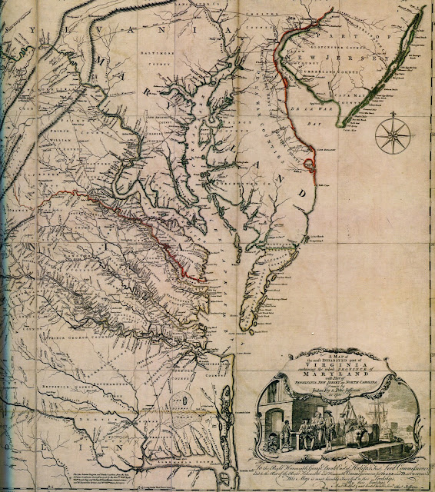

In August 1653, John Sherlock received land in Lancaster County (which was created from Northumberland County in 1652) for the transport of three persons that included Epper a (possible corruption of Christopher?) Holliman, and another grant in November 1653 for the transport of four persons that included both Judith and Christoper Holliman.

A possible connection to both John Cox and Christopher Hollyman is a Vincent Cox who was transported to Virginia as an indentured servant to a Richard Cole on the ship Honor in October 1649. His birth in 1632 can be traced to Bedford. His father was Henry Cox, and he had a younger brother, John Cox but that brother died ten days after birth in 1634 according to Bedfordshire record. In 1653 Cox and Cole legally disputed the end to his term of indenture and that legal fight provides us today the detailed record to trace his passage from England. After winning his release, Vincent Cox settled in Westmoreland County (which was also created from Northumberland County in 1652) and later would receive land in both counties several times in the 1660s.

Both the Wilkinsons and the Coxes are known to have property in Isle of Wight County in the time period of Christopher and Judith's arrivals. The Cox and Wilkinson families later intermarried.

There is a recent 2006 (expanding a 1996) book on the history of the Wilkinsons entitled The Wilkinsons of Isle of Wight, Surry and Sussex Counties and Related Families (including Cox) by Gene Cox Wilkinson and George Carroll Wilkinson. I have recently attempted to contact the authors to see where in England these families had originated and any information on Cox and Wilkinson's activities in the years of Christopher and Judith, but have had not had success as yet.- Robert Holloman
More in the next post concerning possible Royalist connections....

SUNDAY, MARCH 20, 2011

Our Family's Colonial Era, Part XXI
by Glenn N. Holliman
Were the Holymans Royalists Escaping the English Civil War?
Part I by Robert Holloman
Why did the Holymans come to Virginia at the time they did? A descendant of Christopher Holyman, Sr., Robert Holloman, who holds a B.A. in history from the University of Virginia, recently shared this hypothesis with me. With his permission, I share it with the larger family. This is interesting reading, and points out more research is needed. This is part one of several articles. - Glenn N. Holliman
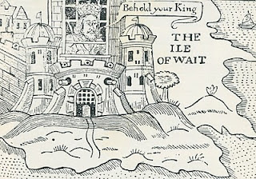
Ironically near the end of the English Civil War in 1648, the English King, Charles the First, was incarcerated by Commonwealth troops on the Isle of Wight, England (not of course Isle of Wight County, Virginia where the Holymans were to live). In this political cartoon Isle of Wight is labeled the Ile of Wait as the leaders of the rebellion, Oliver Cromwell, and others were trying to decide what to do with the defeated King. A court found the King guilty of treason, and he went to the executioner's block (see below).
One approach I have recently been exploring is to investigate whether there is a connection between the events of the English Civil War and the emigration of the Hollimans to Virginia. Bedfordshire, England is an area that gave strong support to Parliament against King Charles. If the Bedford Hollimans were royalist supporters, there may be records of fines they paid since royalists were required to pay to Parliament to either avoid military service or to support Parliament's campaigns.
As John, Thomas, Christopher and even Stephen Holliman of Bedford would have been of age to serve in the military, there may be records that reveal if any had served and in what capacity. The National Archives at Kew has a guide to researchers about records it holds of the English civil war and other potential sources - http://www.nationalarchives.gov.uk/records/research-guides/civil-war-soldiers.htm.
Could John Holliman have been a Royalist Supporter?
John Holliman's emigration to Virginia and his possession of a cutlass as evidenced by his will (1650) intrigues me. As we know, Virginia (and Maryland) remained supportive of royalists through 1651 when Cromwell sent a fleet to suppress Virginia. His representatives replaced the governor, William Berkeley, who had been appointed by Charles in 1641. This is the same William Berkeley who later in his second stint as governor would pardon Christopher Hollyman and his son after Bacon's rebellion in 1676.
I think if John (Holyman who died 1650) had emigrated from England in the 1640's, it could be he was a royalist supporter. Northampton County in Virginia where he died had previously been called Accomac Shire and was renamed Northampton County by the Virginia colony in 1644 to honor Lord Compton, Earl of Northampton, a royalist military leader who died at the battle of Hopton Heath in 1643.
Judith and Christopher Holliman - Royalists or Puritans?
Another interesting question for me is reconciling the multiple Jamestown landing records for Christopher and Judith Holleman. As there are records indicating both Christopher and Judith's arrivals in both 1650 or 1653, to me these two dates represent very different political regimes in the Virginia colony. The unapologetic, royalist era ended in March 1652 when Richard Bennett became governor. He was one of the few Puritans in the Virginia Land Company and also part of a major founding family in Isle of Wight County that over the years recruited hundreds of settlers to Virginia.
While there is strong evidence that the marketing campaigns of the Virginia company and its landholders presenting Virginia as a paradise attracted Englishmen of all persuasions between 1645 and 1670, the change of Governors in 1652 may have resulted in the perception of greater opportunity in Virginia for those who had supported Parliament and Puritans in particular. - Robert Holloman, a multiple great grandson of Christopher Holliman, Sr (d 1691)
The King represented Divine Right rule. Parliament forces fostered representative democracy. The Royalist forces were eventually defeated in battle, the King imprisoned and tried for treason. King Charles I lost his head (see below) and the Commonwealth came into being. In 1660 the monarchy was restored and King Charles II came to the throne. The Stuarts always had troubles with various Parliaments and in 1688, James II was forced from the throne. He fled to France rather than losing his head (literally) as had his father..
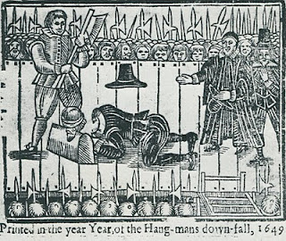
Comment on the above intriguing article by Robert Holloman, distant cousin, is most welcome.....Another article on possible Royalist connections continues in the next posting.
Posted by Glenn N. Holliman at 2:36 PM 1 comments
Labels: Christopher Holliman Sr.

WEDNESDAY, MARCH 9, 2011

Our Family's Colonial Era, Part XX
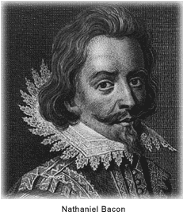
by Glenn N. Holliman

The Empire Strikes Back

With the premature death of Nathaniel Bacon, the rebellion in 1676 in Colonial Virginia began to die for lack of leadership. Royal Governor William Berkeley returned from exile on the eastern shore of Virginia, and began to reek vengeance with a rope. Before King Charles II and his new colonial appointees could stop the aged and angry governor, over 20 rebels went to the gallows.

When news of the rebellion reached London, the King and his council responded dynamically. For the first time in Colonial American history, troops from England entered the colonies to restore law and order and suppress a rebellion against the Royal Government. Over 1,000 British soldiers arrived with new civilian leadership in tow. Berkeley was summarily dismissed, and sent back to England to explain the rebellion and his actions. Before he could appear before Council, he had the good fortune to die of natural causes.

King Charles II, whose government had grown dependent of taxes from Chesapeake tobacco, was furious that Berkeley and his government had 'squeezed' the tobacco planters too tightly. The ability of the Crown to collect taxes had been jeopardized, and the complaints of the planters had best be addressed.

Virginia historian John Boddie reports that over 80 enlisted men and their officers were billeted in homes in Isle of Wight County for up to a year in 1677 and 1678. As in the 1770s in Boston, Massachusetts having civilians board soldiers quickly created stress and a financial burden on the home. Rowdy troops rapidly wore out their welcome. Here in America for the first time were planted the seeds of the 3rd Amendment to the Constitution.

Perhaps the presence of troops encouraged both Christopher Holyman Sr. and Jr. to join seventy or so of their fellow Isle of Wight citizens to sign a 1677 petition begging the pardon of the Royal Government and pledging loyalty to the same.

Again from John Boddie, "We humbly beg and lay hold of His Majesties most gracious Pardon, for as much as we, or some of us, at sometime or the other, since this Horrid Rebellion through fear, force or otherwise, deviated from our duties and allegiance to His Most Sacred Majesty."

This bit of public crawling seems to have moderated some of the anger of the new governor, Herbert Jeffreys, who wanted nothing so much as the planters to return to their fields and generate both tobacco and tax revenues. Our Holymans, caught in the middle of a vicious civil quarrel, survived and continued their lives as farmers along Blackwater River branch known as Middle Swamp.

We can surmise Christopher Jr's birthday as he had to be at least 21 to sign the petition. He now has officially appeared in a public record. In future postings, we will attempt to trace his life.

Next post, More on the Holyman family of Colonial Virginia.....

