FRIDAY, MARCH 30, 2012
Those Were the Days!
by Dr. Rhodes B. Holliman, Dublin, Virginia
Dr. Rhodes Holliman, a descendant of pioneer families in Fayette County, Alabama, concludes his reflections on visiting his aunts and uncles in Newtonville, Alabama in the 1930s, a time gone by. - GNH
"These wonderful kinfolks never owned a gas or electric stove, a refrigerator or even an ice box; there was no washing machine or dryer and electric lights. No running water, tub or shower. No indoor plumbing whatsoever. If you wanted water there was a hand-dug well in the back yard."
Below is a Fayette County example of a 'dog trot' home prevalent in the 19th Century. While not his Uncle Eura's home, this rustic building has a middle hall way with an enclosed room on each side. Usually one built first one cabin and then as one prospered added a second side. Often one side was a kitchen. The wood stove made it extremely hot in Alabama summers, so the family lived in the opposite room. Photo courtesy of Dr. Rhodes Holliman and his niece, Glenda Norris.
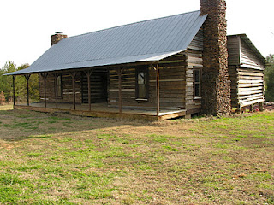
"Needed to wash clothes? There was a big, cast iron, 3 legged pot in the back yard, in which you put water and under which you built a fire. When the water was hot, you would put the dirty clothes in the pot with some homemade lye soap. You would pull out the wet garments and scrub them over a wash board and then rinse with cold water.

Needed a cook stove? There was a chop block near the well where you would split stove wood. Needed a bath? There was a 16 gallon washtub in front of the hearth or wood stove. Needed lights? Kerosene lamps did the trick. Needed to store cooked food? There was the pie safe. Needed heat in the winter? Back to the chop block or cross cut saw. Needed air conditioning? Get out your cardboard church fan.
Needed to go somewhere? There was a buggy and a horse or mule in the barn. A few wealthy folk had a Model T or A Ford. Needed groceries? Go to the storm cellar and pick up home canned vegetables and/or take a sack of corn or grain to the local grist mill and come back with meal or flour. Needed meat? Go out to the smokehouse and cut down a ham, bacon or sow belly."
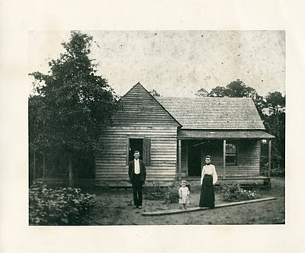
Above, approximately 1905, James Monroe Holliman, Cecil Rhodes Holliman and Elizabeth Baker Holliman at their turn of the 20th Century home in Newtonville, Alabama. James Monroe Holliman, the writer's grandfather, would become a lawyer, and as many during World War I, he took his family to an urban area, in this case Birmingham, Alabama and became a successful attorney. Many of his grandchildren and great grandchildren follow the same profession today in Birmingham.
"Needed a doctor? Dr. Blakeney could be reached on your crank phone and he would come to your house in his antique car or on horseback. Need to satisfy a sense of visceral urgency? There was a path to the outhouse. It could be a one holer or a two holer. Worried about cholesterol? What was cholesterol?

In my boyhood mind, everyone was happy and did not seem to miss anything in life and always looked forward to family visiting, family reunions, church homecomings and revivals and all day singing and ‘eating on the grounds’. It was in this wonderful world of simplicity that I grew to manhood never feeling that I missed anything."

Next posting, a return to our English roots....

FRIDAY, MARCH 23, 2012
Those Were the Days
by Dr. Rhodes Holliman

My second cousin, Dr. Rhodes Holliman continues his touching memoir of his childhood in rural Fayette County, Alabama in the 1930s. Rhodes, along with his father, Cecil Rhodes Holliman, and his niece, Glenda Norris, has done much to preserve Holliman family history. - GNH

"Hunting was my passion. A great uncle named Eura Carter lived in southern Fayette County near Patton’s Chapel and very close to the Sipsey River. He had a fox terrier named ‘Beans’ that was the finest squirrel dog that ever put a nose to the ground.

Beans was a silent tracker. He did not bark until he had the squirrel treed and then would bark one time. You had to keep Beans in sight because if you did not hear his solo bark, you could lose him and he would hold a squirrel up a tree for hours. He was never a house pet. The only time he ever showed any friendly emotion was when we came out of the house with a shotgun and indicated that we were going hunting. Then he was bundle of energy leading the way."

Below, young Rhodes Holliman grew up in Birmingham, Alabama, but looked forward to summer days and school holidays in the country side of West Alabama.
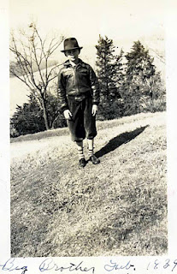

"In those days the virgin timber in the Sipsey Bottoms was composed of giant gum, water oak, beech, hickory and other trees that grew 100 plus feet tall and produced a canopy so dense that sunlight could not reach the forest floor except in the dead of winter. There was very little undergrowth and you could walk through the forest without being encumbered by thickets of briars, brush and saplings. It was in this pristine wilderness that I first went hunting at age 4 with my Dad, Cecil Rhodes Holliman, Uncle Eura and Beans.

Beans trotted along ahead, nose to the ground and presently he barked, and we saw him. If you couldn’t see the squirrel, you just got down on your knees and looked up Beans’ nose and there was the quarry! If the squirrel moved, Beans would move, always keeping his nose pointing dead on target. Well, Beans was pointing, Dad was loading his shotgun and I was standing under the tree looking straight up. There was a tremendous ‘BANG’, a thrashing in the tree top, and the squirrel fell directly on my head. Luckily, the squirrel was DOA (dead on arrival) and did not bite or claw me.

From that moment on, I was hooked to squirrel hunting and my question arose immediately, ‘when can I have a gun?’ Such a question today would probably instill a sense of horror and fear in a city bred parent but, ‘in the good old days’, a conservative father, reared on a farm, would give this question some serious consideration. I had to wait until I was 6 years old and learn hunter safety and be strong enough to carry a firearm.

At 6, I became the happiest child in the Sipsey Swamps with my new .410 single barrel while Dad carried the ammunition. Beans would find the squirrel, Dad would stand behind me and hand me a shell and another squirrel would ‘bite the dust’. That gun produced a mighty kick for a 6 year old but the harvest it produced offset the pain and bruises."
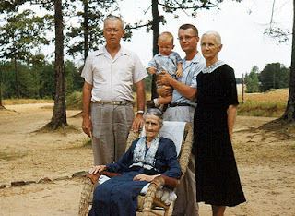
Left to right, Cecil Rhodes Holliman, Jim Holliman, Dr. Rhodes Holliman and Elizabeth Baker Holliman (widow of James Monroe Holliman). Rocking in front is Belzy Anne Blakeney Baker, mother of Elizabeth. This picture was made ca. 1955.
"In the days of the Great Depression, squirrel meat was a staple source of protein in Fayette County and many other rural areas of the South. We would par-boil the squirrel first --then fry them up or cook them to make squirrel dumplings. Yum! I learned quickly that the hunter is responsible for cleaning his harvest and Uncle Eura was a master teacher of the techniques for skinning squirrel. Any coon hounds standing around would be happy to eat the raw squirrel hides, hair and all, in one gulp!"

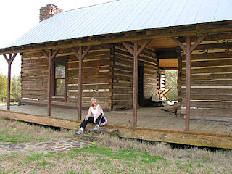
Glenda Norris, a niece of Dr. Rhodes Holliman and daughter of Cecile Eugenia Holliman Youngblood, poses on the porch of her ancestor, Thomas Blakeney's dog trot home in Newtonville, Alabama in 2006. The home still stands serving as a reminder of life in the 19th Century Deep South.
"There was much sadness when Beans departed this life. I continued to hunt squirrels with hounds but none of them could ever match the skill of Beans. After a while I would just go into the woods without a hound and find a good spot near a beech or hickory mast. I would look for a squirrel den in a hollow tree and there I would wait, sitting very still, watching for movement.
Using this technique at only 14 years of age brought me a bounty of 6 squirrels from one giant red oak den. I would shoot and the squirrel would hit the ground. Each time I would mark the spot but not move and wait for the next one to appear. This kind of hunting took a lot of patience and perseverance especially for a young boy. As I grew older, night time coon and possum hunting were added to my list of favorite things to do down by the Sipsey in Fayette County, Alabama."

Next Posting, more on life in rural Alabama in an earlier generation....

SATURDAY, MARCH 17, 2012
Those Were the Days!
by Dr. Rhodes B. Holliman, Dublin, Virginia

Rhodes Holliman, who has had a distinguished college career in teaching and biological research, recorded in 2007 his boyhood memories of Fayette County, Alabama and some memories of his Holliman, Blakeney and Baker relatives. He captures nostalgically an earlier time in a rural America in the 1930s then largely still untouched by 20th Century domestic conveniences.– GNH, his second cousin

"As a boy, I lived for the opportunity to leave my home in Birmingham, Alabama to travel to Fayette County, Alabama in the Newtonville area, approximately thirty miles north of Tuscaloosa. I would stay with great aunts and uncles. I would hunt, fish and get back to the frontier environment away from the clamor of city life.

My pleading to my father, Cecil Rhodes Holliman, who was an attorney in Birmingham, was perpetual, and seasoned, ‘Let’s go see Uncle Eura, Aunt Mae, Uncle Mute, Aunt Ila, Uncle Virgil and Aunt Pearl’, knowing full well that the roads might be impassable in wet weather and the old 1929 Ford A-Model sedan might break down."
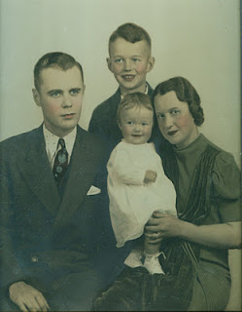
Above Dr. Rhodes Holliman, center top, poses with his family in the 1930s. Rhode's father, Cecil Rhodes Holliman is left; center is his sister, Cecile Eugenia Holliman Youngblood and his mother, Ruby Burns Holliman, right. Like his father, Cecil, Rhodes has invested countless hours in researching his family history.

"This was a time, the 1930s, when the crossroads at Newtonville seemed almost as primitive as when the Native Americans moved out and my ancestors migrated in from South Carolina in the 1830s. There was no pavement south of Fayette, which was known as the rail road town. There was no electricity, only crank phones, no municipal water and no sewage treatment. Instead of having six rooms and a bath, most of the homes were dog trots, ‘4 rooms and a path!’"
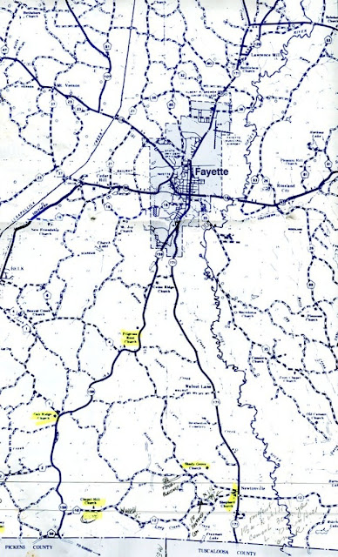
The above map of Fayette County, Alabama is from the Walt O. Holliman Resource Collection for Holliman and Associated Families. Walt (1927 - 2003) marked in yellow numerous Holliman family cemeteries. Newtonville is in the lower right corner near Shepherd's Church. The county seat of Fayette is further north. Walt Holliman's notes and use of a yellow marker are visible on the map. Many of the Bakers are buried at Shepherd Cemetery.- GNH

Glenda Norris, a niece of Dr. Rhodes Holliman, has helped identify the aunts and uncles mentioned above. They are:
Eura Carter (1878 - Nov 4, 1956)
Allie Mae Baker Carter, (b. 1888)
J. Mutius Baker (Aug 23, 1885 - Apr 28, 1965), husband of Ila Yerby Baker
Ila Lula Yerby Baker (July 9, 1891 - Apr 22, 1975), wife of J. Mutius Baker
Virgil Benton Gibson
Pearl Baker Gibson
The parents of the above Baker children, all of whom were born in Newtonville, Alabama, are George W. (March 13, 1851 - November 21, 1928) and Belzy Ann Blakeney Baker (September 1859 - March 16, 1960).
Additional Baker children are Anna Elizabeth, who married James Monroe Holliman (the grandparents of the writer, Rhodes Holliman, of this article); Francis Hillman, who married Elsie Dunscomb; Ruth Guyton, who was married first to B. T. Lovette and then to F.N. Henderson; Pearl, who married Virgil Benton Gibson; Montie Lea, who married Lynn Davis Boshell; Frederick Coleman, who married first to Fleta Williams and second to a lady from Ohio whose first name was Bernadetta; Georgia Bell, who married Earl Ray; Nora Louise, who died at the age of six years and two infants who died shortly after birth. Several of the mates of George and Belzy Baker's children were also descendants of Newtonville, Alabama pioneers such as the Yerbys, Gibsons, Rays and Hollimans.
Next, more on the 1930s in rural West Alabama....

