Saturday, March 2, 2013

When We Were English, Part LIII
by Glenn N. Holliman
Continuing the Will of Thomas Holyman, 1558....
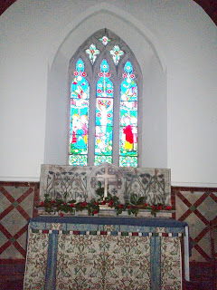
﻿
Above the altar in the sanctuary of St. Nicolas Church,
Cuddington, Buckinghamshire, England.
We continue our study of the Will for which accumulated evidence indicates was prepared by my 10th great grandfather - Thomas Holyman, yeoman farmer of Cuddington, Buckinghamshire. The Will continues beginning on line nine. Click on Will and it will enlarge.
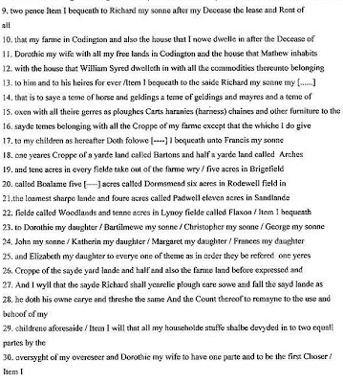

Lines 9 - 13 - Thomas announces that after his wife Dorothy dies, his first born son Richard is to inherit a considerable portion of the estate. This is called by the legal term 'primogeniture' in which the estate is handed down to the eldest son, generation after generation. According to Anne Holmes, professional genealogist who has explored the Holyman family and Cuddington, Richard died in October 1603 and is buried at St. Giles, Cripplegate, London.

One can presume that this great Uncle Richard Holyman had wealth enough to enjoy the countryside at Cuddington and a house in London. The year 1603 was not just any year in English history. The historic reign of Elizabeth I ended and James VI of Scotland became James I of England and began the ill-fated Stuart dynasty. And there was a writer named Shakespeare on the south side of the Thames writing some timeless plays.

Lines 22-26 - Christopher Holyman, my 9th great grandfather and his siblings received a year's crop from the said yard (acreage). He received a modest inheritance as did his brothers other than the first born, Richard. Christopher had to make his way in the world without significant inherited resources. As we shall see later, a good marriage would help.

Information on what had become a prominent family increased during the time of Thomas (d 1558). There were numerous children: Francis who married a person named Mary, died in Cuddington about 1603. Next a John Holyman (no doubt named after his grandfather) died about 1578 in London, and then Christopher, Bartholomew and George Holyman.

Dorothy Holyman, a sibling named after her mother, married John Clark 6 November 1582 in nearby Hughenden, Buckinghamshire. John may have been a cousin on his mother-in-law's side of the family.

Then follow Elizabeth, Frances, Katherine and Margaret.

Below yours truly stands November 2012 on the site of the Holyman manor house of the 16th Century. In the background are the Holyman farm fields and barns, hundreds of years old.

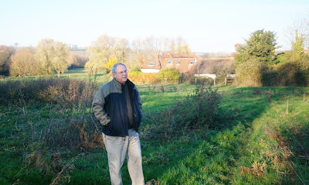

Next post, we finish studying the Will of a Roman Catholic family about to become Anglican as a Queen dies and Elizabeth I comes to the throne of an island nation - England!

Saturday, March 16, 2013

When We Were English, Part LIV
by Glenn N. Holliman
A Final Look at the Will of Thomas Hollyman, 1558
This is the last part of the Will of the person whom I believe to be my 10th great grandfather, Thomas Hollyman of Cuddington, Buckinghamshire, England. My 10th great grandmother was Dorothy Clark. Let's study this section for the secrets it might reveal to a family historian. Click on the Will text twice and it should enlarge.
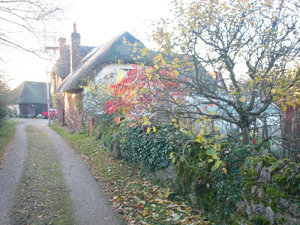
Above the village lane in Cuddington leading to the Holyman farm house and estate. November 2012

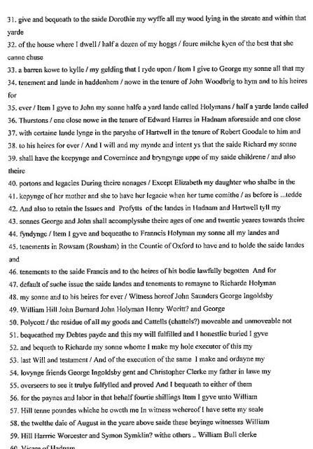
Line 36, 37, 42 and 45 - Thomas revealed he had lands in locations other than the village of Cuddington. This is a remarkable acquisition of property since his father died in 1533. Hadham and Hartwell are a few miles of Cuddington, but Rousham is in another county.
While Thomas made additional arrangements for most of his children, he did not further mention son Christopher, who is my 9th great grandfather (so evidence indicates). Hmmm...rather than believing Christopher was an unfavored child, perhaps Thomas was a minor. However, Christopher's later marriage to another leading Buckinghamshire family, the Lee's of Dinton, would ease his way in the world.
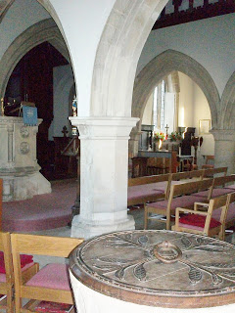

Above the interior of St. Nicolas Church in Cuddington. Although the chairs are 20th Century, the pillars and baptismal font are 13th Century. Below the floor may lie the remains of 16th Century Holymans.
Line 54 - It was common to name one's sons after their father and grandfathers. We note one child named John and the son, Christopher, a name that continues in the family to this day. Where did that name come from? My belief is the name is from Dorothy Clark's father, Christopher, who is identified as Thomas' father-in-law in the Will!
My continuing thanks to genealogist Anne Holmes for her work in translating these 16th Century wills.
Next Holyman's in the first Elizabethan age....

Sunday, March 31, 2013

When We Were English, Part LV
by Glenn N. Holliman
Holymans in the First Elizabethan Age....
In the last post, we closed the Will of Thomas Holyman who died in 1558, the year that Queen Elizabeth I came to the throne of England. The eldest son, Richard Holyman, inherited the lion's share of the large family estate. It is my thesis that this Richard, who died in 1603, was a great uncle (many times over) of the Holymans who migrated to Virginia in 1650.
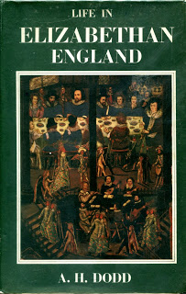
English historian A. H. Dodd in his 1961 work captured the status of country families such as the emerging Holyman family of Cuddington, Buckinghamshire. Thomas Holyman proclaimed himself a yeoman, unlike his father and grandfather (John who died in 1533 and John who died in 1522) who described themselves as husbandmen, a lower social status.
Yeomanry was the rural middle class, and often those in this social class were in a state of economic flux. Yeomanry was a half-way house to gentility. As a member of the gentry, a male was no longer addressed as 'goodman' but rather 'master'. From what we know of our Richard Holyman, Christopher's oldest brother, he moved to the 'gentry' class.
Evidence of this? He had a home in London as well as his 'manor' house in Cuddington, and lands in other parts of Buckinghamshire. The web site 'The Parishes of Stone Hundred - Cuddington, A History of the County of Buckinghamshire' reveals that parts of 'the manor of Cuddington' came into his possession. Later in a lawsuit, he and another Richard Holyman, possibly his son, defended their manorial rights in court.
Richard Holyman also had the rights to the local watermill and leased it for 21 years to Thomas Tyringham in 1582. Even after the sale of the mill along the Great Thames, a tributary to the the Thames River, the Holymans retained their right to a free fishery. Below the entrance to the site of the old water mill in England. Photograph taken April 2012.
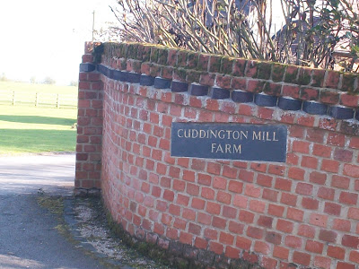

﻿
The Tyringhams were themselves a prominent Cuddington family who also had interests in other parts of Buckinghamshire. The Tyringham Hall still stands in Cuddington, only a long stone's throw from the present Holyman farm. Below, in a November afternoon sun in 2012, the house remains a lovely piece of Stuart era architecture.
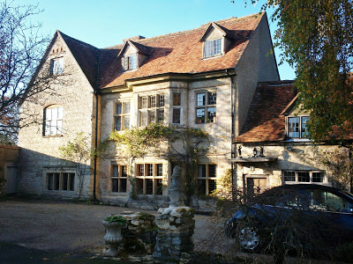
Further evidence of the rise of this branch of the Holyman family was the marriage of Richard's brother, the landless Christopher Holyman who would die in December 1588. This Christopher would marry into a family that was on the rise socially and economically, the Lees of Buckinghamshire.
And Christopher will leave Cuddington for Sherington, and live not far from a Tyringham property in northern Buckinghamshire. Did Christopher, one of the many sons of Thomas Holyman, establish some type of economic relationship with his Cuddington neighbors whose family had relations in Sherington? We do not know but it is an intriguing thought that might explain why Christopher removed himself to a community, 35 miles or so from Cuddington and close to another shire - Bedford.
And from Bedford, Bedfordshire would come Christopher and Judith Holyman who emigrated to Virginia in 1650!
Below, located five or so miles from Sherington is the Tyringham House as it appeared in 2011. This current hall reflects the wealth of the Tyringham family in previous centuries. Today, the house and land are in the possession of another 21st Century family.
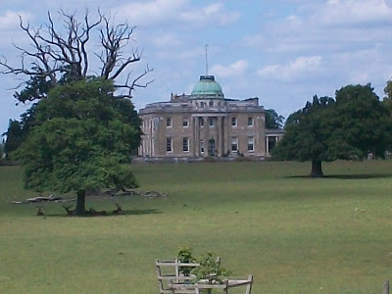
In the next post, we return our attention to Christopher, the person whom I believe is my generation's 9th great grandfather.

