WEDNESDAY, MARCH 14, 2012

A Holliman History by Walter O. Holliman, Part IX
by Glenn N. Holliman
This is the ninth and last in a series of a history of the Holliman family written by Walter O. Holliman in 1995 and edited in 1996.
This generation includes Walt's father and mother.
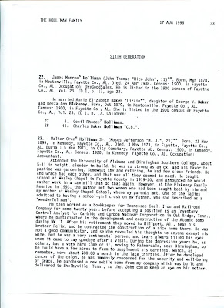

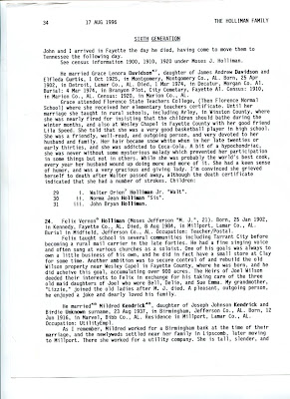

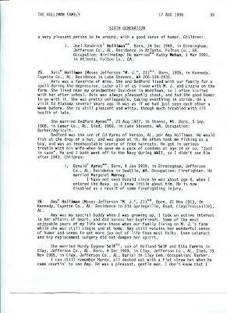

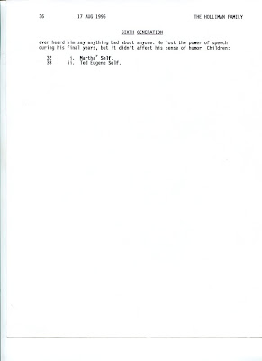
Walter O. Holliman produced dozens of manuscripts of his associated families. Over time, they shall be posted. For our next, blog we will feature the memories of Dr. Rhodes Holliman, another outstanding Holliman historian.
Posted by Glenn N. Holliman at 4:19 PM 0 comments
Labels: Walter O. Holliman

FRIDAY, MARCH 9, 2012

A Holliman History by Walter O. Holliman, Part VIII
by Glenn N. Holliman
This is the eighth in a series of a history of the Holliman family written by Walter O. Holliman in 1995 and edited in 1996.
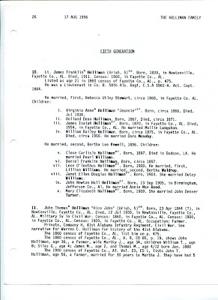

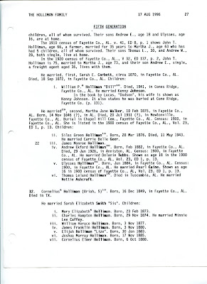

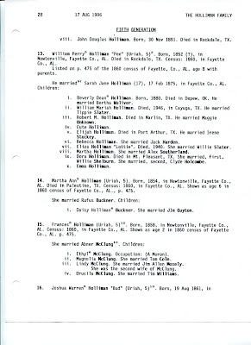

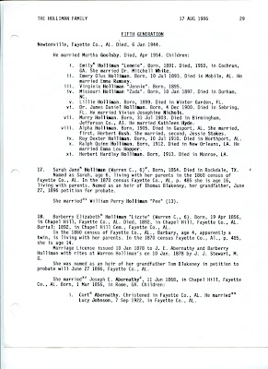

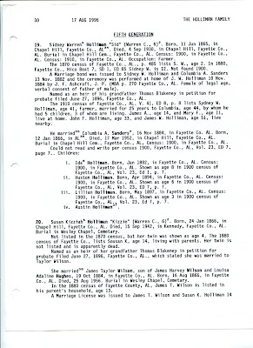

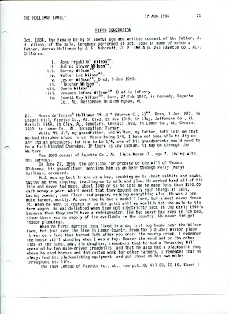

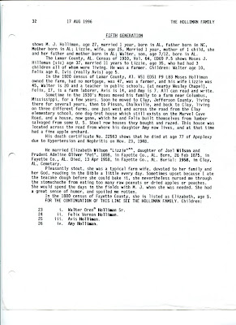
The John Thomas Holliman recorded in these documents is this writer's great grandfather.
Posted by Glenn N. Holliman at 4:09 PM 0 comments
Labels: James Franklin Holliman

SUNDAY, MARCH 4, 2012

A Holliman History by Walter O. Holliman, Part VII
by Glenn N. Holliman
This is the seventh in a series of a history of the Holliman family written by Walter O. Holliman in 1995 and edited in 1996.
Walt named this generation as the 'Fourth' and began it with my second great grandfather, Uriah Holliman (1818 - 1862), a successful farmer who enlisted in the CSA in 1861, and along with his son, Charles, died of the measles in Okalona, Mississippi after the Battles of Shiloh and Corinth. A tragic waste that took the Holliman family generations to recover.
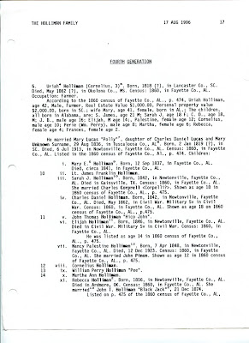

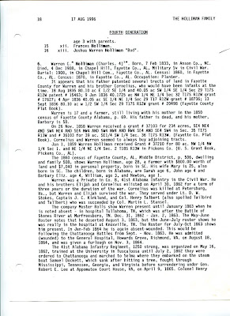

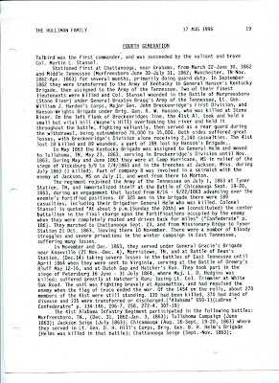

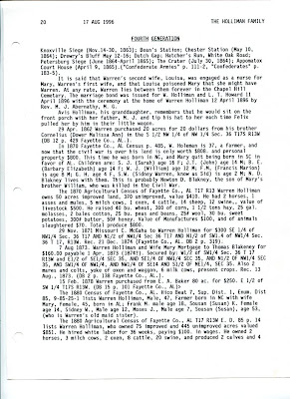

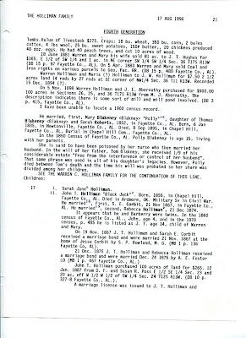

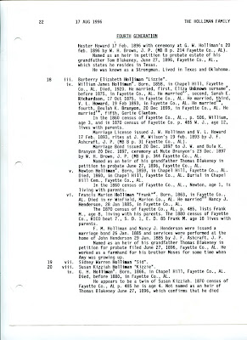

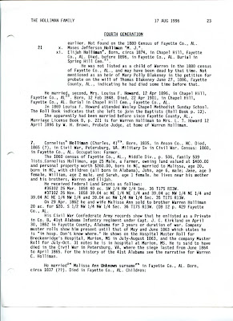

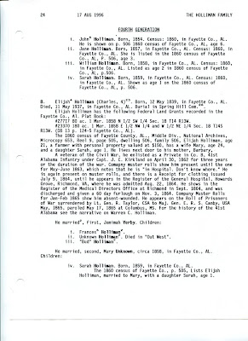

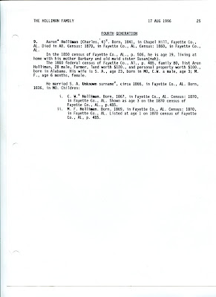
The above represents the extent of information available to Walt in the early 1990s, before the Internet age. Additions and corrections welcome.
Posted by Glenn N. Holliman at 4:42 PM 0 comments
Labels: Uriah Holliman
Newer PostsOlder PostsHome
Subscribe to: Posts (Atom)

