WEDNESDAY, APRIL 28, 2010

Our Family's Colonial Era, Part IV
Mill Swamp and the Church
by Glenn N. Holliman
For the past three weeks, I have described a journey to our family roots in Isle of Wight County, Virginia. Just down the road from the Holleman House is a church that has become part of the family story.
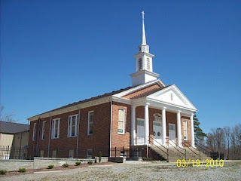The Mill Swamp Baptist Church, Isle of Wight Co., Virginia has been rebuilt many times in nearly 300 years of existence. The church and cemetery are adjacent to land owned by the Holleman's and Gwaltney's. According to cousin Jeanette Holiman Stewart, from 1798 to 1801 Jesse Holleman, Sr. was joint minister of the church with John Gwaltney. Later Jesse Sr., a direct descendant of Christopher Holliman, Sr. pastored the church alone from 1819-1820 when he was 83 years of age.
The first Hollimans were Anglicans, members of the Church of England. Until the American Revolution, there was only one official church in Virginia, and that was the Anglican or as now styled, the Episcopal Church. Our Virginia ancestors did not come to the New World for religious freedom. They came to better themselves economically, and Christopher Holliman, Sr. succeeded.
There were few Episcopal parishes in colonial days. Only one or two in each shire (as the first Virginia counties were called), and many persons felt something missing spiritually in their lives. Into that religious void came the Baptist Church, which gradually spread out of New England into the Middle Atlantic and Southern colonies by the early 1700s. Presbyterians and Methodists soon followed.

Our cousins and contributors, Ron Holliman and Maxine Wright, have pointed out that one Holliman, Ezekiel of Rhode Island, was a founder of the American Baptist Church. Ezekiel Holliman, from the same part of England as Christopher Holliman, Sr., baptised Roger Williams, the founder of Rhode Island and the Baptist Church in America! More on this probable distant cousin in later posts.
One of the first Baptist churches established in southeast Virginia was located adjacent to Holliman and Gwaltney land. The Mill Swamp Baptist Church, founded 1719, was named after the marshy ground and a stream that ran nearby. This church's location proved perfect for baptisms and became the mother church of many others in the Virginia tidewater region.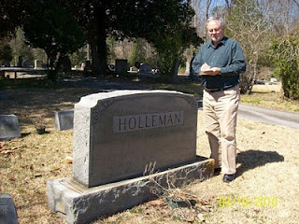In the adjacent cemetery are numerous graves of 19th and 20thcentury Hollemans plus Cofers, Gwaltneys and Atkinsons, all who intermarried in the Holliman family. Photo by Barbara Holliman of Glenn, 2010. A list of those buried in Mill Swamp Baptist Church Cemetery can be found at http://www.iwchs.com/

Yes, there truly is a Mill Swamp near the Blackwater River as noted on the 1684 patent for Christopher Holliman, Sr.
Next week we begin to examine the cash crop, tobacco, which was grown by the Holliman family in the Colonial Era.

FRIDAY, APRIL 23, 2010

Our Family's Colonial Era, 1607 - 1775, Part III
Confirming the Family Tree
by Glenn N. Holliman
For the past several weeks I have been writing about a trip I took with my wife, and granddaughter, to Isle of Wight County, Virginia. In the last blog we posted a photograph of the Holleman House which was constructed by a distant cousin, Wilson Holleman (1803-1873), a son of Josiah Holleman (1771-1848), who was a son of Jesse Holliman and a veteran of the American Revolution, who was a son of John Holliman, who was a son of Christopher Holliman, Jr., the son of Christopher Holliman, Sr., who patented the land in 1684. Christopher Sr. is my four-year-old granddaughter's 10th great grandfather.
Below is a photo of Wilson Holleman's headstone in the family cemetery located by the main house.
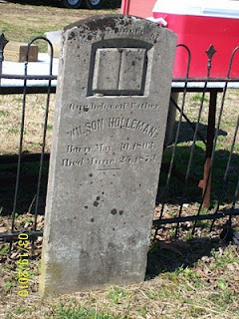
According to current information on our family tree, all in this family cemetery are relatives of Christopher Holliman, Sr., d 1691.
Pictured below is the view from Highway 621, Mill Swamp Road looking back toward the Holleman House on the left, and an older dependency building on the right. The soil is sandy and the ground is flat in the Virginia Tidewater region.
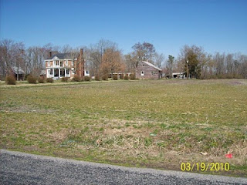Isle of Wight County is only 59 feet above sea level at its highest point. The fertility of the soil was maintained in the 19th century with marl, a local mineral, which helped reclaim the vitality of the soil that was leached by tobacco farming.
Perhaps, as with many early Virginians, the first Holliman generation tilled only a small portion of land for the cash crop tobacco, and utilized the rest for corn, vegetables, wood fuel and range for hogs, poultry and cattle.
The historian, Edmund S. Morgan, reports that in the 1600s and 1700s Virginia, one laborer could handle at most 3 acres of tobacco and three acres of corn. This was the monetary crop and food source for humans, horses and cattle alike. Of course, wild game, still in abundance in the early colonial days, supplemented diets.
As one author of Virginia history notes, “Tobacco chews through soil fertility with ferocity possessed of few other crops. In the absence of fertilizer, it can only be grown on virgin land for four seasons maximum.” Perhaps this first Christopher tilled his acres with the help of children for several years and then moved on to another piece of his land. Future Holliman families would do the same, and as their land was exhausted, they would move south and west into the Deep South, at least until the Civil War and Reconstruction.
Next week we examine the Mill Swamp Cemetery, adjacent to the 1684 plantation, that is the final resting place of 19th and 20th Century cousins.
Posted by Glenn N. Holliman at 3:05 PM 0 comments
Labels: Christopher Holliman Sr., John Holliman, Wilson Holleman

FRIDAY, APRIL 16, 2010

Our Family's Colonial Era, 1607 - 1775, Part II

In Search of Christopher Holliman Sr.'s 17th Century Virginia Plantation
by Glenn N. Holliman
This is the second post of an on-going series of our ancestors. Last March, my wife, Barb, and granddaughter, Holly and I crossed the Blackwater River, the border between Southampton and Isle of Wright Counties, Virginia in search of Christopher Holliman Sr.'s plantation. Our little adventure continues....
We passed picked cotton fields and peanut storage units. Our noses told us that a pig farm, probably the home of future Smithfield Hams, was nearby. After passing Sycamore Corner, we were on Mill Swamp Road. A mile later we saw a decrepit sign which read: Holleman House.
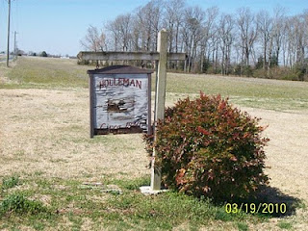Was this it, the remnant of Christopher Sr.'s 17th century plantation? Holliman has been spelled many ways - Holyman, Holleman or Holloman. No one was at home, so we took photographs and left a note. We noticed a family cemetery. The oldest visible stone is of Edward Adolphus Holleman, young son of Wilson and Ann Holleman, b 1810 - d 1819.
We did not expect to discover Christopher's grave. In the 17th, and most of the 18th century, there were no gravestones in the Tidewater area, as they were expensive items at the time. My guess is that his bones rest on this, or an adjacent, property.
Nor did we expect to discover a log cabin that housed the first Hollimans. No cabins from the 1600s survive in the Tidewater region. They burned easily and deteriorated rapidly without paint or protective coatings. It was after 1700 that the red brick plantation homes along the James River were constructed.
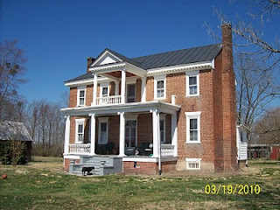Constructed in 1830, this is the Holleman House, located on Mill Swamp Road, Isle of Wight Country, Virginia. This historic Federal period house, with over-sized front doors and saw- tooth cornices, is located on the site of Christopher Holliman, Sr.'s 1,020 acre plantation.
To our amazement, when we visited the Isle of Wight County Museum later that day, we discovered an 1983 book by Helen Haverty King entitled Historic Isle of Wight. The 200 page volume pictures numerous antebellum homes in the county, one being the Holleman home!
The book is available at The Isle of Wight County Museum ($35). On the back cover is an illustrated map showing the location of the Holleman house and many others. 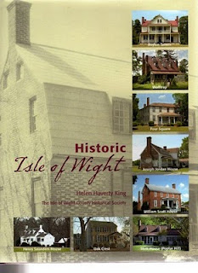
In this volume, one will find confirmation that in 1684 Christopher Holliman, Sr. completed his purchase of 1,020 acres in a corner of Isle of Wight County.
Bordering the family's property were the Atkinsons (whose sons married two of Christopher Sr's. daughters) and the Gwaltneys (who also married future Hollimans). The Gwaltneys became retail sellers of peanuts and hams, and were the founders of the famous Smithfield Ham company. They did well financially, and several of their 19th century mansions are open to visitors in downtown Smithfield today.
Next week, we will continue with our adventure to Colonial Virginia and further explore the history of the Holleman House.

