bWEDNESDAY, APRIL 20, 2011

Our Family's Colonial Era, Part XXIV
Joe Parker is a diligent researcher of Holliman family history tracing his ancestry back to Christopher Holyman, Sr. He has facts at his finger tips on the family from the early 1600s in Bedford, Bedfordshire to his 21st Century relatives in his home state of Texas. Below, he shares his observations on just who those early Holymans were and what could their relationships be to one another. - Glenn N. Holliman
Christopher, Judith and John Holliman, some Additional Information concerning their Emigration to Virginia
by Joe Parker
The Headrights of Christopher and Judith Holyman
In 1650 when they arrived in Jamestown, both Christopher and Judith Holyman received head rights to acreage in the Virginia Colony. My understanding is that when a man received a head right to any block of land, the wife also has ownership of that tract, by privilege of being married to the man who received the acreage.
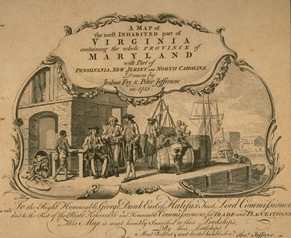
This 1751 work depicts a colonial dock with hogsheads of tobacco on the wharf. West bound from England, the ships would carry English goods and immigrants. East bound from Virginia to England, tobacco in casts would be the item transported.
Why then would - Judith in this case - receive separate notice of receiving such acreage, unless she was possibly recipient of such land as a separate individual? Conclusion, Judith was not the wife of Christopher, but yes, as the Bedfordshire English parish records indicate, more likely was his sister. - Joe Parker
Genealogist Robert W. Baird in his web site Understanding Headrights publishes the following which helps us to grasp more fully some of the reasons our Holymans might have come to the Virginia colony.
"The headright origin is found in the London Company’s “Greate Charter” of 1618:

“That for all persons…which during the next seven years after Midsummer Day 1618 shall go into Virginia with the intent there to inhabite, if they continue there three years or dye after they are shipped there shall be a grant made of fifty acres for every person… which grants shall be made respectively to such persons and their heirs at whose charges the said persons going to inhabite in Virginia shall be transported…”

- There were no restrictions on age or gender. Headrights could be, and often were, children. In fact, many imported indentured servants were teenagers.
- Persons settled in Virginia who subsequently left the colony and returned were sometimes successfully claimed as headrights. A number of patents claimed importation of a specific person “the second time” or the “the third time” (or in one case, a total of six times.) Although this seems contradictory to the spirit of the system, it appears to have been an accepted practice from the very beginning, for several Ancient Planters claimed multiple rights for their own arrivals in Virginia.
- Because there was no system for validating or accounting for headright usage, headrights were often claimed more than once, and persons who had no “intent to inhabit” were used as headrights. More on this later.
Hmmm....much to consider here as we look not just to the mid-1600s, but also the late 1600s and early 1700s and see the Holliman family utilizing the 'headright system'. - GNH

Keeping an Open Mind on just Who was John Holleman
As to John Holleman, who died in 1650 in Northampton County, Virginia, I have an open mind on this individual. The fact that he left no worldly goods to any children should be looked at carefully. He may have divided his fortune with his children (if any) before his death, and this could have left him virtually penniless at death. John left his remaining goods to a friend who would help to settle the estate. Conversely, this John Holleman could have been the husband of Judith, who arrived two weeks after his death in Virginia. Or John could have been her brother, born 1612 in Bedford, Bedfordshire, England.
I am not forming any set opinions until we search more in the Bedfordshire Archives and study additional works. For now, I will return to my review of passenger lists of boats arriving in the Virginia Colony in the 17th and 18th Centuries. - Joe Parker, Texas

MONDAY, APRIL 18, 2011

The Hollimans of Alabama
by Glenn N. Holliman
Back to the 19th Century...A Series of Articles on the Hollimans and Related Families of Fayette County, Alabama
By 1836, several sons of James Grantson Holliman (1750 - 1836) and other associated families had migrated to Fayette County, Alabama from Lancaster, South Carolina. Cornelius (1792 - 1862), Charles (1795 - 1850) and Warren Holliman (1801 - 1876) were part of the westward movement of the American nation and my family in the 19th Century.
Warren would later move on to Arkansas and father many Holliman descendants in that part of the United States. Cornelius, Charles and many of their descendants remained in Fayette and adjoining counties. Many others went to Mississippi, Louisiana and Texas.
An Excursion into History....
On April 9, 2011, Glenda Norris, a descendant of James Grantson and Cornelius Holliman families, led fifteen of her distant cousins through the cemeteries of her many great grandparents to share their stories. She would be the first to tell you that she stands on the shoulders of her grandfather, Cecil Rhodes Holliman, and his son, her uncle, Dr. Rhodes Holliman. The research about to be shared comes from their hands and also of the late Walt Holliman, a descendant of James Grantson and Charles Holliman, his son.
Glenda Norris reports:
"The first stop of the tour was Charles Daniel Lucas, Jr. burial site. It was unseasonably hot for April (92f) even for the Deep South. But that didn’t slow anyone down. Everyone was more than willing to take a short ‘hike’ into the woods, up a small hill and then a left turn into the forest to view the ‘old Indian burial ground” where Charles Daniel Lucas, Jr. gravesite is located.

Here is a photo of everyone getting ready to make the walk. Left to right are: Jeanette Holiman Stewart (Austin, Texas), Glenn Holliman (Newport, Pennsylvania), Lenwood Holliman (Gordo, Alabama), James Franklin Holliman (Sulligent, Alabama), Bishop Holliman (in cap from Avilla, Indiana and the oldest at 91), Laura Vonceil Duckworth (Reform, Alabama), Wally and Tommie Holliman Allen (Irondale, Alabama), Faye Gardner (Kennedy, Alabama), Bill Holliman (Horn Lake, Mississippi), Jean Holliman (Irondale, Alabama), Joey Holliman (Florence, Alabama) and Tyler Duckworth (Tuscaloosa, Alabama and at age 15, the youngest on the trip). Obscured is Robert Holliman and taking the photograph is Norman Holliman (both brothers from Marysville, Tennessee)."
All the above are either descendants of Charles (about 1795 - before 1850) or Cornelius Holliman (1792 - 1862). Of course, all have the DNA of Christopher Holyman, Sr. (1618 - 1691), the Englishman who left Bedford, Bedfordshire and immigrated to Jamestown, Virginia in 1650.
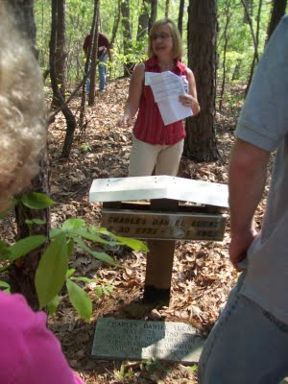
Above, Glenda Norris shares information at the grave site of her 4th great grandfather, Charles Daniel Lucas Jr. whose daughter,Mary 'Polly' Lucas married Uriah Holliman, a son of Cornelius Holliman. Below, Glenda points out a Choctaw Indian burial site. Charles Daniel Lucas, Jr. was a Federal Indian agent and may have been the son of a Catawba Indian mother from South Carolina. When he died, he requested to be buried with his Native American friends. His wish was granted and he lies today sharing the sandy soil with first Alabamians.
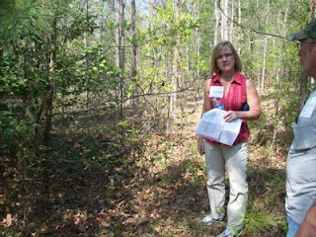
Next post on Fayette County, Glenda provides detailed information on the Lucas family....

SUNDAY, APRIL 10, 2011

Our Family's Colonial Era, Part XXIII
Exploring Further Possible Connections Between the English Civil War and the Early Holymans of Virginia
by Robert Holloman
During the past several articles, Robert Holloman, a descendant of Christopher Holyman, Sr., has been exploring connections between participants in the English Civil War and the arrival of the Holymans to Colonial Virginia. In this posting, he proposes additional evidence that suggests the Holymans were sympathetic to Charles I's forces in the fight with Parliament. One remembers Charles I was executed in 1649, and many of his supporters fled the country. Were some who fled the Holymans? - Glenn N. Holliman
My premise that the English Civil War sparked the emigration of Christopher Hollyman (and/or Judith) to Virginia is obviously not original as many families trace some of their American roots to this period. Documenting the Hollyman (Holyman, Holliman, Holloman, etc) migration is challenging. I have scattered notes and quotes about the topic that I continue to try and arrange in manageable order.
One is struck by comments such as in Richard L. Morton's Colonial Virginia, Vol. I, the Tidewater Period 1607 - 1710 (UNC Press, 1960) where on p. 166 is stated: "After Prince Charles's defeat in 1651 at Worcester, 1,610 Royalist prisoners were granted their request to be sent to Virginia." Although Charles's army was predominately Scottish and not English at Worcester, prior to the battle his army had grown by the influx of English royalist supporters as it had moved south into England from Scotland.
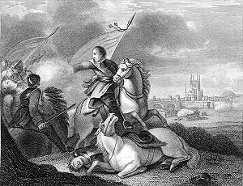
This 19th Century engraving depicts the success of Oliver Cromwell and his forces over the future Charles II at Worcester, England in 1651. After the battle, Prince Charles escaped and hide for a while in an oak tree, since known as the 'Royal Oak'. Cromwell died in 1658 and in 1660, the Stuart family, Charles II, was restored to the throne of England.
Parliament decreed in September 1651 that all prisoners below the rank of Captain were to be sent to the plantations. Prisoners from Chester, Worcester, Liverpool and Shrewsbury were sent to Bristol for transportation to Virginia and Bermuda.
A large number of these left with the annual Virginia fleet in the fall of 1651. This fleet would join with Sir George Ayscue's fleet in Barbados where he was engaged in fighting to subdue Royalist forces that were then controlling the colony.
In December, Ayscue hired 150 prisoners from the fleet to join with his marines for a successful assault on Speight's Town. In January 1652, Barbados submitted to Ayscue as the Virginia fleet continued to Jamestown. The Virginia arrival of the Worcester prisoners is captured in the record of arrival of 270 prisoners from the ship including some of my non-Holliman ancestors, John and Sarah Bridger, who entered the colony as indentured servants. I cannot find any Hollimans on the list but I can not be totally certain because many names are not legible.
I have found other interesting connections between the English Civil War and Christopher Hollyman. One of the first records of Christopher Holyman, Sr in Virginia is his granting of power of attorney to Thomas Pittman in 1660. According to Pittman family websites, Thomas Pittman was a royalist officer who arrived in Virginia in 1649 from Monmouthshire, England. Furthering this connection between the Pittman and Holyman families, his grandson, Thomas Pittman III would later marry Christopher's son William Holliman's widow, Mary Chambers Holliman in 1704.
As my descendants continuously lived in Virginia and North Carolina though my father and mother's generation, through the years I have discovered other members of my families who were Royalist immigrants. For example, Joseph Bridger, who was born in Dursley, Gloucestershire, was a Royalist officer. Joseph Bridger arrived in the mid-1650s and is known to have brought several supporters with him to Virginia. After arrival he would prosper and become one of the leading citizens of Isle of Wight County.
His descendant Sarah Bridger, my 2nd great- great grandmother married my 2nd great-great father Jesse Holloman in 1867. Another descendant of mine, Thomas Carter, Sr, a Royalist arrived in 1650. Charlotte Carter is my 4th great-grandmother.
Although I am skeptical that each story of a royalist emigrant to Virginia between 1645 and 1660 has a basis in fact, I argue that given the dates of Christopher Holyman's arrival in Virginia, that the English Civil War had to have played a prominent roll in the decision to emigrate. Hopefully, with more research, a data trail can shed further light on this proposition. - Robert Holloman

