SATURDAY, APRIL 21, 2012

When We Were English, Part XXXVIII
by Glenn N. Holliman
Questions Concerning Those English Ancestors...
In previous posts, I shared some startling information provided by the research of Bob Hollyman-Mawson of Wales that my generation's tenth great grandfather was quite possibly Thomas Holyman of Cuddington, Buckinghamshire.
This Thomas, whose will was probated in 1558 in Cuddington, is of the same family that produced two outstanding Roman Catholic and Protestant leaders in the 16th and 17th centuries.
So what additional must be done to drive even deeper into the Holyman past? Being a Holliman, I made a list and here it is.
1. Learn more about Christopher Holyman who died in 1588, the suspected grandfather of our Christopher Holliman who died in 1691 in Virginia.

2. Study carefully the original will of Thomas Holyman (1558) of Cuddington, Buckinghamshire.

3. Discover the name and details of this Thomas Holyman’s father and ancestors.
4. Ascertain how long the Holyman family had been in the Cuddington, Buckinghamshire area. Additional information is now surfacing from another source, family genealogist Peter Smith of Bedfordshire, suggesting that the Holyman’s may have originated in London. So it is back to the Buckinghamshire Archives I will be going, probably with the assistance of my good friend below.
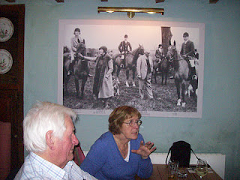
Above, in the fall of 2011, family historian Peter Smith and his wife, Maureen, discuss English history with the writer at the Swan Inn, Swinbrook, England. The photograph in the back ground is of the famous Mitford family that lived in Swinbrook in that lovely part of England called the Cotswolds.
Peter believes the Hollyman families emerged from the London area before moving north and west to Buckinghamshire, Herfordshire, Worcestershire and Somerset during the late Middle Ages.
5. Discover how connected Bob Hollyman-Mawson’s family, whose origins are in the Bristol and Somersetshire, England area of the middle 1600s, is to the Buckinghamshire Holymans. Below, Fred Cooper, left, of Bristol, England, another Hollyman genealogist, discusses outside of his home November 2011 with this writer his thoughts on Somerset Hollymans. Fred has written a 400 page tome (which I am holding) on his research into the family since the 1600s. Soon, I will be sharing Fred's incredible research with readers.
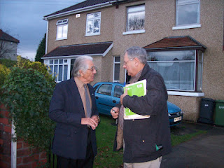

But before exploring the probable Somerset and Buckinghamshire Holyman connections and Fred's excellent work, let’s continue our close look at the Holyman’s of Cuddington….

Posted by Glenn N. Holliman at 11:13 AM 0 comments
Labels: Christopher Holyman, Fred Cooper, John Thomas Holyman, Peter Smith

SATURDAY, APRIL 14, 2012

When We Were English, Part XXXVII
Additional Evidence of Buckinghamshire Roots
By Glenn N. Holliman

This article continues my series on Holliman English Roots and my 2011 revealing visit with another Holliman genealogist, Bob Hollyman-Mawson of Carnarvon, Wales. The photo below captures Bob along the Carnarvon waterfront. Bob has always felt the call of the sea serving aboard a British aircraft carrier in the 1960s. During my visit to his sea port city in late 2011, we explored our families' histories.
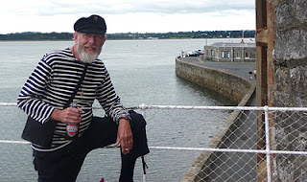
In previous articles at this site, I have presented evidence that American Hollimans have English roots. A quick summary of my thesis is as follows:

- Christopher Holyman, Sr., who arrived in Jamestown, Virginia in 1650 and died in 1691, had been born in 1618 in Bedford, Bedfordshire, England, (My generation’s 7th great grandfather)

- and that his father was Thomas Holyman of Bedford, who was schooled and raised in the late 1500s in nearby Sherington, Buckinghamshire, and is listed in his father’s will as a second son, (If this thesis be correct, Thomas is my 8th GGF)

- and that Thomas’s father was one Christopher Holyman whose will was administered in Sherington, Buckinghamshire in 1589, (Making this Christopher my 9th GGF)

- and now thanks to information provided by Bob Hollyman-Mawson, the above Christopher, according to his will, died in 1588 in Cuddington, Buckinghamshire, evidently Christopher’s childhood home and the location of a prominent Holyman family.

- and further in 1558, one Thomas Holyman died in Cuddington and in his will left legacies to several children, one being aChristopher Holyman! Serious question – is this Christopher Holyman the gentle man who died in 1588 in Cuddington and whose will was proved in Sherington, 30 or so miles north, the same Christopher listed in this 1558 will?
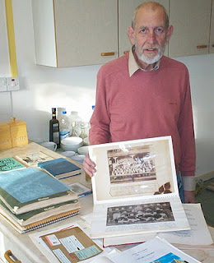

Right, Bob Hollyman-Mawson shows a display and photographs of his Hollyman research. He has in hand information from the original records concerning the wills of Christopher Holyman (1589) and Thomas Holyman (1558), both of Buckinghamshire, England.
Bob is a post-graduate of the University of Wales, Bangor where he earned an honours degree in Linguistics with the English Language as well as a Certificate in Teaching English as a Foreign Language. He is fluent in the Welsh language, still spoken by over a million persons.
Is this Thomas Holyman who died in 1558 in Cuddington my generation’s 10th great grandfather?!
If so, then we seem to have found the missing piece of evidence tying the American Holymans to the paradoxical families of The Rt. Rev. John Holyman, Roman Catholic Bishop of Bristol, and enemy of the Reformation and Ezekiel Holyman, a Nonconformist and a founder of the Baptist Church in Rhode Island, USA!

Next posting, the quest continues....

Posted by Glenn N. Holliman at 1:04 AM 1 comments
Labels: Bob Hollyman-Mawson, Christopher Holyman Sr., Peter Smith,Thomas Holyman

SATURDAY, APRIL 7, 2012

When We Were English, Part XXXVI
Additional Clues to our British Origins
By Glenn N. Holliman
In the summer of 2011, cousin Bob Holloman infomed me that he had found a reference on the web to a work held by the National Library of Wales at Aberystwyth. It was entitled "Hollyman, A One-Name Study, Volume I" and was written by Bob Hollyman-Mawson.
Encouraged by our American Bob to make contact with the English Bob, who lives in Carnarvon, Wales, I subsequently achieved this aim on Facebook. After a favourable response, we corresponded via email, which resulted in a visit to the west Welch country by yours truly in November 2011.

Robert Hollyman-Mawson has proved a wealth of family information and put me into contact with other Hollymans in the U.K. His work also gave me an essential clue as to the American Holliman’s origins in England, an important piece of information I discuss in the next posting.
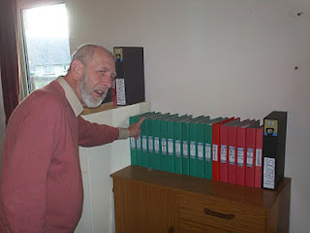
Bob Hollyman-Mawson, left in photo, has an organized and comprehensive collection of records on the last 400 years of his Hollyman ancestors. Pictured are just a portion of his volumes of meticulous research maintained in the study of his Carnarvon, Wales home.

Born in Kirkby-in-Ashfield, Nottinghamshire, England, Bob has lived all but a few months of his life in Wales in historic Carnarvon where the Princes of Wales are invested. A Royal Navy sailor in his youth, he is active in veteran organizations and is an avid student of U.S. Civil War history. A Hollyman descended through his mother and grandmother, he has amassed records of Hollymans (and associated spellings) from around the world. Bob is now preparing materials to post on his future website in due course.

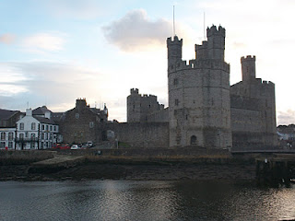
Carnarvon Castle over looks the harbour of this former Roman settlement, the most western outpost in Britainnia of that ancient empire. The white building to the left of the archway is called the Anglesey Hotel, which overlooks the Menai Straits and the Isle of Anglesey. This is where I stayed the night during my visit to Carnarvon.

Below are the ruins of a Roman settlement now looking west to the city of Carnarvon. On this 1,800 year old site are the remains of the Segontium Roman Fort, which reposes both adjacent to and across the way from Bob's place of residence.
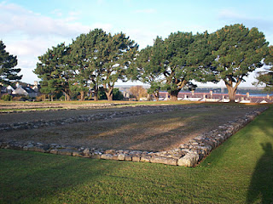
Carnarvon, a historic Welsh city which incorporates thousands of years of human habitations, reminds American Hollimans of the complexity of our British heritage. We are composed of Neolithic, Celtic, Roman, Angle, Saxon, Jute, Danish, Viking and French Norman DNA.
Mix this together, stir for several thousand years and one becomes British. Sail to the New World, add yet more cultures and races, plus several hundred additional years and one becomes an American.
More on Bob Hollyman-Mawson and his insights in the next post….

