Friday, April 12, 2013

When we were English LVI
by Glenn N. Holliman
Christopher Holyman makes his way in Elizabethan England...
Sometime in the late 1560s or 1570s, the persons, of which cumulative evidence indicates are my 9th great grandparents, married. They were Christopher Holyman, a son of Thomas Holyman (d 1558) who died in 1588 in Cuddington, Buckinghamshire, England and Margaret Lee, daughter of Thomas Lee of Dinton, Buckinghamshire. The Lees were substantial landowners and persons of prominence in Buckinghamshire. We shall explore this important maternal line in the next post.
According to professional genealogist, Anne Holmes of England, during the mid to late 16th Century the Holymans of Cuddington achieved their highest level of social and economic prominence. In that era, Elizabeth I securely held the throne, her Sea Dogs such as Francis Drake raided Spanish treasure ships, and the realm settled on a religious compromise between Roman Catholicism and rising Puritanism. That middle way is known as the Church of England, the Anglican Church if you will. In the United States, this form of Protestantism is known today as the Episcopal Church.
When Christopher and Judith Holyman (whom I contend were grandchildren of this first Christopher Holyman) arrived in Virginia in 1650, they were Church of England, no longer Roman Catholics as had been their grandfather at his birth. Nor were they non-conformists as was their distant cousin, Ezekiel Holliman, a founder of the American Baptist Church in the Rhode Island plantations.
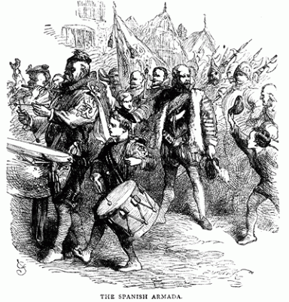

English soldiers mustered to repel the expected Spanish invasion in 1588, As an officer of the Queen's Guard, Christopher Holyman, d 1588, may have rallied with his men.
Thomas Holyman (d 1558) had numerous children and, as we noted in previous posts, according to the laws and customs of the time, the first born son, Richard, inherited the bulk of the estate. Our Christopher, who may have been a minor when his father died, received only some income from the harvest from one of the numerous lands of Richard.
Thus, Christopher and his brothers who inherited little had to make their own way in the world, generally through the church or the military, or one could step down the social ladder and become a tradesman. Alas, one of Christopher and Margaret's sons, one Thomas Holyman (d ca 1650) of Bedfordshire, inherited very little and became a member of the merchant class in the early 1600s, a story to be explored later.
Margaret Lee probably bought a substantial dowry into the marriage with Christopher and that no doubt eased his way in life. We know from several sources he was a prominent person in Sherington, Buckinghamshire, the location where he lived comfortably with his wife and growing numbers of children in the 1580s.
Seeking a career, landless Christopher joined the Army. When and where we do not know, but the year he died in 1588, he was a member of the prestigious Queen's Guard, a company of soldiers who served at the Queen's pleasure. To give us some idea of the status of this elite group, in the 1590s, a few years after Christopher's death, the famous Sir Walter Raleigh, a favorite of Queen Elizabeth, commanded the Guard. Raleigh, North Carolina takes its name from this entrepreneur, adventurer and later writer, who attempted to found the doomed Roanoke Colony in the 1580s.
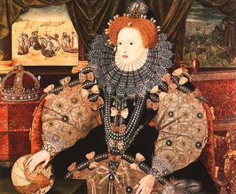

Above Elizabeth I, the Armada Portrait celebrating the victory of 1588.
The Queen's Guard survives to this day, well known to American tourists who have witnessed the Changing of the Guard in their bright red uniforms and tall bear furred head gear every day at 11 a.m. at Buckingham Palace, London.
Was Christopher called out during the feared invasion by the Spanish Armada in 1588? Was he in the field at Kent when Elizabeth marshaled the country's land forces in readiness? Did our 9th great grandfather hear his Queen forcefully proclaim that she had the feeble body of a woman but the heart of a king (such as her father Henry VIII)?
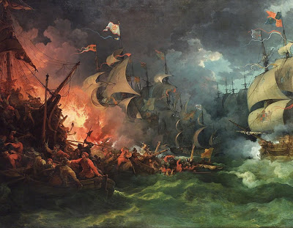

The English fire ships wrought havoc to the Spanish fleet as captured in this painting of the time.

Fortunately this gathering of English soldiers was never tested. At Gravesends, the courageous Sir Francis Drake maneuvered his smaller ships close to the hulking Spanish galleons. He sent fire ships to panic the anchored enemy fleet. Many of the larger, less agile Spanish titans, caught fire and burned. The panicked Iberian fleet scattered only to be battered by fierce storms that decimated the remainder of the shattered Spanish fleet. King Phillip II of Spain, once Elizabeth's brother-in-law, prayed aloud asking how he, a Catholic king, could have so displeased God?!
The invasion threat receded, the English soldiers returned home, but did our Christopher leave with the germ of a common killer of soldiers, a camp fever? He died in December 1588, not an old man.
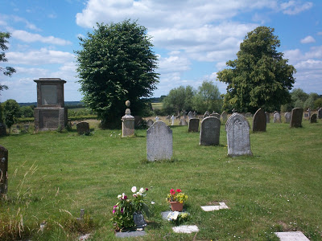

Above the parish cemetery in Sherington, England. Photo taken 2011.

Is Chris buried in the grave yard in Cuddington, his ancestral home, or in Sherington where he and his wife, Margaret Lee, raised their family of children, one being a young Thomas at the time of his father's death? We do not know.
Next Post, Christopher Holyman marries well into prosperous Lee family, wealthy and growing more so!

Friday, April 26, 2013

When We Were English, Part LVII
by Glenn N. Holliman
The Family of Margaret Lee Holyman....
This post continues our exploration of the life and extended family of Christopher Holyman, d. 1588, of Sherington, Buckinghamshire, England. Evidence indicates he is a son of John Holyman, d. 1558, of Cuddington, Buckinghamshire and that his grandfather was Christopher Clark of the same shire. This appears to be the origin of the first name Christopher which still appears to this generation in the Holyman families (and various spellings) in the United States.
Thanks be to the research of professional genealogist Anne Holmes of Buckinghamshire, England, we have information on the wife of Christopher Holyman, d. 1588. This person, whom I believe is a direct great grandmother of mine, was Margaret Lee of Moreton in the parish of Dinton, Buckinghamshire.
The Lees were a family of landed gentry, who settled in the area sometime in the 15th Century. Margaret's father was Thomas Lee who died in 1572. In his will, he does not describe himself as either gentleman or knight. However, his son, Thomas, Margaret's brother, who died in 1626 does describe himself as a knight in is Will, a person of high social status in Stuart England.
This brother-in-law of Christopher Holyman married Eleanor Hampden, the sister of Sir Alexander Hampden. After the death of Alexander Hampden in 1618, a major estate passed into the Lee family through Eleanor (his sister), that being the Hartwell House of Dinton.
Below in 2012, Anne Holmes and yours truly shared a pub meal in Aylesbury, Buckinghamshire and reviewed family history. Upon rising from the table, we discovered the print behind us was ironically of the Lee family Hartwell House. Photo by Barbara Holliman.
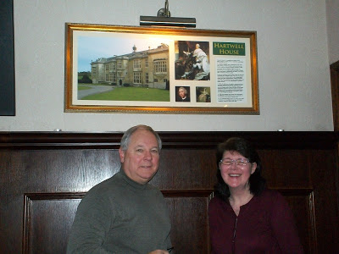

Anne Holmes speculates Thomas Lee, d 1626, acquired his knighthood possibly through the Hartwell Estate. "By the end of the 17th Century, the Lees had become Baronets. In contrast, the Holyman family star in Buckinghamshire was at its brightest in the mid 16th Century when Thomas Holyman (d 1558) had the manor of Cuddington and his kinsman, The Rt. Rev. John Holyman, was Bishop of Bristol.
In the mid 16th century, the Holyman and Lee families would probably have been seen as contemporary equals in social status hence the marriage of Christopher Holyman to Margaret Lee" write Mrs. Holmes.
Eleanor Lee (nee Hampden) would then be a sister-in-law to Christopher Holyman (d 1588). According to The Victoria County History of Buckinghamshire, Eleanor and Thomas had twenty-four children! This great aunt died in 1633, one would imagine of exhaustion, and is buried in Dinton, Buckinghamshire. The following plaque in the parish church records her 'achievement' and also her kindness to the poor. (Click on copy twice to enlarge.)
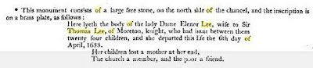

References for this article are found at http://www.british-history.ac.uk/report.aspx?compid=62771&;strquery=Lee and William Betham's late 19th Century publication The Baronetage of England
Next Post, more on the fascinating Lee family of Buckinghamshire....

