THURSDAY, MAY 5, 2011

The 'Holliman' Name
by Glenn N. Holliman
The Name Holyman and its Spelling Varieties
Recently I was perusing Archives.com, a subscription service, and clicked on Family History. Lo and behold, the site revealed the numbers of Holliman (and other various spellings) households in the U.S. and the states in which persons of this spelling reside. Here is what I found.
Holliman
This is the 4,999 (not 5,000 mind you) most popular name in America, and there are all of 1,350 households in the country with this name. Frankly, that is a tiny portion of perhaps 75 to 100 million or so residences in these United States. This confirmed my 'feeling' that there were not many of us out there.
Where do Hollimans live? As those of us who follow these things are generally from the southeast, and as Holymans entered North American in Jamestown, Virginia, the vast majority of us still live in the south and southwest. Here is a partial ranking of those of us who in Colonial times adopted an 'i' and dropped the 'y'.
Georgia - 15.3%
Mississippi - 14.4%
Alabama - 11% (my state of origin)
Arkansas - 9.1%
Texas - 8.4%
Tennessee - 5.4%
Oklahoma - 4.4%
Illinois - 2.7%
North Carolina - 2.4%
Virginia - 2.4%
South Carolina - only 1%
Hmmm....So the Hollimans left Virginia, settled for a while in North Carolina in the 1700s,and generally kept moving southwest to the states of the Old Confederacy. We did not go much further west than Texas and Oklahoma (California has all of 2% of the Hollimans). One group did go north to Illinois, perhaps African-American Hollimans who live in the Chicago area, part of the migration between the world wars?
No one of this spelling live in Maine, the Dakotas, Idaho, Wyoming, Nevada or Arizona.
Holloman
Let's try a variation on the name, Holloman. A bit more common - this spelling is 3,350 on the list or about 2,240 households in the entire country. What a difference a vowel makes! Again a very predominant Southern name.
North Carolina - 23.5%
Virginia - 11.6%
Texas - 7.1%
Georgia - 6.7%
South Carolina - 5.8%
Florida - 4.6%
Mississippi - 3.3%
Alabama - 3.1%
Tennessee 2.1%
Whoo...those descendants of Christopher Holyman, Sr (d 1691) who stayed in Virginia and migrated to North Carolina (and put down roots) tended to spell their name with an 'o' not an 'i'.
Holleman
This spelling, fairly common in Isle of Wight County, Virginia a ranks 10,490 as the most common in America; pretty low. There are about 1,350 families in America with this spelling.
Texas - 21%
North Carolina - 18%
Illinois - 5.1%
Tennessee - 4.8%
California - 4.6%
Michigan - 4.3%
Georgia - 4%
Mississippi and Okolahoma - 3.5% each
Virginia 3.3% or only 43 residences
Were a number of these Hollemans African-Americans who moved to Chicago and Detroit between the world wars? Perhaps the descendants of slaves from the deep south? Perhaps?
Hollimon
Opps...this spelling is the 30,255 most popular, pretty low in the name 'market'. There are only 260 residences of cousins who use an 'o', instead of the 'a' in the last syllable. And where do you live? No surprise, again the deep South.
Mississippi - 19.8%
Texas 12.1%
Georgia - 11.3%
Alabama - 7.4%
and so on....
Granted in the Colonial times and in early censuses (dare I say this) our ancestors and those dealing with official records may have lacked certain 'spelling skills' which has led to our various spellings. Whatever happened to Holyman and Hollyman, the names that show up in England and early Colonial records?
Hollyman
Strangely, the spellings of Holyman and Hollyman have disappeared (almost). Only 75 residences in the entire U.S. are labeled 'Hollyman'.
Illinois - 15.6%
Missouri - 15.6%
California - 15.6%
Does this suggest a later migration to the Colonies from another family? Virtually none by this name live in the Deep South as do the known descendants of Christopher Holyman, Sr. (or Hollyman).
Holyman
This is the spelling one will find in 16th and 17th wills in England, and yet in all the United States, only three residences have this spelling. One person each in Missouri, West Virginia and Pennsylvania.
Next post, back to the 19th Century....
So if you are descended from the three brothers, Charles, Warren and Cornelius Holliman, who immigrated to Alabama in 1836 from the Carolinas, you may wish to attend a Holliman Family Round Table at the Fayette County, Alabama Civic Center, October 15, 2011, 10 a.m. to 3 p.m. To reserve lunch, contact Glenda Norris at gnorris@bcbsal.org or Glenn Holliman at Glennhistory@gmail.com.

MONDAY, MAY 2, 2011

The Hollimans of Alabama
by Glenn N. Holliman
Back to the 19th Century...A Series of Articles on the Hollimans and Related Families of Fayette County, Alabama
We continue our series of the April 9, 2011 tour of Holliman sites in Fayette County, Alabama led by Glenda Norris, descendant of Christopher Holyman, Sr (1618 - 1691).
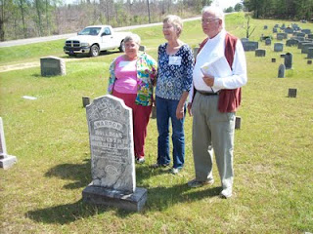
Above at the Chapel Hill Cemetery near Newtonville, Alabama are from left to right: Faye Gardner (Reform, Alabama), Jeanette Holiman Stewart (Austin, Texas) and Lenwood Holliman (Gordo, Alabama). In this April 9, 2011 photograph, they stand behind the grave of Civil War veteran Warren Holliman (1833 - 1908), a son of Charles Holliman (1795 - 1852), of whom the three are descended. Warren is misspelled Warren on his tombstone.
Warren Holliman's story...
In 1836, numerous children accompanied the three brothers, Cornelius, Charles and Warren Holliman, on their journey from the North Carolina/South Carolina border to Fayette County. One of the children of Charles Holliman and wife, Barberry (sometimes Barbara) Walters, was their son, Warren, age 3 at the time.
According to U.S. Census records Fayette County had a population of over 3,000 in 1830, and would more than double in size to over 6,000 in 1840 as immigrates moved west to the yet untitled soil of Alabama.
Warren married Mary Polly Blakeney, the daughter of Thomas and Sarah Kemp (or Roberts?) Blakeney. Thomas (1800 - 1892) was a son of William Blakeney and a grandson of Capt. John Blekeney (1732 - 1832). The Blakeneys had migrated to Alabama from Chesterfield, South Carolina. Warren and Polly would have 11 children, 3 girls and 8 boys which helped entrench the Holliman name in the area.
Warren's generation came of age as the American Union dissolved and Civil War engulfed our ancestors. Warren and his two brothers, Cornelius and Elijah, and cousins (including my great grandfather, John Thomas Holliman) joined with other Fayette Countians in enlisting in the 41st Alabama Infantry Regiment. Warren was known as the 'strong man' of the county. He could pick up a bale of cotton (500 pounds) and walk with it!
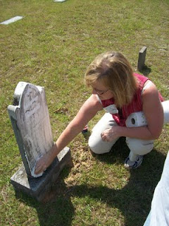
Glenda Norris uses a genealogical technique she learned from Rhodes Holliman, the application of shaving cream to faded tombstones, to reveal hidden names and dates. This is Warren Holliman's grave site.
In the next post, Warren Holliman's historic war service with the 41st Alabama Infantry Regiment....

MONDAY, APRIL 25, 2011

The Hollimans of Alabama
by Glenn N. Holliman

Back to the 19th Century...A Series of Articles on the Hollimans and Related Families of Fayette County, Alabama
Below are observations by Holliman family historian, Glenda Norris. She credits much of her knowledge to Dr. Rhodes Holliman, her uncle. It was Rhodes who, as a boy in the 1930s, would hike several miles into the piney woods, dodging more than a few snakes to re-discover the location for the family. Several monuments now mark this spot.

Glenda Norris reports:
"Charles Daniel Lucas, Jr. was the son of Charles Daniel Lucas, Sr. and 'Dorcas' (no last name has been found). It is believed that the mother of Charles Daniel Lucas, Jr. could be a Catawba Indian from the Pee Dee River area in Marlboro County, South Carolina. She was only 13 years old when she married Charles Daniel Lucas, Sr., a tailor. Their son, Charles Jr., was born on June 30, 1771 and died May 31, 1853."

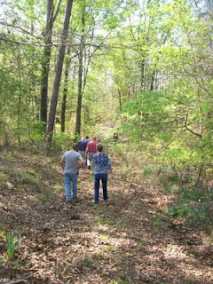
Above, on April 9, 2011, Holliman and Lucas descendants take the trail to the Lucas and Indian graves which are located several hundred yards through the woods off County Road 100 in south Fayette County.
"Charles Daniel Lucas, Jr. was a traveler and migrated from South Carolina to Alabama before the Holliman brothers. His first homestead was in Marengo County, Alabama where he purchased 80 acres on October 20, 1823 and then 80 more the next spring. Two years later, he established a homestead in Fayette County, and still ambitious, 40 acres on October 16, 1834 in Tuscaloosa County.
The Fayette and Tuscaloosa properties were connected, almost touching Highway 171 on its east side. He was a deacon at the Spring Hill Baptist Church in Tuscaloosa County. A monument at the church celebrates he and Cornelius Holliman, a son-in-law, as ‘founders’ of this church.
Charles Jr. earned his living 'stock dipping' and as a Federal Indian agent. Newtonville, Alabama straddled the line between the territory of the Chickasaw (north) and the Choctaw (south). By 1836, all these land claims were extinguished. In a dreadful and, even in that day, controversial act, most of the Native Americans remaining were removed to Indian Territory (present day Oklahoma).
With the dispersal of the tribes, the Federal government sold the land to immigrant families from the south east U.S. - the Hollimans, Lucases and other associated families.
Charles Lucas, Jr. claimed to be ‘black Dutch’, a term at the time to obscure one's possible Indian ancestry but this has not been proven, only speculated. He was a man of large stature (6’4” - 6’6”) and had great strength. It has been passed down through generations that Charles Daniel killed a panther with his bare hands.
His burial site is in southern Fayette County, Newtonville area off of County Road 100 (Walnut Lane). At one time this land belonged to Charles Jr. and his home was not far from the burial site. His grave is on a ridge line, over looking a ravine. The site is an Indian burial ground as he chose to be buried with his friends."
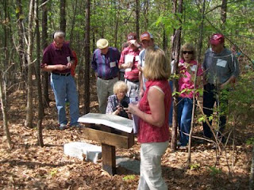
Glenda Norris, foreground, provides information at the internment site and memorials to Charles Daniel Lucas, Jr. The site contains numerous Choctaw or Chickasaw Indian burials, disturbed in an earlier century by grave robbers.
"Charles Daniel Jr. was married to Mary Hasten (in some places spelled Hastings). They had 10 children together. Family historians suggest that Charles Daniel ‘over disciplined’ one of his children with his cane. This did not go over very well with his family and because of his temper, his wife, Mary and the rest of his children left him and moved to the Bluff community. Due to this estrangement Mary Hasten Lucas was buried at the Spring Hill Cemetery, 20 or so miles north of this pioneer’s resting place."

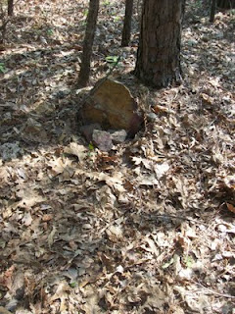
This original stone marker stands on the burial site of Charles Daniel Lucas, Jr., pioneer and Indian agent, who helped open Northwest Alabama to Anglo and African American settlement in the early 19th Century.
When Charles Daniel Lucas, Jr. was born, George III, was sovereign over the American colonies. When Charles Jr. died, Franklin Pierce had just become president of the United States, a union on the verge of dissolving."

For additional information on Charles Daniel Lucas, Jr., go to Archives and the February 13 and 26, 2010 editions of this blog. Rhodes Holliman incorporated his own research and that of his father, Cecil Holliman and the late Walt Holliman to create some excellent articles that are available for all to read. Some of the general information for these postings comes also from Robert Scott Davis's book, "Tracing your Alabama Past" (University of Mississippi Press, 2003).

More soon on the Holliman migrations across the Southern United States from the 17th to the 19th Centuries....Information and your written insights always welcome as we share together.
Posted by Glenn N. Holliman at 7:25 AM 0 comments
Labels: Charles Daniel Lucas, Glenda Norris, Mary Hasten Lucas
Newer PostsOlder PostsHome
Subscribe to: Posts (Atom)

