FRIDAY, MAY 21, 2010

A Salute of our Family's World War II Veterans: Part 2
"If there must be trouble let it be in my day, that my child may have peace."
– Thomas Paine
Our second account is a personal one. My great uncle, RalphHolliman, was kind enough to take the time to write about his experience during the war. His description of life on a troop transport ship is an image I will not soon forget. - Grace
World War II: My Story
by Ralph Holliman
(photo: Ralph Holliman 1944)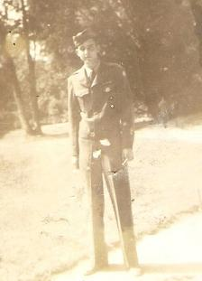
First of all, I want to say that I never shot at, nor was I shot at by anyone while in the service. I am not a hero. Having said that, I will try to give a short history of my two and a half years in the service to our country.
In late January, 1943, I visited the draft board to see where my name was listed and when I might be called up. They always kept a list posted in the window. Naturally, when I found my name , I learned that I would be the very next person to be called. So in March 1943, five months short of my 19th birthday, I found myself at Fort McClellan in Anniston, AL. (On the 21st of February, Motie Chism and I were married). After a few days at Fort McClellan, I was moved to Fort McPherson in Atlanta. After a couple of weeks of physical, mental and other examinations, I was on a train to an unknown destination. To my happy surprise, I realized we were heading south and to the Tides Hotel, Miami Beach, FL. I was assigned to the Air Corps (later called Air Force).
While at Miami, we had basic training: learning how to shoot a gun, calisthenics, getting up at dawn and learning to say, "Yes, Sir" and salute. After a couple of months there, I was sent to Denver, Colorado for further training. En route to Denver, our train stopped in Birmingham but I was not allowed to get off or call Motie or Mama and Daddy. Army rules. After Denver, I was sent to Sacramento, California with the idea that I would end up in the Pacific. As it turned out, I was put on a troop train and traveled across the country to Newark, New Jersey. (If you want a thrill, spend more than a week on a troop train with no air conditioner.)
After Newark, in October, I was on a troop ship headed for Europe. One thing that I learned quickly was to not volunteer for anything in the Army. I learned this when they asked for volunteers to stand watch on the ship’s gun turrets while crossing the Atlantic, four hours on and eight hours off. With no knowledge of what to do while on duty, it was fortunate that we did not encounter a submarine. On duty during the winter at three o’clock in the morning in the North Atlantic is not my idea of a cruise.
With several thousand soldiers on board, our living standards left a lot to be desired. Our sleeping quarters were stacked four or five high. When eating, we stood at a long table, and when the ship changed directions, our trays would slide down the table and would come back to us when the ship righted. The weather and seas were not smooth and a lot of men would get sick. The line to the latrine was always long. After a visit to the latrine, you would usually get back in line because you knew that by the time you could get in you probably would need it.
Twenty-one days later, we landed at the Firth of Clyde, Scotland. After that I was stationed in Bournemouth, England on the English Channel until D-Day. On D-Day I was stationed in Oxford and later was moved to Creil, France, about thirty-five miles north of Paris. At that time I was in the 326th Ferrying Squadron of the 9th Air Force. The 9th Air Force had the fighting planes (P47 and P51) and the 8th Air Force had the heavy bombers (B17 & B24).
While at Creil, (I was a Staff Sergeant by this time), the Germans decided to make a final thrust at the Battle of the Bulge. Due to the shortage of Army infantrymen to meet this thrust, they began calling men from the Air Force who were under the rank of S/Sgt. so I missed this action. The war finally ended and I was in Paris on V-E day. You can imagine what an experience that was.
In the summer of 1945 after V-E Day, I moved about from place to place - Germany, Belgium and ended up in Marseilles, France on my way to the Philippines through the Suez Canal. President Truman authorized dropping the atomic bomb on Japan and the war was over. I came home on the ship that was scheduled for the Pacific. In October, 1945, I landed at Newport News, Virginia and received a forty-five day furlough. While at home, I had enough points to be discharged.
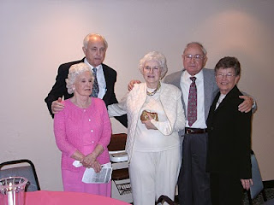In 2002, Ralph (back left), his wife, Motie - the girl he married at age 18 in 1943, his sister, Virginia Holliman Cornelius and his brother, Bishop Hollimanand wife, Ellen, gathered to celebrate Virginia's 80th birthday in Texas.
As I look back over that time of my life, I realize how fortunate I was to survive the experience without the suffering that so many of my fellow soldiers endured. It is my hope that someday the leaders of this world will find a better way to solve their differences than sacrificing the lives of so many people and that there will be peace in this world.
Next week, we tell the story of Ralph's brother, BishopHolliman, my grandfather who served in the U.S. Navy during World War II. - Grace
Posted by Glenn N. Holliman at 6:00 AM 0 comments
Labels: Ralph Holliman, WWII

FRIDAY, MAY 14, 2010

A Salute to Our Family's World War II Veterans, Part I
Duty is the most sublime word in our language. Do your duty in all things. You cannot do more. You should never wish to do less. ---Robert E. Lee
World War II, 1939-1945, was a time of horrible destruction, hatred and sadness. Young men, with the support of women, were asked to leave their homes to fight an aggressive enemy on foreign land. They went to Europe, Africa, and the Pacific, places they had only heard of, or read about, in school books. These soldiers witnessed the atrocities of modern warfare, yet, upon their return home, were able to build the foundation for the superpower nation we live in today.
In his book, Tom Brokaw aptly describes the men and women of the WW II era, "… it is, I believe, the greatest generation any society has ever produced."
Over the next four weeks we take time, and the Weblog space, to pay tribute to some of the WWII Veterans in our family, and to the veterans of every great generation.
- Grace Holliman
A Soldier's Duty
by Norman Holliman
My father, August Harold Holliman, was born in Burleson County, Texas, September 27, 1923 and passed away March 11, 1991, much too young. My mother was born November 2, 1928 in Maryville, Tennessee and survives him.
Dad enlisted in the Army on May 19, 1944 at Fort Sam Houston in Texas. He was sent to the front lines in France and Germany where he was in the Battle of the Bulge (December 1944-January 1945). He reported that, in some places, he had to walk in thigh-high snow in sub zero conditions.
One evening my father was on guard duty. When he finished his watch, he went to the campfire to get his replacement. The soldier who was to replace my father said, "The hell with them, let them come and get us.” Instead of going to the CO (commanding officer), my dad pulled his replacement’s shift in that unbearable snow and almost lost his feet to frostbite.
When I asked my dad why he didn't do something about the soldier’s reply he said, "I knew what he was going through. He was having a hard time dealing with the circumstances.” My father was humble like that; of course he was a Holliman!
When my father got to the hospital in England, his feet where black with frostbite. The good nurses rubbed his feet nonstop with alcohol, relieving each other periodically. My dad made it home and was medically discharged from the Army on August 2, 1945 with a Purple Heart and the European – African – Middle Eastern Campaign Medal. My father was a rifleman in his service to his country.
Later in his life, my dad was the Post Commander at the local VFW inRockdale, TX. I hope any child who has a father who is, or was, a veteran of any war can admire him as much as I admire my father!
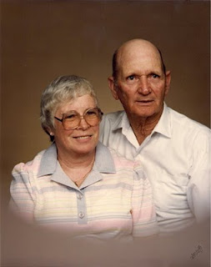
Right, a photo of August Harold Holliman and wife, Betty. They married June 25, 1957.
Next week, we highlight the war service of a distant cousin of Norman's, William RalphHolliman. Norman and Ralph, who is the youngest son of Ulyssand Pearl CaineHolliman, share a great grandfather, John GrantsonHolliman (1850-1836), who fought North Carolina Tories and the British Army in 1780 during the American Revolution. Additional information on Norman and Ralph can be found in our Contributor's page.
Posted by Glenn N. Holliman at 5:30 AM 0 comments
Labels: August Holliman, Norman Holliman, WWII

FRIDAY, MAY 7, 2010

Our Family's Colonial Era, Part V
Tobacco and Our Family
by Glenn N. Holliman
As noted, our great grandfather Christopher Holliman Sr. acquired much land in Virginia. By the time of his death in 1691, he left 1,020 acres, along the Blackwater River and Mill Swamp (purchase completed 1684), to his four sons.
Christopher Sr. was also well respected in the community. The Thomas Pittman family tree website reports that in 1671 Christopher Sr. was witnessing deeds, and in 1676, joined other leaders in the Isle of Wight community who signed a petition concerning Nathaniel Bacon's ill-fated rebellion against the Royal Government.
There is some information that Sr. may have been in the shipping business, probably with some brothers and later with his son,Richard Holliman. In 1702 Richard Holliman transported enough persons to Virginia to claim over 1,000 acres of land through the Virginia headright system. If one imported, or paid for the importation of an immigrant, the transporter received 50 acres in land per person.
The shipping sketch portrays one of
the fragile sailing ships of the time. Note the
barrels of tobacco being loaded for England.
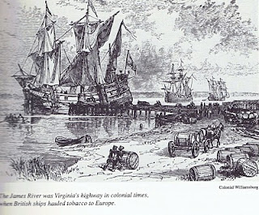
Most assuredly the Holliman family grew tobacco (Christopher Sr.’s will mentions tobacco barns). They probably hauled hogsheads to the river where it was then shipped to England. Tobacco as a commercial crop was first developed by John Rolfe, Pocahontas’s husband, in 1610s.
Thus began an ecological and social alliance with tobacco and slavery; two items that would shape the future of our family and country.
Next week, we will take a break from the 17th century and visit the 20th century through some Holliman World War II veterans. My daughter, Grace, has edited several articles sent in by relatives honoring all Hollimans for their service. In June we will continue our tour of Colonial Virginia and look further back to our Holliman English roots.
Posted by Glenn N. Holliman at 5:33 AM 0 comments
Labels: Christopher Holliman Sr., Thomas Holliman
Newer PostsOlder PostsHome
Subscribe to: Posts (Atom)

