MONDAY, MAY 23, 2011

The Hollimans of Alabama
by Glenn N. Holliman
Back to the 19th Century...A Series of Articles on the Hollimans and Related Families of Fayette County, Alabama

Below, H. Bishop Holliman, great grandson of Samuel T. Walker, and Glenda Norris, 3 great grand daughter of Samuel, stand at his grave at Pilgrim's Rest Church in Fayette County, Alabama. Glenda led a tour on April 9, 2011 of Holliman and associated family cemetery sites. Glenda and two cousins, Normanand Robert Holliman, are attempting to have installed a Confederate tombstone marking the incredible military service of this family ancestor. Samuel (1820 - 1900) was one of the 7,000 or so troops left in Lee's army when he surrendered at Appomattox!
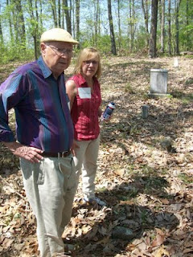
The late Cecil Rhodes Holliman (1901 - 1980) has written extensively on the Walker family and in later postings the history of the Walkers and especially Samuel will be explored. One of Samuel Walker's daughter's, Martha Jane, married John Thomas Holliman (1844 - 1930), a grandson of Cornelius Holliman and son of Uriah Holliman (1820 - 1862). John Thomas and Martha Janes Holliman had five children, one being Glenda's great grandfather, James Monroe Holliman. Another child was Ulyss Holliman (1884 - 1965), the father of Bishop Holliman, above.
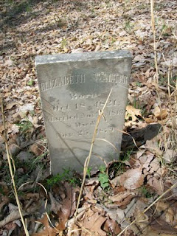
Located near Samuel's resting place at Pilgrim's Rest is his wife,Elizabeth Walker (1821 - 1879), mother of Martha Jane Walker Holliman.
More next week on the Hollimans and associated families....
Plan now to attend the Holliman and Associated Families Genealogical Round Table at the Fayette County, Alabama Civic Center, 10 am to 3 pm, Saturday, October 15, 2011. Sessions on the Holymans from England to Alabama, Holliman sites in Fayette County, Alabama, and general sharing of Associated Families material. All invited! For information and reservations for lunch, contact Glenda Norris at gnorris@bcbsal.org or Glenn Holliman at Glennhistory@gmail.com.
Posted by Glenn N. Holliman at 7:28 AM 0 comments
Labels: Bishop Holliman, Glenda Norris, Norman Holliman, Robert Holliman, Samuel Walker

MONDAY, MAY 16, 2011

The Hollimans of Alabama

by Glenn N. Holliman
Alabamians Crossing Paths
During my recent sojourns to my native state of Alabama, I have been staying with my first cousin Mary and her husband Elliot Clayton (E.C.) Herrin. I have known E.C. since his marriage toMary Daly in 1951. As am I, Mary is a 3 great grand child ofCornelius Holliman (1792 - 1862) who immigrated to Fayette County, Alabama as a pioneer family from South Carolina in 1836. Mary and E.C. have raised a family of four and now have six grandchildren. After service in the U.S. Navy and graduating from Howard College (now Samford University), E.C. in the 1950s worked as an accountant in the Birmingham steel industry. However, he had an ambition to be an attorney.
Below, the lovely Mary Daly Herrin, the year before her marriage to E.C. Herrin in Irondale, Alabama. Her parents are the lateRobert W. Daly, Sr. and Vena Holliman Daly. Mary is the grand daughter of Ulyss and Pearl Caine Holliman, Irondale, Alabama and great grand daughter of John Thomas and Martha Walker Holliman, Fayette, Alabama. Her 7th great grandfather is Christopher Holyman, Sr. (1618 - 1691), the founder of the Holliman families of Virginia and America. On the Daly side of her family are Irish ancestors who engineered railroads in 19th Century Alabama.
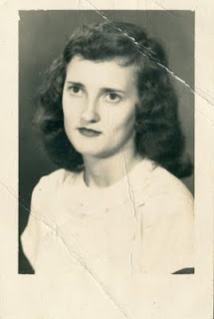
In a punishing schedule, strongly supported by Mary and the family, E.C. Herrin went to law school for years, sometimes three to five nights a week. In 1964, he passed the Alabama Bar and in 1967 became the municipal judge for the city of Helena, Alabama. In 2011, now 81 years old, he continues to hold court for the city twice a month. He is the longest serving municipal judge currently on the bench in Alabama, a distinguished record of service. He may be the longest serving municipal judge in Alabama history!
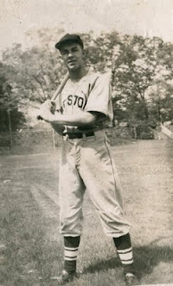
E.C. Herrin has loved sports all his life and played sandlot ball many afternoons as a youngster. Above he is in his high school baseball uniform in the 1940s. A favorite childhood companion was John Thomas Vaughan, another youngster growing up in the Depression in a small town in east central Alabama. Born in 1932, Dr. Tom Vaughan became a outstanding veterinarian and served for 18 years as the 6th Dean of the College of Veterinary Medicine at Auburn. Today, the large animal hospital at the University of Auburn is named after the well-respected and well-known Dr. Vaughan. (photo above)
These Alabamians Crossed Paths!
While these two children played their sandlot games prior to World War II, an old dignified Black man used to stop and watch. After a time, he came to know the boys by name. "Hello, Mr. E.C., Hello, Mr. Tom", he would say in the parlance of the pre-Civil Rights era. And in the societal manner of a different age, the two boys, eight or nine years of age, would respond to the ancient figure, "Hello, George, how are you today?" This happened on numerous occasions.
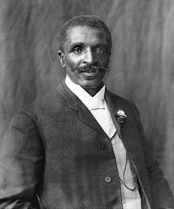
E.C. has never forgotten the kind, older African-American gentleman who died in 1943. Who was the man who befriended these two children? He was the distinguished Alabamian, a former slave who did his scientific work at Tuskegee Institute - none other than the legendary George Washington Carver, who revolutionized agriculture in the South! The above photo of Dr. Carver was taken in 1906.
More in the next post on the Hollimans and Associated families of Alabama....and paths that crossed....
Plan now to attend the Holliman and Associated Families Genealogical Round Table at the Fayette County, Alabama Civic Center, 10 am to 3 pm, Saturday, October 15, 2011. For information and reservations for lunch, contact Glenda Norris at gnorris@bcbsal.org or Glenn Holliman at Glennhistory@gmail.com. Sessions to include Tracing the Holymans from England to Alabama, Holliman Farm Sites in Fayette County and sharing of information on Associated Families. All invited!
Posted by Glenn N. Holliman at 3:09 AM 0 comments
Labels: E.C. Herrin, George Washington Carver, Mary Daly Herrin, Tom Vaughan

MONDAY, MAY 9, 2011

The Hollimans of Alabama
by Glenn N. Holliman
Back to the 19th Century...A Series of Articles on the Hollimans and Related Families of Fayette County, Alabama
Warren Holliman (1833 - 1908), A Civil War Veteran of the 41st Alabama Infantry Regiment
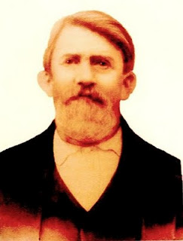
Above Warren Holliman (1833 - 1908) took a .58 mini-ball to the arm on August 17, 1864 during the siege of Petersburg, Virginia, knocking him out of the Civil War. At age 29, he signed up for the conflict with his relatives and neighbors with the 41st Confederate Alabama Infantry. This storied regiment was at Stones River, Chattanooga, Knoxville, Richmond and Petersburg before surrendering with General Robert E. Lee at Appomattox, Virginia in April 1865. After three months in a Richmond hospital, Warren was sent home in November 1864, his war effectively over. Photo and information from the extensive files of Dr. Rhodes Holliman, family historian, and Vonceil Duckworth, descendant ofCornelius Holliman. More on Warren and his military adventures in later posts.
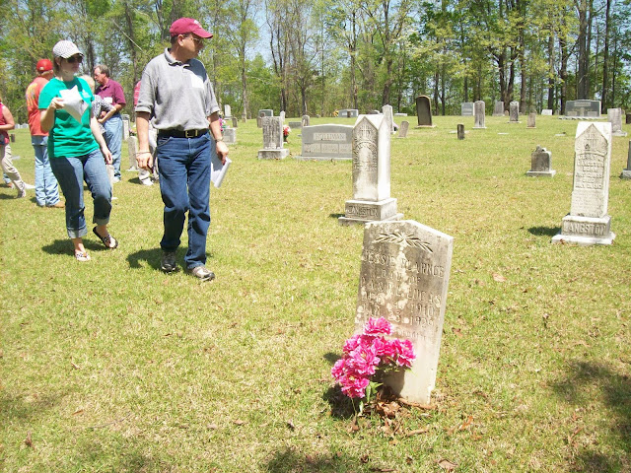
Above on a warm, sunny April day, 2011, Bill and his daughter,Joey Holliman, look for Holliman grave stones at Chapel Hill Cemetery in Fayette County, Alabama. Warren Holliman and his two wives are buried at Chapel Hill (see previous article). Bill Holliman, a multi-great nephew of Warren, is a 3rd great grandson of Cornelius Holliman (1792 - 1862).
Now living in Mississippi, Bill grew up in Irondale, Alabama, a grandson of Ulyss (1884 - 1965) and Pearl Caine Holliman (1887 - 1955), who migrated from Fayette County to Jefferson County in 1917 to take advantage of employment opportunities in the Birmingham area. This migration from rural Alabama communities to metropolitan areas accelerated during the World War I era. Today, descendants such as Joey and Bill return to Fayette, Lamar and Tuscaloosa Counties to discover family roots and stories.
More soon on the Fayette County family tour led by Glenda Norris, a 4th great grand daughter of Cornelius Holliman.
Plan now to attend the Holliman and Associated Families Genealogical Round Table at the Fayette County, Alabama Civic Center, 10 am to 3 pm, Saturday, October 15, 2011. For information and reservations for lunch, contact Glenda Norris at gnorris@bcbsal.org or Glenn Holliman at Glennhistory@gmail.com.
Posted by Glenn N. Holliman at 1:57 AM 0 comments
Labels: Bill Holliman, Cornelius Holliman, Joey Holliman, Rhodes Holliman, Vonceil Duckworth, Warren Holliman
Newer PostsOlder PostsHome
Subscribe to: Posts (Atom)

