SUNDAY, MAY 20, 2012

When We Were English, Part XIL
A Visit with Distant Cousins
by Glenn N. Holliman
After visiting Bob Hollyman-Mawson in Carnarvon, Wales, United Kingdom in November 2011, he and I drove over to the quaint village of Porthmadog to rendezvous with a retired chemist (that's a pharmacist in the U.S.), another Hollyman. Peter Hollyman's family left Somerset in the 1800s and moved to Cardiff and other cities across the channel from England.
Peter Hollyman on the left below and Bob Hollyman-Mawson do what Englishmen do when in Wales (or England or Scotland) and that is enjoy a glass of bitter at lunchtime. This picture and others were taken in Porthmadog which lies at the foot of the Snowdonian mountain chain.
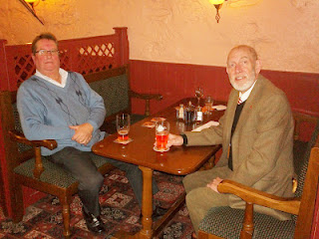
Peter is retired after a career as chemist and owner of several shops. His grandparents hail from Somerset, but the family moved to Cardiff in the 1800s. In time, Peter matriculated at the University in Cardiff, Wales majoring in pharmaceutics. After a stint in London, he moved his growing family west to Wales in the middle 1970s.
Below, three distant cousins in Wales on a blustery day in November 2011. Left to right and enjoying life after six decades are Bob Hollyman-Mawson, Glenn Holliman (the writer of this blog) and Peter Hollyman.
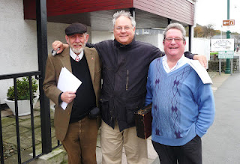
What I learned from Peter is, that like Bob, his family came out of Somerset near Bath, England. Unfortunately the family research cannot take either back past the early 1600s. Question - how are the Somerset (and now Welsh Hollymans) related to the Holymans of Buckinghamshire in the 1500s? Did the Rt. Rev. John Holyman (1495-1558) take along some nephews with him when in 1554 he assumed the Episcopate in the Diocese of Bristol? Bob has some hints he and I will share later in other posts.
Another theory is that Hollymans in Worcestershire floated down the Severn River (easy enough to do) and landed in Somerset. As I wrote last year in this space, we have records of Hollymans (spelled several ways of course) inhabiting the west country of England.
Below, Peter Hollyman points to Transportation Island in the Porthmadog bay where ships used to drop their ballast and load Welsh slate from the Snowdonia mountains. Peter is pointing also to the east, and to the east I drove to learn more about the Somerset Hollymans.
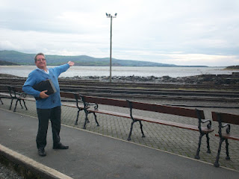
In later writings, more about our United Kingdom roots thanks to cousins such as Bob and Peter....
Posted by Glenn N. Holliman at 4:18 PM 0 comments
Labels: Bob Hollyman-Mawson, Glenn Holliman, Peter Hollyman

SATURDAY, MAY 12, 2012

When We Were English, Part XL
by Glenn N. Holliman

That Holyman Manor House

Below is the site of the 15th Century Holyman Manor House in Cuddington, Buckinghamshire as it looked in 2010. Today it is pasture land as part of the remaining Holyman farm.

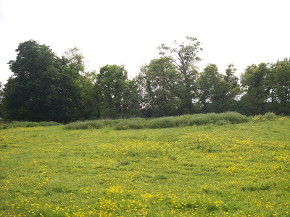
In 1851, a survey was done of the farm and the document below records what was left over a century and a half ago.

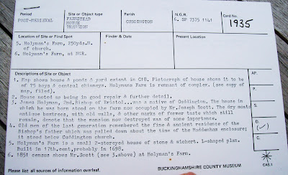

Notice item 3 above in this statement about a post-medieval site. James (an error; it is John) Holyman is listed accurately as the 2nd Bishop of Bristol. A Mr. Joseph Scott lived on the property in the middle 1800s. Dry moats, boxtrees and old walls still stood at that time and that ‘the masion now destroyed was of some importance’. Item 4 states that house lasted until the early 1800s. A smaller 1698 stone and thatched cottage as well as stables do remain in 2010.

What might have this manor house looked like?

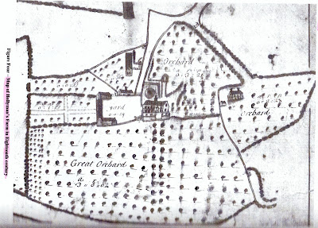
The map above from the 1700s gives us some idea of the size of the farm and a look at the Holyman manor house. It appears to be three floors (dormer windows and attic as the 3rd floor) with a small tower and wind vane on top center.

By the 1700s, the Holymans must have been producing considerable cider judging from the number of apple orchards.

What more can be learned? I must return to the archives in Aylesbury, Buckinghamshire for more research. For now, thanks to the current owner (Caroline Stonham) of the Holyman farm in Cuddington, we have the above and a view into our ancestral past.

Next a Visit to more Hollymans in the United Kingdom!

Posted by Glenn N. Holliman at 10:02 AM 0 comments
Labels: Bishop John Holyman, Cuddington

MONDAY, APRIL 30, 2012

When We Were English, Part XXXIX
A Deeper Look into Buckinghamshire Roots
By Glenn N. Holliman

Cuddington, some nine miles from Aylesbury and forty or so miles east of London, was and is a small village. There is a pub and an ancient village church. If you look below at this hand drawn map provided by Carolyn Stonham, a professor who lives in Holyman House (1698) on the site of the 15thCentury Holyman Manor House (long since decayed), one can understand better the dimensions of the small town.

This map is in three parts. The bottom half shows Cuddington in relationship to Aylesbury (right) and the M-40 (left), a major motorway which flows west toward Oxford and east toward London.

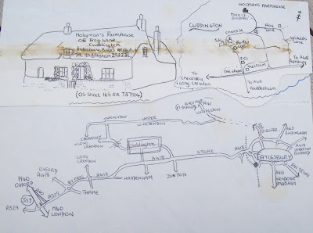

The upper right part of the map is a visual of the village with the Holyman Farm in the upper middle. The left upper part of the map is the 1698 Holyman House where Professor Stonham lives today, a thatched roofed cottage. Unfortunately the remains of sticky tape have marred the map a bit.

If one recalls my last article, I advanced the thesis that one Thomas Holliman of Cuddington (will – 1558) is a direct grandfather of mine. Hmmm…if so who begat Thomas and when and from where did these Cuddington Holymans appear?

Below is another document Professor Stonham shared with me and which my wife copied with our digital camera. This is a muster and tax roll representing two generations. The muster certificate is from 1522 and the manorial survey from 1555.

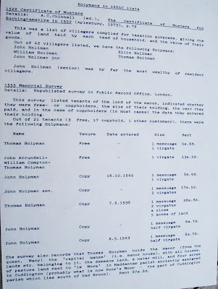

Notice that a Thomas Holliman is listed on both. In the earlier document, John Holiman is the wealthiest. In the later document, Thomas Holyman (Holiman) is recorded as the person with the most wealth. Is this Thomas my generation’s 10th great grandfather?

This Thomas Holyman did quite well, holding the manor and land granted by Queen Mary Tudor. Let’s reflect a bit….Mary Tudor tried in her reign from 1553 – 1558 to restore the Roman Catholic Church to England. Her Cardinal Pole appointed a parish priest and former monk, John Holyman of Cuddington, as Bishop of Bristol. John died in 1558, one month after Queen Mary.

Did the Holyman family in Cuddington benefit from the benevolence of the Queen because the family, especially The Rt. Rev. John Holyman, was loyal to the old faith, the Roman Catholic Church?

Did the fortunes of the Holymans begin to unravel with the establishment of the Protestant Church of England during the long reign of the next queen – Elizabeth from 1558 – 1603?
Did the surviving Holymans flow with the times?

One notes from published sources that Chistopher Holyman (will – 1589) of Cuddington and Sherington is listed as a member of Queen Elizabeth’s guard. Hmmm….much to consider and a lot of questions that cannot be easily if ever answered.

Let's keep researching and pondering....
Posted by Glenn N. Holliman at 9:49 AM 0 comments
Labels: Bishop John Holyman, Thomas Holyman
Older PostsHome
Subscribe to: Posts (Atom)

