Friday, May 10, 2013

When We Were English, Part LVIII
by Glenn N. Holliman
More on the Lees and Holymans of Buckinghamshire...the Story Continues....
The research on the Lee and Holyman family connections has been gathered by professional genealogist Anne Holmes of Buckinghamshire, England. Her sources include William Betham's 1805 work 'The Baronetage of England', George Lipscombe's 1847 volume 'The History and Antiquities of the County of Buckingham' and the peerage.com at http://www.thepeerage.com/ , the Ashmolean Museum web page on brass rubbings in churches in Buckinghamshire and 'The Victoria County History of Buckinghamshire on line at http://www.british-history.ac.uk/ . Anne Holmes also has a blog of Buckinghamshire history at www.bucksancestors.co.uk .
The person I believe to be my 9th great grandfather, Christopher Holyman (d 1588) married Margaret Lee of Moreton, Buckinghamshire sometime between 1572 and 1578. A son of Thomas Holyman (d 1558) of Cuddington, Buckinghamshire, Christopher could have been born anytime between 1538 and 1557. Thus he died young possibly only in his 40s.
Margaret was the daughter of Thomas Lee who died in 1572. Margaret's mother was Ursala Yates Lee. This Thomas had a father named Francis Lee, whose father, John Lee, died in London in March 1503. John's father was one William Lee who died in October 9, 1486. William's wife was named Anne.
The Lee's evidently originated in High Legh and Lyme in Cheshire. During the overthrow of King Richard II in the 1390s, the family supported the reigning Richard and later underwent 'persecution' for opposing the successful new king, Henry IV. The family then settled in Moreton in the parish of Dinton, Buckinghamshire adjacent to Hartwell.
One of the oldest monuments in the Dinton church is of William Lee, Esq. and Anne, his wife. For five generations the Lees resided at Moreton, where the ruins of the house surrounded by a moat are still visible. Below, the church in Dinton where Lees worshipped and were buried prior to the early 1600s. This pictured was made by Anne Holmes in May 2013. Christopher Holyman (d 1588) and Margaret Lee may have married at this church.
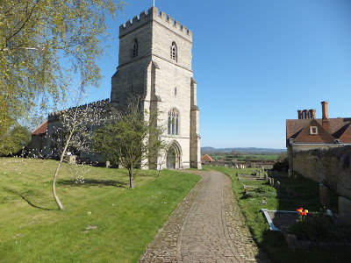
Margaret Lee Holyman's brother, another Thomas Lee (d 1626) married an Eleanor Hampden (they had 24 children as described in a previous post). When Eleanor's brother died, the Lees acquired the manor house Hartwell and Thomas, the title of Knight. By the middle of the 1600s, the Lees had become barons.
Below the Hartwell House today is a National Trust hotel with a storied past. For photos of the current house with beautiful interiors click on www.hartwell-house.com/the-hotel . Photo taken November 2012.
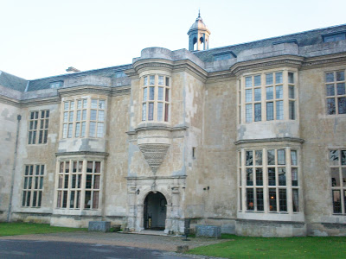

Below, the chapel at Hartwell House where Lees were entombed beginning in the early 1600s.
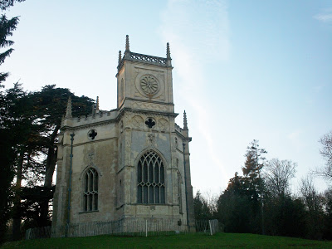
The monument below hangs in the parish cemetery at Cuddington, historic home of the Holyman families of America. This 19th Century Lee is probably a distant cousin of the Holymans. Eleanor and Thomas Lee of the late 1500s had so many children that Lee became a popular name in Buckinghamshire. Some authorities speculate this is the origin of the Robert E. Lee family of Virginia but this has not been proven one way or another. Photos taken November 2012.
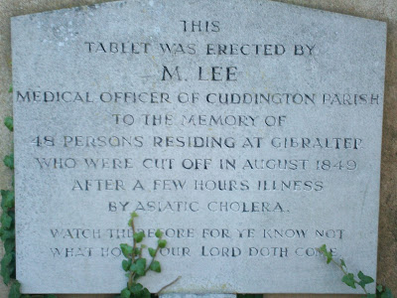
While the Lee family 'star' continued to rise in the 17th Century, some Holyman descendants of the Lee line moved down the social and economic scale. And that story will take us up to the momentous decision of another Christopher Holyman (1618-1691) to stake his fortune and future in Virginia in the year 1650.

Next posting on England examines of the children of Christopher and Margaret Lee Holyman....

Sunday, May 26, 2013

Isaac Holliman - A Story of the Old South, Part I
by Glenn N. Holliman
Last year in this space, Sandi Royal of Virginia, told the family story of her great great grandparents, one a former slave and one a slave owner's daughter, who defied the severe mores of the 1800s, eloped, married and against social odds raised a family. In the 21st Century descendants of this couple, Isaac and Ann Gray Holliman, gather regularly in southeast Virginia to celebrate their history and family. In October 2012, my son, Christopher S. Holliman, and I joined several of these descendants to explore our shared history in Isle of Wight County, Virginia.
This is a story of people connected by history and family....
As the tobacco and later cotton culture of the southern colonies and later states took hold in the 18th and 19th Centuries, some Holliman families, descendants of Christopher Holyman (who died in 1691 without owning other human beings), purchased slaves. We know this because in their Wills, these Hollemans (of various spellings) devolved persons in bondage to their off-spring.
Due to the lack of legally recording early births in Virginia, we have an incomplete understanding of family relations, especially so among African-Americans, most of whom were held as slaves. In addition, marriage was not legally recognized or recorded for slaves. Indeed part of the special horror of southern slavery was that husbands were sold away from wives and children, and children from their parents.
As generations passed these African-Americans who had lost their language, their religions and their very names, adopted European names and melded the remains of their past with the emerging culture of a new United States. Persons held in bondage took the names of the slave owners, and hence today, especially in southeastern Virginia, one will find numerous African-American Hollimans who have gone on to prosper in the New World.
Which leads us into the story of Isaac and Ann Gray Holliman....
Below, soy bean fields and autumn wild flowers on the original farm of Christopher Holyman, who came to Virginia in 1650 from Bedford, Bedfordshire, England and farmed in Isle of Wight, Virginia until his death in 1691.
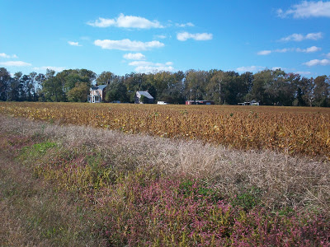
Below some descendants of Isaac Holliman and Ann Gray on an autumn tour in southeastern Virginia to explore ancestral sites. Right to left are Cyndi Barnett, Tammy Hunt, Doris Knox and Robert Royal, husband of Sandi Royal. This photo was taken October 2012 on a bridge overlooking the Blackwater River in Isle of Wight County, Virginia, the area where Isaac and Ann Gray Holliman lived after the Civil War. The original Christopher Holyman plantation was established along the Blackwater River and Mill Swamp bordering Surry County. Hollemans today of African and English descent still live in these first settlements of what became the United States.
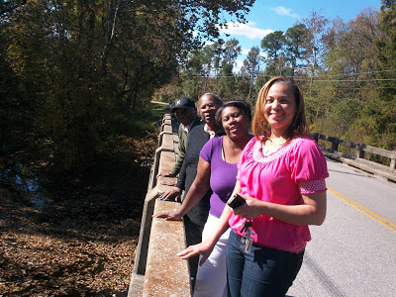

Next posting, more of the amazing story of Isaac and Ann Holliman and their American legacy....

