SUNDAY, JULY 4, 2010

When We Were English, Part V
The Turbulent Life of The Right Rev. John Holyman, Installment 2
by Glenn N. Holliman
Below we continue the paper of John Holyman that Miss Peggy Cattell presented in 2005 to the Cuddington Historical Society, Buckinghamshire, England.
"John went to school in Winchester (a prestigious school, second only to Eaton), probably at the age of eleven and developed into a fine scholar. From there he entered New College, Oxford and was awarded the Bachelor of Divinity in 1526. For a short time he was rector in Colerne (in Ireland) but this did not suit him. He turned to Oxford, this time to Exeter College, where he acquired a Doctor of Divinity degree.
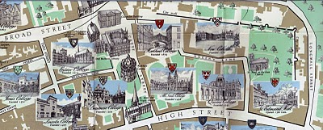New College, top right on the above map, is just inside the Old City Wall in Oxford. Not so new, New College was founded in 1379. Center left of the map is Exeter College, a bit older founded in 1314.
"After this second time at Oxford, Dr. Holyman became a monk at St. Mary's Abbey, Reading."
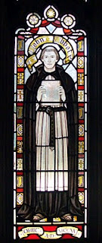This stained glass window at the Bristol, England Cathedral is of the founder of the abbey which later became the Cathedral where The Rt. Rev. John Holyman presided from 1554 - 1558. Brother John Holyman, when a monk, would have worn a habit such as above and had tonsured hair. Photo by Barbara Holliman.
"By this time, he was known as a brilliant scholar, a man of great piety and most eloquent preacher - fine qualities but not ones to blaze his name over the country, but this was soon to come. "
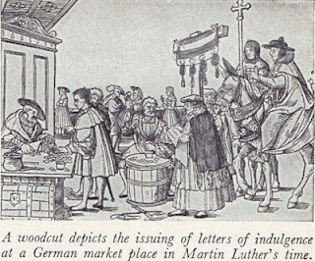"The age in which he was living was one of great religious upheaval. Up to 1517 all of Europe belonged to the Roman Catholic Church owing allegiance to the Pope. In Germany, Martin Luther spoke out again the selling of indulgences - that is people being offered the chance to buy themselves absolution from their sins. Luther believed that only through faith in Jesus Christ could sins be absolved. His concerns spread and a wide rift developed in the church. Those who protested again the Pope and Roman Catholic Church came to be known as Protestants."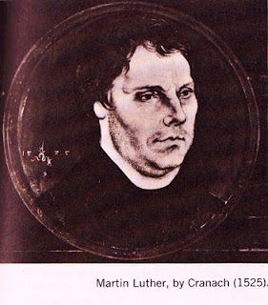

" Holyman's abbot became concerned at what he described as this Lutheran Heresy spreading to England and he sent his best preacher up to London to speak against these thoughts at St. Paul's Cross. And so Holyman was thrust into the centre of this important conflict!" (Speaking at St. Paul's Cross in the 1500s would be today's equivalent of appearing on all the major television news channels.)
In the next posting, the Reformation and a Royal divorce engulf King Henry VIII, his Queens Catherine and Ann Boleyn, Cardinal Thomas Wolsey, Sir Thomas More and our own Brother John Holyman.
Posted by Glenn N. Holliman at 11:00 AM 0 comments
Labels: Ann Boleyn, Henry VIII, John Holyman, Queen Catherine

MONDAY, JUNE 28, 2010

When We Were English, Part IV
The Turbulent Life of The Rt. Rev. John Holyman, First Installment
by Glenn N. Holliman
The small village of Cuddington, Buckinghamshire, England is approximately 12 miles from Tring, Hertfordshire, the believed homesite of John Holyman (1572 - 1650). Another John Holyman, The Rt. Rev. John Holyman, lived earlier during the eventful times of the Tudor kings and queens. This earlier John played a role in attempting to forestall the Protestant Reformation in England. While we do not know his lineage, time, place and name suggest we American Hollimans carry some of his DNA. A ancestral cousin or uncle? I would say the odds favor such, and perhaps some day we can connect all the dots.
It was while researching Holymans in the Tring Library, I came upon the incredible news that a Holyman farm existed in nearby Cuddington, and that Bishop John Holyman had been born there. Cousin Maxine Wright of Arkansas had emailed a blurb on this John Holyman several months earlier alerting me to the existence of this particular Holliman. Within the hour, my wife and I drove to the village and indeed visited the Holyman farm, met the present owner, and the next day interviewed one of the village historians, Miss Peggy Cattell. We spent several hours with Miss Cattell and her sister, Nancy, collecting information and papers.
What follows is the first portion of a paper presented in 2005 to the local historical by Miss Peggy Cattell (photo below right) which we reproduce with her permission.
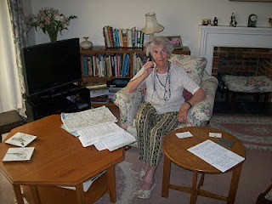
"They Lived In Cuddington"
" It was in 1495 that John Holyman was born. Records don't give any further information about his life in Cuddington, other than that he was born here but the family home was probably a manor house in the field near to the present Holyman's Farmhouse."
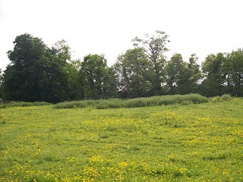On the site of this grassy knole on the west side of Cuddington stood the manor house of the Holyman family in the 15, 16 and 17th centuries. Today this field stands fallow on still existing farm land.
"Another and more accurate assumption can be made that he must have been baptised in Cuddington Church, in the font which we still use. The font goes back well before his day. We know that the font was moved into its present position in the south aisle from the north aisle in the later part of the nineteenth century."
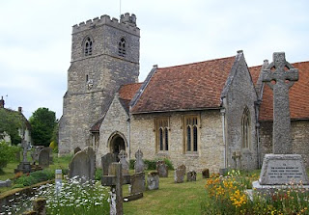
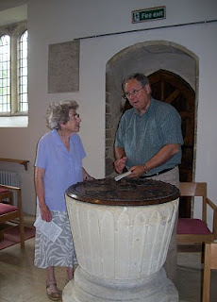
The photo above right is the exterior of the Cuddington parish. The above left photo is of the baptismal font which is over 500 years old. Miss Nancy Cattell is on the left, and the author on the right taking notes. Photos by Barbara Holliman.
"We can say for certain that his parents brought him through the present north doorway, and from the list of vicars we can assume that the incumbent of that time - William Burtone, priest from 1494 to 1511 - must have performed the baptism."
In the next post, we continue our study of the turbulent life of Bishop John Holyman....
Posted by Glenn N. Holliman at 10:26 AM 0 comments
Labels: Bishop John Holyman, Maxine Wright

FRIDAY, JUNE 25, 2010

When We Were English, Part III
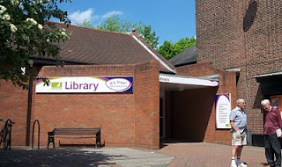A Holyman in the Late Middle Ages
by Glenn N. Holliman
In the local history section of the Tring, Hertfordshire library (photo to the left with patrons in front) there is a book entitledA History of Tring by Sheila Richards, a denizen of the area. Published in 1974 by the Tring Urban Council in Hertfordshire, it contains many stories, family names and records. While recently pursuing this work I found on page 53 the following information that was translated from middle English.
From the Court Rolls of the Manor of Tring - Courts 28 May, 18 June and 9 July 1444 (yes, 1444, not 1944!)
"Plaint Continued: the plaint between William Holyman, defendant, and Richard Brame of Chedyngdon, plaintiff, in a pleas of trespass, is continued by order."
Observations?
1. Holymans had surnames by the 1400s as did most English by this century.
2. Holymans lived in Tring two centuries before American founder, Christopher Holliman, sailed for Virginia in 1650.
3. This complaint of trespass may have involved a stray animal or William planting a crop on Brame's leasehold. Everyone leased from the Lord of the Manor or shared the common fields surrounding Tring. This lack of personal land is what attracted many of our ancestors to America.
4. As the complaint was continued to another day, perhaps it was settled out of court (just as most legal complaints are today).
There is another mention of William on page 54. He is listed as a juror to decide a leasehold inheritance on shared common town lands known as Goldfield and Bulbourne crofts surrounding Tring.
Observations on this entry?
1. Whatever William's issue in the trespass complaint, it did not keep the judge from appointing him to a jury that summer.
2. Although English common law was in its infancy, the jury system was working, wills were common and so were lawsuits in England by the 1400s.
3. To be appointed to a jury is a compliment indicating some standing in the community. Hats off to our William Holyman. I hope he is one of our great grandfathers. At least he lives in the community which we believe saw the birth to Christopher Holliman, Sr.
Unfortunately, I have found no further records on this William YET. Nothing else in this book on him. Thomas Cromwell, Henry VIII's chancellor, in 1538 required all churches to keep parish records on baptisms, marriages and deaths. Too late for this 15th century William. So where to look? Manorial Court records? Yes. And where are they? Alas, at the Public Record Office in Kew, near London. Did this William have a will? Here is an English government web site to explore: http://www.nationalarchives.gov.uk/.
The Middle Ages were Ending
What was happening in our England of 1444 when this possible Holyman ancestor was having legal troubles?
A weak king, Henry VI (photo below) occupied the throne from the first year of his life 1422 until deposed in 1461. He would have made an excellent monk, but was a poor king. He is the only English sovereign to have been crowned in both England and France. His mind was unbalanced and when a protector stepped in to serve the crown, a civil war broke out. The Houses of Lancaster and York began fighting the War of the Roses.
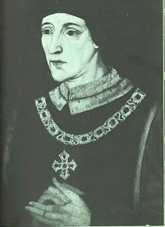
France and England were near the end of their Hundred Years War. Henry's father, Henry V, had conquered a considerable portion of France during his short reign. However, the French reclaimed almost all of their land during Henry VI's time on the throne.
This was the period when the charismatic Joan of Arc (her photo below) revitalized the French army. The English nobles, not at all pleased by such a turn of events, burned her at the stake as a witch. Remember, this was the Middle Ages, and burnings would continue even in the English colony of New York until the 1700s. Nasty way to shuffle off one's mortal coil.
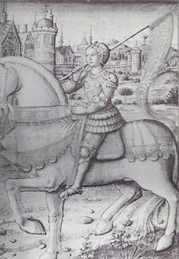
Next post, more adventures with our Holyman ancestors....

