TUESDAY, JUNE 14, 2011

The Hollimans of Alabama
by Glenn N. Holliman
Back to the 19th Century...A Series of Articles on the Hollimans and Related Families of Fayette County, Alabama
Spring Hill Cemetery in Bluff, Alabama is the final resting place of a pioneer ancestor who made the trek from the Carolinas to Alabama in 1836, raised a large family, survived the Civil War although losing a husband and two sons, farmed, midwifed and lived to be 94 years old. Family lore has her enjoying her 'flowers' - her 'Four Roses' - deep into her final years.
"Mary Polly Lucas Holliman, January 2, 1819 - July 5, 1913, Pioneer Strength, Integrity, Human Kindness"
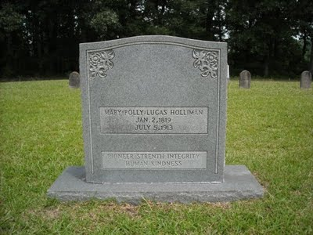
Even thought 'strenth' may be mis-spelled, this grave stone speaks eloquently of the wife of Uriah Holliman, 1817 - 1862. As Dr.Rhodes Holliman, a great, great grandson has written (see Archives of this blog, March 2010 and copy below), Polly buried a husband and son (Charles Daniel Holliman) at Okalona, Mississippi after the Battle of Shiloh in 1862. Sick herself, she rode home, raised the children remaining and lived to the age of 94. During the decades after the war she served as a mid-wife, delivering many of her own grandchildren.
"In 21 years of married life, Mary Polly and Uriah would produce 13 children - seven boys and six girls. She could hitch up a mule to a plow and till the soil as well as any man. While maintaining her farm, she became the only source of medical assistance in her community as a herb doctor, caregiver, and midwife to many of her neighbors. She would accept appeals for help from all over the area, saddle up a mule and ride out to provide services." - Dr. Rhodes Holliman
Below family members, four of whom are direct descendants of Polly Lucas Holliman, gaze over the Spring Hill Cemetery in the Bluff community of Fayette, County. Left to right: Wally Allen, Jean Holliman, Tommie Holliman Allen, Bill Holliman, Bishop Holliman (great grandson of Polly Lucas) and Jeanette Holiman Stewart. Bishop Holliman,b 1919, is a first cousin of Rhodes Holliman's father, Cecil Rhodes Holliman (1903 - 1982).
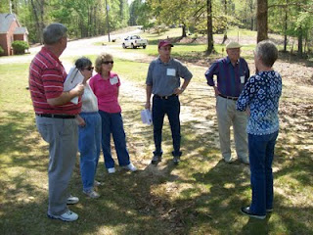
On that early April day in 2011, when sixteen Holliman descendants traveled through Fayette County, the trees were leafing out in pastel green. One noticed that the soil of Fayette County could not decide if it wanted to be red clay or sandy stone and rock. Both pine and oak thrive in the ravines and on the ridges adjacent to the Sipsey River that flows north to south through the county. Swamps cover many areas near the river bottoms. From this soil our 19th Century ancestors harvested cotton, corn and lumber. Hogs and cattle grazed in the woods and pastures. Below the ground, coal emerged, and today oil and gas flow deep from the Alabama earth.
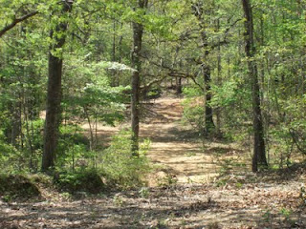
Above, a dirt road winds off from the Bluff cemetery
Next more posts on the Hollimans of Alabama....
Plan now to attend the Holliman and Associated Families Genealogical Round Table at the Fayette County, Alabama Civic Center, 10 am to 3 pm, Saturday, October 15, 2011. For information and reservations for lunch, contact Glenda Norris at gnorris@bcbsal.org or Glenn Holliman at Glennhistory@gmail.com. Sessions to include Tracing the Holymans from England to Alabama, Holliman Farm Sites in Fayette County and sharing of information on Associated Families. All invited!
Posted by Glenn N. Holliman at 1:24 AM 0 comments
Labels: Bill Holliman, Bishop Holliman, Jean Holliman, Jeanette Stewart,Mary Polly Lucas Holliman, Rhodes Holliman, Tommie Holliman Allen,Wally Allen

TUESDAY, JUNE 7, 2011

The Hollimans of Alabama
by Glenn N. Holliman
Back to the 19th Century...A Series of Articles on the Hollimans and Related Families of Fayette County, Alabama

The Visit to Caine's Ridge, a Family Excursion in 2011
Lecturing on family history near the burial sites of this paternal and maternal grandparents is 91 year old H. Bishop Holliman (in purple shirt with cap). As a boy he used to visit John Thomas andMartha Jane Walker Holliman, his paternal grandparents at their last home near the Fayette train depot. One of his memories is sitting on their porch on the south side of town watching the trains come into town.
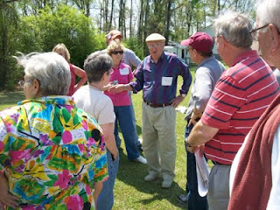
Below in a photograph taken in either 1928 or 1929 are John Thomas and Martha Jane Walker Holliman standing in front of their home in Fayette. John would died in 1930 and Martha Jane in 1931. The young man sitting on the porch in a white shirt and tie on the far right is 10 year old Bishop Holliman!
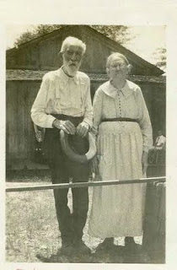

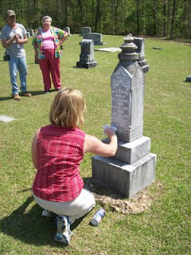
Cleaning the Caine monument is Glenda Norris using shaving cream. When gently scrapped off, the cream reveals difficult to read letters. Glenda credits her Uncle Rhodes Holliman for the process. In the background are Robert Holliman and Faye Gardner.
Bishop Holliman's father was Ulyss Holliman (1884 - 1965) who grew up in Fayette, married Pearl Caine (1887 - 1955) in 1906, and removed to Jefferson County, Alabama in 1917 in search of increased income for his growing family. Pearl Caine's grandparents, William Ellison and Melissa Anthony Caine, lie buried under the gravestone above. It was Pearl's grandfather who gave the land for the church.
The journey to explore Holliman and their families continues in the next post....
Plan now to attend the Holliman and Associated Families Genealogical Round Table at the Fayette County, Alabama Civic Center, 10 am to 3 pm, Saturday, October 15, 2011. For information and reservations for lunch, contact Glenda Norris at gnorris@bcbsal.org or Glenn Holliman at Glennhistory@gmail.com. Sessions to include Tracing the Holymans from England to Alabama, Holliman Farm Sites in Fayette County and sharing of information on Associated Families. All invited!
Posted by Glenn N. Holliman at 9:36 AM 0 comments
Labels: Bishop Holliman, Glenda Norris, John Thomas Holliman, Martha Jane Walker Holliman, Melissa Anthony Caine, William E. Caine

TUESDAY, MAY 31, 2011

The Hollimans of Alabama
By Glenn N. Holliman
Back to the 19th Century...A Series of Articles on the Hollimans and Related Families of Fayette County, Alabama
April 9, 2011 distant cousins from six states gathered in Fayette County, Alabama to discover and rediscover ancestral grave sites. The picture below was taken at Caine's Ridge Baptist Church cemetery where lie John Thomas and Martha Jane Walker Holliman and members of the associated family of Caine.
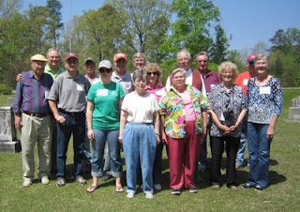
Left to right, Bishop Holliman (Indiana), Glenn Holliman(Pennsylvania), Bill Holliman (Mississippi), Robert Holliman(Tennessee), Joey Holliman (Alabama), Norman Holliman(Tennessee), Wally Allen, Jean Holliman, Tommie Holliman Allen, Faye Gardner, Lenwood Holliman, James Franklin (Frank) Holliman, Vonceil Duckworth, Tyler Duckworth(all from Alabama) and Jeanette Holiman Stewart (Texas). The photograph was taken by Glenda Norris, organizer of the excursion.
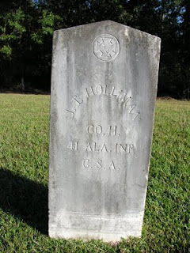
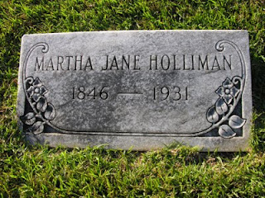
The earthly remains ofJohn Thomas andMartha Jane Walker Holliman lie side by side at Caine's Ridge, a few miles south of their former home in Fayette. The story of John Thomas Holliman is told in its sad glory by one of his great grandson's Rhodes Holliman in this blog, February and March 2010. Please go to the Archives function and to seek the articles.
More next posting on the Holliman and their associated families in Fayette County, Alabama.
Plan now to attend the Holliman and Associated Families Genealogical Round Table at the Fayette County, Alabama Civic Center, 10 am to 3 pm, Saturday, October 15, 2011. For information and reservations for lunch, contact Glenda Norris at gnorris@bcbsal.org or Glenn Holliman at Glennhistory@gmail.com. Sessions to include Tracing the Holymans from England to Alabama, Holliman Farm Sites in Fayette County and sharing of information on Associated Families. All invited!
Posted by Glenn N. Holliman at 9:13 AM 0 comments

