MONDAY, JUNE 21, 2010

When We Were English, Part II
by Glenn N. Holliman
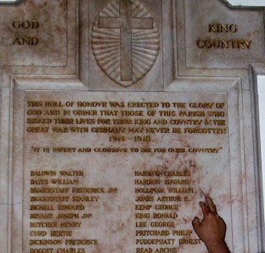With the exception of the historical painting of Elizabeth I below, the other photos in this blog are of memorials to Hollimans and others in St. Paul's parish, Chipperfield, Hertfordshire, approximately 25 miles northwest of Central London.
August 31, 1997, my wife, Barb, and I assembled for the baptism for our godson, Joseph Jeffries, at St. Paul's Anglican parish inChipperfield, Hertfordshire, England. What should have been a day of joy, instead was a sad morning. Princess Dianna, formerly Princess of Wales, and her boyfriend, Dody Fahad, had died in the early hours in a Paris car crash.
The priest, a lady of whose gender there were only a few at that time in all the England Church, prayed for the repose of the departed souls as she attempted to turn the congregation’s attention to the welcoming of Joseph into the Christian family. Ironically, Diana’s car had smashed itself to a compressed block of metal, plastic and human flesh in a tunnel just a block from where Barb worked the year before at the capital campaign for the American Cathedral in France.
With these conflicting thoughts tumbling through our heads, we ventured to gaze around the lovely neo-gothic nave. Good grief! The walls were covered with war memorial plaques in memory of Hollimans and other villagers! Had we stumbled on to the ancestral home of the Holliman clan? Much evidence indicates that yes, the English Hollimans (or Holleman, Hollyman, Hollomon, etc.) did establish themselves or at least some of the family in Hertfordshire, England around the villages of Chipperfield and Tring, located 30 or so miles northwest of London proper. Other villages with Hollymans were Berkhamsted, Aldbury, Cholesbury and Cuddington.
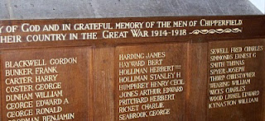
Most of our American genealogical trees begin with one John Holyman, born 1572 in Tring, Hertfordshire. This was during the reign (and rule) of that magnificent Tudor queen, Elizabeth I. Anglicanism had replaced the Roman Catholic faith in the land, helped along by several burnings at stakes of recalcitrant Catholics and not a few Spanish Jesuits who sought to return England to the Old Faith. The friction between Spain and England, exacerbated by privateers Drake and Raleigh, eventually led to the sailing of the Spanish Armada of 1588.
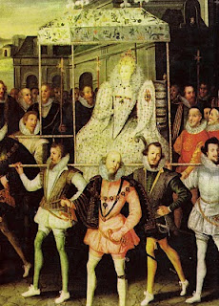This is Robert Peale's painting of Queen Elizabeth being carried by her devoted courtiers.
Elizabeth called out the able bodied men of England to repel the invader if the embryonic English fleet was not able to do so. One wonders if John Holyman and our kinsmen did not muster on a village green with pike in hand?
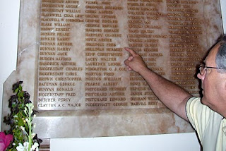
It is obvious from these memorials that in the last two World Wars, numerous Holliman kinsmen mustered with their English regiments, and sadly all did not return.
More on the English Holliman's in the next posting!
Posted by Glenn N. Holliman at 8:00 AM 0 comments

THURSDAY, JUNE 17, 2010

Yes, Christopher Holliman Still Lives In Virginia!
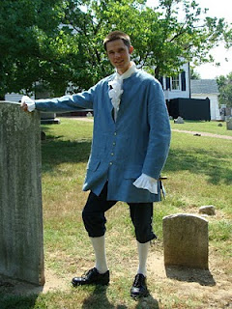by Christopher S. Holliman
At right is Christopher Holliman (b 1978), a 9th great grandson of Christopher Holliman, Sr. (d 1691) dressed in his Colonial reenactment costume at St. John's Episcopal Church, Richmond, Virginia. Chris gives tours to visitors at this historic site on Saturdays and Sundays during the summer months.
St. John's Church is a National Historic Landmark in recognition of it being the site where Patrick Henry gave his famous "Liberty or Death" speech. With such men as George Washington and Thomas Jefferson in the audience, St. John's Church was, for a few days in March 1775, the center of the American Revolution. Visitors come to reconnect with this historical moment, and I'm lucky to be one of the people that they may meet while they are here.
A typical day here includes giving tours to school groups, walking tourists around the cemetery and church, and generally interpreting history for them. My favorite part of the job is meeting people that come from all over the world and care deeply about history.
On Sunday afternoons in the summer we provide a reenactment of Patrick Henry's speech at the church. Costumed actors perform the various roles of the famous patriots. We pack the church for each performance, and the energy in the room is absolutely electric. It's like watching history come to life.
So, if you are traveling in Virginia this vacation season, stop by Richmond and meet both Patrick Henry and me, Christopher Holliman, a relative of those who read this Weblog. For information on and directions to this Colonial history site, visithttp://www.historicstjohnschurch.org/. Hope to see you soon! "
When not providing historical interpretations, Chris is a librarian with the Henrico County Library system. His three-year-old daughter, Camille, is a 10th, possibly 11th generation American (if we count John Holyman, d 1650 as the first generation). Yes, Chris is the brother of Grace Holliman, and son of Glenn Holliman, who prepare this blog.
Posted by Glenn N. Holliman at 3:49 PM 0 comments
Labels: Christopher Holliman

WEDNESDAY, JUNE 16, 2010

When We Were English, Part I
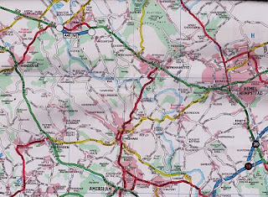
Some First Thoughts on Our English Roots
by Glenn N. Holliman
This map is somewhat dated, but in the upper left hand corner is Tring, Hertforshire, England. Just to the east of it is the little village of Aldbury and south is Cholesbury. To the west of Hemel Hempstead is Berkhamsted. Toward the lower right hand corner is the tiny village of Chipperfield. In left center is Wendover, and to the west, but not on this map, is Cuddington. London is off the map to the southeast. There is evidence that Holymans and Hollimans lived in these villages and towns.
I have had the pleasure of traveling to England numerous times in my life. As I have become older, my interest in family history has grown. Recently, my wife and I invested a number of days researching Holliman history in an area approximately 25 to 30 miles from the center of London. These towns and villages were Tring, Aldbury, Cholesbury, Cuddington, Chipperfield and Berkhamstead in both Hertfordshire and Buckinghamshire.
In graduate school, (gasp 40 years ago!) I studied history and know that primary evidence is crucial to any research. There is a popular and evidently well-researched Holliman family tree website that lists John Holyman (1572 - 1650) as the direct line of our family, born in Tring, Hertfordshire and died in Southampton, Virginia. Unfortunately, no one has yet shared with me the hard evidence of this birth and death date or the fact that the gentleman ever existed. This does not mean that facts do not exist somewhere; it is just that I have not seen such or discovered it in my research.
Let me quickly say that hard primary evidence exists for our first American Holliman, one Christopher Holliman, Sr, who died in Isle of Wight County, Virginia in 1691. We have his will and many legal records. Unfortunately his birth place and date are still a matter of conjecture.
You might want to review the map above because in our next post we will explore our English roots. Internet sites suggest this is not the only part of England where Hollimans may have lived in the 17th century, but I'll begin our journey in the Chiltern Hills around Tring. More on this subject soon.
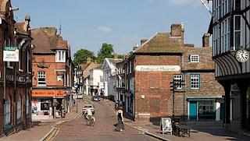High Street in downtown Tring, Hertfordshire, a town over 1,000 years old.
Posted by Glenn N. Holliman at 7:00 AM 0 comments
Newer PostsOlder PostsHome
Subscribe to: Posts (Atom)

