WEDNESDAY, JULY 28, 2010

When We Were English, Part XI
by Glenn N. Holliman
More on the Holyman Farm, Cuddington, Buckinghamshire, England

In the past few posts, I have been sharing information and photographs of a Holyman farm, described in some English sources as a former 15th century manor house. In the photobelow is a contemporary plaque attached to one of the barms, now a residence. This sign celebrates the name of the farm and its most famous namesake, Brother John Holyman (1495 - 1558), a monk and later the Rt. Rev. John Holyman of Bristol. Photo by Barbara Holliman
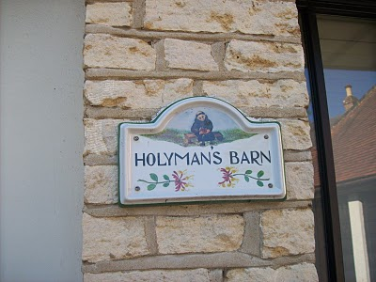
Below from The Monuments of Buckinghamshire is a description of the 17th century thatched cottage that we have featured in previous posts (see archives). Click twice and the manuscript will enlarge.
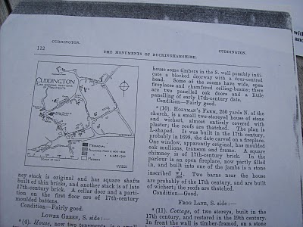
The current owner of Holyman Farm, Mrs. Caroline Stonham, has prepared the following family tree of the Holyman family and others that lived on the property. Perhaps it is of some use to those studying deeply into our English past. Through it one may be able to connect the family to our other English ancestors reportedly from Tring and/or Bedford. Where there are no last names, insert Holyman.Again, click twice and the document will enlarge. Photos by Barbara Holliman
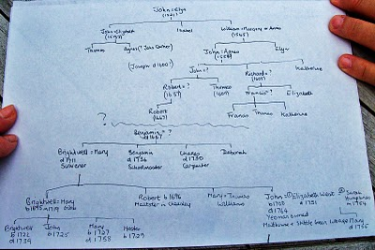
Next posting, more research on our English roots....
Posted by Glenn N. Holliman at 4:29 PM 0 comments
Labels: Bishop John Holyman, Caroline Stonham

FRIDAY, JULY 23, 2010

When We Were English, Part X
by Glenn N. Holliman
Continuing the Search for our Ancestors in England
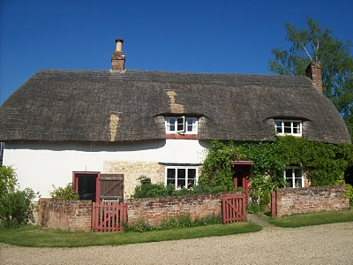In the above 17th century thatch cottage lived great nieces and nephews of The Rt. Rev. John Holyman who was born on this farm in 1495. Numerous legal papers and research tell of the family. Beloware copies of research from Caroline Stonham, current proprietor of the Holyman Farm in Cuddington, Buckinghamshire. Click on the documents to enlarge them.
Page 1
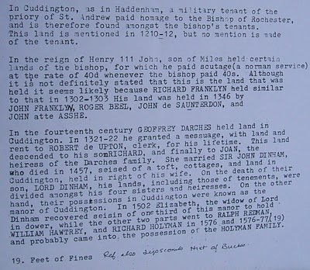
Page 2
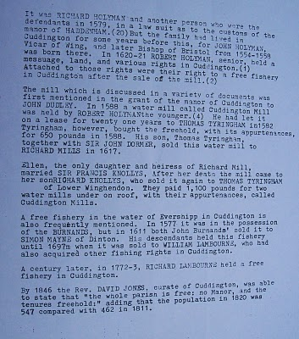These documents may be of use to any Hollimans who research our English roots....unfortunately the names of JohnHolyman (1572 - 1650) and Christopher Holliman (1631? - 1691) have not appeared in documents from the Holyman Farm. The search continues for our direct ancestors....
Posted by Glenn N. Holliman at 4:45 PM 0 comments
Labels: Bishop John Holyman, Caroline Stonham, Cuddington

WEDNESDAY, JULY 21, 2010

When We Were English, Part IX
by Glenn N. Holliman
Bishop John Holyman's Will, 1558

In my recent postings, I have been chronicling the life and times of The Rt. Rev. John Holyman, probably a distant uncle of our Hollimanfamily. During my recent visit to the village of Cuddington,Buckinghamshire, England, this photograph (below) was taken of Mrs. Caroline Stonham and myself in the back garden of her 17thcentury thatch cottage.

What is remarkable about this cottage is that it rests on theHolyman farm, and Holymans used to live in the residence in this photograph!
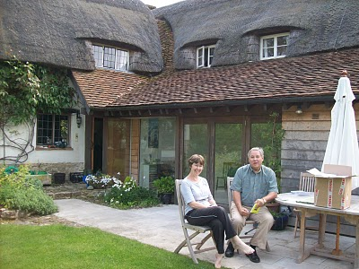
In an earlier posting, I dropped in a photograph of the location of the old 'manor' house where 16th century Holymans lived, approximately 200 yards from where Caroline and I are sitting.
We are reviewing Holyman papers she has collected in the twenty years she has lived on the farm. She is a geography teacher and has a keen appreciation of the history of her home. She kindly shared of her research and gatherings with me, allowing my wife to photograph the many documents. With her permission, I now share them with you.

One of the papers we reviewed is below. It is the 1558 will of Bishop John Holyman. It is a transcription but it does contain a bit of Shakespeare era English. Being celibate, John had no children, but he did have servants whom he remembered and he left funds to colleges and the parish where he is interred. Notice he left funds to pray for the repose of his soul. For one who had been a monk, and had taken a vow of poverty, he left a sizable estate although no land.
If one places the cursor over the document and clicks, the will should enlarge for easier reading.
Page 1
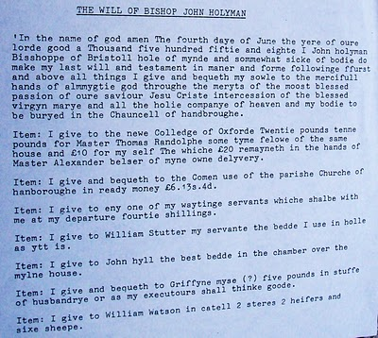
Page 2
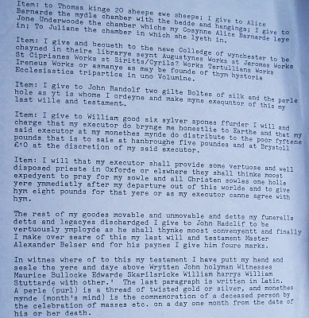
This will was transcribed under the direction of Bob Hollyman-Mawson of Wales, for whom we all are indebted.
Next posting, more on the Holyman farm and family documents in Cuddington, Buckinghamshire, England....
Posted by Glenn N. Holliman at 4:58 PM 0 comments
Labels: Bishop John Holyman, Bob Hollyman-Mawson, Caroline Stonham,Glenn Holliman
Newer PostsOlder PostsHome
Subscribe to: Posts (Atom)

