MONDAY, JULY 25, 2011

The Hollimans of Alabama
by Glenn N . Holliman
Back to the 19th Century...A Series of Articles on the Hollimans and Related Families of Fayette County, Alabama
Below Norman Holliman photographs his distant cousin, Glenda Norris, at the head stone of a common great grandfather, Cornelius Holliman, 1792 - 1862. Cornelius is buried in the Old Blooming Grove Cemetery in the Bluff community of Fayette County. It was wretched year for the Holliman family. A son and grandson of Cornelius, Uriah and Charles Daniel Holliman, died in May of 1862 after the Battle of Shiloh. Now in the autumn of that tragic year of 1862, Cornelius, passed away from natural causes. Born in North Carolina, he rests in Alabama soil.
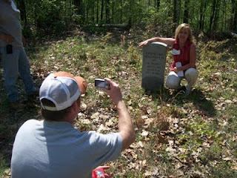

Below members of the Holliman excursion view graves at Old Blooming Grove Cemetery. It was early spring, the trees were leafing out and the brush and weeds were still few and low to the ground.
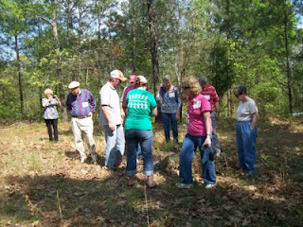
Here Bishop Holliman, b 1919, and great, great grandson ofCornelius, stands with his son, Glenn N. Holliman, b 1946 at the headstone of the pioneer who left the Carolinas and by horse and wagon in 1836 crossed Georgia and much of Alabama to reach the ravine and river bottom country of Fayette County. One hundred and twenty-five years later, some of his many descendants paid homage to his courage and energy and those of his brothers,Charles and Warren, and their wives and children who treked west with them.
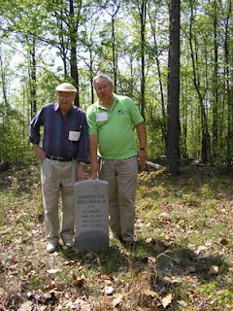Plan now to attend the Holliman and Associated Families Genealogical Round Table at the Fayette County, Alabama Civic Center, 10 am to 3 pm, Saturday, October 15, 2011. For information and reservations for lunch, contact Glenda Norris at gnorris@bcbsal.org or Glenn Holliman at Glennhistory@gmail.com. Sessions to include Tracing the Holymans from England to Alabama, Holliman Farm Sites in Fayette County and sharing of information on Associated Families. All invited also to the 5:30 pm to 9 pm social at the Rose House Inn in Fayette, Friday, October 14, 2011!

Posted by Glenn N. Holliman at 5:58 AM 0 comments
Labels: Bishop Holliman, Glenda Norris, Glenn Holliman, Norman Holliman

WEDNESDAY, JULY 20, 2011

The Hollimans of Alabama
by Glenn N. Holliman
Back to the 19th Century...A Series of Articles on the Hollimans and Related Families of Fayette County, Alabama
One of the more unusual stops on our April 9th, 2011 excursion was a visit to memorial for some Hollimans who fought in the Civil War. While not a burial spot, a well-meaning distant cousin ordered and set up near the William Bailey Holliman home a series of memorial stones honoring James Franklin Holliman, John Thomas Holliman, Uriah Holliman and Elijah Holliman.
Future generations, please be aware many of the dates are incorrect and some facts are wrong on the stones.
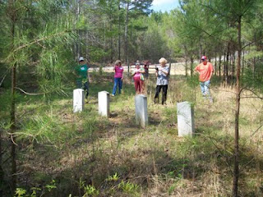
Surveying the memorial stones are left to right, Joey Holliman, Tommie Holliman Allen, Faye Gardner, Jeanette Holliman and Tyler Duckworth. A front view of the stones reveals an old barn in a collapsed state in the background. Pictured below are Bill Holliman and Robert Holliman.
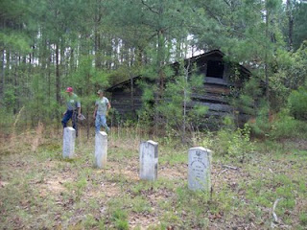

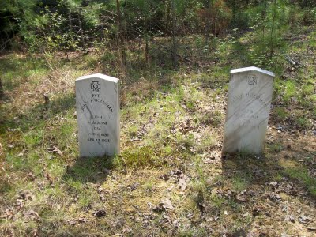
The date on John T. Holliman's stone is incorrect. He died in 1930. While these are not grave sites, one notes that several of these persons did not come home. Elijah Holliman died not at Petersburg, Virginia, but rather at La Grange, Georgia of typhoid fever. He is buried there having served with the 56th Alabama Partisan Rangers. Uriah Holliman died in Okalona, Mississippi along with his son, Charles Daniel Holliman.
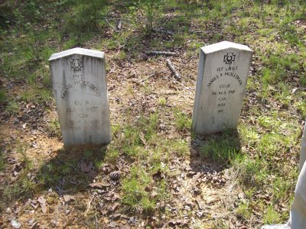
James F. Holliman is NOT buried in this plot but in the Stewart-Holliman Cemetery.
Uriah Holliman was born on July 6, 1816, in Lancaster County, SC. He married Mary "Polly" Lucas in
Tuscaloosa County, AL on Aug. 31, 1836. Performing the ceremony was the Rev. John Walters. Mary was 17 years old. The couple later settled southwest of Bluff in Fayette County, where government land records show that Uriah received patents for more than 320 acres in the late 1850s. Uriah joined the Confederate Army in 1861 at the age of 45! He was Pvt. Uriah H. Holliman, Co. B of the 9th Alabama
Battalion of Volunteers, 26th Regiment, CSA.
He died of measles and pneumonia at Okolona, Chickasaw County, MS, on May 8, 1862, attended by his wife until death. Their son,Charles Daniel Holliman, same military unit, same place, died on May 12, 1862, of the same diseases. Their grave sites are unknown but probably in the Confederate Cemetery in Okolona, MS. Fayette County, Alabama. - Information provided by Dr. Rhodes Holliman, great, great grandson of Uriah Holliman.
I leave this blog up as a caution to those who stumble on the stones near Bluff, Alabama sometime in the future. They are not accurate.
Plan now to attend the Holliman and Associated Families Genealogical Round Table at the Fayette County, Alabama Civic Center, 10 am to 3 pm, Saturday, October 15, 2011. For information and reservations for lunch, contact Glenda Norris at gnorris@bcbsal.org or Glenn Holliman at Glennhistory@gmail.com. Sessions to include Tracing the Holymans from England to Alabama, Holliman Farm Sites in Fayette County and sharing of information on Associated Families. All invited!
More Holliman sites of Fayette County in the next post.
Posted by Glenn N. Holliman at 4:29 AM 0 comments
Labels: Elijah Holliman, James Franklin Holliman, John Thomas Holliman,Uriah Holliman

SATURDAY, JULY 16, 2011

The Hollimans of Alabama
by Glenn N. Holliman
Back to the 19th Century...A Series of Articles on the Hollimans and Related Families of Fayette County, Alabama
Frank Holliman shares information with Bill Holliman, left, and Bill's Uncle Bishop Holliman at the Holliman-Stewart Cemetery in the Bluff Community of Fayette County, Alabama.
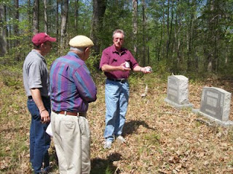
Pictured is the gravestone of Frank Holliman's grandfather, William Bailey Holliman, a son of James Franklin Holliman and Rebecca Stewart Holliman.
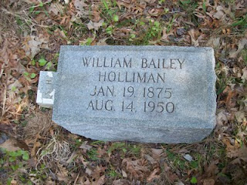

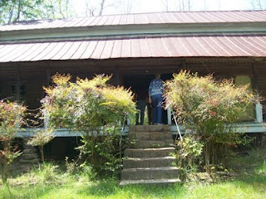
Right, located near the Holliman-Stewart Cemetery is the old home of William Baily Holliman, a classic early 19th Century 'dog-trot'. The name originated as the family dogs would sleep or trot through the opening between the two sides of the cabin. Generally one side was built to hold the kitchen with its wood stove (not comfortable in the summer) and the living rooms on the other side. Of course, no running water, central heat or air, or electricity. Those were the good ole days?
Plan now to attend the Holliman and Associated Families Genealogical Round Table at the Fayette County, Alabama Civic Center, 10 am to 3 pm, Saturday, October 15, 2011. For information and reservations for lunch, contact Glenda Norris at gnorris@bcbsal.org or Glenn Holliman at Glennhistory@gmail.com. Sessions to include Tracing the Holymans from England to Alabama, Holliman Farm Sites in Fayette County and sharing of information on Associated Families. All invited!
Posted by Glenn N. Holliman at 6:08 AM 0 comments
Labels: Bill Holliman, Bishop Holliman, James Franklin Holliman, William Bailey Holliman
Newer PostsOlder PostsHome
Subscribe to: Posts (Atom)

