Tuesday, July 16, 2013

From the Galaxy of Holliman Cousins
By Glenn N. Holliman
From Westminster Abby to the Sipsey River....
Not many Americans can claim a family floor plaque in London's hollowed Westminster Abby, the site of British coronations and stately funerals. However, one will find there a monument to the forerunner of the Blakeneys in the United States.
While beyond the purview of this space to provide an intensive history of the lineage of the Blakeneys (they are kin to this writer by 19th Century marriages in Fayette County, Alabama), I do want to proclaim the writing skills of a distant cousin of mine and a direct scion of the esteemed Lord William Blakeney.
That person is Reed Blakeney, whose American lineage takes his descendants from the Carolinas to Alabama, his home state. While most of his life he was a successful businessman, he has found the talent and time to write several page turners on Southern history. Below, Reed with one of his books, A Mulberry Summer, a story based on a true event of racial strife in Georgia in the 1940s.

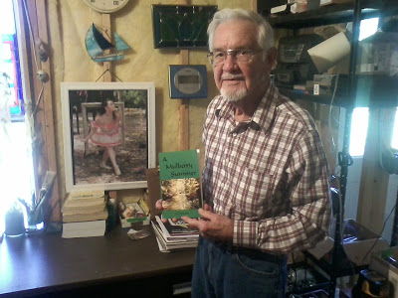

My interest in Reed's handiwork was tweaked by a closer cousin, Dr. Rhodes Holliman, a specialist in Holliman, Blakeney and Baker family histories, all of whom hale in part from the Newtonville, Fayette County, Alabama area. I wrote Reed, and he mailed me a copy of his work, Sipsey which is based on a true story of one of his descendants in Newtonville. Earlier this summer, I had the opportunity to visit with him and his wife, Penny, in his central Georgia home.﻿

The work captures the trek of a family from upper South Carolina to west Alabama when the state was little more than a frontier in the 1830s. One will find an Indian maiden, Mobile brothels, steamboats, cotton plantations, mixed race relationships, Civil War violence and finally human acceptance and reconciliation. I could not put the book down, and not just because the local farm of the Holloman (sic) family popped up in the story from time to time.

In the middle 1830s, the United States Government, led by President Andrew Jackson forcibly removed the remaining Native American tribes from east of the Mississippi to Oklahoma. Creek, Cherokee, Choctaw and Chickasaw land opened in Alabama. Once again Alabama Fever struck the southeast, and young families from the Carolinas picked up their children, livestock and also their slaves and moved as whole neighborhoods west to virgin lands.

Among these neighbors in Anson County, North Carolina and Lancaster County, South Carolina were families such as Holliman, Blakeney, Yerby, Lucas, Pyler, Hughes and others who settled in Tuscaloosa County and in the southeast corner of Fayette County, along the Sipsey River. At one time primitive steamboats up from Mobile plied the Tombigbee River and steered into the swallower Sipsey transporting cotton and pioneers.
Reed Blakeney's book Sipsey encompasses the frontier spirit and conflicted lives that helped built a state and settled families. You can find the book and others by the author on Amazon.com.
And if you are a Holliman, Blakeney or other Fayette County descendant, you will find much more than snippets of the lives of our ancestors.
More on the Blakeneys in the Next Post....

