SUNDAY, AUGUST 15, 2010

When We Were English, Part XIV
by Glenn N. Holliman

Before We Leave Cuddington, England...
and yes, Holliman in this posting is spelled several ways as recorded in primary source material

I had not planned to write more on the Holyman farm in Cuddington, but an email by cousin Betty in the Tina Peddie chat room asking more about the family tree from the farm sent me deeper into my research papers. Alas, I reviewed again scattered papers from Lipscomb's A History of the County ofBuckinghamshire, Vs. 1 & 2, photocopied from Miss Peggy Catell's collection of genealogical materials.

Then I pulled out from other historical records (listed below) of Holyman material and have created a time line, which I hope will be of some benefit someday to someone. I then compared this time line to the family tree of Caroline Stonham's (see When We Were English, Part XII in the archive). This can be confusing so do not feel one has to memorize the article. I plan to tie all this to TringHolyman's very soon.

Let's begin with this photo below from 1965 supplied by Mrs. Stonham, current owner of the HolymanFarm. This picture shows a working farm 45 years ago. The thatch cottage is the same one I have been posting, constructed during the time of William and Mary, 1689. The farmer in front wears a typical English sweater and cap. Notice the stone fence. Quintessential England!
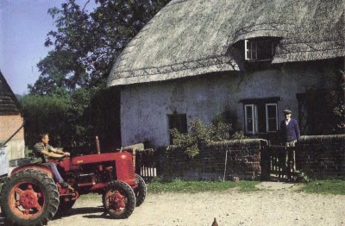
Below, a Time Line of the Holyman Farm using theBuckinghamshire History, The 1522 Certificate of Musters in Cuddington, the 1555 Manorial Survey and the HolymanFamily Tree prepared by Carolyn Stonham of Cuddington

1495 - The Rt. Rev. John Holyman born at the manor. His father was John Holyman (d 1521) married to Elyn in theStonham family tree.

1511 - A Richard Hollyman receives receipts on behalf of the Priory of Rochester which was at that time still 'lord of the manor'. No mention is made of a Richard Holyman in the Stonhamtree. As noted in the Manorial Survey of 1555, the farm had been divided and Richard probably was a brother or uncle of Bishop John Holyman.

1522 - The Certificate of Musters from Buckinghamshire in 1522 (Aylesbury, 1973), p. 72 listed the villagers of Cuddington for tax purposes. The following Holymans were listed as holders of land:

John Holliman (deceased that year and father of Bishop Holyman)

John (James) Holiman Jr. (as son of the above who d 1521)

William Holiman (a son of the above who d 1521)

Ellin Holiman (wife of John (d 1521) and mother of James and William)

Thomas Holiman, son of John (James) Holiman, Jr.

1527 - A John (James) Hollyman took over the 'farm' of Cuddingtonfrom the Priory for a lease of 30 years. This would be a son of John (d 1521). This John (James) had a brother named William who married Margery or Annis. William died in 1545. William and John, according to Stonham, were brothers of Bishop John Holyman. Stonham believes the records reads "James" not John Holyman as is printed in her Holyman family tree.

1531 - John (James) dies in 1531 and wills the lease and 'bedding' to his son Thomas Hollyman. This John makes provision in his will for the repair of the Cuddington bridge. This is in agreement with the Stonham family tree showing a John (James)Holyman, married to Elizabeth dying in 1532 (when the will was probated or by the old calendar).

1539 - Henry VIII dissolves all monasteries and nunneries, and this king takes legal possession of the Farm. Thomas Hollyman, 'farmer' ofCuddington now leases from the king and no longer the Priory of Rochester. The Stonham document does not list the date of Thomas' death unfortunately or any further children, but we do have Thomas still listed in a 1555 manorial survey.

1542 - Thomas made a profit of over 20 pounds from the farm.

1545 - Elizabeth Holyman of Cuddington in her will wrote (as normal in those days), "I bequeath my soulle to the great mercye ofallmightie God and to his mother Marie and all the saints in hevyne." (Remember at this time in England, almost all were Roman Catholics and the Anglican Church was just emerging from the Reformation in Europe.) According to Stonham, Elizabeth was Thomas'smother.

1545 - William Holyman of Cuddington leaves a bequest in his will to mend and repair the bryg waye (by way or road) in the village. (It was common for individual charity to maintain roads in the 16thcentury.) As noted above, Stonham agrees with this death date. Again William was a brother of Bishop Holyman.

1530s - The Rev. John Holyman writes two books in Latin - A Treatise against the teaching of Martin Luther and A Defence of the Marriage of Queen Catherine with King Henry VIII. The works do not survive, but his politically explosive books resulted a new title for John. He was now 'an enemy to the King's cause'. Not good for the Holymanfamily!!

Fr. John is thought to have retired to the Farm at Cuddington and stayed until he was appointed to the vicarage of Wing in 1546. Later he would be vicar at Hanborough prior to becoming Bishop of Bristol.According to Stonham, this elder John would be staying with his nephews - Thomas, the son of John and Elizabethand John, a son of William who died in 1545. This younger John dies in 1558, ironically the same year as his famous uncle.

1554 - 1558 - John Holyman appointed Roman Catholic bishop of Bristol by Cardinal Pole under Queen Mary Tudor. Bishop Holymaninvolved in the trials for four of the five bishops executed for heresy during 'Bloody Mary's' reign: Cranmer, Latiner, Ridley and Hooper.

1555 - A Manorial Survey from the Public Record Office in London listed Thomas Holyman as the holder of manor from Queen Mary Tudor which included all houses, lands, a water mill and four acres of pasture land. His nephew, John Holyman, son of the late WilliamHollyman also held considerable lands as a copy holder.

1574 - Richard Hollyman, the younger, of Cuddington initiated a legal suit against Richard Beake over the custom of bedripp or an extra harvest duty. (Yes, people have quarreled always about taxes. Notice this is Richard the Younger.) According to Stonham, this Richard would be a great nephew of Bishop Holyman. This Richard died in 1605 considerably outliving his father, John (d 1558) who was the son of William (d 1545), who was the son of John (d 1521). This Richard was then a great, great nephew of Bishop Holyman.

1600s - Manor remains crown land until reign of James I.

1689 - Thatched cottage (see above) built. Date is on fireplace mantel in main room of the house.

1700s - The Farm evidently stayed in the Holyman family (according to Stonham) until at least the late 1700s.

1900 - Approximately around the turn of the century, the lastHolyman dies in poverty in Cuddington.

So what to make of the above?

While this family tree and supporting evidence appears firm, one of the above Holymans, perhaps one of Bishop John Holyman's two brothers - John (James) and William had a male offspring who moved at some point to Tring and Cholesbury. Unfortunately CarolineStonham does not take the family tree out of Cuddington.

Below a map of the Holyman Farm in the 1500s.
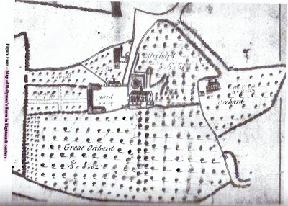
In the next posting, we travel a few miles to Tring to begin to connect this Cuddington family to one Ezikiel Holyman, a founder of Rhode Island and perhaps our mysterious John Holyman who died in Virginia in 1650.
Posted by Glenn N. Holliman at 7:38 AM 0 comments
Labels: Bishop John Holyman, Caroline Stonham, Cuddington, Elizabeth Holyman, Holyman Farm, Richard Hollyman, Thomas Hollyman, William Hollyman

MONDAY, AUGUST 9, 2010

When We Were English, Part XIII
by Glenn N. Holliman
Leaving the Lovely Village of Cuddington

Below a photograph of sheep grazing on a Chiltern hillside near Cuddington, Buckinghamshire. This pastoral scene is typical of the landscape around Tring, Cholesbury, Aldbury and Berkhamstead where the name Holyman pops up in parish registers and legal documents in the 17th and 16th centuries.
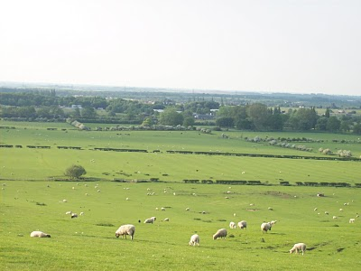
The folk of Cuddington, including Peggy Cattell and Caroline Stonham, were kind and generous with their information on the Holyman family. Below is Nancy Cattell who showed us around the parish church and village. Notice the thatch cottage on the right. It dates to the 1500s. The last reproduction (bottom photo) gives some idea of what an English cottage looked like in the 1600s, something akin to how our ancestors were domiciled.
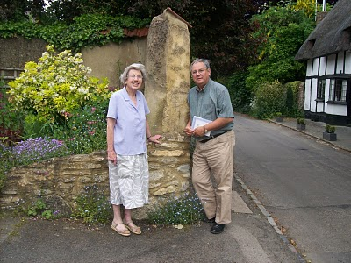
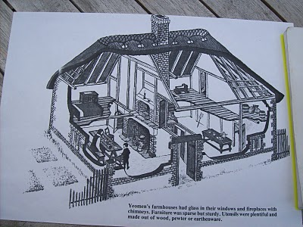
Next we try to connect some ancestral dots....
Posted by Glenn N. Holliman at 5:36 AM 0 comments
Labels: Caroline Stonham, Cuddington, Nancy Cattell, Peggy Cattell

TUESDAY, AUGUST 3, 2010

When We Were English, Part XII

The Holyman Farm of Cuddington has Secrets to Reveal
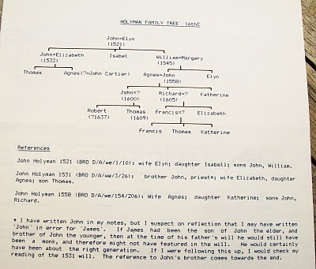
by Glenn N. Holliman

To the left is a typed family tree of the Holyman farm prepared by its present owner, Caroline Stonham.

Below is an 19th century description of the farm from the Buckinghamshire County Museum. In the 1800s a Mr. Scott owned the property. Double click to enlarge. Photos by Barb Holliman.

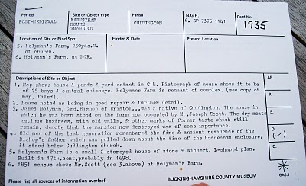
Below is a wing of the 1698 thatched cottage on the Holyman Farm.
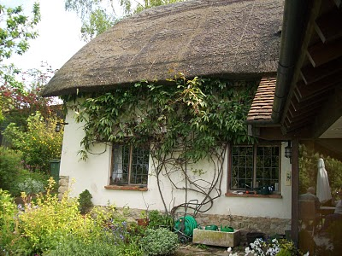
Next post, we say good bye to our eventful visit to Cuddington....
Posted by Glenn N. Holliman at 5:12 AM 0 comments
Labels: Caroline Stonham, Holyman Farm
Newer PostsOlder PostsHome
Subscribe to: Posts (Atom)

