Wednesday, August 8, 2012

When We were English, Part XIIL
A Visit to Fred Cooper of Bristol, England - a Hollyman Family Researcher Extrordinaire by Glenn N. Holliman
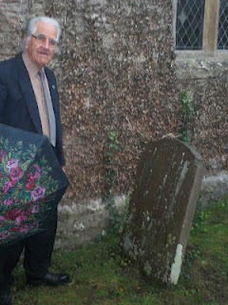
As I have written on more than one occasion, meeting and visiting with cousins, near and far, is one of the delights of family history. Thanks to a generous introduction by Bob Hollyman-Mawson, an English cousin who lives in Wales, my wife and I enjoyed a November 2011 day touring with Fred Cooper, a retired engineer, living in Bristol, England.
Although the showers flowed from the heavens during much of our expedition, we all three enjoyed a pub lunch and looked upon the many monuments of Hollymans in Somerset who have lived before us.
In 2011, Fred Cooper with an ubiquitous British umbrella led us on a fascinating tour of various cemeteries and parish churches where his wife's ancestors, Hollymans, are resting. This photo was taken at the parish church in Abotts Leigh on a hill overlooking the Gordano Valley.
Fred's late beloved wife, Sheila Wallace Cooper, is a Hollyman, descended through her mother, Caroline Hollyman Wallace, late of Abbots Leigh, a small farming community west of Bristol, Somerset, England.
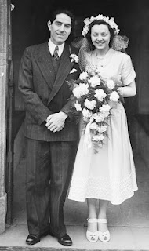
Right, Fred and Sheila on their wedding day in the 1952. It proved to be a most happy marriage producing two surviving sons. Sheila's grandfather was Alfred William Hollyman and great grandfather, John Hollyman. All were farmers living in the community of Abbots Leigh in Somerset.
Since the 1700s, this family of Hollymans have lived also in other Somerset villages such as Kenn, Clevedon and Clapton overlooking and in a picturesque valley known as Gordano. Today the busy M-5 runs through the lush green valley south to Devon.
In the 1800s, part of the family crossed the Severn Estuary, and settled in Wales, ancestors of Peter Hollyman of Pwllheli, whose story and pictures were displayed in an early blog article. (Go to the Archives feature of this blog and type in Peter's name to refresh one's memory.)
Below the map helps our understanding of places. X marks the location of Abbots Leigh, just west of Bristol, England. Further west and south is Clevedon, where another major Hollyman branch settled and thrived. The body of water bordering Clevedon is the Severn Estuary which divides England from Wales. Note the major motorway, the M5 running north and south through the Gordano Valley.
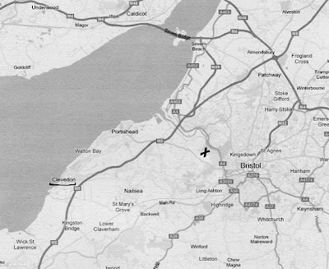
Next post we continue to explore Hollyman sites in Somerset....

Posted byGlenn N. Hollimanat9:55 AMNo comments:
Labels:Alfred William Hollyman,Bob Hollyman-Mawson,Caroline Wallace Cooper,Fred Cooper,John Hollyman,Peter Hollyman,Sheila Wallace Cooper

Thursday, August 2, 2012

Maxine Wright makes available a Warren Holliman Family History
by Glenn N. Holliman
Holliman cousin, Maxine Wright, recently sent me a booklet prepared several decades ago by the late Mavis Williams and the late Chester Bullock, a Baptist minister. Most of this 65 page manuscript highlights the life of Warren Holliman and his descendants in Arkansas. Ms. Williams was a great granddaughter of Warren Holliman (1801-1876), one of the three Holliman brothers who left Lancaster County, South Carolina in 1836 to move their families to Alabama.
Warren was restless and after several years, left his brothers Charles and Cornelius in Alabama and moved his family and others by wagon train to Arkansas in 1840. The brother, Charles Holliman, is Maxine's great great grandfather and brother Cornelius is this writer's great, great, great grandfather.
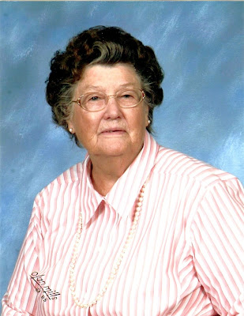
Maxine writes: "I started doing research back before computers, subscribed to genealogy magazines and wrote letters to different Hollimans. I posted queries in books and sent SASE along with family group sheets. Most always received a reply. There is a picture of Warren Holliman and his wife Barbara in a museum in Sheriden, Arkansas."
Thanks to Maxine this manuscript has now been scanned and with her permission is available by email to those who might be descendants of Warren Holliman or who wish to add to their family library. She writes that Mavis and Chester had wanted it shared with all.
Maxine is so kind to share of her collection of family history materials, and like the family of the late Walt O. Holliman, hopefully their example will encourage others to share research and memorabilia via the Internet.
For a copy of the manuscript on the life and family of Warren Holliman, please write me at glennhistory@gmail.com. Since the last posting of this blog, several have requested manuscripts prepared by Walt O. Holliman, which I have been happy to oblige.
Posted byGlenn N. Hollimanat4:00 AMNo comments:
Labels:Charles Holliman,Chester Bullock,Cornelius Holliman,Mavis Williams,Maxine Wright,Walt O. Holliman

Wednesday, July 25, 2012

Walt O. Holliman Manuscripts
by Glenn N. Holliman
The late Walt O. Holliman (1927 - 2003), a native of Alabama, had an excellent mind and a bent to collect data on family. In the pre-Internet age he did an incredible job of researching his families and those of his wife. In the autumn of 2011, his children shipped me his 20 plus boxes of research. With their permission I have scanned his 55 manuscripts of his related families and now have them ready to email to whomever might have an interest. Our continued thank you to Walt's family for preserving and protecting these documents.
Walt's father was Moses Holliman, the son of Warren C. Holliman, the son of Charles Holliman, who was the son of James Grantson Holliman (1750-1836), a common grandfather to many reading this blog.
Some of the manuscripts are in draft, others polished and all footnoted. I can be reached at glennhistory@gmail.com for copies or additional information. If you believe you are related to these families and want to have a look, I am happy to email manuscripts which are in the red color. Additional information on research items can be found in Walt O. Holliman page on the left hand side of the blog.
Below four of Walt's manuscripts - the Alexanders, Beall, Blekeney and Bryan families.
.
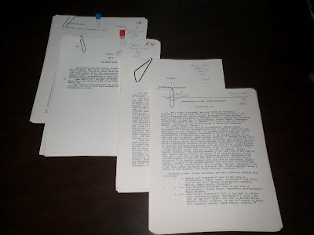
Alexander Family – 80 pages approximately of manuscript and two large binders of research materials of Walt's wife's family from Tennessee. This manuscript has been scanned and can be emailed.

Beall or Bell Family – Approximately 60 pages of manuscript and some 30 pages of research materials; two manuscripts have been scanned and can be emailed.
Blakeney Family – 100 pages of manuscript; these manuscripts (3) have been scanned and can be emailed.
Bryan Family – 20 pages of manuscript, large binders and notebook of research by names of Bryan Family of Tennessee, Mississippi Territory and Pickens Co., Alabama; three manuscripts have seen scanned and can be emailed.

Champion Family - 7 page manuscript of an early Isle of Wight and Surry Co., Virginia family that married into the Beall family; manuscript has been scanned and can be emailed.

Curtis Family – 11 pages of manuscript and research of census records; manuscript scanned and ready for emailing.
Davidson Family plus Index– 101 pages of manuscript plus massive research binders on Walter O. Holliman’s maternal family; manuscript ready for emailing - has Bryan, Champion, Curtis, Egerton, Emerson, Guyton, Hawkins, Judkins, Love, McKnight, Petite, Petway, Smith, Wallace, Whiteaker and other ancestors.
Davies Family – 6 pages manuscript; scanned and ready for emailing.
De Mallpas Family – 2 pages of manuscript; scanned and ready for emailing.
Douglas Family – 2 page manuscript and basically research copies of Scottish newsletters from 1990s; scanned and ready for emailing

Edwards Family – 8 pages approximately of manuscript and research photocopies from Virginia including Surry County; scanned and ready for emailing.
Egerton Family – 40 pages approximately of manuscript– Massive folder full of notes and photcopies; scanned and available for emailing.
Emerson Family -2 pages of manuscript; scanned and ready for emailing.
Fitzhugh Family - 2 pages of manuscript; scanned and ready for emailing.
Fowlehurst Family – 2 pages of manuscript; scanned and ready for emailing.
Gonson Family - 2 pages of manuscript
Graves Family – 30 pages of manuscript and a massive research folder of photocopies and some notes; scanned and ready for emailing.
Gray Family – 6 pages of manuscript and individual folders of research and photocopies of Grays of Virginia, N.C., S.C., KY and Alabama, hundreds of pages; manuscript only scanned and ready for emailing.
Guyton Family – 77 pages of manuscript and two hundred research pages of records, notes and photocopies; manuscript only scanned and ready for emailing.
Hall Family – 3 pages of manuscipt; scanned and ready for emailing.
Hawkins Family – 35 pages approximately of manuscript and several hundred pages of photocopies covering four states; scanned and ready for emailing.
Hendrix Family – 20 pages approximately of manuscript and research photocopies of wills and personal notes, not in order: manuscript scanned and ready for emailing.
Holliman Family – over 200 pages of manuscript, many duplicates. Research is extensive and included in the appendix. This manuscript is available for emailing. Contact Glennhistory@gmail.com.

Howard Family – 20 pages approximately of manuscript and perhaps 50 pages of notes; scanned and ready for emailing.

Judkins Family – 15 pages approximately of manuscript and many research pages of notes; Scanned and ready for emailing.
Love Family – 5 pages of manuscript and research records and photocopies; scanned and ready for emailing.

Mansfield Family – 2 pages of manuscript; scanned and ready for emailing.
Manwaring Family – 2 pages of manuscript; scanned and ready for emailing.
McBee – 2 pages of manuscript and one page of research; scanned and ready for emailing.

McKnight Family – 2 page manuscript of family history; scanned and ready for emailing.
Moore Family – 2 pages of manuscript and a research binder, at least fifty pages of photocopies, many of Surry and Southampton County, Virginia records; scanned and ready for emailing.

Nicholson Family – 3 pages of manuscript and research of Virginia Colonial Abstracts for James City; scanned and ready for emailing.

O’Dell Family – 58 pages of manuscript and a large binder of research material; scanned and ready for emailing.
Oliver Family – 67 pages of manuscript and a large research file; scanned and ready for emailing.

Below a portion of the Walt O. Holliman Collection at the ad hoc Holliman Family History Library, Newport, Pennsylvania

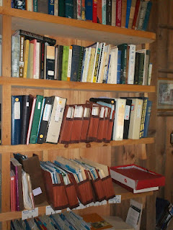
Pearce or Peerce Family – 18 pages of manuscript and a large file of research; scanned and ready for emailing.
Petway Family – 9 page manuscript and Surry County, VA and Granville Co., N.C. research records; scanned and ready for emailing.

Petite Family – 18 pages of manuscript and fifty pages at least of research; scanned and ready for email
Peerce (Pearce) Family - A 12 page manuscript; scanned and ready for emailing
Ridgely Family – 42 pages with duplication of manuscript and over 100 pages of research including Maryland records; scanned and ready for emailing.
Riggan Family – 18 pages of manuscript with massive file on this Monroe, Mississippi family; over 100 pages of photocopies of records from Virginia and Maryland Counties. Many personal notes all in a brown large folder. Manuscript scanned and ready for emailing.
Roberts Family – 49 pages manuscript with a very large file (5 inches); scanned and ready for emailing.
Smith Family – 106 pages of manuscript and research on Jonathan and Henry Smith with photocopies of wills and estates; scanned and ready for emailing.
Spencer Family – 2 pages of manuscript; scanned and ready for emailing.
Sprigg Family – 19 pages of manuscript plus search of Maryland photocopies of records, perhaps 75 pages; scanned and ready for emailing.
Standley Family – 2 pages of manuscript; scanned and ready for emailing.

Thompson Family – 3 pages of manuscript and research notes and census of 1790 in South Carolina; scanned and ready for emailing.
Thornton Family – 2 pages of manuscript; scanned and ready for emailing.
Trelawney Family – 2 pages of manuscript; scanned and ready for emailing.

Wallace Family – 5 pages of manuscript and several research pages including a 1965 history of the family; scanned and ready for emailing.
Walters Family – 20 page manuscript and research photocopies and notes; scanned and ready for emailing.
Williams Family – 3 page manuscript and three research pages of photocopies; scanned and ready for emailing.
Wilmot Family – 3 page manuscript and South Caroline research records including history of state senate; scanned and ready for emailing.
Whitaker Family – 18 page draft manuscript and large binder of notes and materials; scanned and ready for emailing.

Whitten Family, Bible and Wesley Chapel Methodist Church Roles – 59 pages of manuscript and a larger binder of materials plus the Whitten and Wilson Family Bible including the Sunday School Record Book, Wesley Chapel Methodist Church, Fayette County, AL, 1851-1878. Scanned and ready for emailing.
Wilson Family – over 200 pages of manuscripts, many duplicates of this South Carolina and Alabama family. These manuscripts have been scanned and can be emailed.

Again my email is glennhistory@gmail.com if you desire a down load of material!
Posted byGlenn N. Hollimanat2:18 PMNo comments:
Labels:Beall,Blakeney,Bryan,Champion,Curtis,Davidson,Davies,Edwards,Egerton,Emerison,Families: Alexander,Graves,Gray,Guyton,Hawkins,Hendrix,Holliman,Howard,O'Dell,Walt O. Holliman
Older PostsHome
Subscribe to:Posts (Atom)

