TUESDAY, JULY 20, 2010

When We Were English, Part VIII
by Glenn N. Holliman

The Turbulent Life of The Rt. Rev. John Holyman, Installment 5

The life of John Holyman reached a climax during the reign of Queen Mary Tudor, or 'Bloody Mary' as she was termed by Protestants. Nancy Cattell of Cuddington, Buckinghamshire, England concludes her story of this distant ancestor.

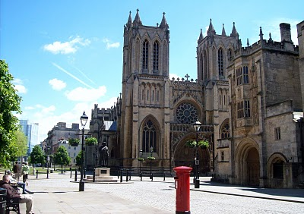The west entrance to the Bristol Cathedral with a quintessential Royal Post Box in foreground. From 1554 to 1558 The Rt. Rev. John Holyman occupied this Episcopate.Photo by Glenn Holliman
"Upon the accession of the Catholic Mary, daughter of Catherine ofAragon, John Holyman was appointed Bishop of Bristol, obviously as a reward for his support of her mother. Once again Holyman was into the limelight for now the Protestants who had supported Kings Henry VIII and Edward VI were to be tried. Bishop Holyman was included in the commission that tried Latimer, Bishop of Worchester and Ridley, Bishop of London. They were found guilty of heresy. In 1554,Holyman also participated in the disputation of Archbishop of Canterbury, Thomas Cranmer."
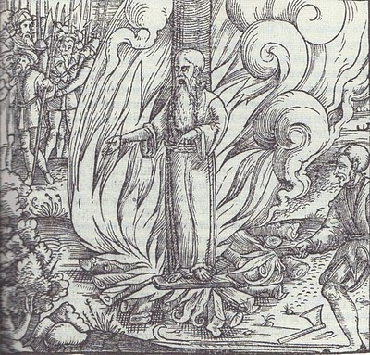
All three Protestant bishops were burned at the stake at Canditch in Oxford for their 'heresy'. The above woodcut is of Cranmer's death from the famous Fox's Book of Martyrs. In Bristol from 1554 - 1558, five more Protestants found martyrdom as 'candles' for Protestantism. In fairness to The Rt. Rev. John Holyman, he is reported to have opposed such actions, but they did occur during his episcopate.
"In 1558, Mary died and was succeeded by the Protestant Elizabeth. So once again the tables were turned and the Catholics were now put on trial. Bishop John Holyman avoided a violent death, as he died of natural causes a month after the accession of Queen Elizabeth I. His burial took place at Hanborough Church."
"I am so amazed that anyone born in the 16th century in what must have been at that time the most obscure of little villages should have produced a man who was at the centre of all the important happenings of that tumultuous time." - Nancy Cattell, Cuddington,Buckinghamshire, UK 2005
Paul Bushe, the first Bishop of Bristol received an ornate tomb with effigy (photo below of Cathedral sanctuary).
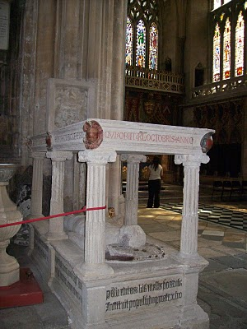

But the second bishop, much more controversial and in disrepute at his death, lies buried in LongHandborough in his former parish church. John Holyman's remains lie under or near this 16th century memorial (photo below) in the small village parish near Oxford.Photos by Barbara Holliman
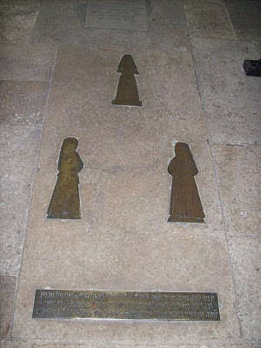

Next post, a visit to the Holymanfarm inCuddington,Buckinghamshire....
Posted by Glenn N. Holliman at 9:59 PM 0 comments
Labels: Bishop John Holyman, Paul Bushe, Thomas Cranmer

SATURDAY, JULY 10, 2010

When We Were English, Part VII
The Turbulent Life of The Rt. Rev. John Holyman, Installment 4
by Glenn N. Holliman
During the last years of Henry VIII and the reign of the boy king, Edward VI, our John Holyman served as priest at Long Handborough, near Oxford, and later vicar at Wing, near Tring, Hertfordshire.
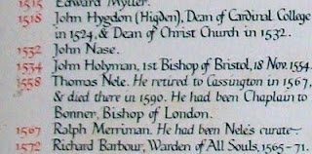
The name John Holyman appears (above) on this list of rectors who have served the parish in Handborough. This roster hangs on the church wall. There is an error; John Holyman was the second, not first Bishop of Bristol.
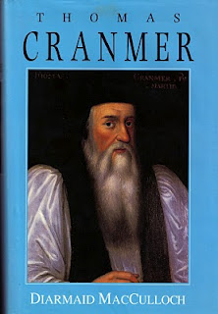
The photo of the book to theleft of Archbishop Thomas Cranmer is the latest in many excellent works on this pivotal priest during the Reformation. Some of the activities of our Bishop of Bristol are recorded in Diarmaid MacCulloch's biography which was published Yale University Press in 1996.

During the English Reformation, out went certain Roman traditions and services and in came a more simplist style of worship and church decorations. English, not Latin, became the language of the pulpit and altar. Cranmer wrote the first Anglican Church prayer books, the model and language which survives even into the 21st century in the American Episcopal Church.
<p&~~special_remove!#~~gt;how did="" john="" holyman="" retain="" his="" priesthood="" and="" parishes="" in="" all="" this="" change="" which="" he="">Discretion must have been his middle name.
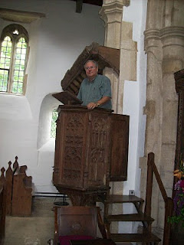

However, one of his distant descendants practices an indiscretion, standing in the 15th century pulpit where John Holyman preached in the 1540s in Long Handborough. Photo by Barbara Holliman, wife of the bogus preacher.
Next posting, we continue with the paper on ancestor John Holyman (1495 - 1558) presented by Peggy Cattell of Cuddington, Buckinghamshire, England.
</p&~~special_remove!#~~gt;how>
Posted by Glenn N. Holliman at 10:46 AM 0 comments
Labels: Thomas Cranmer

FRIDAY, JULY 9, 2010

When We Were English, Part VI
The Turbulent Life of The Rt. Rev. JohnHolyman, Installment 3
by Glenn N. Holliman
Historian Nancy Cattell continues her paper on Cuddington,Buckingshire resident John Holyman.
"While in London Brother John embroiled himself in not just Reformation issues but also the marriage crisis of King Henry VIII (1581 - 1547). Henry had decided that must ask the Pope to grant him a divorce from his first wife, Catherine of Aragon. He claimed that because she had been his brother's widow he should not have been given the dispensation to marry her. This 'sin' was smoting him."
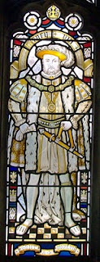This likeness of King Henry VIII is in the Cathedral at Bristol, England, the Cathedral from which Bishop John Holyman presided 1554 to 1558. Photo by Barbara Holliman.
"This after 20 years of marriage, but of course the real reasons for his desire for a divorce were (a) that Catherine had not provided him the son he wanted and (b) much more important - he had fallen desperately in love with Ann Boleyn and wanted to marry her."
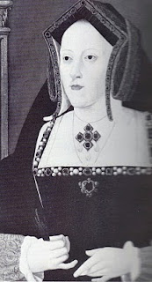"The Pope refused Henry's request and good Catholic that he was Brother Holyman started preaching in favour of the validity of the marriage to Catherine (photo right). This was a very courageous act or if you like, a very foolhardy one for Henry did not approve of criticism."
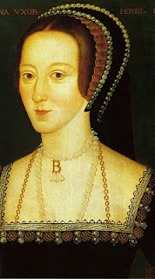Catherine is the mother of Queen Mary Tudor.
"Holyman must have made a discreet move from London otherwise he would surely have lost his head - one book I read told me that his abbot did and certainly the Abbey was dissolved during Thomas Cromwell's 'displacement'. "
Anne Boyleyn, the mother of Queen Elizabeth I, photo left.
"As we know when the Pope refused to grant the divorce, Henry cut the Church in England off from the Roman Catholic Church and thus the Church of England came into being. Henry declared himself the head of the Church and so obtained his divorce from his new Archbishop Thomas Cranmer."
"Brother John Holyman left London and sought refuge in LongHandborough, near Woodstock where he became the rector (and kept his head and kept it down)."
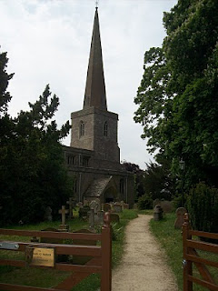
The parish church in Long Handbourgh stands today between Oxford and the historic town of Woodstock, the home of BleninPalace and the birthplace of Sir Winston Churchill.
Next posting, more on the career of Bishop JohnHolyman....
Posted by Glenn N. Holliman at 1:14 PM 0 comments
Labels: Bishop John Holyman, King Henry VIII, Nancy Cattell
Newer PostsOlder PostsHome
Subscribe to: Posts (Atom)

