WEDNESDAY, JULY 6, 2011

The Hollimans of Alabama
by Glenn N. Holliman
Back to the 19th Century...A Series of Articles on the Hollimans and Related Families of Fayette County, Alabama

More on the Civil War Veteran who became a School Teacher
Below on April 9, 2011, Holliman descendant Faye Gardner snaps photographs of Holliman and Stewart grave sites while Robert Holliman and his brother, Norman (not visible) work at removing vines and bushes from covered grave sites of Hollimans and Stewarts near Bluff, Alabama.

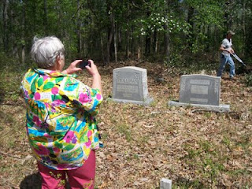
Below, Glenda Norris stands by the memorial stone for Daniel F. Holliman, son of James Franklin and Bertha Lee Holliman - Oct 20, 1895 - May 27, 1897. Lt. James Franklin Holliman is a great, great uncle of hers.
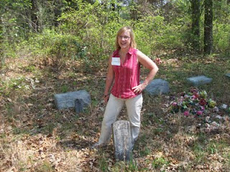
Below, James Franklin Holliman in the early 1900s. This Civil War veteran dedicated his life to school teaching after the violence of his military service from 1861 - 1865. Photo from the collection ofDr. Rhodes Holliman, a great nephew of James Franklin.
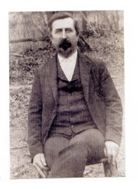
More on the Hollimans of Fayette County, Alabama, next post....
Posted by Glenn N. Holliman at 2:41 PM 0 comments
Labels: Faye Gartner, Glenda Norris

TUESDAY, JUNE 28, 2011

The Hollimans of Alabama
by Glenn N. Holliman
Back to the 19th Century...A Series of Articles on the Hollimans and Related Families of Fayette County, Alabama

Visiting the Grave site of James Franklin Holliman, An Officer and a Teacher
Below the 21st Century James Franklin Holliman stands by the grave of his great grandfather, James Franklin (1839 - 1908) and his great grandmother, Bertha Lee Holliman. James Franklin Holliman's first wife, Rebecca Stewart, the one to whom he wrote a series of letters during the Civil War, lies on the other side of his grave. The location is the Steward-Holliman Cemetery near the Bluff community.
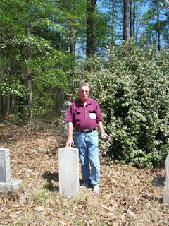
Below Robert Holliman, a great great grandson of Uriah and Polly Lucas Holliman clears brush near the grave site of his great, great uncle, James Franklin Holliman at the Stewart-Holliman Cemetery.
Lt. James Franklin Holliman of the Alabama 58th Regiment, Co. B, was captured at Missionary Ridge, Tennessee. After incarceration for two years at the infamous Johnson's Island in Lake Erie, Ohio, on June 13, 1865, he was released, and walked home to Alabama, At home he did some thing even more heroic - he started a school in his own community and devoted his life to educating the citizens of northern Fayette County. The school was located a few miles from his grave site in the Bluff community. This information courtesy ofRhodes Holliman.
More on this Cemetery in the next post....

TUESDAY, JUNE 21, 2011

The Hollimans of Alabama
by Glenn N. Holliman
Back to the 19th Century...A Series of Articles on the Hollimans and Related Families of Fayette County, Alabama
Nancy Palestine Holliman, one of the thirteen children of Uriah and Polly Lucas Holliman, is buried at Springhill Cemetery in the Bluff Community of Fayette County, Alabama near her mother, Mary Polly Lucas Holliman. Athough her name is listed as Holliman on the stone, Nancy Palestine is reported by Rhodes Holliman to have been married to John Pinion, but they had no children.
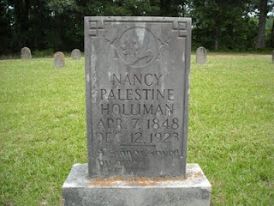
Below, J. Frank Holliman, a second great grandson of Uriah and Polly Lucas Holliman, tells the tale of the winter time burial of his great aunt, Palestine, at the Bluff community, Spring Hill Cemetery. His great grandfather and other relatives dug the grave on a cold, stormy night in 1923.
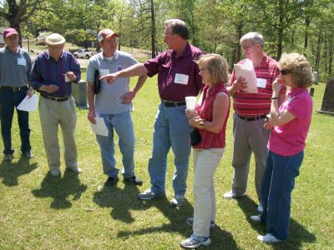
Left to right are Bill Holliman, Bishop Holliman, Norman Holliman, James Franklin (Frank) Holliman, Glenda Norris, Wally and Tommie Holliman Allen. Frank Holliman, who still lives on and near the land farmed by Uriah Holliman prior to the Civil War, is most familiar with Holliman ancestors in the northern part of Fayette County and southern part of Lamar County, Alabama. This excursion to north central Alabama on April 9, 2011 was organized by Uriah and Polly Lucas Holliman's 3rd great grand daughter, Glenda Norris.
More next post on the Hollimans of Fayette County....

