TUESDAY, SEPTEMBER 7, 2010

When We Were English, Part XVII
by Glenn N. Holliman

Continuing the Search for John Holyman (1572 - 1650)
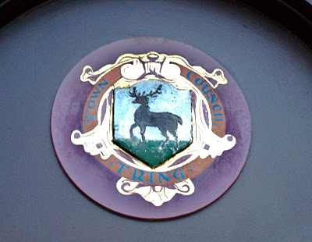Tring, Hertfordshire traces it roots to Anglo-Saxon times, and was located just west of the Danelaw in the 900s. The hamlet is listed in William of Normandy's Doomsday Book. The above is the town logo.(Photo by Barbara Holliman)
I am still looking for that elusive John Holyman who, according to one prominent Holliman genealogical website and the LDS records, was born in Tring, Hertfordshire in 1572. John is the widely reported father of Christopher Holliman, Sr., who is our ancestor of solid record.

We do know a John Holyman did die in Southampton, Virginia in 1650 and left a will which devolved property to a friend, not family. For the past few months, I have been posting information found during an excursion to England seeking Holyman roots and our reported very great grandfather. I continue.

As readers of this web log know, there was a Bishop John Holyman(1495-1558) and an Ezekiel Holyman (1586 - 1659), both religious leaders. One was Roman Catholic and the other a Baptist Protestant. The evidence supports that they are related.

Cousin Jennette Stewart shared by email information that in theEnglish Origins of New England Families, Vol. III, pages 193 - 195, one will find an article by G. Andrews Moriarty entitled 'TheHolymans'. In this article Moriarty quotes The Register, an English genealogical publication, that the Holymans were a family of 'substantial yeomen' with branches in Cuddington, Cholesbury andChesham. The Rt. Rev. John Holyman, Bishop of Bristol from 1554 to 1558 was a member of this family as was one Jayne Holyman(1552 - 1632) and her nephew, Ezekiel Holyman.

From the Latter Day Saints genealogical website, we have the following:

One Leonard Holyman (1520 - 1573) was born in Cholesbury and died in Tring. From the above source we know that Leonard is related to the Cuddington Holymans. I refer all to my post of August 23, 2010, 'When We Were England, Part XV'. Leonard is a contemporary of Bishop John Holyman. Were they brothers or cousins? Cuddington, as the earlier map notes, is an hour or two by horse from Tring andCholesbury.

Leonard married a Joan (b 1525) also of Cholesbury. They had at least seven children. One was the Jane (Jayne), referred to above, b 1552 in Tring, Cholesbury, died 1636 and is buried in Chesham (nearCholesbury). She married Richard Weedon, as noted in the last posting. One of their sons, James, immigrated to Rhode Island, as did Jayne's nephew, Ezekiel.

Jayne's brother John Holyman (1548 - 1597) was a weaver and had a wife named Ales (Alice). There were a number of children of this marriage, one being Ezekiel Holyman, who would immigrate to New England and help found the Baptist Church in America. Another child,Elsabeth, married into the Weedon family herself.

Two of Leonard's sons, Edward and William, left wills of which I found and made copies while in the Hertfordshire Archives. I will be publishing these wills later and transcribing what I can. There was a third son, John, whose will is below and lifted from the English Origins of New England Families.

The Will of John Holyman (1548 - 1597)
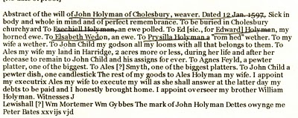

Now John Holyman (d 1597) left a will (abstract above) which does not list a son named John Holyman (remembering we are looking for a John Holyman, b. 1572 in Tring). John (d 1597) does list a godchild, whom he terms John Child. To this godchild, Holymanleft his 'looms and all that belongs to them'. His own children received much less, Ezekiel only getting a ewe. Why did he favor the godchild over his natural children? Perhaps John Child had an aptitude for weaving while the others did not? But this John also left John Child his land after his wife's death.

Why favor John Child over one's own children?

Could John Child have taken the last name Holyman from his godfather, John Holyman? Could this John Child be the elusive JohnHolyman (d 1650 in Virginia)? The dates work. Could this godchild be a natural offspring of John Holyman (d 1597), given perhaps a last name (Child) to obscure a birth out of wedlock? This is only speculation on my part, but the bequests are odd.

So John Holyman (d 1650) is still hidden in history as far as primary sources are concerned, if he be from the Tring area. As cousins Maxine Wright and Joe Parker have revealed, there is evidence JohnHolyman (d 1650) may have been from twenty-five to thirty miles north in Bedford. If so, why are so many web sites placing him inTring?

So are the Bedford and Tring area relatives very closely related, perhaps a branch just recently relocated to Bedford from Tring in the late 1500s? Perhaps, somewhere, someplace, some Holyman stated to an authority, "Yes, my family is originally from Tring, before recently moving to Bedford."

I will look further. Thank you for your patience as I attempt to place all this research by several persons and sources in narrative format and on the record. As ever, I am grateful to my distant cousins for their sharing of knowledge and evidence. Opinions expressed and conclusions drawn, as well as errors, are mine alone.

Next posting....looking at the will of William Holyman, a son of John Holyman (d 1597).
Posted by Glenn N. Holliman at 1:25 PM 0 comments
Labels: Christopher Holliman Sr., Edward Holyman, Ezekiel Holliman,Jeanette Stewart, Joe Parker, John Holyman, Leonard Holyman, Maxine Wright, Weedon family, William Hollyman

WEDNESDAY, AUGUST 25, 2010

When We Were English, Part XVI
by Glenn N. Holliman
Connecting Cuddington Holymans to Cholesbury Holymans and Tring Holymans
Note: Cousin Jeanette Stewart recently shared in a Holliman chat room information on the Holyman and Weedon (Wedon) families of Hertfordshire, England from the English Origins of New England Families. Before reviewing her excellent research, I had been preparing the article below which echoes and strengthens her findings. In future postings, I will attempt to weave her public work into the growing narrative of the Holymans in Tring and Cuddington, England in the 16th and 17th centuries. My thanks to Jeanette, Joe Parker and all for making available to the larger Holliman, Holleman, Hollimon, etc. families their increasing knowledge of our historic roots.

Last spring my cousin Maxine Wright, a relentless researcher in pursuit of Holliman origins, mailed me the following information of one Richard Wedon, who lived in Botley, a small village near Cholesbury and Tring. As one can read in the first paragraph of this p. 187 of The Register, published 1954, Richard had to pay a fine in 1567 for breaking the head on another man's servant. Hmmm....

Richard must have matured because nine years later, in 1576 he married Jayne Holyman in Cholesbury, near Tring. The information below states that this Jayne Holyman was from 'a yeoman family of good standing in Cuddington', descendents of Bishop John Holyman, whose life we have reviewed in previous blogs.

Several other items leap out at us. Richard and Jayne had a son named James who evidently immigrated to Rhode Island! Did James join a cousin named Ezekiel of Tring in Rhode Island?One remembers that Ezekiel Holyman, an Anabaptist, baptised Roger Williams the founder of Rhode Island!
Notice that Richard Wedon writes a will in 1618 (it is probated in 1624, presumably the year of his death). The will is witnessed by William Holyman. Double click to enlarge.
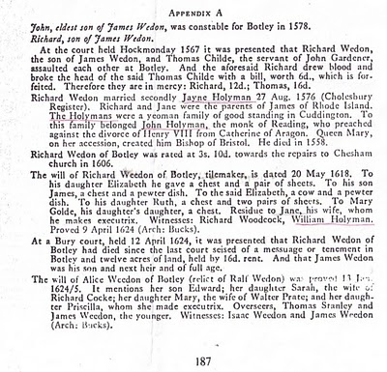
Now the issue grows more complicated. Above we have Jayne Holliman married to Richard Wedon. Below in another section of the Register, we have a John Holyman appearing in marriage in 1593 and dying a few years later. Goodbye to this John who had no children.

However, now William Holyman, the eldest son of another William Holyman, appears again (noticed who witnessed Richard Wedon's will), baptized June 1583 and his sister Priscilla February 1584/5. They have a brother named Ezekiel.

This Ezekiel according to many web sites and those who have researched Baptist Church history is the Ezekiel who sailed to Massachusetts and helped found Rhode Island!

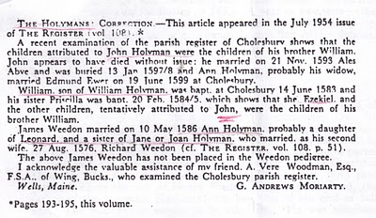
Notice in the next paragraph an Ann Holyman married another Wedon May 1586, and is noted as a probable daughter of Leonard Holyman and a sister of Jane Holyman.

Confusing? Yes, but stay with me. In the next blog, we are going to examine Leonard Holyman and his offspring. In web sites, Leonard is listed as the father of Ezekiel Holyman.

So, two thoughts emerge:

1. Leonard Holyman and other Holymans of Tring and Cholesbury, including Ezekiel, are indeed descendants of Bishop John Holyman of Cuddington.

2. Bishop John Holyman, a devout Roman Catholic, therefore is probably a great or great great uncle or cousin of Ezekiel Holyman, who was religiously antithetical by 180 degrees, to his prominent descendant, an Anabaptist in America! For those interested in religious history this is an amazing journey for a family. One generation burns Protestants at the stake; another helps establish the Baptist Church in Rhode Island.

So are all these interesting Holymans our direct ancestors?Ancestors, most probably yes; direct, we still do not know.

The elusive John Holyman, who died in Virginia in 1650 and is named in various web sites as the father of Christopher Holliman, Sr. (whom we know is the father of the American Hollimans), still has not appeared in the Tring records many of us have researched.

More in the next posting on resolving this mystery. Is our Christopher Sr. really from Bedford, Bedfordshire, another 30 miles or so up the road from Tring? Stayed tuned for more research....
Posted by Glenn N. Holliman at 2:20 AM 0 comments
Labels: Ezekiel Holliman, Jayne Holyman, Jeanette Stewart, Joe Parker,Leonard Holyman, Maxine Wright, William Hollyman

MONDAY, AUGUST 23, 2010

When We Were English, Part XV
Making Sense of Our Cloudy and Confusing English Past
by Glenn N. Holliman
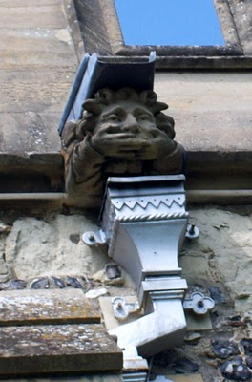This gargoyle on the parish church at Tring, Hertfordshire, England represents the challenges to discover our Holliman roots. The 'past', this gargoyle, seemingly does not wish to tell us what we long to hear....who are our ancestors? Photos by Barbara Holliman

Indeed, new research provided by cousins Maxine Wright and Joe Parker is moving the focus of our search from Tring to Bedford, Bedfordshire, England, approximately 35 miles to the north.

In the meantime, I continue to share some findings in Buckinghamshire and Hertfordshire, about 25 to 30 miles northwest of London. Below is a map of the villages where Holymans lived in the 16th and early 17 centuries: Cuddington, Tring, Cholesbury, Berkhamstead and Aldbury. They are overshadowed in a yellow marker. Double click to make larger.

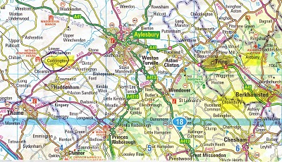
The gargoyle at the top of this posting is from the Tring parish in the photo below.
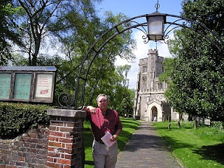
In the photo above, I stand in front of the Tring, Hertfordshire parish church, which has been reconstructed several times since its 11thcentury founding. The present structure was erected in 1470. In this sacred space in England some of our distant ancestors probably worshiped and their remains may linger in the ground behind me.
After visiting the Tring parish church a first time in 2005, my wife and I stepped down the block to visit a charity shop (seeking yet more royal coronation ware, a vice of mine). The kind clerk showed us the local telephone book. Yes, seven or eight Hollimans were listed in the local exchange. Hmm… Later we motored to a pub for roast lamb and red wine (and I remember little more that day!).
Next posting, we continue to explore the villages and paperwork that connects Holymans in Cuddington to Cholesbury and Cholesbury to Tring and Tring to Berkhamsted and Aldbury.
Some new insights published via email by cousins Jeanette, Joe, Maxine, Betty and others continue to add to the tapestry that is emerging concerning our English roots. My continuing thanks to them for sharing.
Posted by Glenn N. Holliman at 7:27 AM 0 comments
Labels: Joe Parker, Maxine Wright, Tring
Newer PostsOlder PostsHome
Subscribe to: Posts (Atom)

