SATURDAY, SEPTEMBER 10, 2011

When We Were English, Part XXX
Some More Names and Thoughts on Worcester Holymans
by Glenn N. Holliman
From the Calendar of Wills and Administrations of the Consistory Court of the Bishop of Worchester, 1661 – 1699, we have more names of Holymans who wrote wills. In Bedfordshire, there are few wills of Holymans; in Worcestershire during the same time period, many. Strange. The archivist in Bedford told me only about 5% of the population in that shire wrote wills in the 1600s. More did so in Worcester.

1672, Aug. 21, John Hollyman, Bromsgrove.
1687, May 9 – Hugh Hollyman, Leigh.
1691, Aug. 7, Thomas Holliman, Bromsgrove.

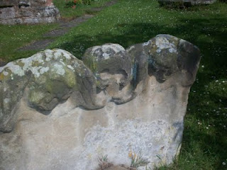
At the Leigh St. Edburga parish from a 1700s tombstone, these eroded figures of two children and grisly skull remind us that young people died often before reaching adulthood.
As my research time was limited, I cannot say that a Judith and Christopher Holyman or other Virginia Holymans did not come from Worcester. Additional hours must be dedicated to reading the microfilm of each will (looking for names) and parish records, as no parish index exists for Worcestershire (sigh…). Only then will be able to rule out or welcome Worcestershire as the ancestral home of at least some of the Hollimans. So much more work to be done.

BUT no name of Christopher or Judith leaped out as such as surfaced in Bedford, England. So for now, I still favor the Bedford Holymans as the origin of our Virginia family.

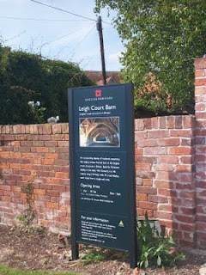
Adjacent to St. Edburga parish is the medieval tithe barn, now maintained by English Heritage. Members of the community were required to support the church (and the civil functions it carried out) through a 10% 'tax' on their harvest. Hence the need for a parish barn to hold the 'tithe'.
A closing thought – the Severn River runs south from Worcester into the Bristol Channel. Bristol, we are told by historians, was the chief port for English relocating to the American colonies. So if one wanted to immigrate to America, Worcestershire would be a convenient location from which to begin an odyssey to the New World.

Therefore as a note of interest, as Christopher and Judith Holyman were transported to Virginia in 1650 sponsored by a man named John Cox, I found this recording in “The Complete Book of Emigrants, 1607-1660” by Peter Wilson Coldham, Baltimore, Genealogical Publishing, 1987:

“April 9, 1650 – Sir Henry Chicheley to be released and allowed to pass to Virginia on the usual security . Pass also for Thomas Cox and Robert Pigge to go to Virginia.” Hmm....

Next a visit to the Buckinghamshire Archives, still searching for the ancestors of Christopher Holyman, Sr. (1618 - 1691)....
Posted by Glenn N. Holliman at 11:23 AM 0 comments
Labels: Thomas Cox, Thomas Holliman

MONDAY, SEPTEMBER 5, 2011

When We Were English, Part XXIX
A Look at the Holymans of Worcestershire
by Glenn N. Holliman

During my visit to the Worcestershire Archives I explored several volumes. My first was Wills and Administrations , Volume 1, 1451 – 1600 by the Worcestershire Historical Society, 1904. These names are indexed for wills as follows. Unfortunately transcripts of the wills have not been published thus requiring, eventually, a look at all the wills to build a family tree.

Spellings of towns vary as certain names were spelled by sound.

1541 – Richard Holyman, Sturbridge.
1553 – Thomas Holyman, the Elder, Lye. (Leigh).
1558 – Elizabeth Holyman, Lyghe (Leigh).
1575 – Hufrey Holyma(n), Blakesall, Wolverley.
1582 – Thomas Holyman(n), Woluley (Wolverley), a M. bond to Alice Stower.
1593 – Thomas Holliman, husbandman, Lyghe (Leigh).
1596, Nov. 23 –William Holliman, victualer, St. Peter’s, Worcester.
1597, Feb. 13 – Thomas Holliman, husbandman, Leigh.

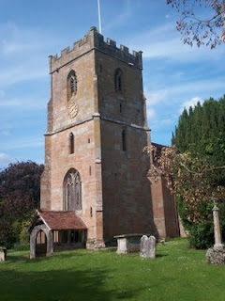
The parish church of St. Edburga at Leigh, Worcestershire. Holymans must lie in the church cemetery.

Then from Wills and Administrations, Probate Registry of Worcester, 1601 – 1652, one finds:

1607 – Roger Hollyman, labourer, Kidderminister.
1608 – Thomas Holliman, husbandman, Leigh.
1610 – John Holliman, Purshullgreene.
1611 – Humfrey Holleymon, yeoman, Wolverley.
1614 – Ann Hollyman, widow, Leigh.
1627 – Samuel Hollyman, Wolverly.
1629 – Francis Holliman, Chadisley (Chaddesley) Corbertt, a scythesmith left a total of 82 pounds (A sizeable sum in the 17thCentury. A scythesmith was a metalworker.)
1642 – Richard Hollyman, yeoman, Leigh.

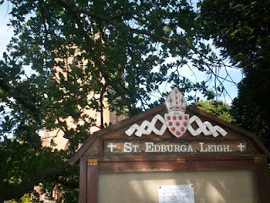

Next post, a few more Hollyman names and some thoughts....

Posted by Glenn N. Holliman at 1:11 AM 0 comments
Labels: Thomas Holyman of Leigh

MONDAY, AUGUST 29, 2011

When We Were English, Part XXVIII
ARE WE WORCESTERSHIRE HOLLIMANS?
by Glenn N. Holliman

Cousin Jeanette Holiman Stewart pointed out in 2010 that there were numerous Hollymans living in Worcestershire, England in the 1500 and 1600s, according to the International Genealogical Index. Could one of these Holymans be the origin of our Christopher Holyman, Sr., founder of the American family?

Could one be Thomas or John Holiman who lived in Virginia in 1636 and 1650 respectively? Or other Hollymans who appeared in the 1650s and 1660s?

Worcester is located 40 miles or so east by northeast from our cottage near Stow in the Wold, so we took a day and motored over to the Family Heritage Centre there.

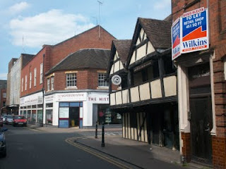
Above on the corner of this Worcester photograph stands the Heritage Centre of Worcestershire which holds many family records. We spent several hours exploring the files and local histories. Unfortunately the parish records were not indexed as in Bedfordshire, which means one must go through reams of microfilm, time which we did not have on this trip. Yes, there is more investigation to do in Worcester, but we found considerable Holyman information which I share in the next post.

The Tutor building in the foreground (above) is one of the oldest structures in the shire, dating back to the 1400s. Did some of our ancestors enjoy a pint of ale in that former inn, now preserved in a historical trust?

Oh, yes, many Hollimans lived in Worcestershire in previous centuries! They left many wills. Would we find evidence that this area, 80 or so miles west of Buckingham and Bedford Shires, could be the origin of the American Hollimans, or at least some of them?

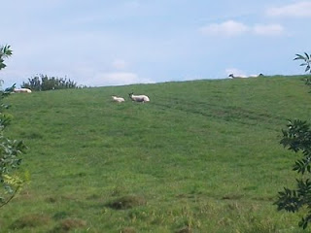

Just a few miles from the centre of Worcester, one encounters a countryside still providing pasture of the sheep. Wool was and is a source of wealth for the English farmer. This particular pastoral scene (photo above) is in Leigh, Worcestershire. Many Holymans lived in and around this village in the 1500s.

My search of the various archives of England made very evident to me that groups of Holyman families lived in several parts of the country in the 15th to 17th Centuries. From where did they originate and why were they scattered?
Distant cousin Jim Maule of Philadelphia, Pennsylvania shared a theory with me recently as to why there are several locations where obviously dozens of Holymans lived. He believes the 14th Century Black Death and the decrease in available labour led many persons to move about the country, financially bettering themselves. Hence pockets of Holymans in several parts of England. Makes sense.

Next post, a listing of Holymans found in Worcestershire - they left many wills!

Posted by Glenn N. Holliman at 6:23 AM 0 comments
Labels: Jim Maule
Newer PostsOlder PostsHome
Subscribe to: Posts (Atom)

