TUESDAY, AUGUST 23, 2011

When We Were English, Part XXVII
A LOOK DEEP INTO THE BEDFORDSHIRE ARCHIVES
by Glenn N. Holliman

Last June, with the help of Bedfordshire family historian, Peter Smith (photo below), we explored the Bedfordshire, England Archives.

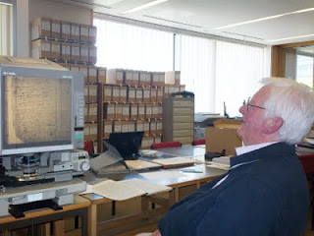

In addition to our reading microfilm of 17th Century parish records, the archivists (see photo below) open the files of the almost 400 year old Bishop’s Transcripts (copies held by the dioceses of parish records).

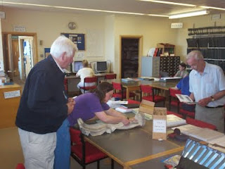

I held the transcripts and viewed the names of Christopher andJudith Holyman (see below), born in 1618 and 1621. The father’s name is given as Thomas.

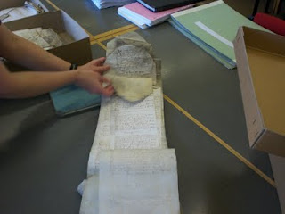

If there be any question about the authenticity of these two persons, that is put to rest.
Is this then truly the Christopher who sailed to Jamestown and inhabited the Isle of Wight County? Were there other Christopher’s in England at this time? Can we find more evidence to support the Bedford thesis or disprove it?

Can we find the birthplace of Thomas Holyman who married in 1609 and sired Christopher Holyman, born 1618? When did this Thomas die and where? The parish records do not tell us, yet.

Are there other places and archives in England to investigate?

Let’s keep looking….

Posted by Glenn N. Holliman at 6:09 AM 0 comments
Labels: Christopher Holliman Sr., Judith Holyman, Thomas Holyman

THURSDAY, AUGUST 18, 2011

When We Were English, Part XXVI
ARE WE WOBURN, BEDFORDSHIRE HOLLIMANS?
by Glenn Holliman

Woburn is the home of the Dukes of Bedford, whose families have occupied the Abby property there since the 1500s when Henry VIII dissolved the monasteries. For centuries the village was a staging station for travelers moving north and south from and to London, approximately 40 miles to the south. The town today was rebuilt after a fire in the early 1700s, and retains a Georgian architectural look as viewed in the photograph below.

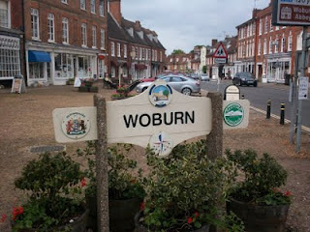

The name Holman concerns me. In other shires, Holyman is plainly written, as it is in Bedford St. Mary’s parish records. One grants handwriting is often a guess as many of the parish clerks were near illiterate in the late 1500s and letter formation had not yet finalized as it is in today’s English script.

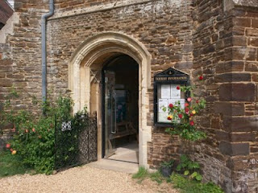

Photographed below is an index of Woburn parish records located in the Heritage Centre (pictured above - the former parish church which is now the museum and Centre). Beginning in 1538, Henry VIII’s chancellor, Thomas Cromwell, required all churches to record all baptisms, marriages and burials. This Cromwell helped convict Anne Boleyn of treason that led to her beheading. Later Chancellor Cromwell lost his own head to Henry’s bad temper!

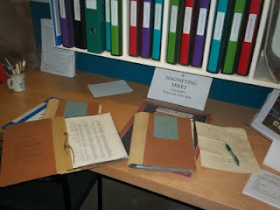

In these Woburn records (pictured above), one will find a host of Holmans and Hollmans but that middle vowel is always missing, no ‘i’, ‘e’ , ‘o’ or ‘y’. Hmmm….There are numerous families whose head of households were named Robert, John, William and Thomas. There is even one Judith Holman, baptized February 16, 1609, daughter of Kath Holman and Henry Dally….hmmmm….born evidently out of wedlock.
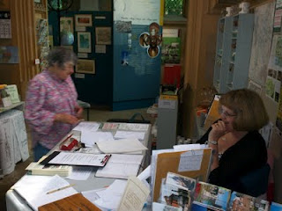
Above, as is common in England, kindly volunteers and staff do all they can to assist Americans in their search for English ancestors.

Yes, there is a Thomas Holman, son of Jn Holman, baptized March 4, 1576, but nary a Christopher born, married or died in Woburn between 1567 and 1670. But if Thomas moved to Bedford, married and had his children, one would not expect to discover such in Woburn. So Woburn cannot be ruled out totally even though the name does not quite match.

Let’s go back to Bedford and search some more.

Posted by Glenn N. Holliman at 1:18 AM 0 comments
Labels: Judith Holman, Thomas Cromwell, Thomas Holman

SATURDAY, AUGUST 13, 2011

When We Were English, Part XXV
Are We Bedfordshire Holymans?
by Glenn N. Holliman
According to parish records, Thomas Holiman (Holyman) of Bedford, who may or may not have been born fifteen or so miles south in Woburn, married at St. Peter’s Church in Bedford in 1609 toHelenara Poynard. Roger Smith suggests the name Helena might be Eleanor, and Poynard, which is not yet found in other Bedford records, may be P’nard or Peynard. Spellings were not yet ‘settled’ nor is the handwriting of parish administrators always legible.

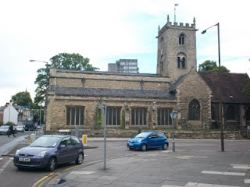
St. Mary's parish is today an archaeological trust facility, and has long since ceased to be a place of Anglican worship. The building and cemetery stand on a busy street corner, two blocks from the river and across the street from Bedford College. Imagine if you will four hundred years ago, no automobiles, only muddy streets, horse carts and the Holyman couple having their children baptised in this parish. How many of them now reside in the cemetery? We don't know.

Again according to parish records, this couple had the following children, all baptized at St. Mary’s Church in south Bedford, two blocks from the River Great Ouse (a wonderful name!).

John, b 1610 (was he named after a grandfather?)

Eleanor, b and d 1612 (may have been named after her mother)

Joan, b 1613

Thomas, b 1616 (named after his father)

Christopher, b 1618 (the believed to be emigrant to Jamestown, Virginia in 1650)

Judith, b 1621 (the believed to be emigrant to Jamestown, Virginia in 1650)

Eleanor, b 1625 (named after her mother and deceased sister)

Stephen, b 1625

Mary, b 1628

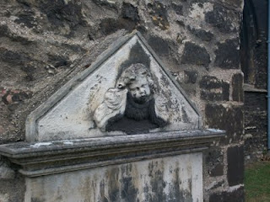

Tombstones were rare in 17th Century England (as in Virginia). This one of a grieving angel in St. Mary's grave yard, is only from the 1800s. Coal smoke and pollution have worn away the stone carving. The cemetery, like the church, is abandoned but the lawn is kept up and the grass mowed. Do our 8th great grandfather, Thomas, and his wife lie in these grounds?

As discussed in earlier articles, a John Holiman died in Virginia in 1650, and a Thomas Holiman (or Holman) took possession of land at Martin’s Hundred, Virginia in 1636. Are John and Thomas from this same family, and is this the encouragement that led to Christopher and Judith to leave for Jamestown, Virginia?

Encouragement Christopher and Judith undoubtedly had, but the 1636 Thomas in Virginia is most probably not the off spring of Thomas who married in Bedford in 1609. Parish records indicate aThomas Holiman married in 1639 at St. Paul’s, Bedford, and my guess this is the second son of the 1609 marriage. Tragically, a son Matthew, died was buried at St. Paul's in 1640.

Next posting….a visit to Woburn and the Heritage Center there.
Posted by Glenn N. Holliman at 4:25 AM 0 comments
Labels: Christopher Holliman Sr., Judith Holyman, Thomas Hollyman
Newer PostsOlder PostsHome
Subscribe to: Posts (Atom)

