MONDAY, AUGUST 8, 2011

When We Were English, Part XXIV
Back to England for More Research!
by Glenn N. Holliman
As I have written in earlier posts, in the spring of 2010, my wife and I did considerable research on the Holyman family in the Tring, Hertfordshire and Cuddington, Buckinghamshire areas of England. The two villages are approximately a dozen or so miles apart, and in the 15th to 17th Centuries contained families named Holliman (Hollyman, etc.)

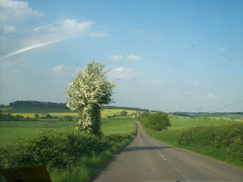

A highway leads from Cuddington, Buckinghamshire through the English countryside. The Rt. Rev. John Holyman and other Holymans were born in Buckingham, Bedfordshire and Hertfordshire in the 1400s and 1500s. More and more evidence suggests these persons are the ancestors of the Virginia Hollimans of the 17th Century.

As described several of these Holymans became prominent; one The Rt. Rev. John Holyman (1495 – 1558) was the Roman Catholic Bishop of Bristol, England and was caught up in the English Counter Reformation. Another Holyman, Ezekiel, a great nephew of Bishop Holyman, ironically helped found the Baptist Church in Rhode Island.

Additional research by cousins in the States in 2010 revealed parish records of St. Mary’s in Bedford, Bedfordshire, England that registered a Holliman family that in the early 1600s gave birth to children named, among others, Christopher (b 1618) and Judith ( b 1621)). Two persons with these names migrated to Jamestown, Virginia in 1650.

Judith disappears to history (probably married to one of the surplus males in the colony) and Christopher to marry, have six children and prosper financially. He left a plantation of 1,020 acres at his death in 1691, and is credited with being the founder of all the Hollimans and various spellings in the now United States.

And So to Bedfordshire
So in the spring of 2011, my wife and I sailed to England to research further the Holliman family (with its various spellings). In addition to American cousins doing considerable research, we have been assisted by a family researcher in Bedfordshire, one Peter Smith, seen below in the photo with the author in May 2011. We are reviewing materials over lunch at the Swan Hotel in Bedford, Bedfordshire, north of London.

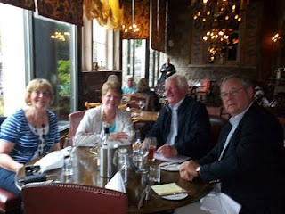
In May 2011, two couples met at the historic Swan Hotel in Bedford, Bedfordshire, England to review genealogical materials pertinent to the Holyman family. John Bunyan, author of Pilgrim's Progress, lunched here in the middle 1600s. Left to right are Maureen Smith, Barbara Holliman, my wife, Peter Smith, a family historian and member of the local genealogical society, and yours truly. One can observe that not all family history research and sharing occurs in a musty archives. More of that later.
Peter had not found (nor did I) Holymans in Bedford before the 1609 marriage of Thomas Holyman, and the subsequent birth of his children. Peter, in his research, however, had found a John Holman born 1560 in Woburn, Bedfordshire, approximately 15 miles south of Bedford and 15 miles north of Tring, Hertfordshire. This John married early – 1575, but no wife is named.
While young, it may have been a required marriage as one Thomas Holiman was born in Woburn in 1576. Two other children are recorded of that marriage – Robert, b 1581 and Joan, 1586, both born in Woburn. Hmmm…..interesting. Could this Thomas be Christopher Holyman, Sr.’s father? Some believe this Woburn, Bedfordshire Thomas is an ancestor of ours.
Next posting in Woburn, Bedfordshire....
Posted by Glenn N. Holliman at 2:57 AM 0 comments
Labels: Barb Holliman, Christopher Holyman, Judith Holyman, Peter Smith, Thomas Holyman

FRIDAY, AUGUST 5, 2011

The Hollimans of Alabama
by Glenn N. Holliman
Back to the 19th Century...A Series of Articles on the Hollimans and Related Families of Fayette County, Alabama
This is my last post on the April 9, 2011 Fayette County, Alabama excursion organized by my second cousin, Glenda Norris. Working with information from her Uncle Rhodes and Grandfather Cecil Rhodes Holliman, Glenda scheduled the day, and even did a 'test drive' before leading 15 of her distant cousins on a trip through family history. Below in the Tuscaloosa County, Spring Hill Baptist Church Cemetery, Glenda in the background cleans a tombstone while her husband, Scott, and Norman Holliman look on. Robert Holliman in the foreground takes photos.
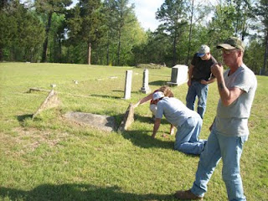
In this cemetery is the unmarked grave of my generation's third great grandmother, Elizabeth Holliman, wife of Cornelius. They led their family by horse and wagon in 1836 from Lancaster County, South Carolina near the North Carolina line through George to west Alabama. Here on recently released Indian land, the family purchased land and began farming. Two brothers, Warren and Charles Holliman, made the trek also, although Warren moved on in a few years to Arkansas to put down roots and establish the Holliman name there. In the photo below, 91 year old H. Bishop Holliman, who visited Fayette County for the first time in the 1920s (He was born in Irondale, Alabama in the 1919) explores the cemetery.
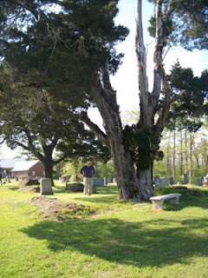
Several earthen grave sites dot the Spring Hill Cemetery. In one of these resting places, may be the remains of Elizabeth Plyler Holliman, pioneer Mother and Grandmother
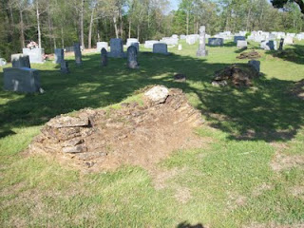
Next post, we return to study earlier Hollimans in England....

MONDAY, AUGUST 1, 2011

The Hollimans of Alabama
by Glenn N. Holliman
Back to the 19th Century...A Series of Articles on the Hollimans and Related Families of Fayette County, Alabama
Actually this article is about a Baptist Church just south of Fayette County and Newtonville. Spring Hill Baptist Church is located just over the Tuscaloosa County line. The memorial stone below in front of the church honors to of my generations’ three great grandfathers -Charles Daniel Lucas and Cornelius Holliman. Their graves were visited on April 9, 2011 by some of their descendants.
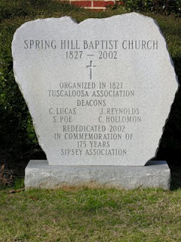
Below the church with the memorial stone in front.
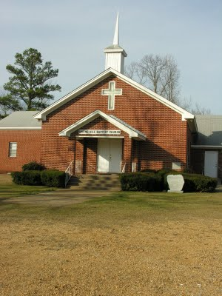
As we know, Charles Daniel Lucas is buried several miles away in an Indian grave site. Cornelius is at peace twenty or so miles north at Old Blooming Grove in the Bluff Community. Glenda Norris believes Cornelius's wife, Elizabeth Plyler, is buried inside the gates of the Spring Hill Cemetery. However, her grave is lost.
