MONDAY, SEPTEMBER 27, 2010

When We Were English, Part XX
by Glenn N. Holliman

Looking for John Holyman in Edward Hollyman's Will of 1617

Just to remind all, the William listed in the last post is the uncle of Ezekiel Holliman, one of the founders of the Baptist Church in Rhode Island and the person who baptized Roger Williams, an architect of American religious liberties. The Edward Hollyman in this post is also Ezekiel's uncle. John Holyman (see Post When we Were English, Part XVII), a brother of William and Edward, is Ezekiel's father.

So here we are knowing Bishop John Holyman (1495 - 1558), devout Roman Catholic who burned Protestants at the stake during the reign of Mary Tudor, is a great uncle or second or so cousin of Ezekiel. Now in all this where is the mysterious John Holyman ofTring (1572 - 1650), believed by many to be the founder of AmericanHollimans in Virginia?

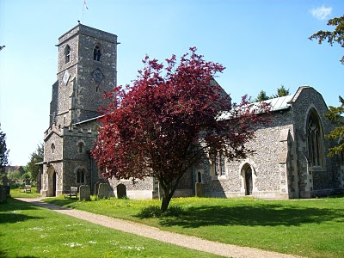The parish church in Aldbury, located a few miles east of Tring,Hertfordshire. Are our relatives buried here also? Photo by BarbaraHolliman, 2010.
In the last posting we explored the 1623 will of William Holyman ofTring, son of Leonard Holyman. In this article we reproduce below from the Hertfordshire Archives, the will of Edward Hollyman ofAldbury, brother of William. Aldbury is only a few miles from Tring. Edward lived from 1546 to 1617, and spelled his name with two 'L's. Edward was more prosperous listing furniture and household items to be dispersed as well as land holdings. Note brother William Holymanwitnessed this will. As the scanner cannot record the entire will at once, it is divided into two parts. Click twice to enlarge.
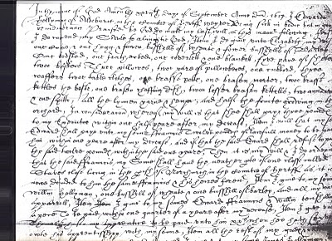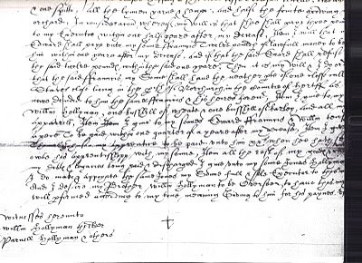
I have not attempted to transcribe this document, but have studied closely the bequests and names. This will seems more difficult to read than William's. A name intrigues, and I remain puzzled over it. Double click the second section and look at the fourth line from the bottom of the will. Beginning in the middle, you will read the words which I transcribe as "I give unto my sons Jonas Hollyman," then words are obscure.

I have pondered and pondered this clause. Is this word John in Latin, Medieval French or 16th century English script? What to do about this? One avenue is to check the Aldbury Church of England register. Remember Thomas Cromwell as of 1538, Henry VIII's chancellor, decreed that all parishes register baptisms, marriages and funerals.

However, I cannot find in Edward's will (as in William's) that he asked to be buried in the parish church lawn. Had Edward joined a non-conformist church (Puritan or even more controversial - theAnabaptists for example) by 1617, as obviously had his nephew Ezekiel? If so, Edward's demise would not be recorded in Anglican Church records.

So I will search the Internet to see what can be found, and if nothing can be found, well, back to the Hertfordshire Archives my next trip to England. A clue, a weak one, but....could this be the not-yet-found John Holyman, d. 1650 in Jamestown, Virginia? I agree, this is a big, huge stretch and even if this name be John, would it also be our John, English founder of our American family....?

Below, is a family memorial in the Aldbury parish. No, not a Hollyman plaque, as it remembers another departed family. This ghastly, but fascinating 17th Century monument, vividly displays that century's view of morbidity. Our ancestors were part of this culture.
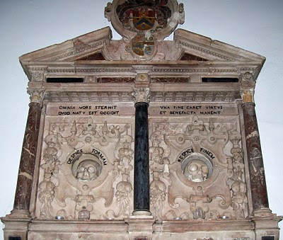Photo 2010 by Barbara Holliman
We are all immigrants from the past...from our families.....
Posted by Glenn N. Holliman at 6:35 AM 1 comments
Labels: Edward Hollyman, William Hollyman; Jonas Hollyman

MONDAY, SEPTEMBER 20, 2010

When We Were English, Part XIX
by Glenn N. Holliman

The Will of William Holyman (1550 - 1623) of Tring, Part II
Still Looking for John Holyman of Tring....

In the index of wills in the Hertfordshire Archives in Hertford, England, I found and copied the last words of William Holyman, son of Leonard Holyman (1520 - 1573). Bear in mind, I was looking for the John Holyman, the reported ancestor of the American Hollimans. While this will does not disclose our elusive direct ancestor, this document does reveal information on the lives and times of our distant cousins, uncles and aunts when we Hollimans were English.Click twice to enlarge. The document is divided into two parts due to my scanner only taking part at a time.
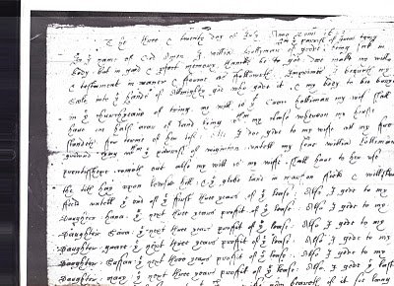
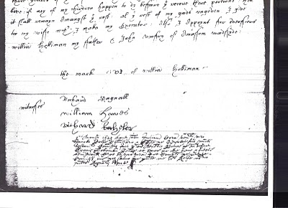What does it say? As no expert, here is my attempt to transcribe the writing form of early 1600s English script.

"The ___ and twentieth day of July Anno Domi 1623 ___ In the Name of God Amen. I, William Holyman of Great (in the parish of Great Tring) being poor in body, but in good and perfect memory, thanks be to God, do make my will and testament in manner and form as followeth,

First, I bequeath my soul into the hands of the Almighty God, who gave it and my body to be buried in the church yard of Tring.

My will is that Grace Holyman, my wife, shall have on half acre of land lying between my house __ for ___ (rest?) of her life. Also I do give to my wife all f___ ___ ___ ___ that ___ of ___. ___ my son William ___ ___ ___ out also my wish is to my wife ___ ___ to her rest the __ hay upon ___ hill; and the glebe land in ma___ field and one of the ___ of the first three years of the field lease. Also I give to my daughter, Hanna, the next ___ years profit of the lease; also I give to my daughter, 'Saiva' or 'Eva', the next three years profit of the ___. Also I give to my daughter, 'Grace' the next ___ profit of ___. I give to my daughter, 'Saffon', the next ___ years profit of the ___. Also I give to my daughter Mary the ___ ___ ___ profit of the ___. Also I give the ___ three ___ of the ___. Unto the ___ my wife ___ ___ if it ___ ___ ___. If any of my children happen to die before they received their portion, then it shall remain amongst the ___. All this ___ of my ___ I give to my wife ___ I make my executor. Also I appoint for administrators (?) William Holyman my father and JohnRomsy of ___ ___.

The Mark of William Holyman, submitted"

My opinion? Here we have described a yeoman farmer living in Tring, to be buried in Tring and farming fields just outside of Tring. He has few worldly goods other than a lease hold on the land.

And to our disappointment, no son named John Holyman.

So the search for the elusive John Holyman continues....
Posted by Glenn N. Holliman at 12:38 AM 0 comments
Labels: Eva, Grace Holyman, Hanna, William Hollyman; Leonard Holyman

MONDAY, SEPTEMBER 13, 2010

When We Were English, Part XVIII
by Glenn N. Holliman

The Will of William Holyman (1550 - 1623), Part I
In the Hertfordshire archives in Hertford, England, one will find several large rooms filled with books, manuscripts microfilm and photographs of local, family and national history. In the short time I was there, the friendly staff pointed me in several directions.

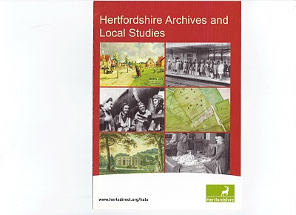This brochure may be of help to those reading this blog. Click twice to enlarge.
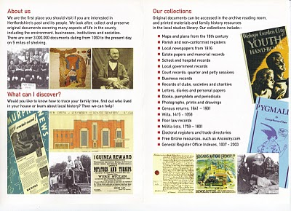

While there I reproduced from microfilm the wills of EdwardHolyman and his brother William Holyman. Before I post them and attempt to transcribe, let me share with readers the way our English alphabet looked in the late 16th and early 17th century. (See below)

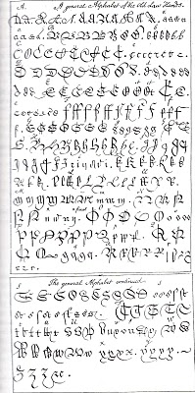

This really is your great grandfather's alphabet! Yes, it is A to Z with several samples for each letter. Some are easy to identify; others are a mystery. It makes interesting reading. Will it get us any closer to the elusive JohnHolyman (1572 - 1650)?
(Again click the reproduction twice to enlarge.)

In Part II of this article, next posting, we will examine William's 1623 will fromTring.
Posted by Glenn N. Holliman at 1:45 PM 0 comments
Labels: William Holyman; Edward Holyman
Newer PostsOlder PostsHome
Subscribe to: Posts (Atom)

