TUESDAY, OCTOBER 4, 2011

[When We Were English, Part XXXIII](http://hollimanfamilyhistory.blogspot.com/2011/10/when-we-were-english-part-xxxiii.html)

**ARE WE FROM SHERINGTON, NEAR MILTON KEYNES, BUCKINGHAMSHIRE?** by Glenn N. Holliman

On a tip from Buckinghamshire family historian Peter Smith, I ventured in June 2011 to the local history section of the Milton Keynes library, about 15 miles north of Aylesbury, Buckinghamshire.  Hopefully there I would find the missing parish records of Sherington, Buckinghamshire, looking as I was for more information on Christopher Holyman (d 1589).

[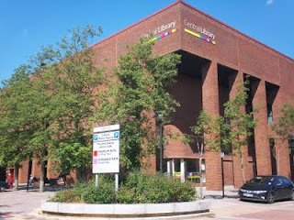](http://4.bp.blogspot.com/-MENFPYRdkpI/ThcunQezthI/AAAAAAAACZo/WbETX3vkCXs/s1600/2011+6-17+Milton+Keynes+library.JPG)

*The modern library and local history room in Milton Keynes is located a 1960s planned development section featuring plenty of parking, retangle office, brick store blocks and urban boredom.*  
  
Milton Keynes is a medieval market town that received a planning make over in the 1960s.  Now a ‘planned community’ of round-abouts and rectangular business plazas, several blocks in length, it does feature plenty of parking even if there be a dreary sameness to its governmental and commercial centre.  Charm, there is none.

Alas, the parish records I sought were still ‘missing’ and after several hours of squinting at microfilm of 17th Century wills, baptisms and burials from 1603 to 1720, I came up with precious few clues on the Holyman family.  However, sometimes it is not what one finds, but what one does not find.  Evidently, the Holyman family, citizens of Sherington in the late 1500s, did not live there in the 1600s after this 1589 Christopher’s death.

So where did the children go?  To Bedford twelve or so miles away and a thriving community in the early 1600s especially if one be a second son, such as Thomas Holyman?

Well, as I was about to leave (my parking was expiring), I glanced at the shelf of local parish publications.  My eye caught a title – “*Fiefs and Fields* *of a Buckinghamshire Village*” by A.C. Chibnall.  The work was published in 1965 by Cambridge University Press of Cambridge. I flipped to the index, not expecting to find anything, when, lo and behold, up popped the names **Christopher Holyman** and**Thomas Holyman**!

On page 178 of the work, I find this: “Two leading inhabitants (of Sherington) Edward Ardes and **Christopher Hollyman**, visited the bishop in 1575 in Buckden to lodge a complaint on rector Henry Barlow, a dissolute fellow.”

[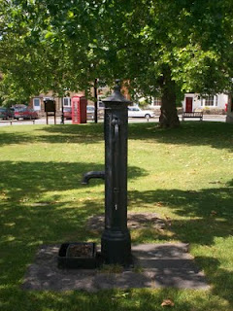](http://4.bp.blogspot.com/-yNctc0rge-4/ThcvPK5M7LI/AAAAAAAACZs/0k4RH0jtDfw/s1600/2011+6-17+Sherington+village+scene+5.JPG)

*Ye ole village pump stands even today on the small village green in Sherington.  The now disappearing British Telephone red box is in the background, and across the street, a closed facility labeled, I think ironically given our family history, the Virginia Store!*

Another page over on 179, the author reports **Christopher Hollyman** serving in Queen Elizabeth’s guard and leasing the rectory for 50 pounds annum.  This Christopher Hollyman (p. 188) died in 1589 after securing more land from his ‘good friend Richard Ardes’ (probable son of Edward Ardes).

Remember in his 1589 will, Christopher Hollyman records a second son, a minor, named Thomas Hollyman.  Well, on pages 193 and 194 of Chibnall’s tome, we are told of a grammar school, 6 or 7 miles from Sherington in Lathbury.  One of the 14 boys listed as attending in 1596 was a **Thomas Hollyman**!   This would make him the right age to be married  in 1609 twelve miles away in Bedford!  
  
  
***The circumstantial evidence is building that we have found the father and grandfather of Christopher Holyman, Sr. (1618 - 1691)....***

Posted by Glenn N. Holliman at [1:33 AM](http://hollimanfamilyhistory.blogspot.com/2011/10/when-we-were-english-part-xxxiii.html) [0 comments](http://hollimanfamilyhistory.blogspot.com/2011/10/when-we-were-english-part-xxxiii.html#comment-form) [[http://img2.blogblog.com/img/icon18_edit_allbkg.gif](http://www.blogger.com/post-edit.g?blogID=919246125180879490&postID=2017618211764567637&from=pencil)](http://www.blogger.com/post-edit.g?blogID=919246125180879490&postID=2017618211764567637&from=pencil)

Labels: [Christopher Holyman](http://hollimanfamilyhistory.blogspot.com/search/label/Christopher%20Holyman), [Thomas Holyman](http://hollimanfamilyhistory.blogspot.com/search/label/Thomas%20Holyman)

TUESDAY, SEPTEMBER 27, 2011

[When We Were English, Part XXXII](http://hollimanfamilyhistory.blogspot.com/2011/09/when-we-were-english-part-xxxii.html)

**A Treasure Found - the Will of Christopher Holyman, 1589!**by Glenn N. Holliman  
  
  
I could not look at all of the Holliman wills in the Buckinghamshire Archives, but three that seemed to match time, place and name, I explored closely.  Now I am not talking about microfilm.

The actual wills were hand carried to me by a lady garbed in a white coat, much like a physician.  She placed three 'ancient' parchments in front of me on a pillow so bindings would not break, and then (gasp) with my uncovered but clean fingers, I turned the pages and held in my 21st Century hands a will signed  in 1589 by **Christopher Holyman**!!!

Was I holding a document signed by my  9th great grandfather????  Could this be the grandfather of Christopher Holyman, Sr. (1618 – 1691) of Isle of Wight, Virginia?  Let me tell you what I found and what it may, repeat, may mean.

*Click twice and the document should enlarge. I have yellowed the names, the first one being Christopher Hollyman!  Note Thomas Hollyman is the second child.*

[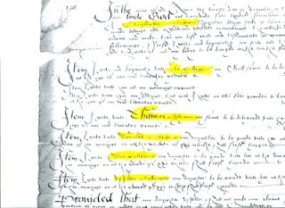](http://1.bp.blogspot.com/-9k_ClaQE9OI/TiRg-qSNTOI/AAAAAAAACc4/wXewBlCqguc/s1600/1589+Christopher's+will.jpg)

1.      This Christopher Hollyman lived in Sherington, Buckinghamshire.

2.    He had children, whose names I make out to be:

A.   John

**B.**  **Thomas, a minor in 1589**

C.    Dorothy (?), a minor

D.   Ellin, a minor

E.    (?) lloy, a minor

F.    Ami, a minor

The wife’s name was **Margaret.**  He appointed his brother, Thomas Hollyman, as executor. Were these persons my 9th great grandmother and a very great uncle?

Yes, for 4 pounds, 20 pence (about $7) I asked for a copy of the will.  It did not reproduce well but here is part of it above.  But there was the signature by an English Christopher Hollyman – chills down my back at this point at this point.  Darn, I forgot to film the document, I was so excited.

So I race to the Sherington, Buckinghamshire parish records to ascertain the baptism records, marriage and burial records of this Hollyman family.  Tragedy!!  No parish records from Sherington UNTIL 1603.  Curses, no way to find out the birth dates of the children.

***What next?***

Posted by Glenn N. Holliman at [8:32 AM](http://hollimanfamilyhistory.blogspot.com/2011/09/when-we-were-english-part-xxxii.html) [0 comments](http://hollimanfamilyhistory.blogspot.com/2011/09/when-we-were-english-part-xxxii.html#comment-form) [[http://img2.blogblog.com/img/icon18_edit_allbkg.gif](http://www.blogger.com/post-edit.g?blogID=919246125180879490&postID=5060558102781369165&from=pencil)](http://www.blogger.com/post-edit.g?blogID=919246125180879490&postID=5060558102781369165&from=pencil)

Labels: [Christopher Holyman](http://hollimanfamilyhistory.blogspot.com/search/label/Christopher%20Holyman), [Margaret Holliman](http://hollimanfamilyhistory.blogspot.com/search/label/Margaret%20Holliman)

SUNDAY, SEPTEMBER 18, 2011

[When We Were English, Part XXXI](http://hollimanfamilyhistory.blogspot.com/2011/09/when-we-were-english-part-xxxi.html)

**ARE WE  BUCKINGHAMSHIRE HOLLIMANS?**  
by Glenn N. Holliman

As one recalls in 2010, I began my research in Hertfordshire before discovering the Holyman 15th Century farm in Cuddington, Buckinghamshire.  So in June 2011, after exploring the Shire Archives in Bedford and Worcester, with the help of family historian, Peter Smith, delved into the Aylesbury, Buckinghamshire Archives.   
  
  
And there, I found treasure!

[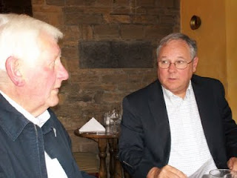](http://3.bp.blogspot.com/-VDamaVmeuLU/ThXK3GaNAEI/AAAAAAAACZY/bVIa4vX6XGg/s1600/2011+5-26+Bedford+Peter+Smith+and+Glenn,+Bedford.JPG)

*Family history 'detective' Peter Smith and the writer discuss findings over lunch.*

A look at the Buckinghamshire Probate Records wills index revealed a plethora of Holliman names.  Unfortunately, the wills are not printed out but must be viewed in the original one at a time.  Here are their names.  Note the ones from Cuddington, the home of the former Holyman Farm and manor house.

1521 – John Holyman, Cuddington. *(see articles posted August 15, 2010 for all Cuddington names)*

1525 – Joan Holyman, Chesham, Leicester.

1525 – John Holyman, Chesham.

1525 – William Holyman, Chesham.

1533 – John Holyman, husbandman, Cuddington.

1545 – William Holyman, husbandman, Cuddington.

1547 – Elizabeth Holyman, Cuddington.

1557 – William Holliman, husbandman, Cuddington (estate valued at 18 pounds).

1558 – John Holyma(n), husbandman, Cuddington.

1573 – Leonard Holyman, weaver, Cholesbury. *(see article posted September 7, 2010 for Leonard Holyman)*

**1589 – Christopher Hollyman, Sherington, testator**.  *(Yes, my eyes doubled, nay tripled, in size when I spotted this one!)*

1598 – John Holyman, weaver, Cholesbury.

1600 – John Holyman, husbandman, Cuddington

1603 – Francis Holliman, yeoman, Cuddington.

1607 – Richard Holyman, labourer, Haddenham.

1618 – John Holeman, shoemaker, Newport Pagnell.

1623 – Thomas Holliman, the elder, yeoman, Cuddington.

1624 – Joseph Hollyman, Haddenham.

1638 – Roberet Hollyman, yeoman, Cuddington.

1648 – Richard Holyman, yeoman, Haddenham.

[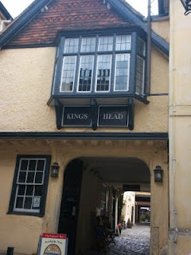](http://1.bp.blogspot.com/-h3NLS0IeuEE/ThXLZG4TTLI/AAAAAAAACZc/T3281S_dBSQ/s1600/2011+6-15+Aylesbury+Kings+Head+National+Trust+pub.JPG)

*Several blocks from the Aylesburg Archives is the Kings Head Pub, one of the few ever listed in England's National Trust.  Henry VIII and Anne Boylen spent the night here on at least one occasion. Whilst in the Archive's the wives of Peter Smith and Glenn Holliman retired for a repast here (after some shopping on High Street!)*  
  
***Next Post - following up on Christopher Holyman (1589)!***