Saturday, September 1, 2012

When We Were English, Part XVL
by Glenn N. Holliman
Hollymans in the Parish Church Cemetery in Clevedon, Somerset
As those of you, who have been reading the past few articles know, that on a rainy day in the late autumn of 2011, distant cousin Fred Cooper of Bristol, England, kindly gave a day to show my wife and me places where persons by the surname of Hollyman had once lived. After a visit to Abbots Leigh, he guided us into the Gordano Valley along the M-5 to the town of Clevedon, a community of over 21,000 today.
Below an aerial view of Clevedon from Wikipedia (the photo is in the public domain) and its 19th Century bathing pier visible jutting into the Bristol Channel.
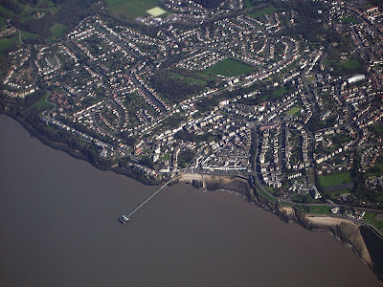
Various Internet history sites tell of Clevedon being listed in the 11th Century Doomsday Book, and the 12th Century Church of St. Andrew's as being possibly constructed on Saxon era foundations. Remains of an Iron Age fort can be found on a local hill.
Below, the entrance to the Anglican Parish at Clevedon where for generations Hollymans worshipped and now lie buried.
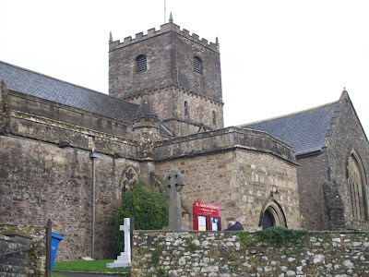
There are few things more melancholy than an English parish cemetery. Below arranged on a hillside overlooking the Bristol Channel is the cemetery of St. Andrew's where persons with the last name of Hollyman are resting. The parish name is from Andrew, one of the disciples who fished, and remains the patron saint of fishermen.
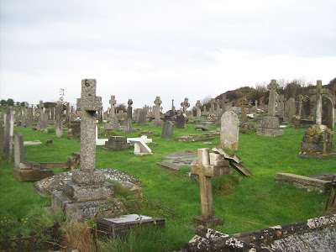

Posted by Glenn N. Holliman at 6:16 AM
Labels: Church of St. Andrew's, Clevedon, Fred Cooper

Monday, September 10, 2012

When We Were English, Part XVIL
by Glenn N. Holliman
Somerset, England...A Home for Hollymans
In the late Fall 2011, Bob Hollyman-Mawson of Wales arranged a visit for my wife and me to call on Fred Cooper, related by marriage to the Hollyman families of Somerset, England. For the past few articles, I have been giving a tour of the area and reproducing some photos I took of locations where Hollymans lived.
In the house below lived in the 19th Century a family named Hollyman. Today, still occupied, the white stucco, thatched roof home in Clevedon is bracketed by roses and protected by a stone fence.
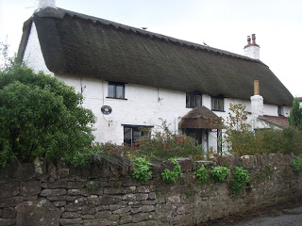
Our genial guide for our tour of Greater Bristol, England was Fred Cooper, a devoted genealogist who has catalogued hundreds of his wife's ancestors. Below in his Bristol home, Fred shows some of his research to Barbara Holliman.
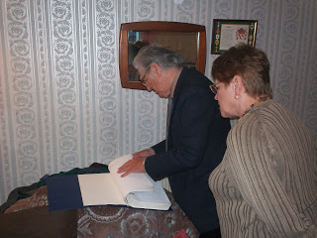
Below, Fred relaxes in an English pub after a morning of sharing with two Americans his knowledge of Hollymans in Abbots Leigh and the Gordano Valley, a picturesque part of Somerset where the Bristol Channel serves as a water bridge uniting England and Wales. Thanks to Fred's kindness and an introduction by Bob Hollyman-Mawson, American and British cousins were brought closer together.
Our thanks to both for a greater understanding of our U.K roots.
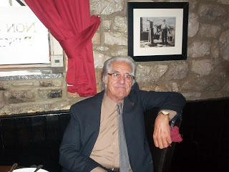
Next article back to the States for some more amazing Holliman cousins....
Posted by Glenn N. Holliman at 2:00 AM

Saturday, September 22, 2012

From the Galaxy of Holliman Cousins, Part I
by Glenn N. Holliman
An Isle of Wight, Virginia Story....
Below, Glenn Holliman, left and Sandi Royal, right, both descendants of Isle of Wight, Virginia first families, compare notes over lunch in July 2012. Sandi, a CPA, contacted me through this blog several months ago seeking more information on her Holliman ancestors.
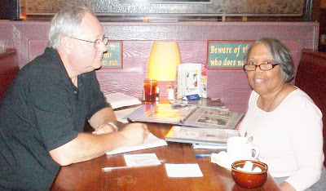
Sandi Royal's great grandfather is Isaac Henry Holliman, born approximately 1824 and died before 1900 in Isle of Wight, County, Virginia. He was born a slave, and his racial make up was of mixed African and European American heritage. His father and mother are not known, not usual for a time of extreme racial prejudice and no official listing of births yet being recorded by the State.
A recent DNA test did not test positive for an Isaac male descendant being in the Christopher Holyman, Sr. (d 1691) line although future testing may yield different results. The surname does substantiate that Isaac took his name from a Holliman family, undoubtedly his 'owner' in the first half of the 19th Century. We do not know who that family is, yet.
Sandi's great grandmother is one Ann Gray, who according to family tradition, was white. Their first of numerous children were born in 1871. The U.S. Census of 1880 records Isaac as being 56 years old and Ann, 37. She would die sometime in the 1930s and is buried with Isaac in Winsor, Virginia. There is uncertainty as to who her parents are although there are at least two options being reviewed. One strong possibility has been suggested by descendant Joshua Holliman, that being that William and Matelida Gray of Isle of Wight were her parents.
Isaac Holliman's descendants tell the remarkable and horrific story of an 1860s couple fleeing from her parents, hiding and living in the Virginia woods to escape an irate father. This couple, evidently much in love, broke not only racist social taboos of the time, but also rigid Virginia law. Yet, under the most trying circumstances imaginable in 19th Century America, the marriage succeeded, and numerous descendants of this remarkable couple prosper today in a freer society and country.
Each year in Suffolk, Virginia, this extended Holliman family gathers, enjoy several meals of regional foods and share the amazing story of a former slave who ran off with a young woman believed to be a slave owner's daughter.
Sandi and distant cousin, Tammy Hunt, have told me this story and with their permission, I share it with the larger family. There is more research to be done to grasp further the details of this stirring saga. Hopefully, we can publish more later. I am grateful to Sandi and Tammy for contacting this site and telling this American story. Cousin Jeanette Stewart also contributed with her usual diligent research.
In the Story of Family, one finds the Story of America....

